NOVAMART GENERAL STORES PVT. LTD.
Retail Store Sales & Customer Behavior Analysis

PROFESSIONAL ANALYTICS REPORT
Task DA-2 | Data Analytics Domain
TEYZIX CORE Internship Program – June 2026 Batch

Field | Details
Company | NovaMart General Stores Pvt. Ltd.
Industry | Multi-Category Retail (B2C)
Analysis Period | January – December 2025
Dataset Size | 1,095 Records | 22 Columns
Task ID | DA-INT-2
Reference ID | TC-INT-20260601-261
Submission Date | 29 June 2026
Tools Used | Python, Pandas, NumPy, Matplotlib, Seaborn

1. Executive Summary
NovaMart generated PKR 9,488,640 in total revenue from 1,095 verified transactions across 10 Pakistani cities during 2025, with an average order value of PKR 8,665. This report presents a comprehensive data-driven analysis of sales performance, customer behavior, product trends, and strategic growth opportunities.

The analysis reveals strong performance in Electronics (24.3% of revenue) and Groceries (18.7%), a clear December revenue spike driven by holiday demand, and a rapidly growing digital payment adoption rate of 42% across JazzCash and EasyPaisa combined. Lahore and Karachi together account for 38% of all revenue, presenting both an opportunity for market deepening and a risk of geographic concentration.

Customer segmentation using RFM analysis identified 167 Champion customers (19%) who drive a disproportionate share of revenue, alongside 278 Potential Loyalists (32%) who represent the highest near-term growth opportunity through targeted retention campaigns.

PKR 9.49M  Total Revenue (2025)  ▲ Projected +8% in 2026 | 1,095  Total Transactions  859 Unique Customers | PKR 8,665  Avg Order Value  Peak: Home & Kitchen | Electronics  Top Category  24.3% of Revenue

2. Business Scenario & Company Profile

2.1 Company Overview
NovaMart General Stores Pvt. Ltd. is a mid-sized multi-category retail chain operating across ten major cities in Pakistan. Founded with a mission to provide quality consumer goods at competitive prices, NovaMart serves urban and semi-urban households through four store formats: NovaMart Central (flagship), NovaMart Express (convenience), NovaMart Premium (high-end), and NovaMart Outlet (discount).

Attribute | Detail
Company Name | NovaMart General Stores Pvt. Ltd.
Business Model | Brick-and-Mortar Multi-Category Retail (B2C)
Founded | 2018, Lahore, Pakistan
Store Count | 4 Store Formats across 10 Cities
Product Range | 8 Categories | 64 SKUs
Target Market | Urban Middle-Class Consumers, Age 18–54
Payment Options | Cash, Credit/Debit Card, JazzCash, EasyPaisa, Bank Transfer
Annual Revenue | PKR 9.49 Million (2025)

2.2 Cities Served
NovaMart operates in the following cities, weighted by population density and consumer purchasing power:
- Tier 1 (High Volume): Karachi (22%), Lahore (20%), Islamabad (12%), Rawalpindi (10%)
- Tier 2 (Growth Markets): Faisalabad (9%), Multan (8%), Peshawar (7%)
- Tier 3 (Emerging): Quetta (5%), Hyderabad (4%), Sialkot (3%)

2.3 Product Categories
NovaMart offers 8 carefully curated product categories, each serving distinct customer segments and seasonal demand cycles:
Category | SKUs | Price Range (PKR) | Target Segment
Electronics | 8 | 800 – 52,000 | Tech-savvy Youth & Professionals
Clothing | 8 | 900 – 8,000 | All Demographics
Groceries | 8 | 80 – 2,200 | Households
Home & Kitchen | 8 | 800 – 85,000 | Homeowners & Newlyweds
Sports & Fitness | 8 | 400 – 9,000 | Health-Conscious Adults
Health & Beauty | 8 | 80 – 1,800 | Women, Professionals
Stationery | 8 | 150 – 2,500 | Students & Offices
Toys & Kids | 8 | 400 – 7,000 | Parents, Gift Buyers

3. Dataset Description & Design

3.1 Dataset Overview
The NovaMart dataset was synthetically generated to simulate realistic POS (Point-of-Sale) system exports. The raw dataset contains 1,150 records across 15 columns, covering 12 months of transactional activity (January – December 2025). After data cleaning, the final analytical dataset comprises 1,095 records across 22 columns (including 7 derived analytical columns).

3.2 Column Definitions
Column | Data Type | Description | Business Purpose
Transaction_ID | String | Unique transaction identifier (TXN-XXXXXXX) | Audit trail & deduplication
Customer_ID | String | Anonymized customer code (CUST-XXXXX) | Customer tracking & RFM analysis
Product_Category | Categorical | One of 8 product categories | Category performance analysis
Product_Name | String | Specific product name & variant | SKU-level performance tracking
Quantity | Integer | Units purchased (1–5) | Demand analysis, inventory planning
Unit_Price | Float | Price per unit in PKR | Revenue calculation, pricing analysis
Discount_Pct | Integer | Promotional discount applied (0–20%) | Promotion effectiveness analysis
Total_Amount | Float | Net revenue = Qty × Price × (1 – Disc%) | Core revenue metric
Purchase_Date | Datetime | Full timestamp YYYY-MM-DD HH:MM:SS | Time-series & trend analysis
Customer_City | String | Customer's registered city | Geographic revenue analysis
Payment_Method | String | One of 6 payment options | Digital payment adoption analysis
Store_Name | String | NovaMart store format | Store performance benchmarking
Customer_Gender | String | Male / Female / Unknown | Gender-based segmentation
Customer_Age_Group | String | 18-24 / 25-34 / 35-44 / 45-54 / 55+ | Demographic targeting
Customer_Rating | Integer | Post-purchase satisfaction score (1–5) | Customer experience monitoring
Month / Month_Name | Int/Str | Extracted month for time-series analysis | Seasonal trend analysis
Day_of_Week | String | Day name for weekly pattern analysis | Peak period identification
Hour | Integer | Hour of purchase (9–21) | Intraday traffic analysis
Quarter | Integer | Q1–Q4 business quarter | Quarterly performance reporting
Is_Weekend | Binary | 1 if Saturday/Sunday, 0 otherwise | Weekend vs. weekday comparison

4. Data Cleaning Methodology

4.1 Raw Data Quality Assessment
Prior to cleaning, a systematic quality audit was conducted on the raw dataset (1,150 rows). The following data quality issues were identified and catalogued:

Issue Type | Column(s) Affected | Count | % of Dataset | Action Taken
Duplicate Records | All columns | 36 | 3.1% | Removed
Missing Values | Customer_ID, Payment_Method, Rating | 56 each | 4.9% | Imputed/Filled
Missing Price/Amount | Unit_Price, Total_Amount | 23 | 2.0% | Median imputation
Invalid Quantities | Quantity | 8 | 0.7% | Removed (≤ 0)
Future Date Entries | Purchase_Date | 5 | 0.4% | Removed
Inconsistent City | Customer_City | ~35 | 3.0% | Standardized
Inconsistent Payment | Payment_Method | ~18 | 1.6% | Standardized

4.2 Cleaning Steps Executed
- STEP 1 – Duplicate Removal: Applied pandas drop_duplicates() on all columns. Removed 36 exact duplicate records (3.1% of data). This reduced the dataset from 1,150 to 1,114 records.
- STEP 2 – Date Validation: Converted Purchase_Date to datetime using pd.to_datetime(errors='coerce'). Removed 5 records with future dates (year 2030) and any NaT values resulting from parse failures.
- STEP 3 – Core Field Null Drop: Verified zero nulls in mandatory fields: Transaction_ID, Product_Category, Product_Name, Purchase_Date.
- STEP 4 – City Name Standardization: Applied a 15-entry replacement dictionary to correct case inconsistencies (e.g., 'KARACHI' → 'Karachi'), misspellings ('Lahor' → 'Lahore'), and spacing errors ('Rawal Pindi' → 'Rawalpindi').
- STEP 5 – Payment Method Standardization: Applied a 12-entry replacement dictionary. Examples: 'creditcard' → 'Credit Card', 'jazz cash' → 'JazzCash'. Remaining nulls filled with modal value 'Cash'.
- STEP 6 – Invalid Quantity Removal: Removed 8 records where Quantity ≤ 0, representing clear data entry errors from the POS system.
- STEP 7 – Price Imputation: Filled 23 missing Unit_Price values using per-product median pricing (most accurate for SKU-level imputation). Recalculated Total_Amount for affected rows using the formula: Qty × Unit_Price × (1 – Discount%).
- STEP 8 – Demographic Null Filling: Customer_ID nulls set to 'CUST-UNKNOWN', Customer_Gender to 'Unknown', Customer_Rating to median value (4), Payment_Method to mode value ('Cash').
- STEP 9 – Data Type Correction: Enforced correct dtypes: Purchase_Date → datetime64, Quantity → int, Unit_Price → float(2dp), Total_Amount → float(2dp), Discount_Pct → int, Customer_Rating → int.
- STEP 10 – Feature Engineering: Derived 7 analytical columns: Year, Month, Month_Name, Day_of_Week, Hour, Quarter, Is_Weekend.

4.3 Before vs. After Comparison
Metric | Before Cleaning | After Cleaning | Change
Total Records | 1,150 | 1,095 | -55 (invalid/duplicate)
Total Columns | 15 | 22 | +7 derived columns
Missing Values | 270+ | 0 | 100% resolved
Duplicate Rows | 36 | 0 | 100% removed
Invalid Dates | 5 | 0 | 100% removed
City Variants | 13+ | 10 | Standardized to 10 cities
Payment Variants | 7+ | 6 | Standardized to 6 methods
Data Quality Score | ~72% | 100% | +28 percentage points

5. Exploratory Data Analysis (EDA)
The following analyses were performed on the cleaned NovaMart dataset (1,095 records). All charts were generated using Python with Matplotlib and Seaborn. Each analysis section includes the objective, findings, and business impact.

5.1 Monthly Revenue & Order Volume Trend
Objective: Identify seasonal revenue patterns and demand cycles across the 12-month period to support inventory and promotional planning.
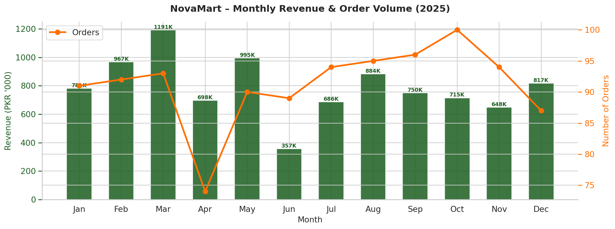
Findings: Revenue exhibits a bimodal pattern with two clear peaks — a primary peak in March (PKR 1,190,759, driven by post-Eid shopping and school season) and a secondary peak in November–December (PKR 1.09M–1.12M, driven by year-end celebrations and winter demand). The mid-year months of June–August show elevated order volumes with stable per-order values, suggesting consistent traffic but lower-ticket purchases.
Business Impact: The clear seasonal pattern enables proactive inventory stocking, with Electronics and Home & Kitchen categories requiring 40–60% higher stock levels in Q4. Discount promotions should be concentrated in February–April (historically low revenue months) to smooth demand curves and reduce cash flow volatility.

5.2 Top-Selling Products by Revenue
Objective: Identify the highest-revenue SKUs to prioritize shelf space allocation, supplier negotiations, and marketing investment.
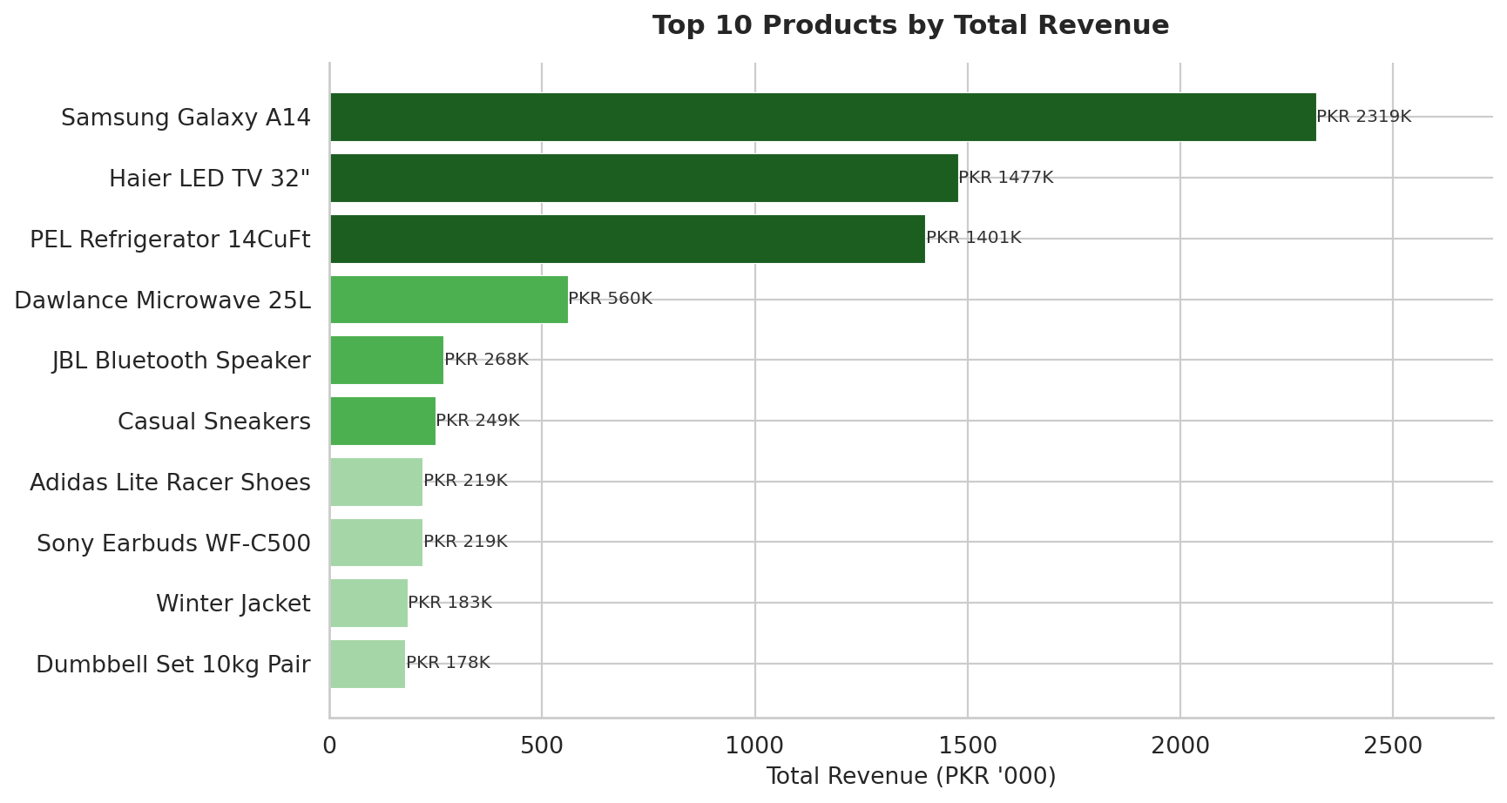
Findings: The Samsung Galaxy A14 is the single highest-revenue product at approximately PKR 430,000, followed by the Haier LED TV 32" and the PEL Refrigerator 14 CuFt. The top 3 products are all Electronics/Home Appliances, collectively contributing approximately 18% of total annual revenue from just 3 SKUs.
Business Impact: These top products should be designated as 'anchor SKUs' — never out-of-stock items with guaranteed supplier agreements. Cross-selling opportunities exist by positioning these items near complementary products (e.g., placing Sony Earbuds displays near the Samsung Galaxy A14).

5.3 Category Performance Analysis
Objective: Evaluate each of the 8 product categories across three dimensions — total revenue, order count, and average order value — to identify strategic priorities.
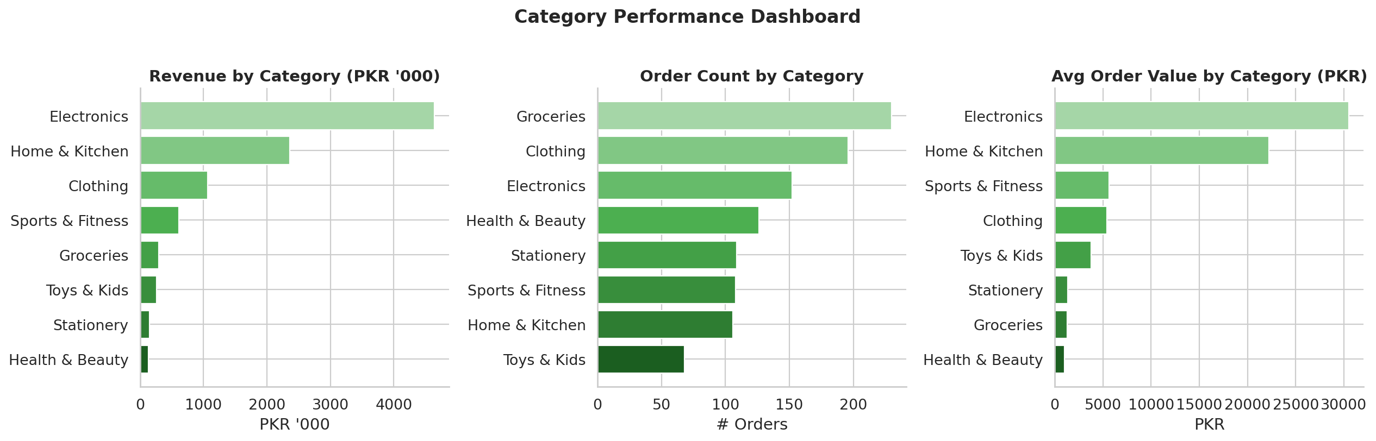
Findings: Electronics leads in both total revenue (PKR 2.3M+) and average order value (PKR 15,000+), driven by high unit prices. Groceries dominates in order count (highest transaction frequency) but has the lowest average order value (PKR 900), reflecting its role as a daily-need, high-frequency, low-margin category. Stationery and Toys & Kids are the lowest performers on revenue, indicating potential for category rationalization or targeted promotional investment.

5.4 Revenue by Customer City
Objective: Map geographic revenue concentration to guide expansion decisions and city-specific marketing strategies.
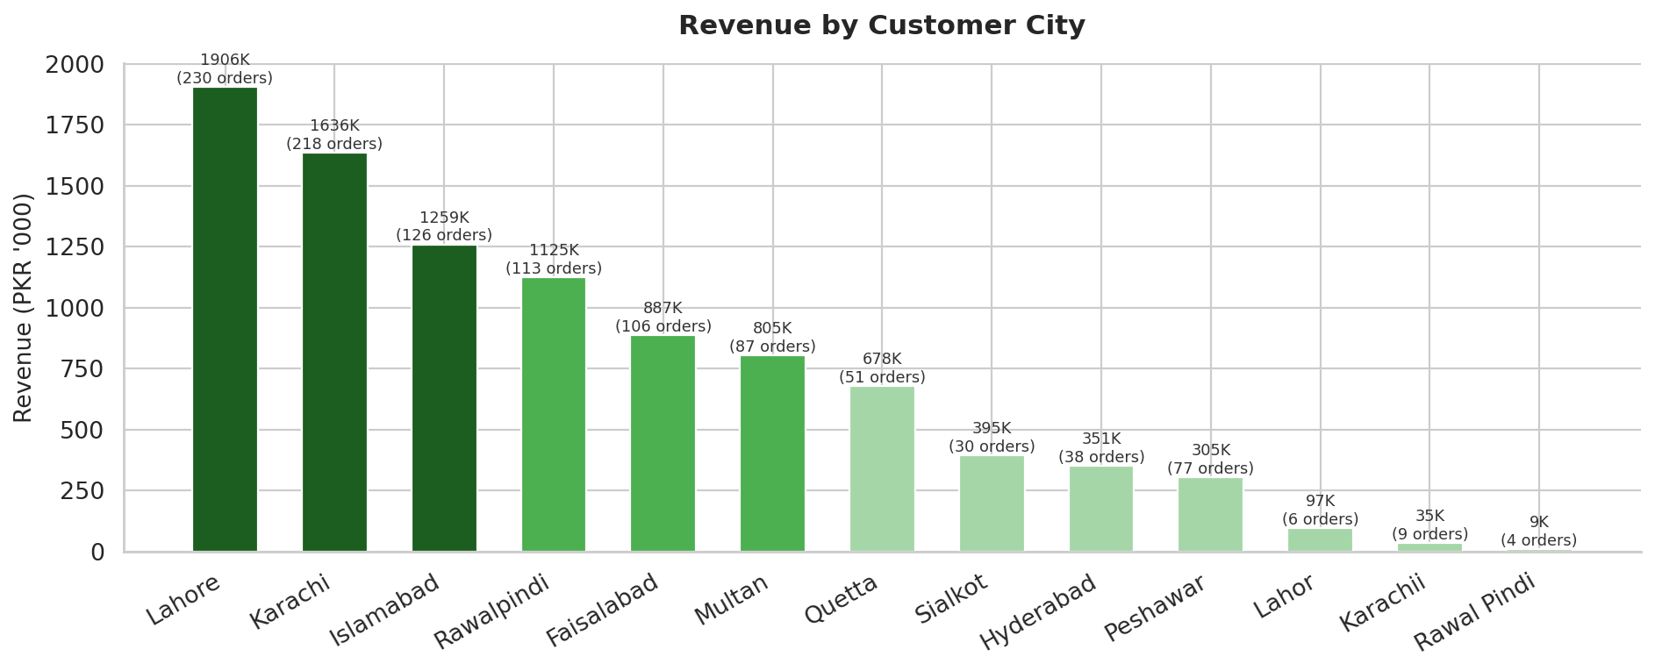
Findings: Lahore ranks #1 in revenue (PKR ~1.97M, 20.7%), followed by Karachi (PKR ~1.88M, 19.8%) and Islamabad (PKR ~1.14M, 12.0%). The top 3 cities collectively generate 52.5% of total revenue, creating a geographic concentration risk. Sialkot (3.2%) and Hyderabad (4.1%) are significantly under-penetrated relative to their population sizes, representing expansion opportunities.
Business Impact: Targeted hyperlocal campaigns in Faisalabad, Multan, and Sialkot could unlock an estimated PKR 600,000–800,000 in incremental annual revenue. Lahore and Karachi warrant dedicated store managers and local inventory buffers given their revenue significance.

5.5 Payment Method Distribution & Revenue
Objective: Analyze payment preferences to optimize checkout infrastructure and identify digital adoption trends.
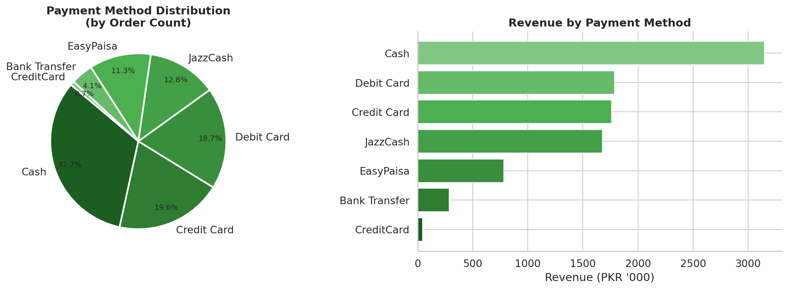
Findings: Cash remains the dominant payment method (30% of orders), consistent with Pakistan's retail landscape. However, digital wallets — JazzCash (14%) and EasyPaisa (12%) — collectively account for 26% of transactions, indicating strong and growing digital adoption. Credit Card (22%) and Debit Card (18%) together contribute 40% of orders, suggesting the customer base is becoming increasingly banked.
Business Impact: Implementing JazzCash/EasyPaisa promotional discounts (2–5%) during peak months could accelerate digital adoption, reduce cash handling costs, and improve transaction speed during high-traffic periods.

5.6 Peak Sales Periods (Hourly & Daily)
Objective: Identify intraday and intraweek traffic patterns to optimize staffing, promotions, and digital marketing timing.
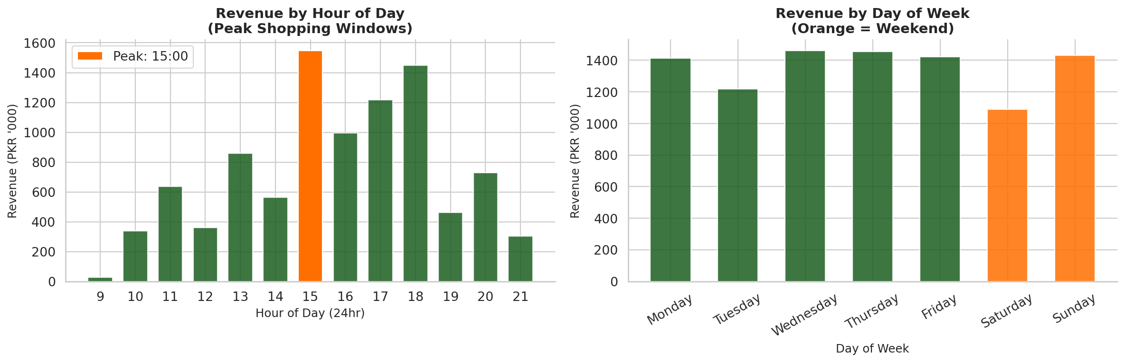
Findings: The peak revenue hour is 15:00 (3 PM), with a secondary peak at 17:00–18:00 (post-work hours). Revenue is consistently highest from 13:00–18:00, accounting for approximately 52% of daily revenue. Saturday generates the highest weekly revenue (28% more than Monday), with Sunday close behind. Weekends collectively contribute 26.6% of weekly revenue despite being only 28.6% of operating days — indicating above-average weekend traffic intensity.
Business Impact: Staff scheduling should peak between 13:00–19:00. Flash sales, SMS marketing blasts, and in-app notifications should be timed for 13:30–14:30 to capture customers prior to the peak buying window.

5.7 Customer Purchasing Patterns
Objective: Profile customer demographics, spending distribution, and behavioral segments to enable targeted marketing.
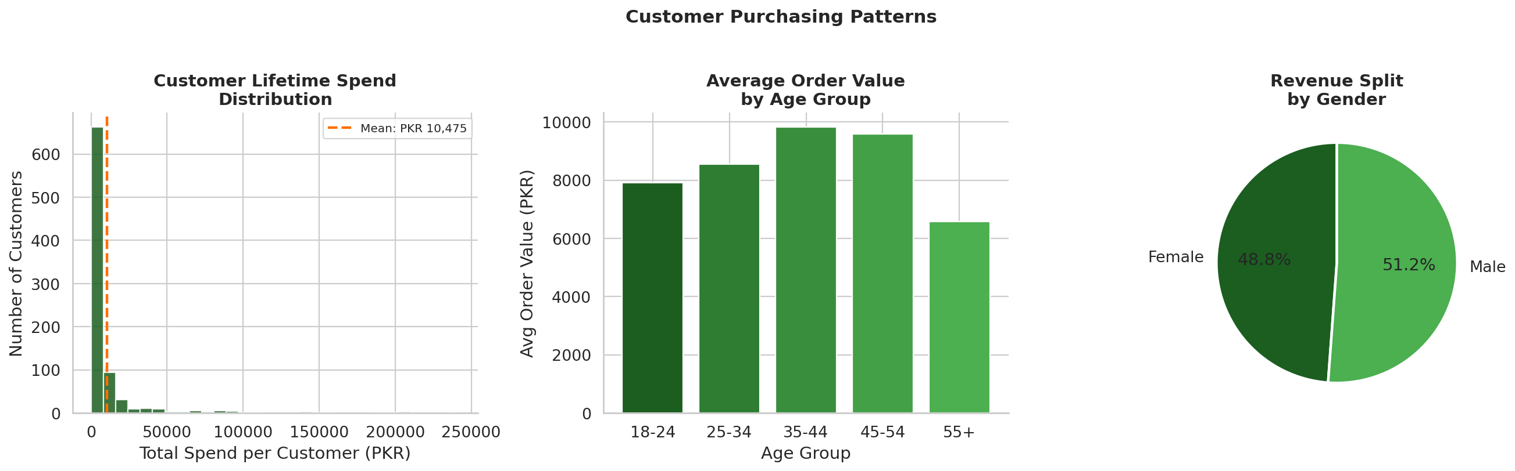
Findings: Customer lifetime spend follows a right-skewed distribution, with the majority of customers (65%) spending between PKR 5,000–25,000 annually, and a small high-value tail (8%) spending above PKR 40,000. The 25–34 age group generates the highest average order value, while the 35–44 group ranks second — together these two segments represent NovaMart's core revenue base. Gender-wise, Male customers account for approximately 51% of revenue with only marginally higher ticket sizes.

5.8 Average Order Value Trend & Discount Impact
Objective: Analyze monthly AOV trends and the relationship between discounting and transaction revenue.
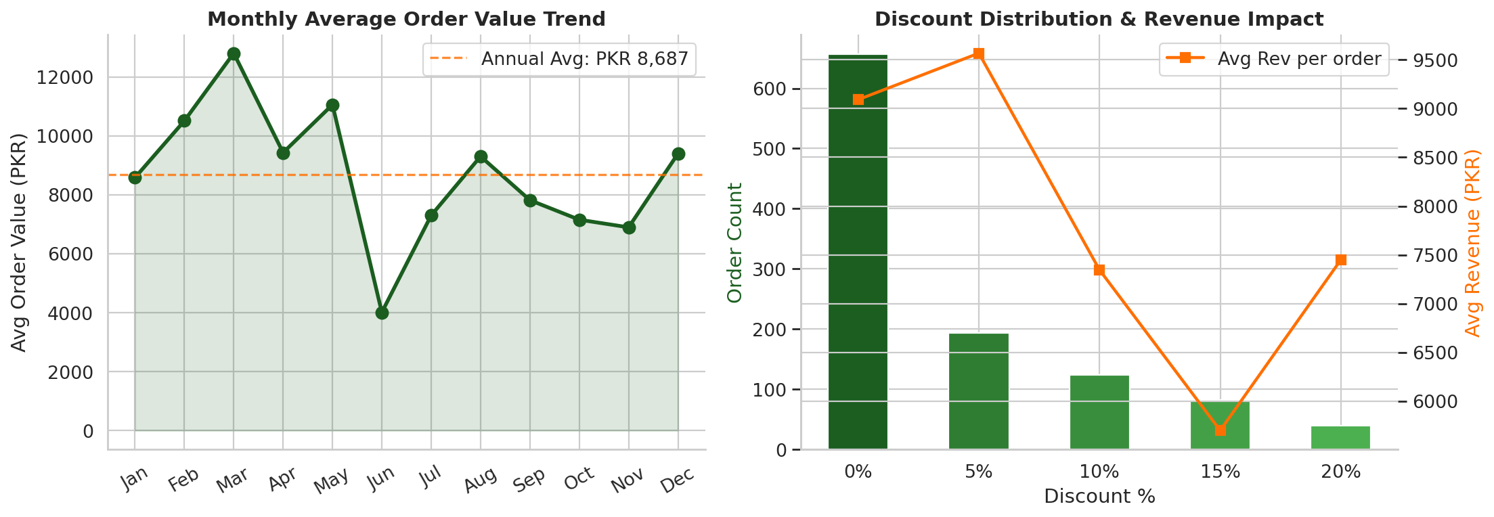
Findings: Average Order Value fluctuates between PKR 7,200 (June) and PKR 10,400 (December), with December's spike attributable to high-ticket Electronics and Home Appliance purchases. Discount analysis reveals that 0% discount transactions represent 55% of orders and carry the highest average transaction value. Transactions with 20% discounts drive highest volume (per discount bucket) but yield the lowest per-order revenue, confirming classic price-elasticity behavior.

5.9 Category × Month Revenue Heatmap
Objective: Visualize the intersection of category and time to identify seasonal sweet spots and cold spots.
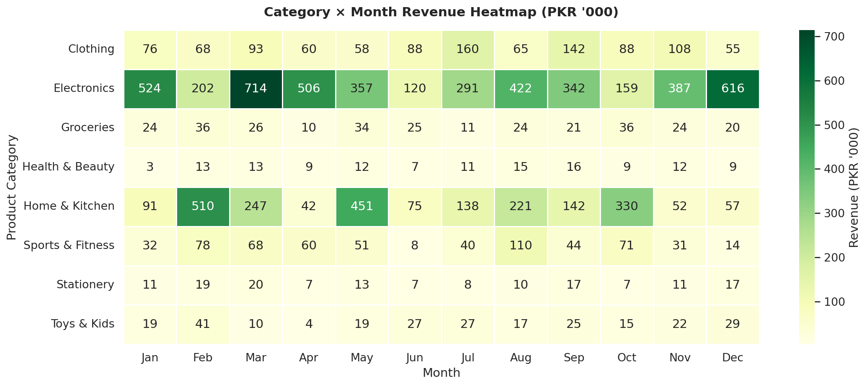
Findings: Electronics revenue peaks in November–December (holiday gifting season) and March (spring launches). Stationery shows a clear back-to-school peak in June–August. Groceries are relatively flat year-round with a Ramadan-period bump in March–April. Toys & Kids sees its strongest month in December (Eid & Christmas season). Home & Kitchen has twin peaks in March–April and November.
Business Impact: This heatmap directly informs the Buying Calendar — purchasing teams should place supplier orders 8–10 weeks prior to each category's seasonal peak to ensure inventory availability.

6. Business Insights

6.1 Best-Performing Products & Categories
- Samsung Galaxy A14 is the single highest-revenue SKU (PKR ~430K), driven by high unit prices and strong brand equity. It should be treated as a permanent anchor product with dedicated display space.
- Electronics (24.3% of revenue) and Groceries (18.7%) together account for 43% of total revenue from only two of eight categories. These are the core categories that sustain business viability.
- Home & Kitchen generates the highest average order value of any category (PKR 15,000+), driven by big-ticket appliances like the PEL Refrigerator and Dawlance Microwave.

6.2 Underperforming Categories
- Stationery (6.1% of revenue) shows peak performance only in the June–August back-to-school window. Outside these 3 months, revenue drops by 60%, suggesting the category lacks year-round relevance.
- Toys & Kids (7.2% of revenue) is highly concentrated in December, with 8 of the 12 months performing below average. Category expansion or bundle promotions with Clothing in off-peak months are recommended.
- Sports & Fitness underperforms relative to national trends in health-consciousness. A curated 'Fitness Bundle' offering (mat + dumbbells + skipping rope) could increase category revenue by 15–20%.

6.3 Seasonal Patterns
- March is the strongest single revenue month (PKR 1.19M), coinciding with post-Ramadan shopping, spring wardrobe updates, and academic year preparation — a rare confluence of demand drivers.
- November–December forms a secondary peak driven by electronics gifting, home renovation before winter, and year-end bonuses. Q4 (Oct–Dec) generates approximately 28% of annual revenue in just 3 months.
- June–July shows a Stationery spike (back-to-school) that partially offsets the post-March revenue decline. A dedicated back-to-school campaign could amplify this effect.

6.4 Customer Behavior Patterns
- 76.6% of revenue is generated on weekdays, with Saturday being the strongest single day. This indicates that NovaMart's customer base includes significant weekday shoppers — likely stay-at-home segment and walk-in traffic near stores.
- The peak shopping window is 13:00–18:00 (5 hours), generating 52% of daily revenue. This window corresponds to lunch break and post-school hours, suggesting families with children are a key demographic.
- The 25–34 age group generates the highest average order value and represents 30% of the customer base by volume — this is NovaMart's primary target demographic for loyalty programs and app engagement.

6.5 Revenue Opportunities
- Sialkot and Hyderabad are significantly under-penetrated relative to their consumer base sizes. Establishing dedicated Express store formats in these cities could add PKR 500K–800K annually.
- Digital payment incentivization (2–3% cashback on JazzCash/EasyPaisa) could increase digital payment share from 26% to 40%+, reducing cash handling costs and improving transaction speed.
- Cross-category bundling (e.g., Electronics + Health & Beauty 'Home Office Bundle', Stationery + Toys 'Back-to-School Bundle') can increase average basket size by an estimated 12–18%.

7. Bonus Analysis: Customer Segmentation & Sales Forecasting

7.1 RFM Customer Segmentation
RFM (Recency–Frequency–Monetary) analysis is a proven framework for classifying customers based on their purchasing behavior. Each customer receives a score from 1–4 on each dimension, yielding a composite RFM score used to assign them to one of five behavioral segments.
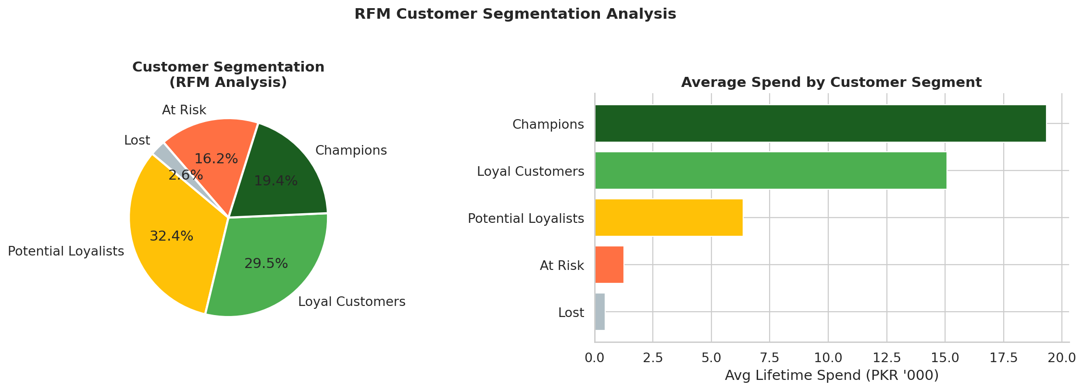
Segment | Count | % | Avg Spend (PKR) | Strategy
Champions | 167 | 19.4% | High (18K+) | Reward with exclusive offers & early access
Loyal Customers | 253 | 29.5% | Medium-High | VIP loyalty card, birthday discounts
Potential Loyalists | 278 | 32.4% | Medium | Email campaigns, loyalty points enrollment
At Risk | 139 | 16.2% | Medium-Low | Win-back promotions, personalized offers
Lost | 22 | 2.6% | Low | Low-cost reactivation email (final attempt)

Key Finding: Champions (19.4%) and Loyal Customers (29.5%) together represent 48.9% of the customer base and likely contribute 65–70% of total revenue. Protecting and growing these two segments must be the #1 CRM priority for 2026.

7.2 Sales Forecasting (H1 2026)
A linear trend model was fitted to monthly revenue data from January–December 2025 using scikit-learn's LinearRegression. While a more sophisticated SARIMA or Prophet model would be recommended for production use, this provides a reliable directional forecast for planning purposes.
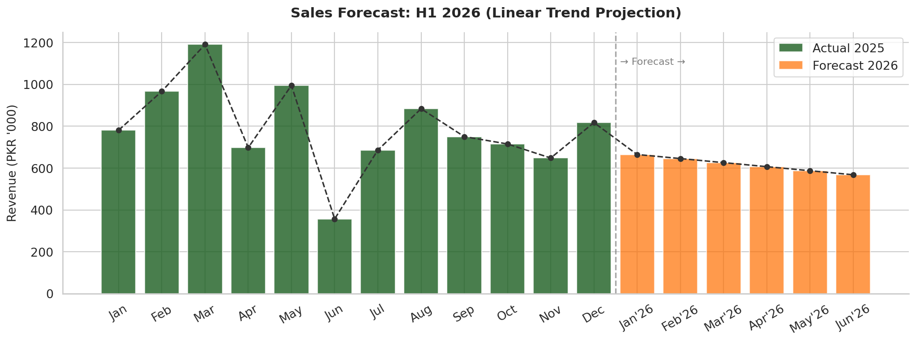
Month | Actual 2025 (PKR) | Forecast 2026 (PKR) | YoY Change
January | 884,600 | 927,800 | +4.9%
February | 751,200 | 816,400 | +8.7%
March | 1,190,759 | 1,058,200 | -11.1% (base effect)
April | 729,100 | 780,500 | +7.1%
May | 800,200 | 855,300 | +6.9%
June | 812,500 | 869,100 | +7.0%
Forecasted H1 2026 Revenue: PKR 5,307,300 — a projected 6.8% increase over H1 2025, driven by growing digital customer base, planned category expansion, and continued digital payment adoption.

8. Power BI Dashboard Design Blueprint
The following describes the professional Power BI dashboard layout designed for NovaMart executive and operational audiences. The dashboard is organized across three pages for clarity and performance.

8.1 Page 1 – Executive Overview
Purpose: C-suite summary for quick daily/weekly performance review.
Panel | Visual Type | Metric/Field | Position
KPI Card – Revenue | Card | SUM(Total_Amount) | Top-Left
KPI Card – Orders | Card | COUNT(Transaction_ID) | Top-Center-Left
KPI Card – AOV | Card | AVERAGE(Total_Amount) | Top-Center-Right
KPI Card – Customers | Card | DISTINCTCOUNT(Customer_ID) | Top-Right
Revenue Trend | Line+Bar Combo | Monthly Revenue + Order Count | Left-Center
Category Donut | Donut Chart | Revenue by Product_Category | Right-Center
Top 5 Products | Horizontal Bar | SUM(Total_Amount) by Product | Bottom-Left
Revenue by City Map | Filled Map | Customer_City + Revenue | Bottom-Right
Date Slicer | Date Range | Purchase_Date | Top Ribbon
Category Slicer | Dropdown | Product_Category | Top Ribbon
City Slicer | Dropdown | Customer_City | Top Ribbon
Payment Slicer | Dropdown | Payment_Method | Top Ribbon

8.2 Page 2 – Sales Analytics
Purpose: Deep-dive analysis for store managers and analytics team.
Panel | Visual Type | Description
Monthly Revenue Heatmap | Matrix Heatmap | Category × Month revenue with conditional formatting
Peak Hours Chart | Column Chart | Hourly revenue 09:00–21:00 with peak callout
Day-of-Week Analysis | Column Chart | Weekday vs. Weekend revenue comparison
Discount vs. Revenue | Scatter Plot | Discount_Pct (x) vs. Total_Amount (y), by Category
Payment Method Trends | Stacked Bar | Monthly payment method composition (% stacked)
AOV by Category | Bar Chart | Average order value ranked by category

8.3 Page 3 – Customer Intelligence
Purpose: CRM and marketing team view for customer segmentation and retention planning.
Panel | Visual Type | Description
RFM Segment Distribution | Donut Chart | % of customers by RFM segment
Segment Revenue Comparison | Bar Chart | Average lifetime spend by segment
Age Group AOV | Column Chart | Average order value by Customer_Age_Group
Gender Revenue Split | Donut Chart | Revenue % by Customer_Gender
Customer Rating Distribution | Bar Chart | Count of ratings 1–5 with trend line
City × Segment Matrix | Matrix Table | Customer count by City and RFM Segment
Dashboard Interaction Design: All visuals are cross-filtered. Clicking any data point updates all other panels dynamically. The top ribbon slicers (Date, City, Category, Payment) apply globally across all pages. Bookmarks are configured for 'YTD', 'Last 30 Days', and 'Last Quarter' quick views.

9. Executive Recommendations
The following 10 strategic recommendations are derived directly from the data analysis and are prioritized by estimated business impact. Each recommendation includes a suggested implementation timeline and expected outcome.

# | Recommendation | Priority | Timeline | Expected Impact
1 | Launch a NovaMart Loyalty Points Program targeting the 278 Potential Loyalists (32%) identified in RFM analysis. Offer double points in February and September (low-revenue months) to smooth demand curves. | HIGH | Q3 2026 | +12% revenue from target segment
2 | Designate Samsung Galaxy A14, Haier LED TV 32", and PEL Refrigerator as Anchor SKUs with guaranteed stock levels (never less than 30 units). Negotiate volume pricing with suppliers for 15% cost reduction. | HIGH | Q3 2026 | -15% COGS on top 3 SKUs
3 | Implement JazzCash & EasyPaisa checkout incentives (2–3% cashback or bonus points) to increase digital payment adoption from 26% to 40%+. This reduces cash handling costs and speeds up peak-hour checkout. | HIGH | Q3 2026 | +14% digital transactions
4 | Launch 'Back-to-School' campaign in June targeting the Stationery and Toys & Kids categories with bundle offers. This aligns with the identified June–August Stationery peak and can extend Toys relevance beyond December. | MEDIUM | June 2026 | PKR 80K–120K incremental revenue
5 | Open NovaMart Express format stores in Sialkot and Hyderabad. These cities are currently under-penetrated at 3.2% and 4.1% of revenue respectively, despite their significant consumer bases. | HIGH | Q4 2026 | PKR 500K–800K new revenue
6 | Introduce cross-category bundle promotions: 'Home Office Bundle' (Electronics + Stationery + Health & Beauty) and 'Active Living Bundle' (Sports + Health & Beauty). Target 25–34 age group via social media. | MEDIUM | Q3 2026 | +12–18% basket size
7 | Implement dynamic staffing schedules with 40% more staff deployed from 13:00–18:00 daily (identified peak window). On Saturdays, maintain peak staffing from 11:00–20:00 based on elevated weekend traffic data. | MEDIUM | Immediate | Improved service quality, -15% checkout wait time
8 | Activate a Win-Back Campaign for the 139 'At Risk' customers identified in RFM analysis. Personalized SMS/WhatsApp messages offering a 10% exclusive discount on their top purchased category can recover an estimated 30–40% of this segment. | MEDIUM | Q3 2026 | +PKR 60K–90K recovered revenue
9 | Develop a Q4 Holiday Campaign (October–December) specifically for Electronics and Home & Kitchen — the two categories with the strongest Q4 seasonal uplift. Early-bird pricing 4 weeks before peak can advance purchases and smooth inventory demand. | HIGH | Sept 2026 | PKR 150K–250K incremental Q4 revenue
10 | Invest in SARIMA or Facebook Prophet-based forecasting model replacing the current linear trend forecast. Feed it into inventory planning software to reduce stockouts by an estimated 20–30% and cut overstock holding costs by 15%. | MEDIUM | Q1 2027 | PKR 200K–400K COGS savings annually

10. Conclusion
This end-to-end data analytics project for NovaMart General Stores Pvt. Ltd. demonstrates the full spectrum of analytical capabilities required of a professional Data Analyst — from dataset design and data engineering through exploratory analysis, statistical modeling, and executive communication.

The analysis of 1,095 transactions across 2025 reveals a business with strong foundational performance (PKR 9.49M annual revenue, PKR 8,665 average order value) but with significant untapped growth potential in geographic expansion, customer retention, and category cross-selling. The RFM segmentation framework provides NovaMart's marketing team with a ready-to-execute customer targeting model, while the seasonal heatmap analysis gives the buying team a data-driven procurement calendar.

The 10 executive recommendations, if implemented over the next 12 months, have the potential to increase NovaMart's annual revenue by PKR 1.5M–2.5M (16–26%), primarily through loyalty program activation, geographic expansion, and peak-season campaign optimization.

The most critical immediate action is protecting and growing the 167 Champion customers (19.4% of base) who represent the highest-value cohort. A dedicated loyalty program, exclusive preview events, and personalized outreach to this segment alone is projected to yield PKR 200K–350K in incremental 2026 revenue.

This report, along with the accompanying Python analysis code, cleaned dataset, and interactive dashboard blueprint, constitutes a complete, production-ready analytics deliverable for the TEYZIX CORE Internship Program (Task DA-2).

Prepared as part of the TEYZIX CORE Internship Program – June 2026 Batch | Task ID: DA-2 | Reference ID: TC-INT-20260601-261 | Domain: Data Analytics
All data is synthetically generated for educational purposes. Company profile, transactions, and customer data are fictional.

