Assignment No 1 Linear Algebra and Analytical Geometry 19SW I / II

Q1 Let and Verify that 

Q2 Prove that the matrix  is Unitary.

**Solution to Qno# 1 & 2:**

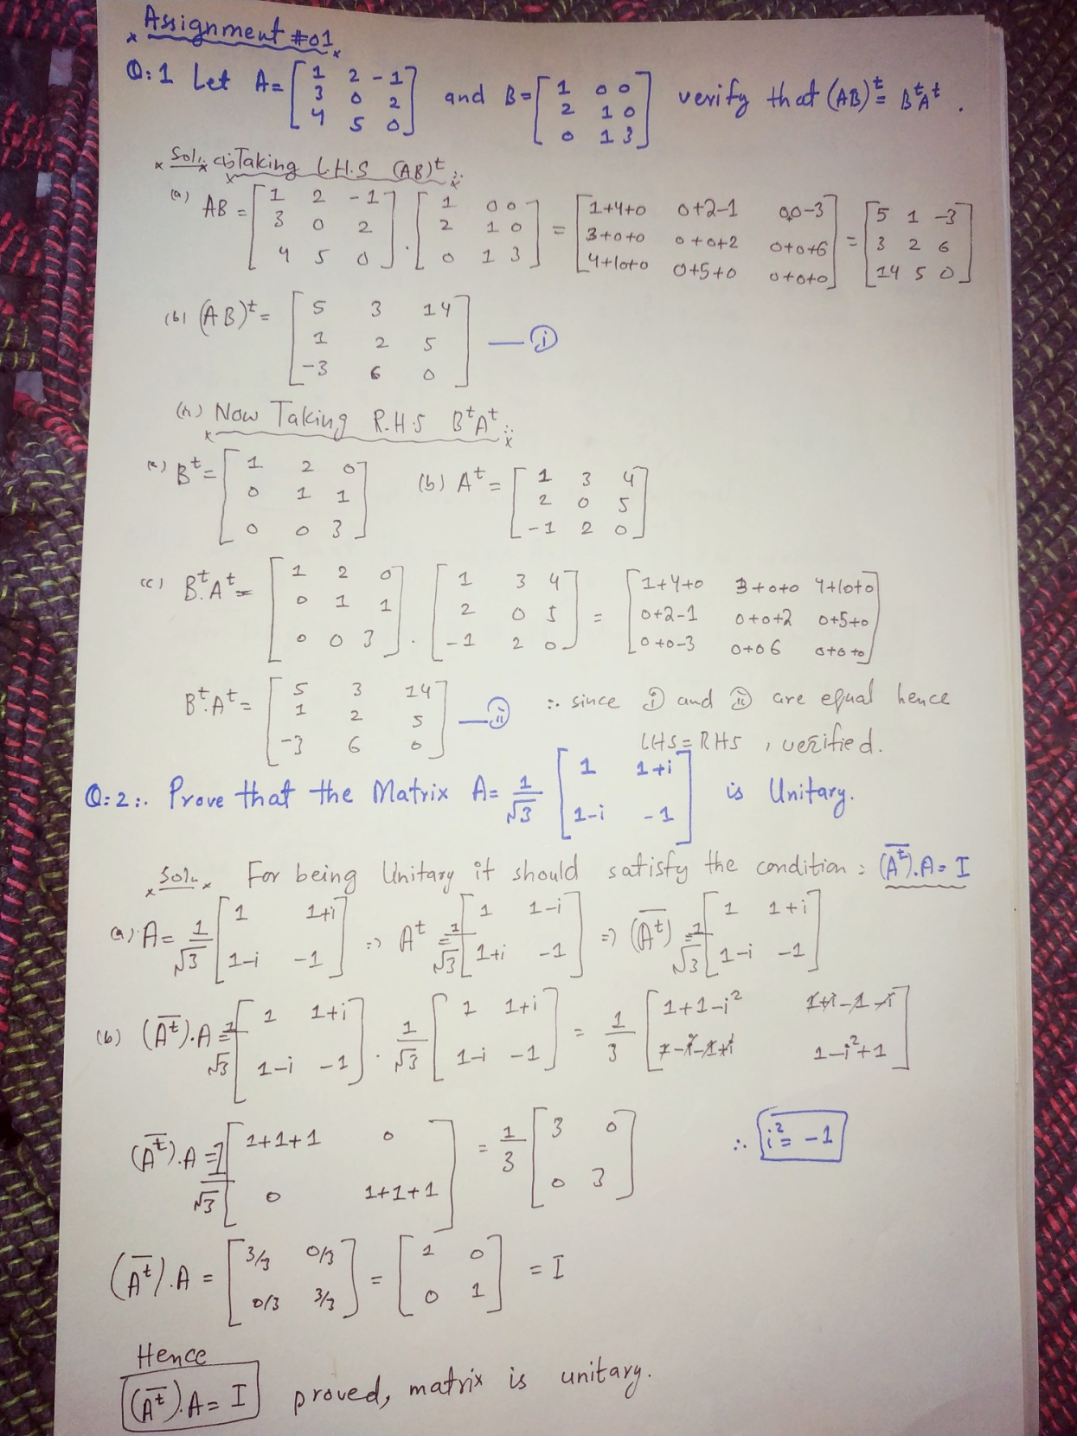

**Q3 (Revised):** If  , show that (A^2)-4A-5I = O , Where O is the null matrix of order 3.

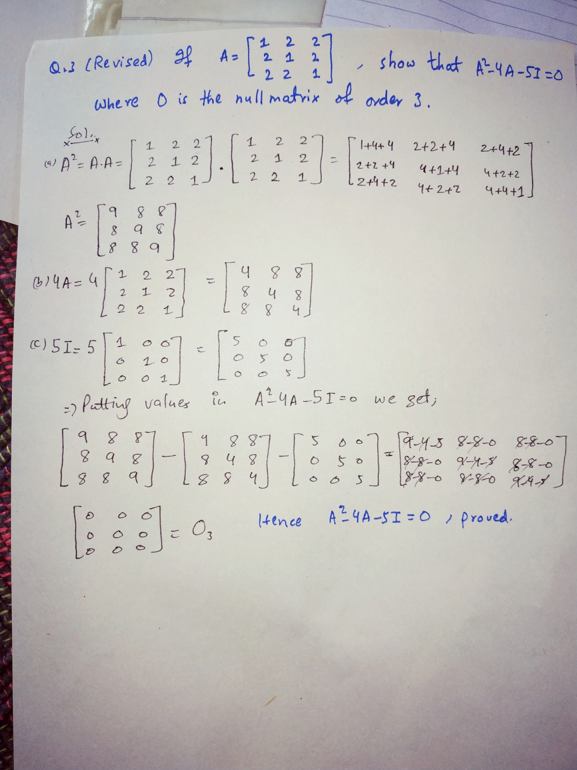

Q4 Show that the matrix  is Involutory.

**Solution to Qno# 4:**

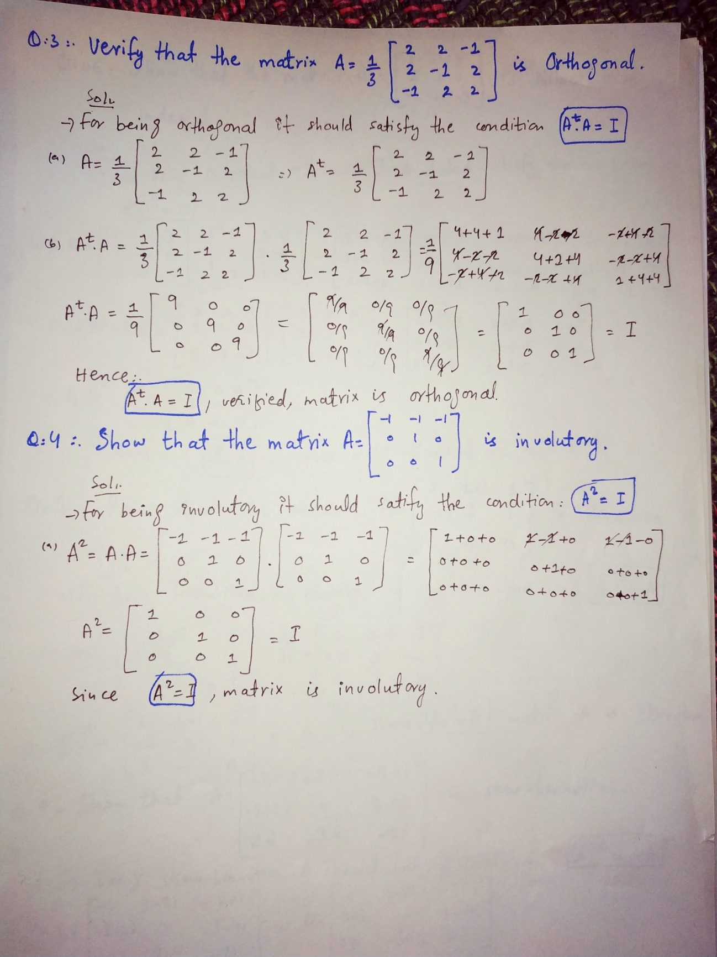

Q5 For what values of a, b and c, the matrix  is Orthogonal.

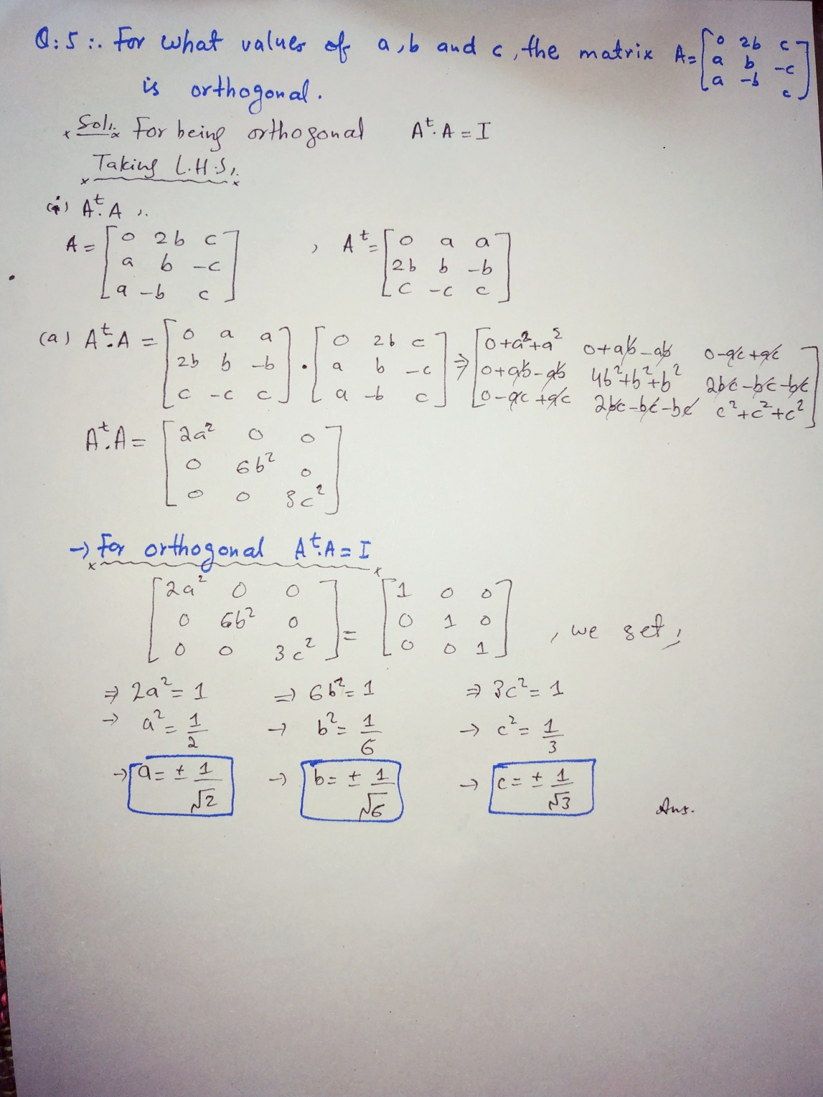

Q6 Show that the matrix  is Nilpotent of index 3.

Q7 Prove that the matrix  is Hermitian.

Q8 Show that  skew – Hermitian.

**Solution to Qno# 6, 7 & 8:**

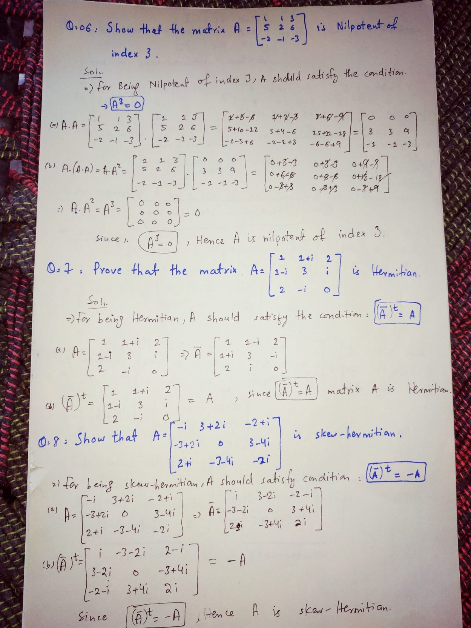

Q9 Express  as the sum of a Hermitian and a skew -Hermitian matrices.

**Solution to Qno# 9:**

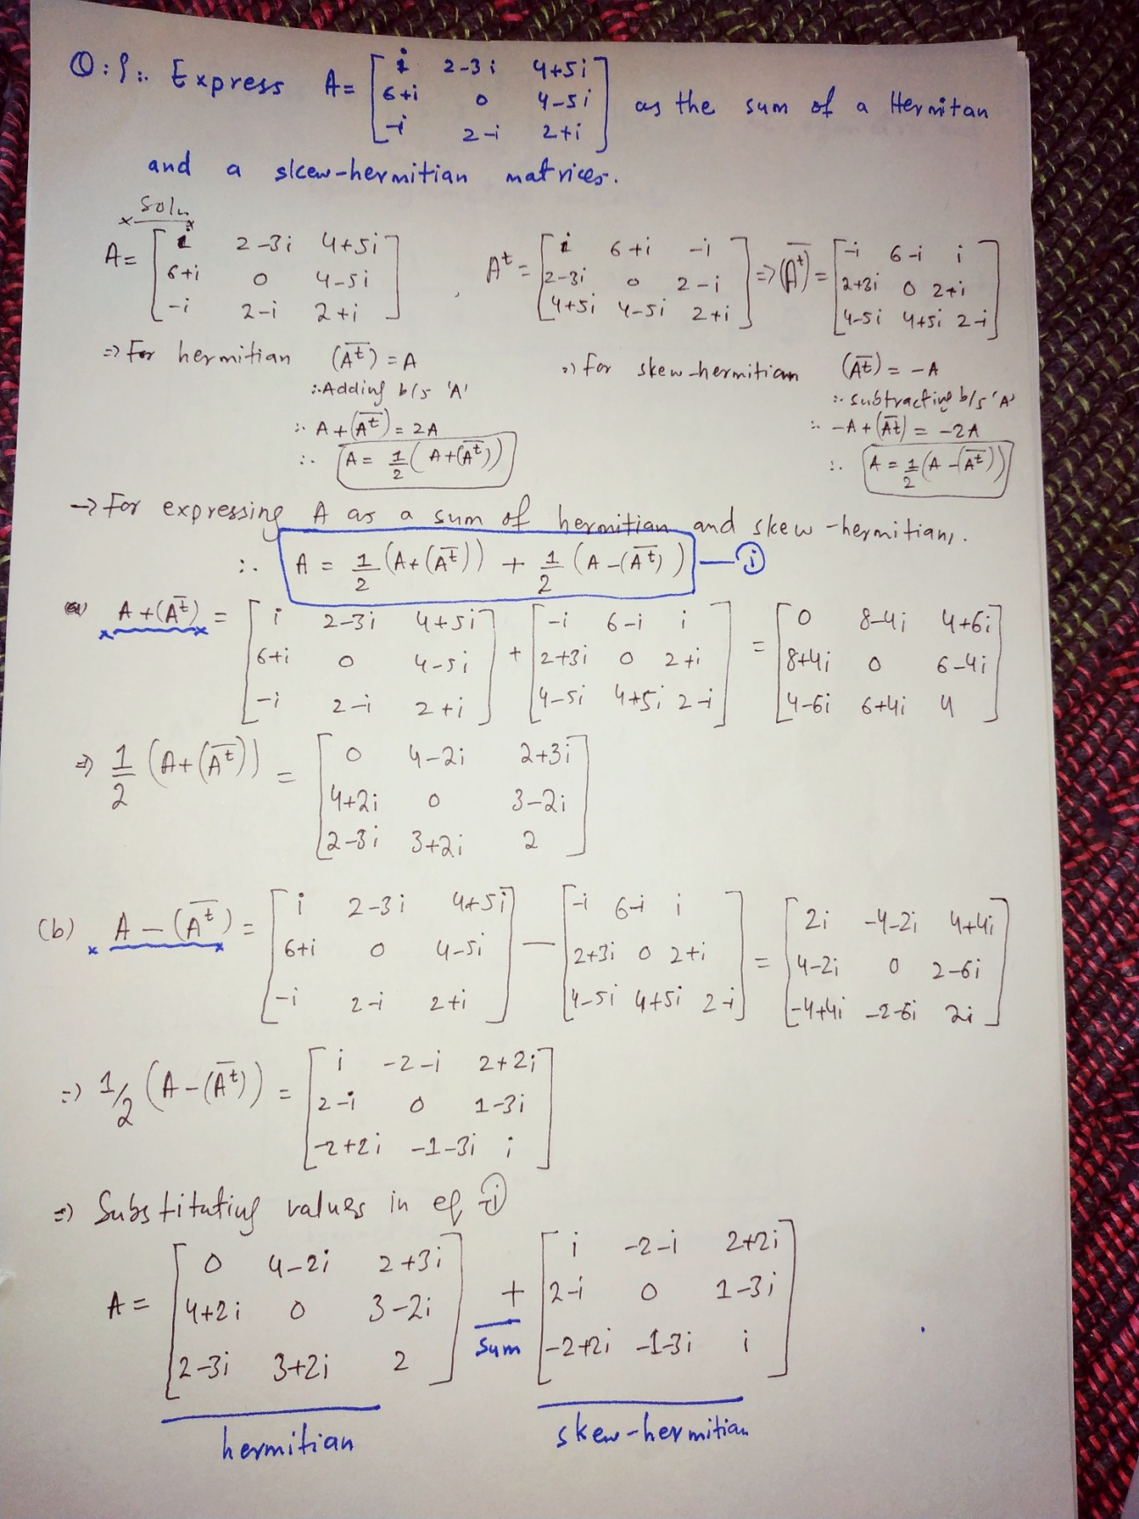

Q10 Express  as the sum of symmetric and skew symmetric matrices.

**Solution to Qno# 10:**

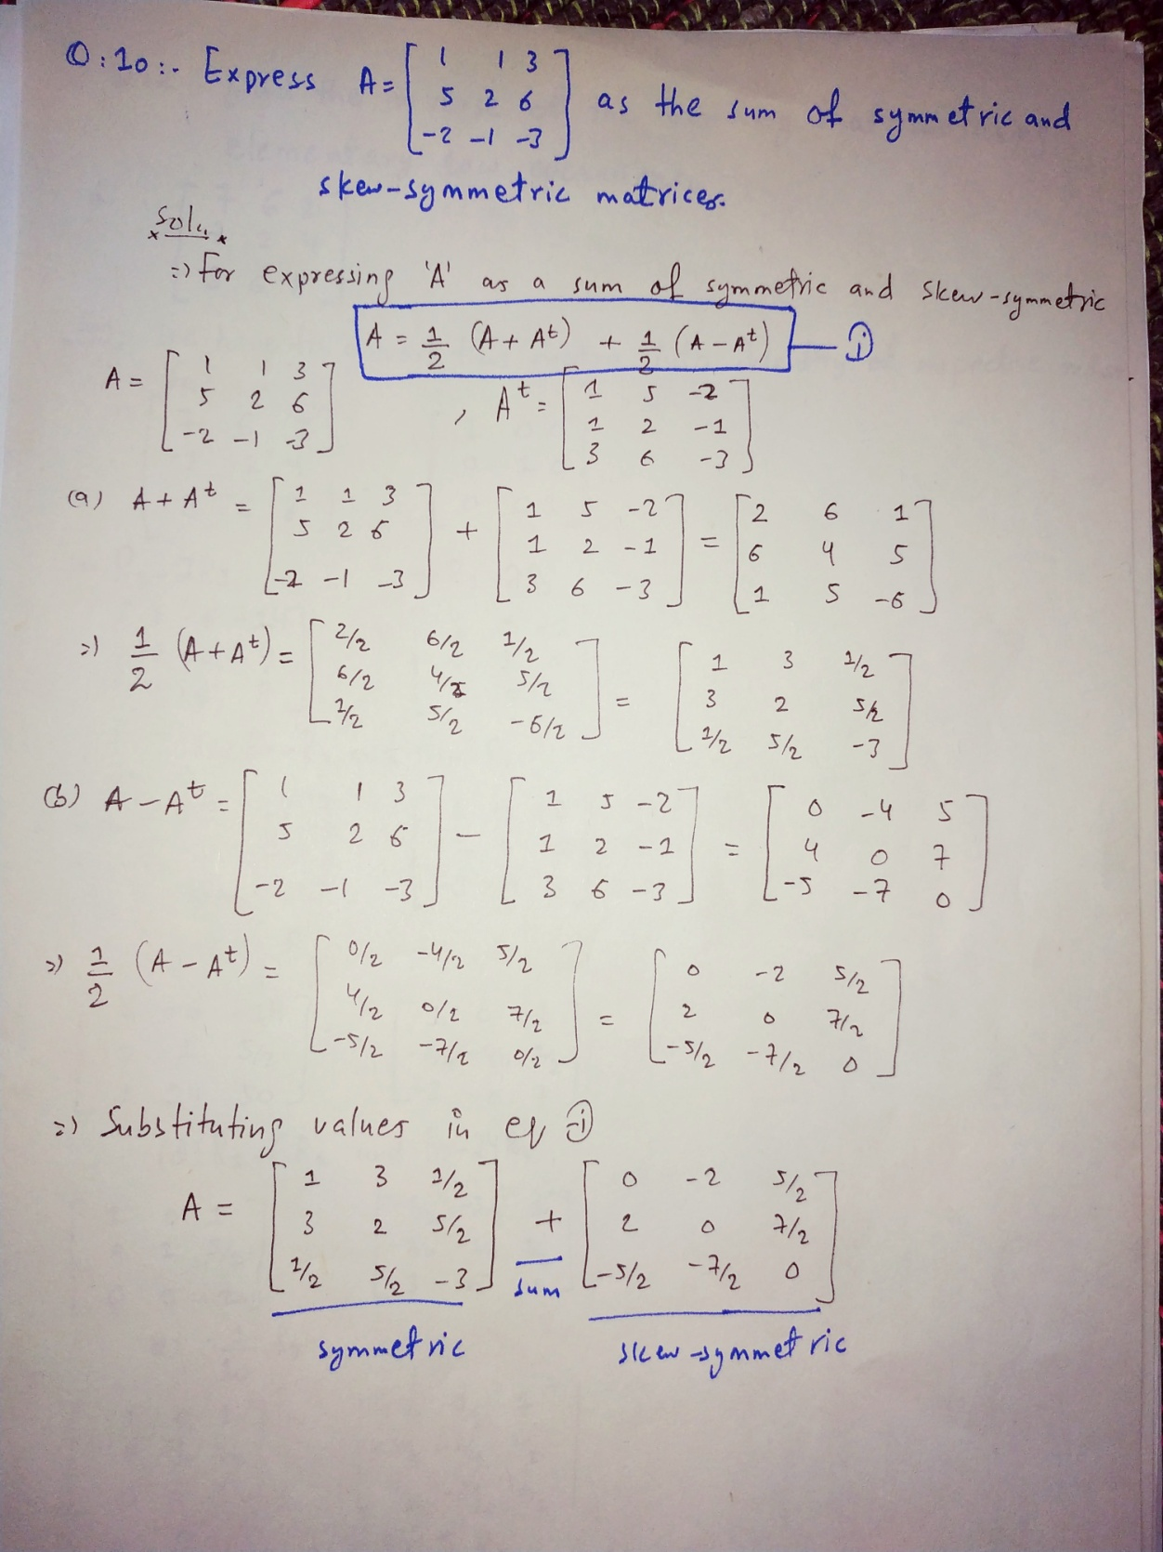

**THE END**