Name: **ZOHAIB HASSAN SOOMRO**

RollNo#: **19SW42**

Subject: **DBS**

**Construct a conceptual and logical model for the following case studies:**

**Task#1:** XYZ departmental store wants to represent information about their products in a database. Each product has a description, a price and a supplier. Suppliers have addresses, phone numbers, and names. Each address is made up of a street address, a city, and a postcode.

1. **Conceptual Model:**

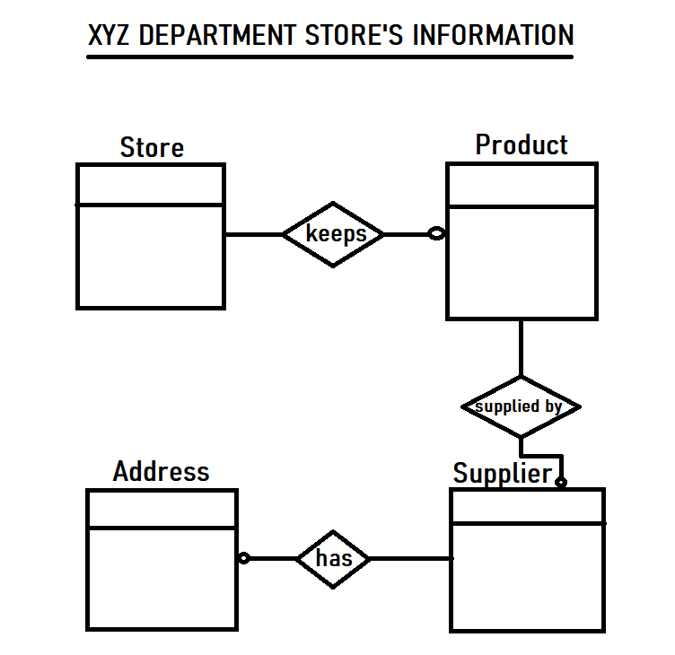

1. **Logical Model:**

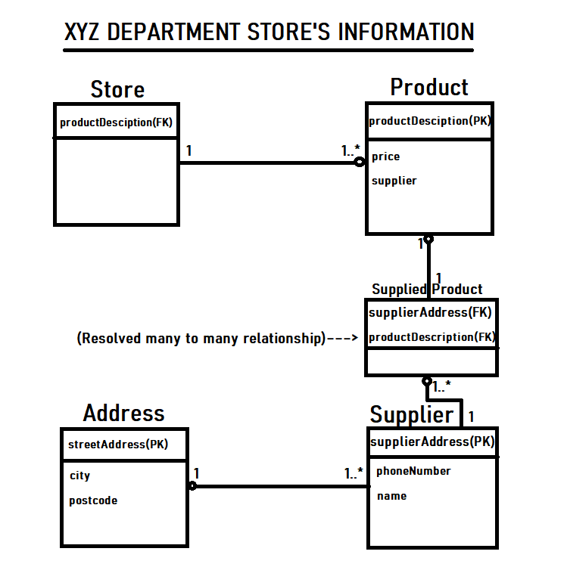

**Task#2:** ABC University is a large institution with several campuses. Each campus has a different name, address, distance to the city center and the only bus running to the campus. Each campus has one club. The name of the club, the building in which the club is located, the phone number of the club and the multiple sports which club offers, should all be recorded. The University consists of several faculties, such as the Art Faculty, the Science Faculty, and so on. Each faculty has a name, dean and building. A faculty may be divided into several schools, for example, the Science Faculty has a School of Physics and a School of Chemistry. Each school belongs to one faculty only and is located on just one campus, but one campus maybe the location of many schools. Every school has name and a building assigned to. Each school offers different programmes and each programme can be offered by only one school. Each programme has a unique code, title, level and duration. Each programme comprises several courses, different programmes have different courses. Each course has a unique code and course title. Some courses may have one or more prerequisite courses and one course can be the prerequisite course of some other courses. Each of the students is enrolled in a single programme of study which involves a fixed core of courses specific to that programme as well as a number of electives taken from other programmes. Students work on courses and are awarded a grade in any course if he/she passes the course. Otherwise, the student has to re-take the failed course. The system needs to record the year and term in which the course was taken, and the grade awarded to the student. Every student has a unique ID. The system also keeps the student name, birthday and the year he/she enrolled in the course. The school employs lecturers to teach the students. A lecturer can work for one school only. Each lecturer is assigned an ID which is unique across the whole university. The system keeps the lecturer’s name, title and the office room. A supervisor maybe in charge of several lecturers, but a lecturer, however, reports to only one supervisor. A lecturer can teach many different courses. A course may also have been taught by many different lecturers. The university is operated by committees. Each faculty has to have several committees with the same titles across the university, such as the Faculty Executive, the Post Graduate Studies Committee, the Health and Sanity Committee, and so on. The committees meet regularly, such as weekly or monthly.

1. **Conceptual Model:**

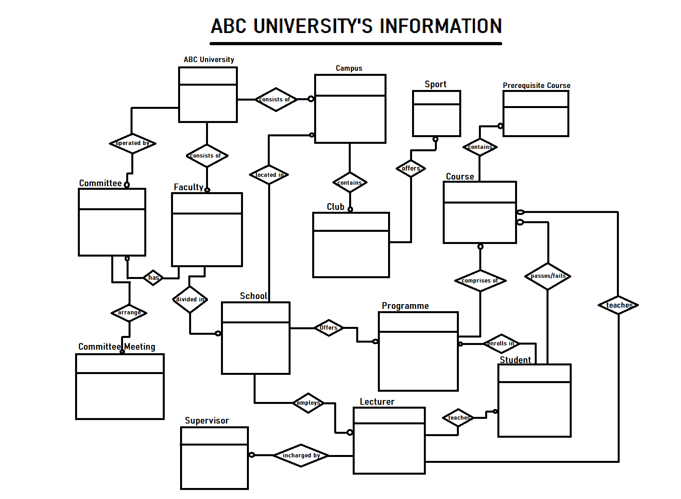

**B. Logical Model:**

