Name: **ZOHAIB HASSAN SOOMRO**

RollNo#: **19SW42**

Subject: **DBS**



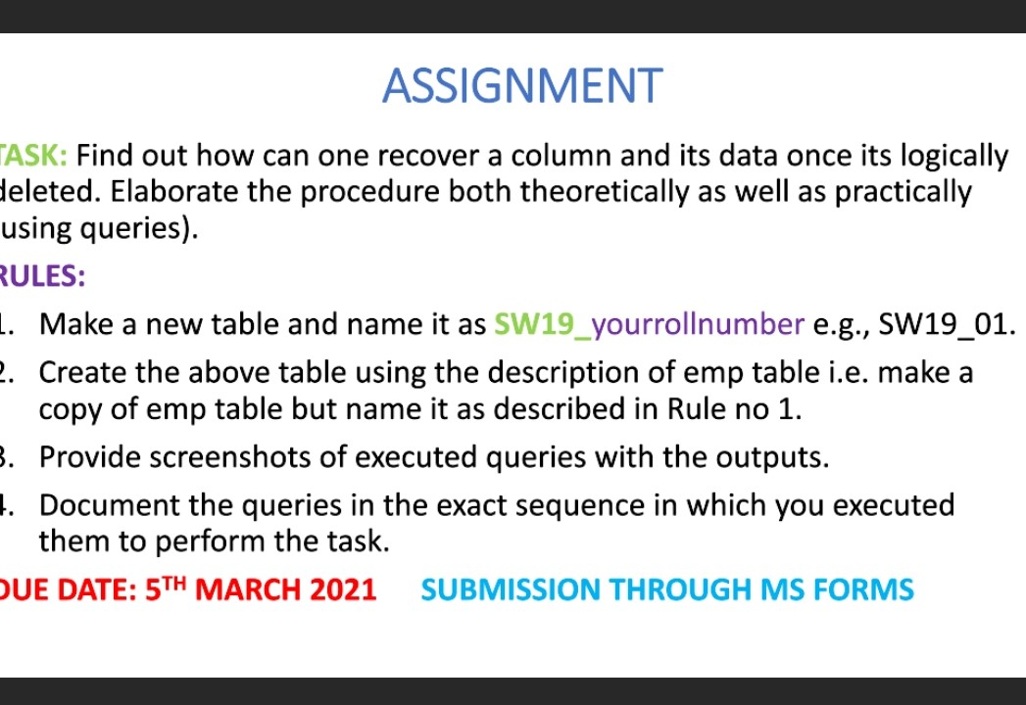

**Emp Table:**

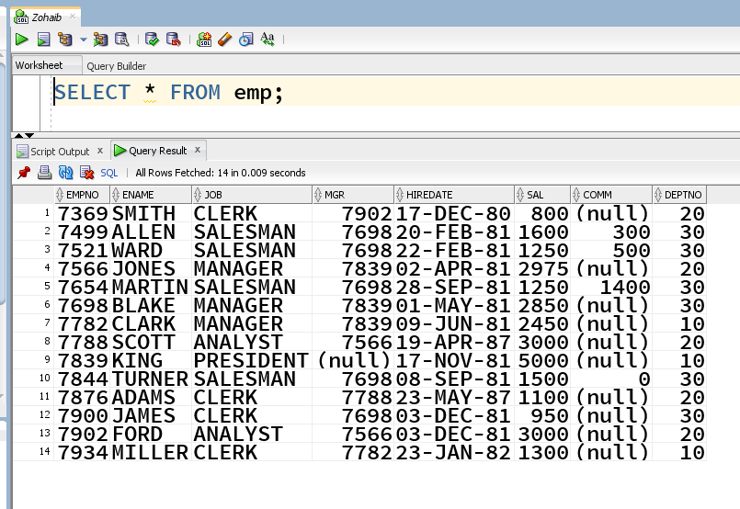

**Step-1: Making new Table as SW19_42 as a copy of ‘EMP’ table:**

* We will create our new table named ‘**SW19_42**’ using ‘CREATE’ COMMAND.

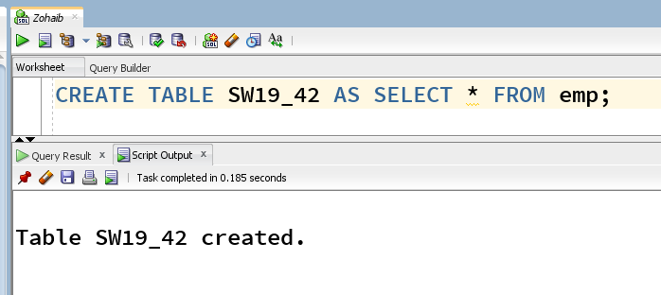

**SW19_42 Table:**

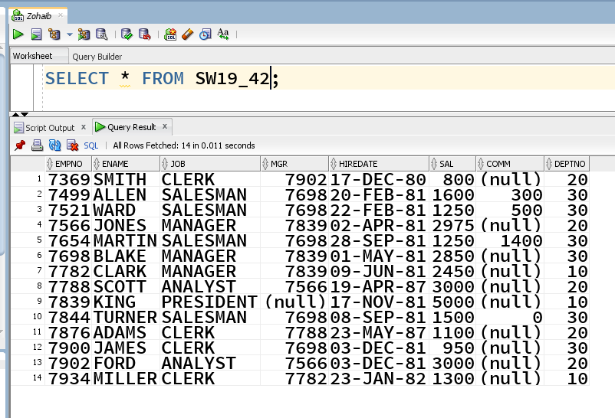

**SW19_42 Table’s Description:**

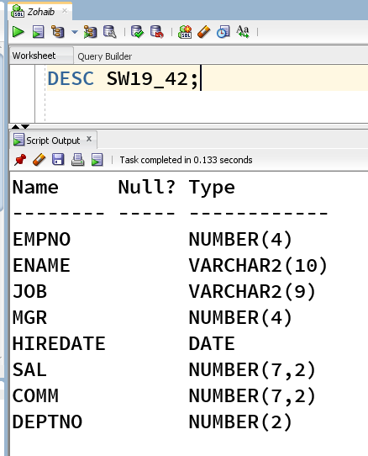

**Step-2: Logically Deleting any of the columns in our table:**

* As we have created our table named ‘**SW19_42**’, so to recover a logically deleted column & its data first we have to soft/logically delete that column from our table.
* So in our task we are going to logically delete the column ‘**deptno**’.
* To delete ‘**deptno**’ column logically we have to use ‘**SET UNUSED**’ keyword with ‘**deptno**’ preceded by ‘**ALTER TABLE SW19_42**’.

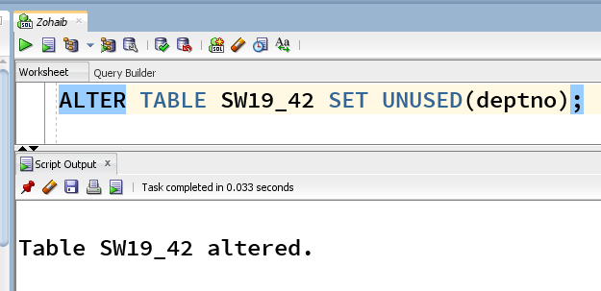

* Table ‘**SW19_42**’ will have no column like ‘**deptno**’ when selecting all from it:

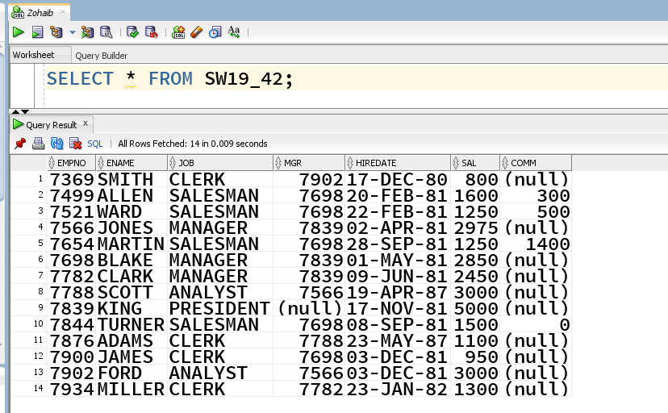

**Step-3: Adding new column with same name in our table:**

* We can’t recover the unused column, as it is treated as it was dropped.
* So now using **ALTER** command we will add a new column to our table ‘**SW19_42’** having same name as of logically deleted column (i.e. **deptno**)

with the same description as it was before.



* Now we can add it to our table:

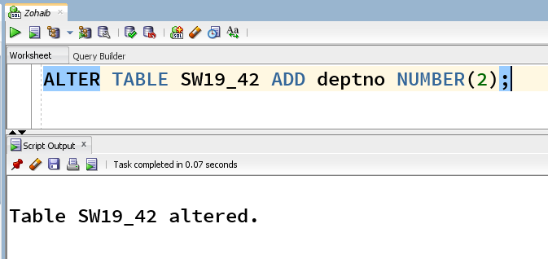

* Table ‘**SW19_42**’ will have now column like ‘**deptno**’ having null values when selecting all from it:

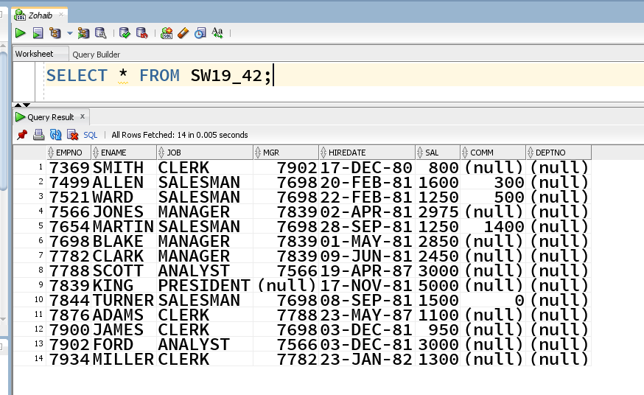

**Step-4: Now we’ll truncate our table using TRUNCATE TABLE command:**

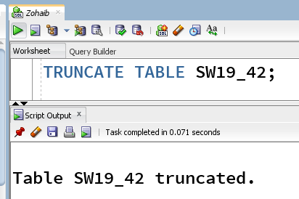

* **Our table will have now no any record in it, for checking we’ll issue SELECT command:**

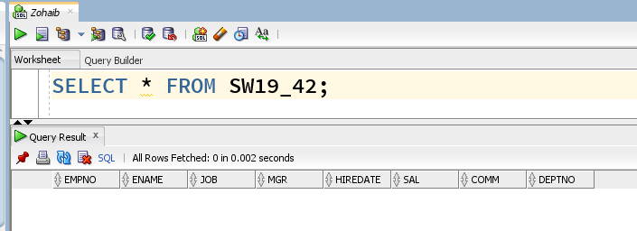

**Step-5: Now we’ll insert all data of EMP table into our table ‘SW19_42’ using INSERT command:**

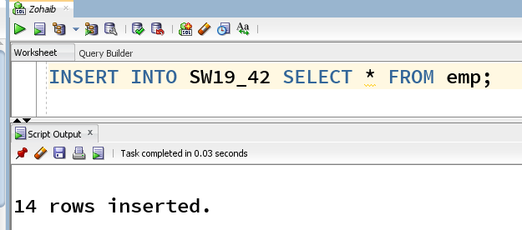

* Now the same data has been inserted into our table, that was in our ‘**SW19_42**’ while creating it as a copy of EMP table.

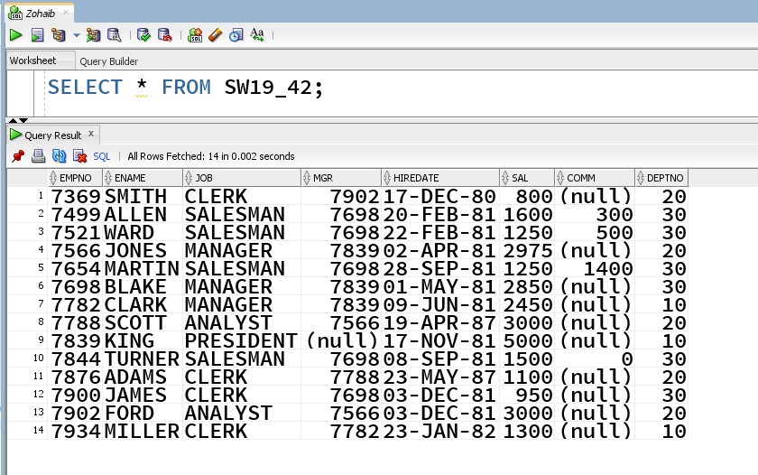

* Hence our column and its data is back, without any recreation of our ‘**SW19_42**’ table.