Name: **ZOHAIB HASSAN SOOMRO**

RollNo#: **19SW42**

Subject: **DBS**



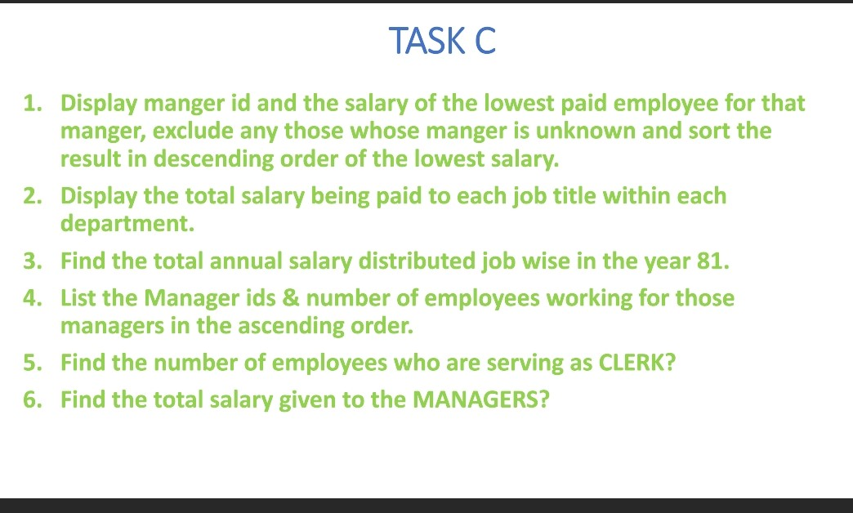

1. Display manager id and salary of the lowest paid employee for that manager, exclude any those whose manager is unknown and sort the result in descending order of the lowest salary.

**QUERY:**

SELECT mgr "MANAGER ID",MIN(sal) "SALARY"

FROM emp

GROUP BY mgr HAVING mgr IS NOT NULL

ORDER BY MIN(sal) DESC;

**OUTPUT:**

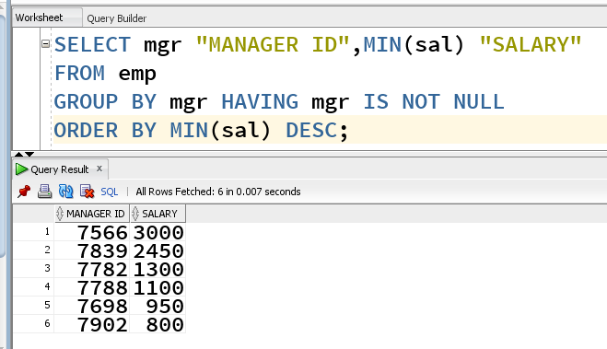

1. Display total salary being paid to each job title within each department.

**QUERY:**

SELECT job,deptno "DEPARTMENT",SUM(sal) "TOTAL SALARY"

FROM emp

GROUP BY job,deptno

ORDER BY deptno;

**OUTPUT:**

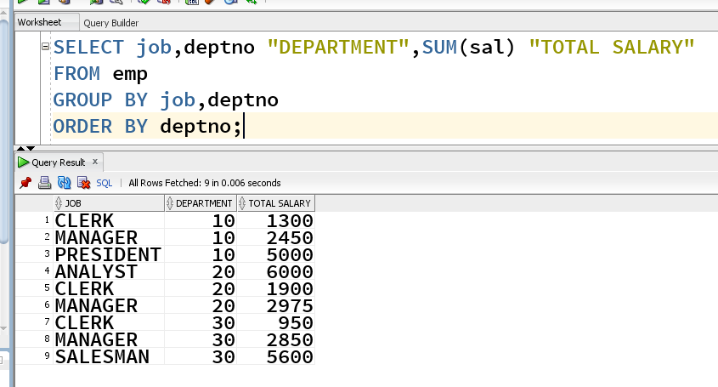

1. Find total annual salary distributed job wise in year 81.

**QUERY:**

SELECT job,SUM(sal*12) "TOTAL ANNUAL SALARY"

FROM emp

WHERE hiredate >= '1-JAN-1981' AND hiredate <= '31-DEC-1981'

GROUP BY job;

**OUTPUT:**

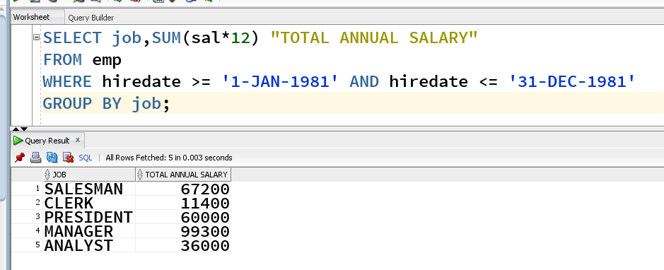

1. List Manager ids & number of employees working for those managers in the ascending order.

**QUERY:**

SELECT mgr "MANAGER ID",COUNT(*) "NO# OF EMPLOYEES"

FROM emp

GROUP BY mgr HAVING mgr IS NOT NULL

ORDER BY COUNT(*) ASC;

**OUTPUT:**

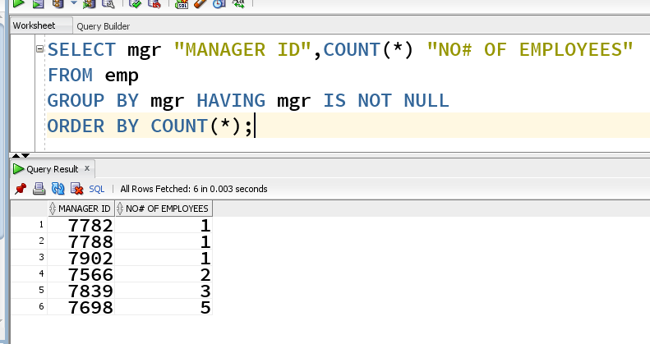

1. Find number of employees who are serving as CLERK.

**QUERY:**

SELECT job,COUNT(*) "NO# OF EMPLOYEES"

FROM emp

GROUP BY job HAVING job='CLERK';

**OUTPUT:**

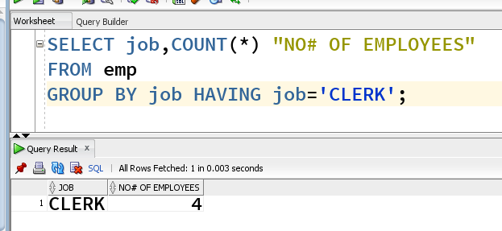

1. Find total salary given to MANAGERS.

**QUERY:**

SELECT job,SUM(sal) "TOTAL SALARY"

FROM emp

GROUP BY job HAVING job='MANAGER';

**OUTPUT:**

