Name: **ZOHAIB HASSAN SOOMRO**

RollNo#: **19SW42**

Subject: **DBS**

**TASK C**

1. **Find all employees whose job is not CLERK and belong to department 20.**

**Query:**

**SELECT * FROM emp WHERE NOT job='CLERK' AND deptno=20;**

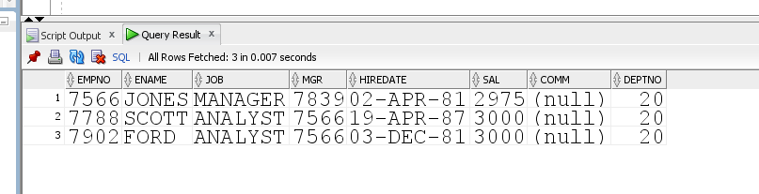

1. **Display the employee’s name, job title & salary based on the following criteria:**
2. **If the employee is a salesman, then he should be included in output.**
3. **If the employee is a manager, then his salary package must be above 2450.**

**Query:**

**SELECT ename,job,sal FROM emp WHERE job='SALESMAN' OR (job='MANAGER' AND sal>2450);**

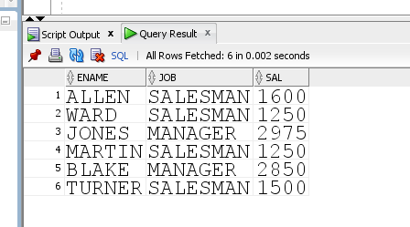

1. **Display employee’s name, Job titles & salary if the employee is either a salesman or a manager and earns more than 2450.**

**Query:**

**SELECT ename,job,sal FROM emp WHERE (job='SALESMAN' OR job='MANAGER') AND sal>2450;**

