Name: **ZOHAIB HASSAN SOOMRO**

RollNo#: **19SW42**

Subject: **DBS**

**TASK F**

1. Display the names of employees according to their seniority.

**Query:**

**SELECT ename FROM emp ORDER BY hiredate;**

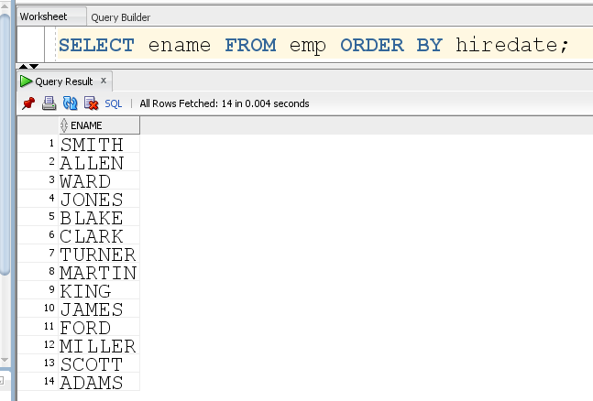

1. Display names and annual salary of all employees, also sort the result based on annual salary in descending order.

**Query:**

**SELECT ename,sal*12 AS "Annual Salary" FROM emp ORDER BY "Annual Salary" DESC;**

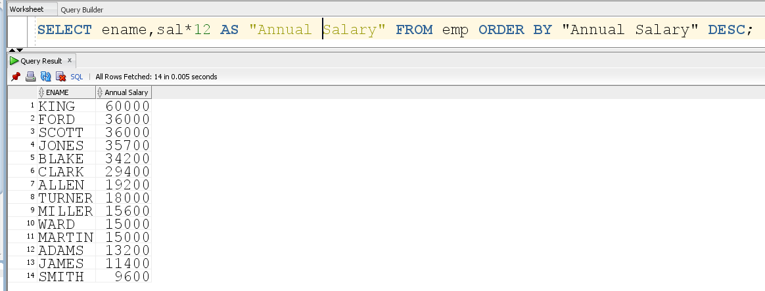

1. Write a query which produces following output:

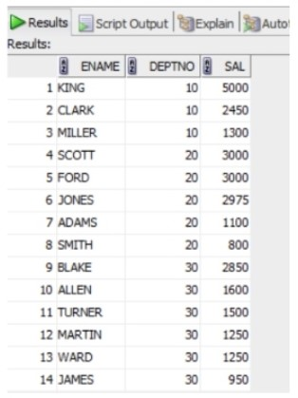

**Statement:**

Display the names, departments and salaries of employees according to departments and highest pay scales.

**Query:**

**SELECT ename,deptno,sal FROM emp ORDER BY deptno,sal DESC;**

**Output:**

