Name: **ZOHAIB HASSAN SOOMRO**

RollNo#: **19SW42**

Subject: **DBS**

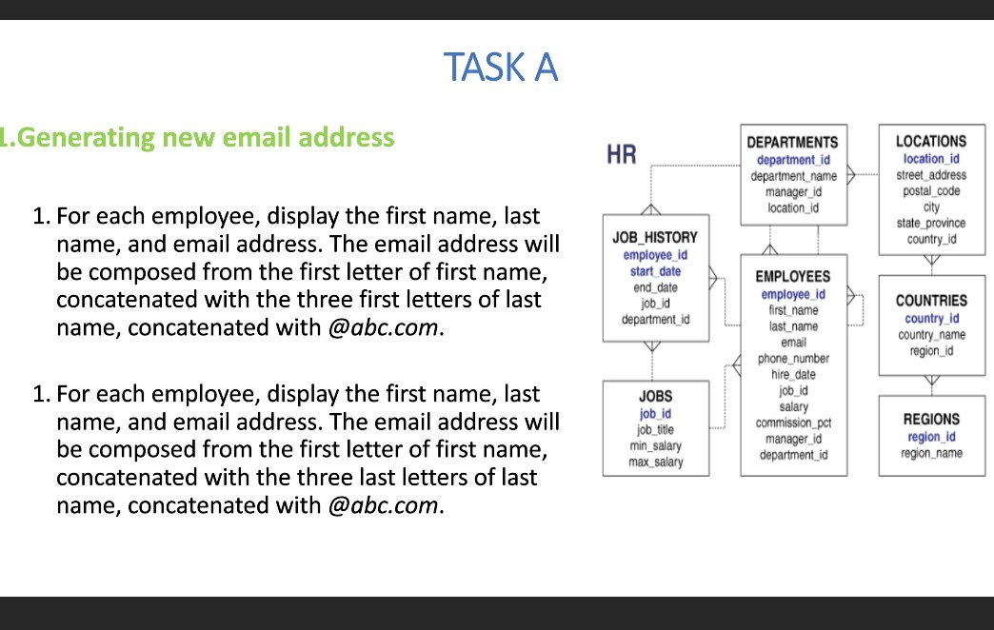

**INSERTED RECORDS IN EMPLOYEE TABLE**

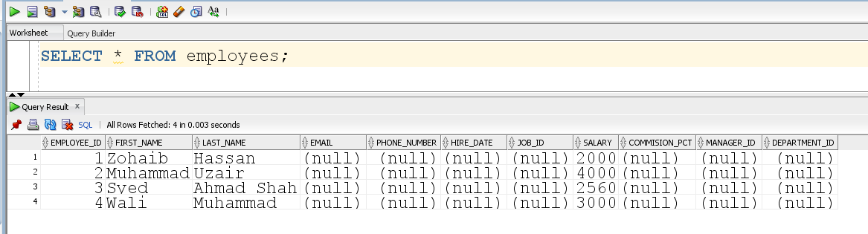

1. Task #1

**Query:**

SELECT

first_name,last_name,CONCAT(CONCAT(SUBSTR(first_name,1,1),SUBSTR(last_name,1,3)),'@abc.com') AS "Email Address" FROM employees;

**Output:**

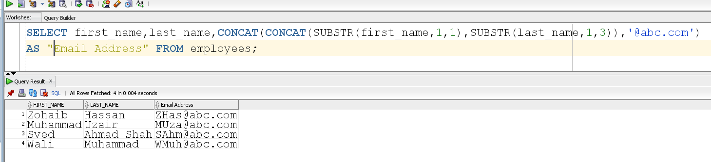

1. Task #2

**Query:**

SELECT first_name,last_name,CONCAT(CONCAT(SUBSTR(first_name,1,1),SUBSTR(last_name,-3,3)),'@abc.com') AS "Email Address" FROM employees;

**Output:**

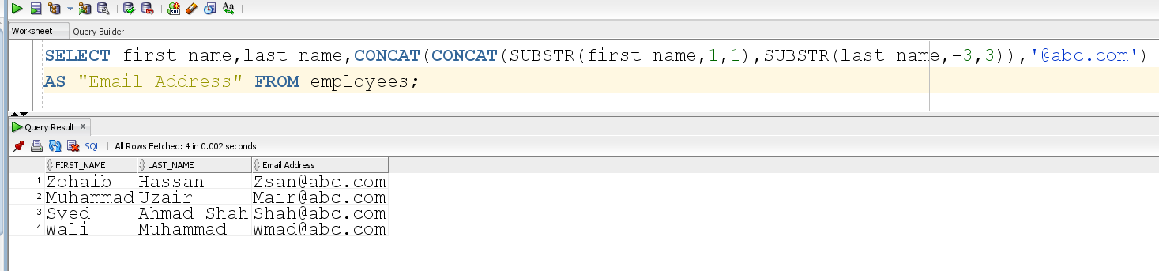



1. Task #3

**Query:**

SELECT ename,NVL2(comm,sal+comm,sal) AS "Gross Pay" FROM emp;

**Output:**

