Name: **ZOHAIB HASSAN SOOMRO**

RollNo#: **19SW42**

Subject: **DBS**

**Task#1.** Find errors (i.e Correct The Query):

SELECT empno, ename sal x 12 Annual Salary FROM emp;

**Correct Query:**

SELECT empno,ename, sal*12 "Annual Salary" FROM emp;

**Output:**

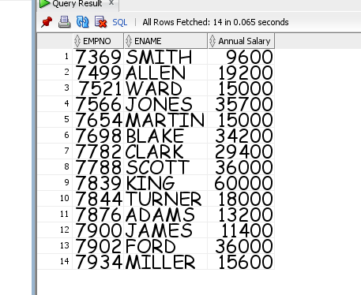

**Task#2:** Display employee’s annual salary with one-time bonus of $100.

**Query:**

SELECT ename || '''s annual salary with one time bonus of $100 is ' || ((sal*12)+100) "Annual Salary + $100(bonus)" FROM emp;

**Output:**

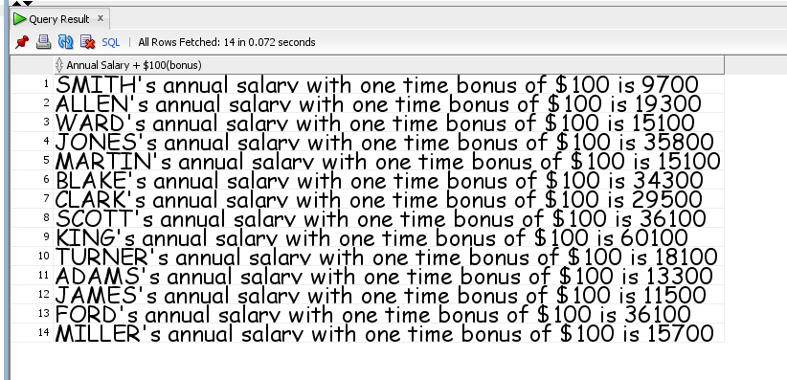

**Task#3**: Display annual compensation as monthly salary plus a monthly bonus of $100**.**

**Query:**

**SELECT sal || ' + 100= ' || (sal+100) "Annual Compensation " FROM emp;**

**Output:**

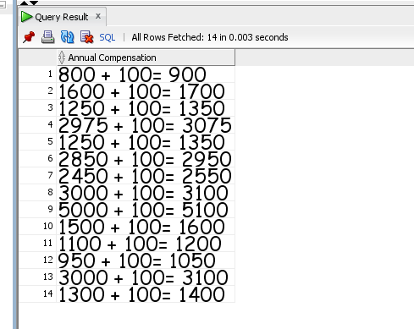

**Task#4:** Display rows in following format

Monthly Salary

King: 1 monthly Salary= 5000

**Query:**

**SELECT ename || ': 1 monthly Salary= ' || sal "Monthly Salary" FROM emp;**

**Output:**

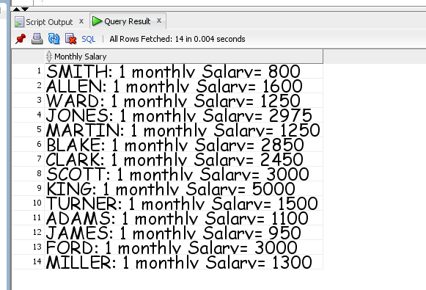

**Task#5:** Display kinds of jobs available in employee table.

**Query:**

**SELECT DISTINCT job FROM emp;**

**Output:**

