Name: **ZOHAIB HASSAN SOOMRO**

RollNo#: **19SW42**

Subject: **DBS**



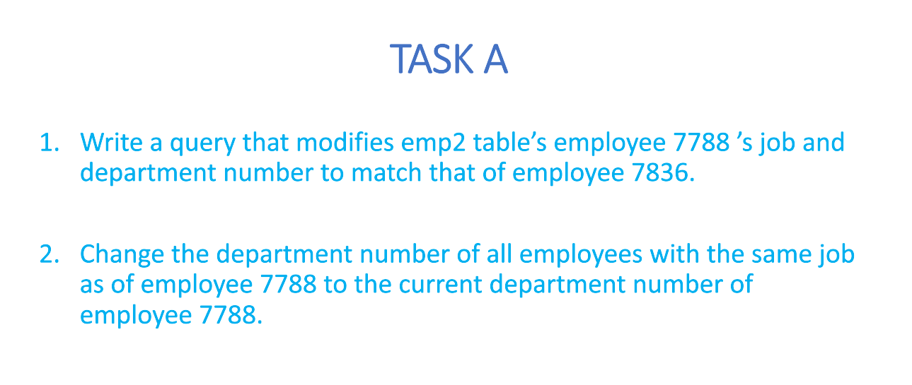

1. Write a query that modifies emp2 table’s employee 7788’s job and department number to match that of employee 7836.

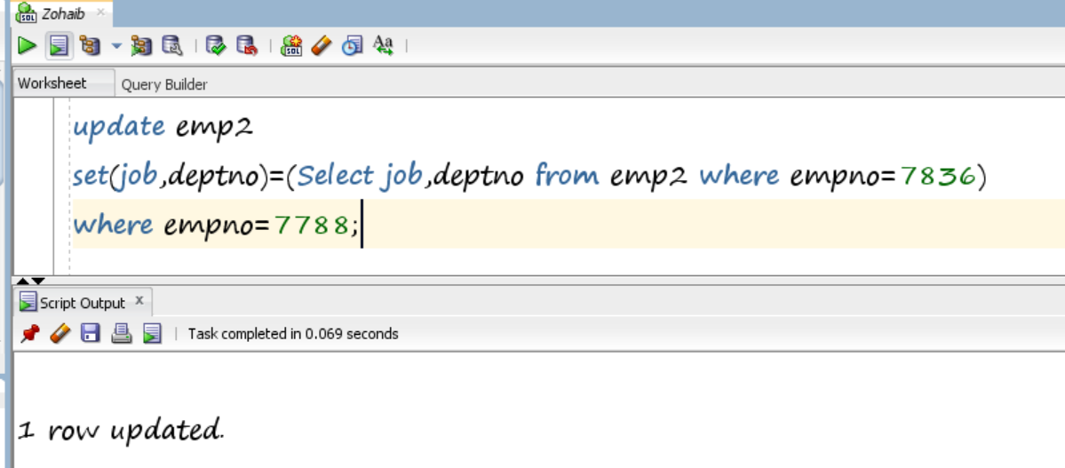

1. Change department number of all employees with the same job as of employee 7788 to the current department number of employee 7788.

