Name: **ZOHAIB HASSAN SOOMRO**

RollNo#: **19SW42**

Subject: **DBS**



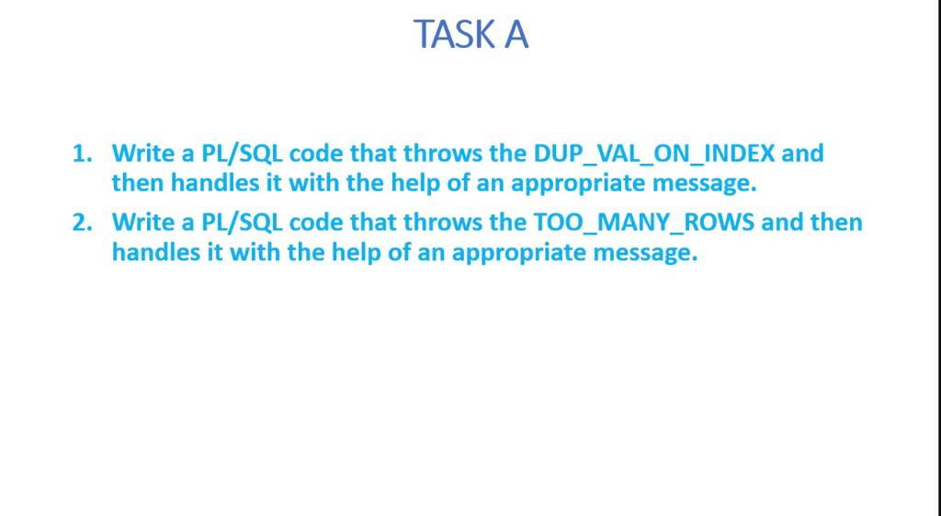

**Initial state of table(JOBS):**

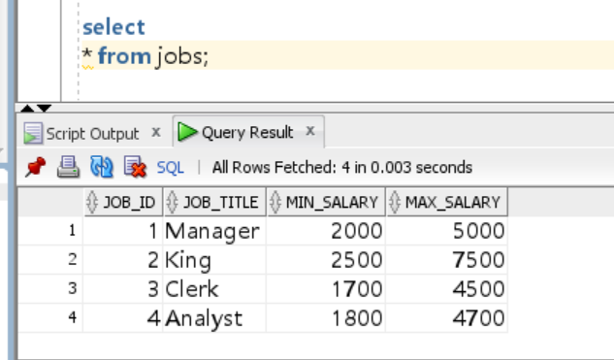

**Task-1:**

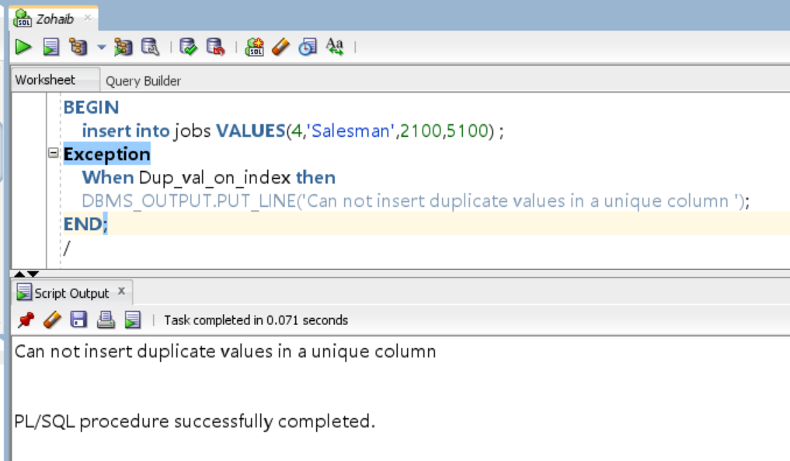

**Task-2:**

