Name: **ZOHAIB HASSAN SOOMRO**

RollNo#: **19SW42**

Subject: **CN**

Topic: **Subnetting**



**Introduction To Subnetting**

When a bigger network is divided into smaller networks, in order to maintain security, then that is known as Subnetting. so, maintenance is easier for smaller networks.

To divide a network into two parts, you need to choose one bit for each Subnet from the host ID part.

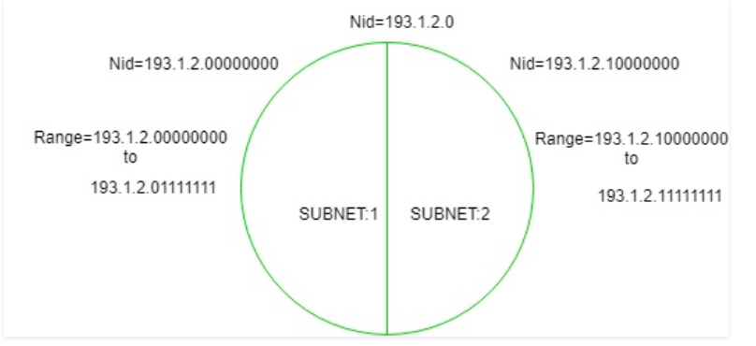

In the above diagram, there are two Subnets.

**Note:** It is a class C IP so, there are 24 bits in the network id part and 8 bits in the host id part.

* **For Subnet-1:**  
  The first bit which is chosen from the host id part is zero and the range will be from (193.1.2.00000000 till you get all 1’s in the host ID part i.e, 193.1.2.01111111) except for the first bit which is chosen zero for subnet id part.

Thus, the range of subnet-1:

193.1.2.0 to 193.1.2.127

* **For Subnet-2:**  
  The first bit chosen from the host id part is one and the range will be from (193.1.2.100000000 till you get all 1’s in the host ID part i.e, 193.1.2.11111111).

Thus, the range of subnet-2:

193.1.2.128 to 193.1.2.255

**Note:**

1. To divide a network into four (22) parts you need to choose two bits from host id part for each subnet i.e, (00, 01, 10, 11).
2. To divide a network into eight (23) parts you need to choose three bits from host id part for each subnet i.e, (000, 001, 010, 011, 100, 101, 110, 111) and so on.

# Advantages and Disadvantages of Subnetting

Subnetting is useful in many ways like:

1. It provides security to one network from another network. eg) In an Organisation, code of the Developer department must not be accessed by another department.
2. It may be possible that a particular subnet might need higher network priority than others. For example, a Sales department need to host webcasts or video conferences.
3. In the case of Small networks, maintenance is easy.

**Along with these advantages, Subnetting also has some disadvantages:**

1. In case of the single network, only three steps are required in order to reach a Process i.e Source Host to Destination Network, Destination Network to Destination Host and then Destination Host to Process.

But in the case of Subnetting four steps are required for Inter-Network Communication. i.e Source Host to Destination Network, Destination Network to proper Subnet, then Subnet to Host and finally Host to Process.

1. It increases Time complexity. In the case of Subnet, more time is required for communication or data transfer.

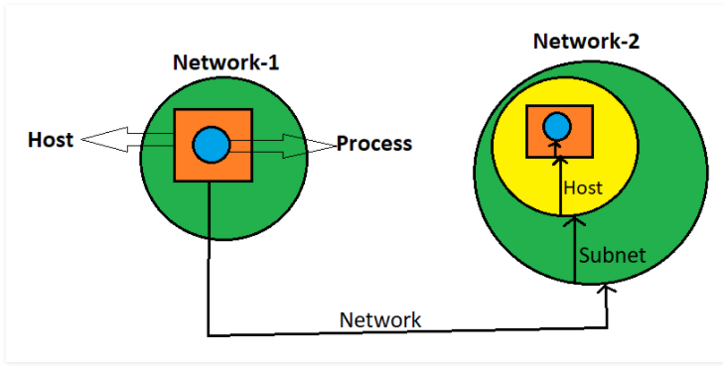

1. In the case of Single Network only two IP addresses are wasted to represent Network Id and Broadcast address but in case of Subnetting two IP addresses are wasted for each Subnet.  
   **Example:** If a Network has four Subnets, it means 8 IP addresses are going to waste.

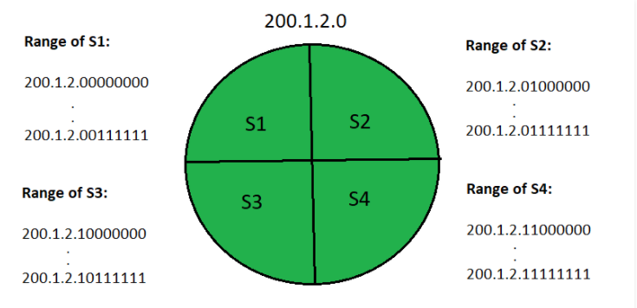

1. **Network Id for S1:** 200.1.2.0

Broadcast address of S1: 200.1.2.63

1. **Network Id for S2:** 200.1.2.64

Broadcast address of S2: 200.1.2.127

1. **Network Id for S3:** 200.1.2.128

Broadcast address of S3: 200.1.2.191

1. **Network Id for S4: 200.1.2.192**

**Direct Broadcast address of S4: 200.1.2.255**

Hence, we can say that Network size will also decrease. We can’t use our Network completely.

1. Cost of the overall Network also increases. Subnetting requires internal routers, Switches, Hubs, Bridges etc. which are very costly.

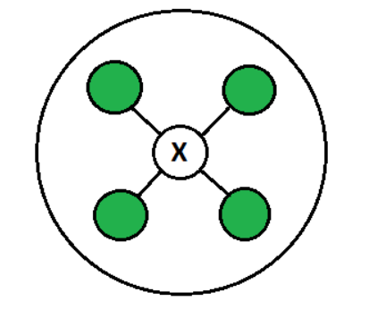

1. Subnetting and network management require an experienced network administrator. This adds to the overall cost as well.