Group Member Names: Syed Ahmed Shah, Zohaib Hassan Soomro

RollNo#: **19SW44,19SW42**

Subject: **SDC**



**HOSPITAL MANAGEMENT SYSTEM (SRS)**

1. **Purpose:**

* It is a software application to manage hospital activities.
* It maintains two levels:
  + Admin Level
  + User level
* It maintains Doctors’, patients’, staffs’ and Accounts’ details.
* Pay slips and report generation.

1. **Scope:**

* HMS will be used to get information from patients and storing it in database.
* It should be having Doctors’ hospital schedule.

1. **Product Perspective**:

* HMS manages activities of hospital i.e related to patients and accounts.
* Account staff will be keeping track of salaries of nurses and other staff.

1. **Product Features:**

* Registration of patients.
* Disease Information.
* Website.
* Routine and schedule.
* Generation of pay slips and reports.
* Patients’ information.
* Staffs’ information.
* Doctors’ information with their names and specialization.
* Search filters.
* Having database to store information.

1. **Database:**

* The system must be using a database i.e Oracle.
* For the current use the **HMS** should be a website.

1. **User-Interface:**

* The interface of this system should be quite decent and simple so that every one could use it easily.

1. **Software-interface**:

* Language to be used is HTML, CSS & JavaScript for front-end development.
* While python will be used for backend.

1. **Non-Functional requirements:**

* Usability.
  + The HMS interface should be quite user-friendly and attractive so the user gets along with it very easily.
* **Performance:**
  + Response time of System should be 1 second after checking any information regarding doctors or patients.
  + The system must support 5000 people at a time.
* **Security:**
  + User shall have a login id and password without it he/she won’t have access to the website.
  + Modification (Insert, Delete, Update) for the database shall only be permitted to admin level user.
* **Availability:**
  + The HMS system shall be available all the time and there should be negligible amount of downtime.
* **Maintainability:** 
  + The HMS system shall be able to be modified time to time.
  + Errors & Bugs should be removed.
  + There should be a backup plan for the data of the system.

1. Class Diagram

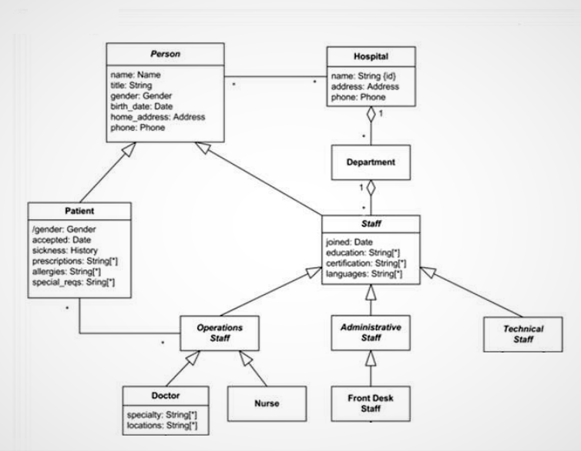

1. Use Case Diagram

