**QUALITY ATTRIBUTES : SOFTWARE**

**ARCHITECTURE**

**by.**

**19SW42**

# Introduction

**2**

* Functionality and Quality Attributes are orthogonal
* Overall factors that affect run-time behavior, system design, and user experience

Software **quality is the degree to which software possesses a desired combination of attributes** (e.g., reliability, interoperability).

**Architecture and Quality Attributes**

**3**

* Architecture, by itself, is unable to achieve qualities
* Architecture should include the factors of interest for each attribute

**Quality Attributes Scenario**

**4**

➢ Is a quality-attribute-specific requirement.

➢

It

consists

of

six

parts

:

◻

Source

of

stimulus

◻

Stimulus

◻

Environment

◻

Artifact

◻

Response

◻

Response

measure

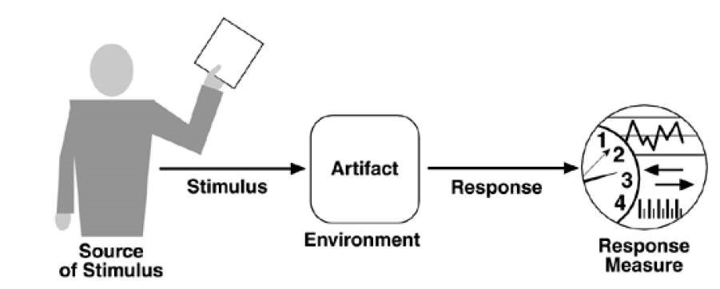

**Figure**

**1**

**:**

**Quality attributes Parts**

# Common Quality Attributes

**5**

➢ It categorizes the attributes in various specific areas

* Design qualities
* Runtime qualities
* System qualities
* User qualities
* Non-runtime qualities
* Architecture qualities
* Business qualities

# Design Quality Attributes

**6**

➢ **Conceptual Integrity:**

* Defines the consistency and coherence of the overall design
* Includes the way that components or modules are designed

➢ **Maintainability:**

* Ability of the system to undergo changes with a degree of ease ➢ **Reusability:**
* Defines the capability for components and subsystems to be suitable for use in other applications

# Runtime Quality Attributes

**7**

➢ **Interoperability:**

* Ability of a system or different systems to operate successfully by communicating and exchanging information with other external systems written and run by external parties ➢ **Manageability:**
* Defines how easy it is for system administrators to manage the application

➢ **Reliability:**

◻ Ability of a system to remain operational over time

➢ **Scalability:**

◻ Ability of a system to either handle increases in load without impact on the performance of the system, or

the ability to be readily enlarged

➢ **Performance:**

◻ Indication of the responsiveness of a system to execute any action

➢ **Security:**

◻ Capability of a system to prevent malicious or accidental actions outside of the designed usage

➢ **Availability:**

* Proportion of time that the system is functional and working
* Measured as a percentage of the total system downtime over a predefined period

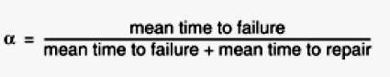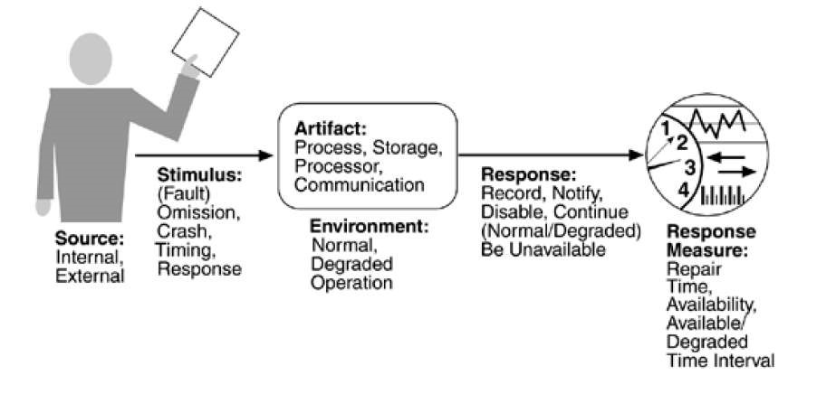

**Figure 2: Availability of general scenario**

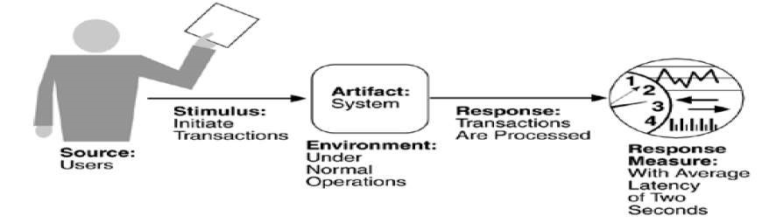

**11**

**Figure**

**3**

**:**

**Sample performance scenario**

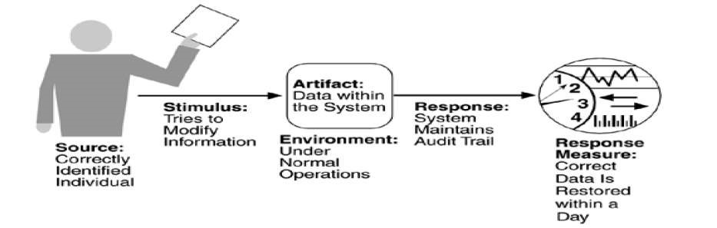

**Figure 4: Sample security scenario**

# System Quality Attributes

**12** ➢ **Supportability:**

* Ability of the system to provide information helpful for identifying and resolving issues when it fails to work correctly ➢ **Testability:**
* Measure of how easy it is to create test criteria for the system and its components

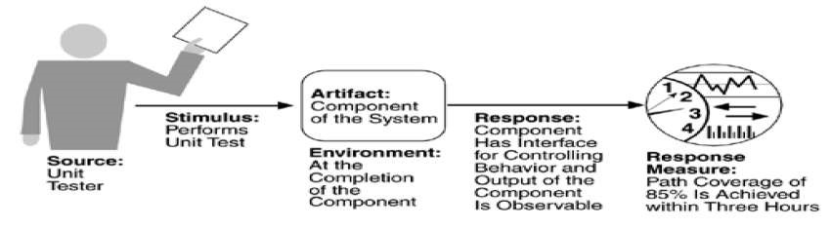

**Figure 5: Sample testability scenario**

# User Quality Attributes

**13**

➢ **Usability:**

◻ Defines how well the application meets the requirements of the user and consumer by being

intuitive

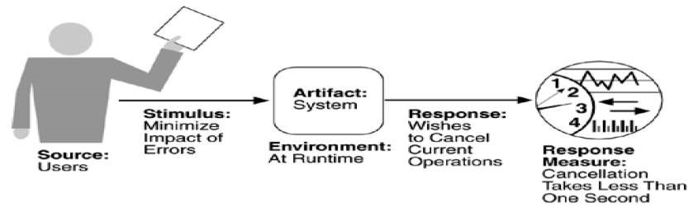

**Figure**

**6**

**:**

**Sample usability scenario**

# Non-runtime Quality Attributes

**14**

➢ **Portability:**

◻ Ability of a system to run under different computing environments

➢ **Reusability:**

◻ Degree to which existing applications can be reused in new applications

➢ **Integrability:**

◻ Ability to make the separately developed components of the system work correctly together

➢ **Modifiability:**

◻ Ease with which a software system can accommodate **15**

changes to its software

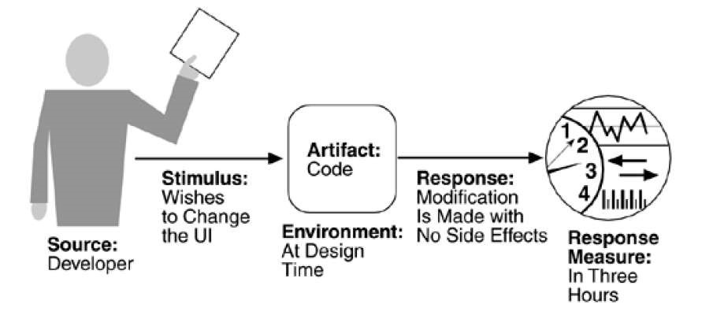

**Figure 7: Sample modifiability scenario**

# Architecture Quality Attributes

**16**

➢ **Correctness:**

◻ Accountability for satisfying all requirements of the system

➢ **Conceptual Integrity:**

◻ Integrity of the overall structure that is composed from a number of small architectural structures

# Business Quality Attributes

**17**

➢ **Cost and schedule:**

* Cost of the system with respect to time to market, expected project lifetime, and utilization of legacy and COTS systems ➢ **Marketability:**
* Use of the system with respect to market competition

**18**

# THANK YOU

**By 19SW42**