Name: **ZOHAIB HASSAN SOOMRO**

RollNo#: **19SW42**

Subject: **Agent** **Based** **Intelligent Systems**



**Q1: Explain Turing Test and its scenario. What procedure will you be adopting if you are assigned a designation of interviewer and have to identify a machine through Turing test?**

**Ans.** A test for intelligence in a computer, requiring that a human being should be unable to distinguish the machine from another human being by using the replies to questions put to both.

* It was introduced in 1950 by Alan Turing to check whether a machine can think like a human or not.
* The test is like a game which involves three players in which one player is Computer, another player is human responder, and the third player is a human Interrogator, who is isolated from other two players and his job is to find that which player is machine among two of them.

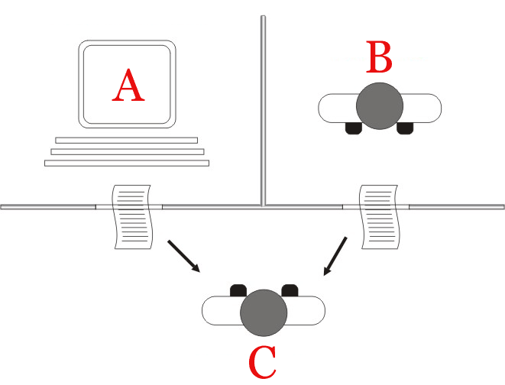

Features required for a machine to pass the Turing test:

* Natural language processing: NLP is required to communicate with Interrogator in general human language like English.
* Knowledge representation: To store and retrieve information during the test.
* Automated reasoning: To use the previously stored information for answering the questions.
* Machine learning: To adapt new changes and can detect generalized patterns.
* Vision: To recognize the interrogator actions and other objects during a test.
* Motor Control: To act upon objects if requested.

**Q2: Search about ELIZA, MYCIN and DENDRAL and describe each in own words. Block diagrams are mandatory (as per your perception)**

**Ans.**

* **ELIZA:** It was a Natural language processing computer program created by Joseph Weizenbaum. It was created to demonstrate the ability of communication between machine and humans. It was one of the first chatterbots, which has attempted the Turing Test.

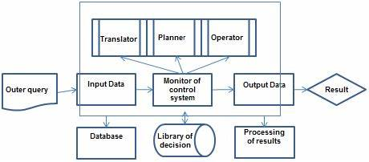

* **MYCIN:** It was one of the earliest backward chaining expert systems that was designed to find the bacteria causing infections like bacteraemia and meningitis. It was also used for the recommendation of antibiotics and the diagnosis of blood clotting diseases.

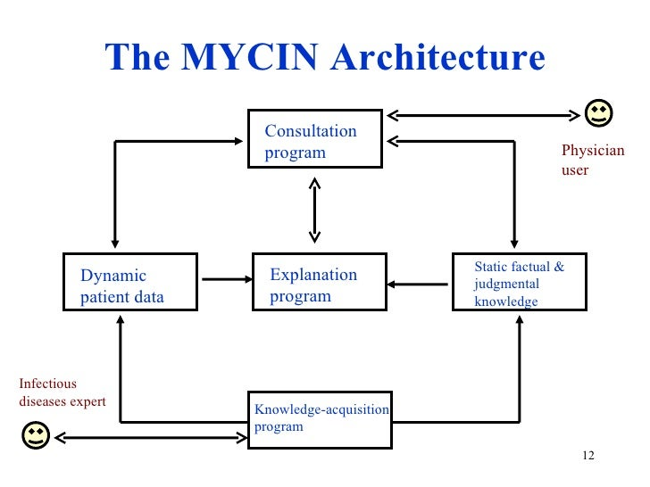

* **DENDRAL:** It was an artificial intelligence project that was made as a chemical analysis expert system. It was used in organic chemistry to detect unknown organic molecules with the help of their mass spectra and knowledge base of chemistry.

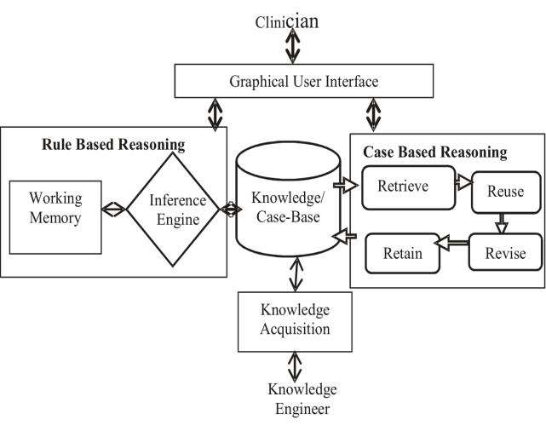

**Q3: List down the State space for tictactoe or sliding tile puzzle or both in your way of knowledge representation.**

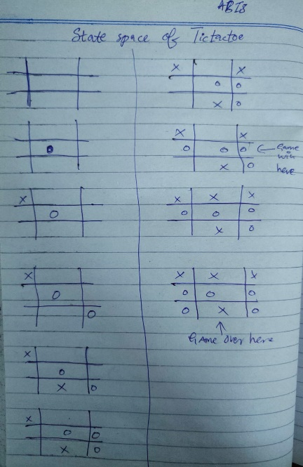

**Ans.**

**Q4: Identify your favorite Intelligent Agent, describe it using 'PAGE', illustrate its architecture, mention its Pseudocode of its processing, also mention its environment attributes.**

**Ans.**

**Agent=Ludo:**

PAGE:

|  |  |  |  |
| --- | --- | --- | --- |
| Percepts | Actions | Goals | Environment |
| Understands dice number | Move tokens, if timeout move tokens intelligently | To end game upon someone’s winning | Board |

**Architecture:**

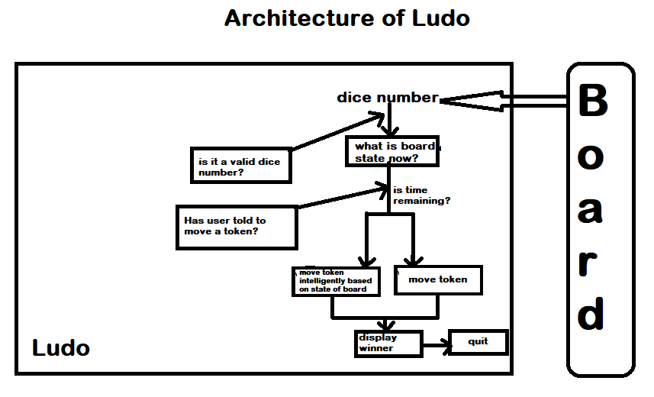

**Pseudocode:**

* SingIn()
* If not login:
  + SignUp()
* Show menu

1. Play game
2. quit
   * If playgame option selected
     + Ask for no# of users
     + Initialize board
     + While not winner declared
       - Roll dices
       - If valid move
         * Move tokens
       - If winner declared
         * Display winner
         * Break
     + Ask user if he want to play again
       - If play again is yes
         * Start game again
       - Else
         * quit game
   * Else
     + quit game

**Characteristics of Environments**

|  |  |  |  |  |  |  |
| --- | --- | --- | --- | --- | --- | --- |
|  | Fully observable? | Deterministic? | Episodic? | Static? | Discrete? | Single Agent? |
| Ludo | **NO** | **Yes** | **No** | **Yes** | **yes** | **Yes** |

***References=***

1. [***https://www.javatpoint.com/turing-test-in-ai***](https://www.javatpoint.com/turing-test-in-ai)
2. [***https://www.javatpoint.com/expert-systems-in-artificial-intelligence***](https://www.javatpoint.com/expert-systems-in-artificial-intelligence)