ToDo List Program

**Informal specification:**

A ToDo list program is a tool for managing tasks that need to be completed. It allows a user to create a list of tasks and mark them as completed as they are finished. In this implementation of a ToDo list, each user has a set of tasks that they need to complete. Each task has a unique ID and a description. The system ensures that each user has exactly three tasks assigned to them. The system also enforces that each task has a unique ID and that no two tasks have the same ID. Users can mark their tasks as completed as they finish them, allowing them to track their progress and keep track of what they have left to do.

**Formal specification:**

1. **Alloy Model:**

-- Defining constant values for status of a task

enum Status{

pending, started, finished

}

-- Defining Task

sig Task{

id: one Int,

description: one String,

status: one Status

}

-- Defining User as a set of tasks

sig User{

name: one String,

tasks: set Task

}

-- Defining todo list with a set of users each having exactly 3 tasks

one sig ToDoList {

users: set User

} {

all u: users | #u.tasks = 3

}

-- Defininig some users

one sig SampleTasks {

t1, t2, t3: Task

}

-- Assigning values to the sample tasks

run {

SampleTasks.t1.id = 1

SampleTasks.t1.description = "FMSE TEST"

SampleTasks.t1.status = pending

SampleTasks.t2.id = 2

SampleTasks.t2.description = "MC LAB"

SampleTasks.t2.status = started

SampleTasks.t3.id= 3

SampleTasks.t3.description = "WE PPT"

SampleTasks.t3.status = finished

}

-- Defininig some users

one sig SampleUsers {

u1, u2, u3: User

}

-- Assigning tasks to the sample users

run {

SampleUsers.u1.tasks = SampleTasks.t1 + SampleTasks.t2

SampleUsers.u2.tasks = SampleTasks.t2 + SampleTasks.t3

SampleUsers.u3.tasks = SampleTasks.t1 + SampleTasks.t3

}

-- Defining some constraints on the to-do list

assert ToDoListConstraints {

-- Each task must have a unique task ID

all t1, t2: Task | t1 != t2 implies t1.id!= t2.id

-- No two task should have same id within user's tasks

all u: User | no t1, t2: u.tasks | t1.id = t2.id

}

--checking assersion for any counter examples

check ToDoListConstraints

-- Runing the model

run {} for 3

**Some output screenshots:**

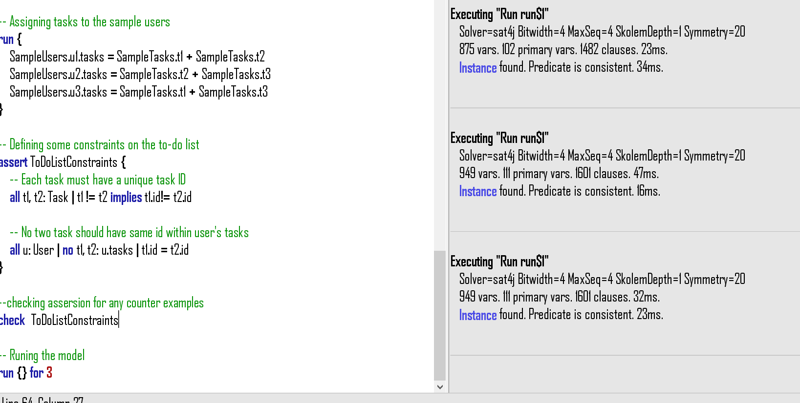

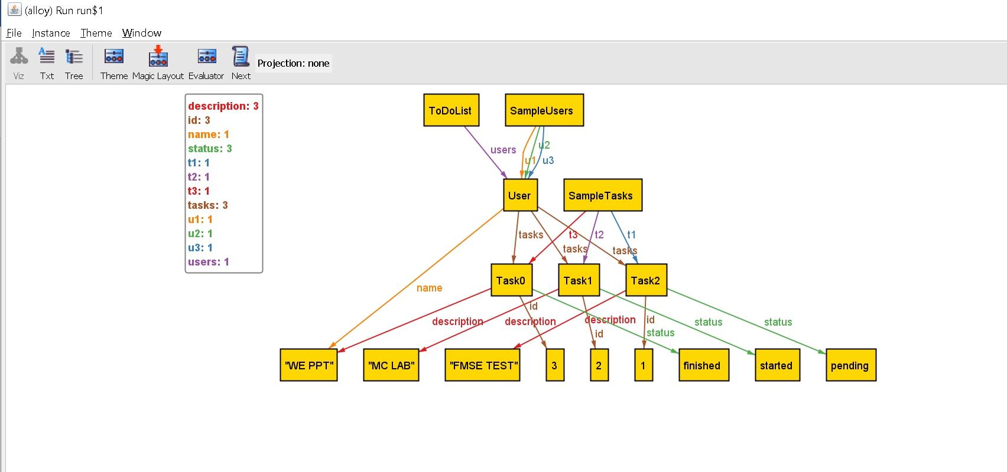

1. **OCL Model:**

model todolistmodel

-- Defining constant values for status of a task

-- Status can be either "pending", "started", or "finished"

enum Status{

pending,

started,

finished

};

-- Defining Task class with three properties:

-- id: an integer representing the unique identifier for a task

-- description: a string describing the task

-- status: constant value from Status enum to represent the current status of the task

class Task

attributes

id: Integer

description: String

status: Status

end

-- Defining User class with two properties:

-- name: a string representing the user's name

-- tasks: a collection of Tasks representing the tasks assigned to the user

class User

attributes

name: String

tasks: Set(Task)

end

-- Defining ToDoList class with one property:

-- users: a collection of User instances representing the users in the to-do list

class ToDoList

attributes

users: Set(User)

end

-- Defining some constraints on the to-do list

-- Each user must have exactly three tasks assigned to them

-- Each task must have a unique task ID

-- No two task should have the same id within a user's tasks

constraints

context ToDoList

inv onlyThreeTasks: self.users->forAll(u | u.tasks->size() = 3)

inv eachTaskWithUniqueId: Task.allInstances()->forAll(t1, t2 | t1 <> t2 implies t1.id <> t2.id)

inv noTwoTaskWithSameIds: User.allInstances()->forAll(u | u.tasks->forAll(t1, t2 | t1 <> t2 implies t1.id <> t2.id))

**Screenshot:**

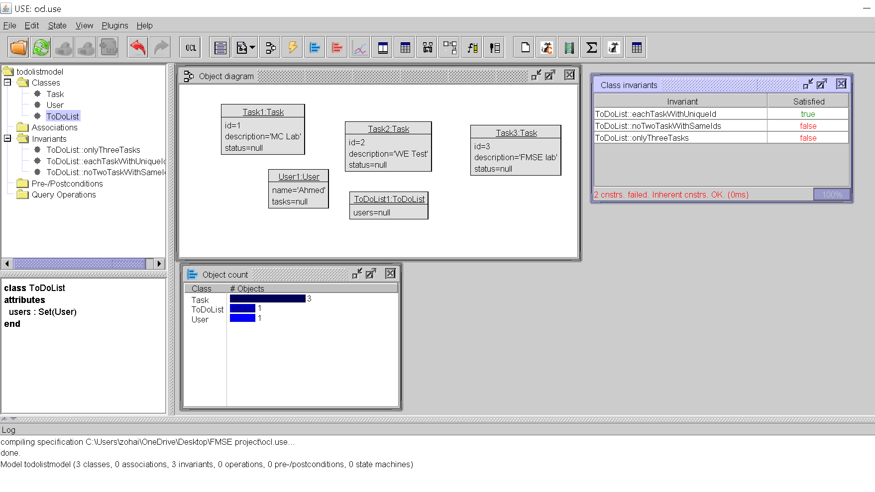

1. **JML Specification:**

//Todo list program JML Specifiation

import java.util.*;

enum Status {

pending, started, finished

}

class Task {

private int id;

private String description;

private Status status;

/* @requires s != null;

@ requires i >= 0;

@ requires d!= null;

@ ensures status == s;

@ ensures id == i;

@ ensures description == d;

@*/

public Task(int i, String d, Status s) {

id = i;

description = d;

status = s;

}

public int getId() {

return id;

}

public String getDescription() {

return description;

}

public Status getStatus() {

return status;

}

}

class User {

private String name;

private HashSet<Task> tasks;

//@ public invariant tasks.size() == 3;

//@ requires n != null;

//@ ensures name == n;

//@ ensures tasks.size() == 3;

public User(String n, Task t1, Task t2, Task t3) {

name = n;

tasks = new HashSet<Task>();

tasks.add(t1);

tasks.add(t2);

tasks.add(t3);

}

//@ requires s == Status.pending || s == Status.started || s == Status.finished;

//@ requires t != null;

//@ ensures tasks.contains(t);

//@ ensures tasks.size() == \old(tasks.size()) + 1;

public void addTask(Task t, Status s) {

t.getStatus() = s;

tasks.add(t);

}

public String getName() {

return name;

}

public HashSet<Task> getTasks() {

return tasks;

}

}

public class ToDoList {

private HashSet<User> users;

/*

-- Defining some constraints

-- Each user must have exactly three tasks assigned to them

-- Each task must have a unique task ID

-- No two task should have the same id within a user's tasks

*/

//@ public invariant(\forall Task t1,t2; t1 != t2 && t1.getId() != t2.getId);

//@ public invariant (\forall User u; u in users; u.getTasks().size() == 3);

//@ public invariant (\forall Task t1,t2; t1 in u1.getTasks() ; t2 in u2.getTasks());t1.getId() != t2.getId());

public ToDoList() {

users = new HashSet<User>();

}

public HashSet<User> getUsers() {

return users;

}

/*@ requires u != null;

@ ensures users.contains(u);

@ ensures users.size() == \old(users.size()) + 1;

@*/

public void addUser(User u) {

users.add(u);

}

/*@ requires t != null;

@ ensures (\exists User u; u in users; t in u.getTasks());

@*/

public void addTaskToUser(Task t) {

for (User u : users) {

u.addTask(t);

}

}

}

