Name: **ZOHAIB HASSAN SOOMRO**

RollNo#: **19SW42**

Subject: **MAD**



INSTALLED FLUTTER :

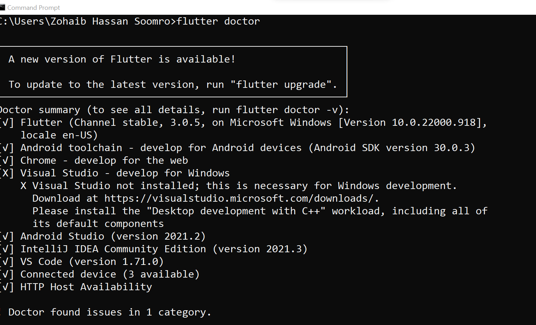

Installed Android Studio:

