Name: **ZOHAIB HASSAN SOOMRO**

RollNo#: **19SW42**

Subject: **MAD**



Task 1: Follow the steps and generate the apk file for publishing your app on the play store.

Ans:

Run the following command to build an APK:

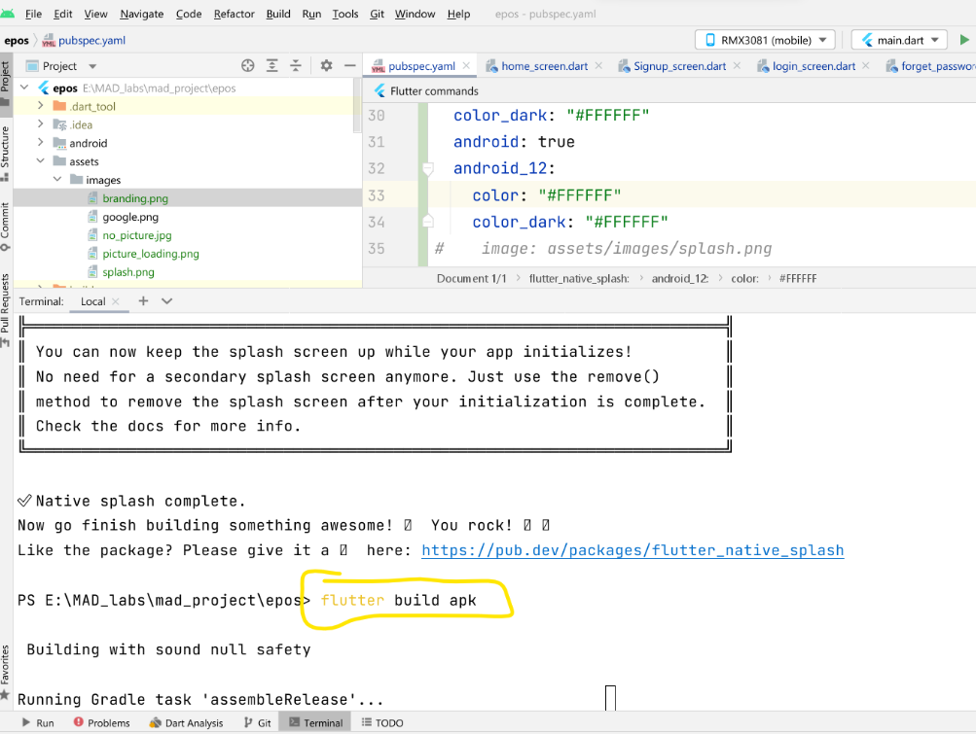

The APK generate here is an unsigned APK for this app to be able to be published to Google Play Store It needs to be a signed APK.

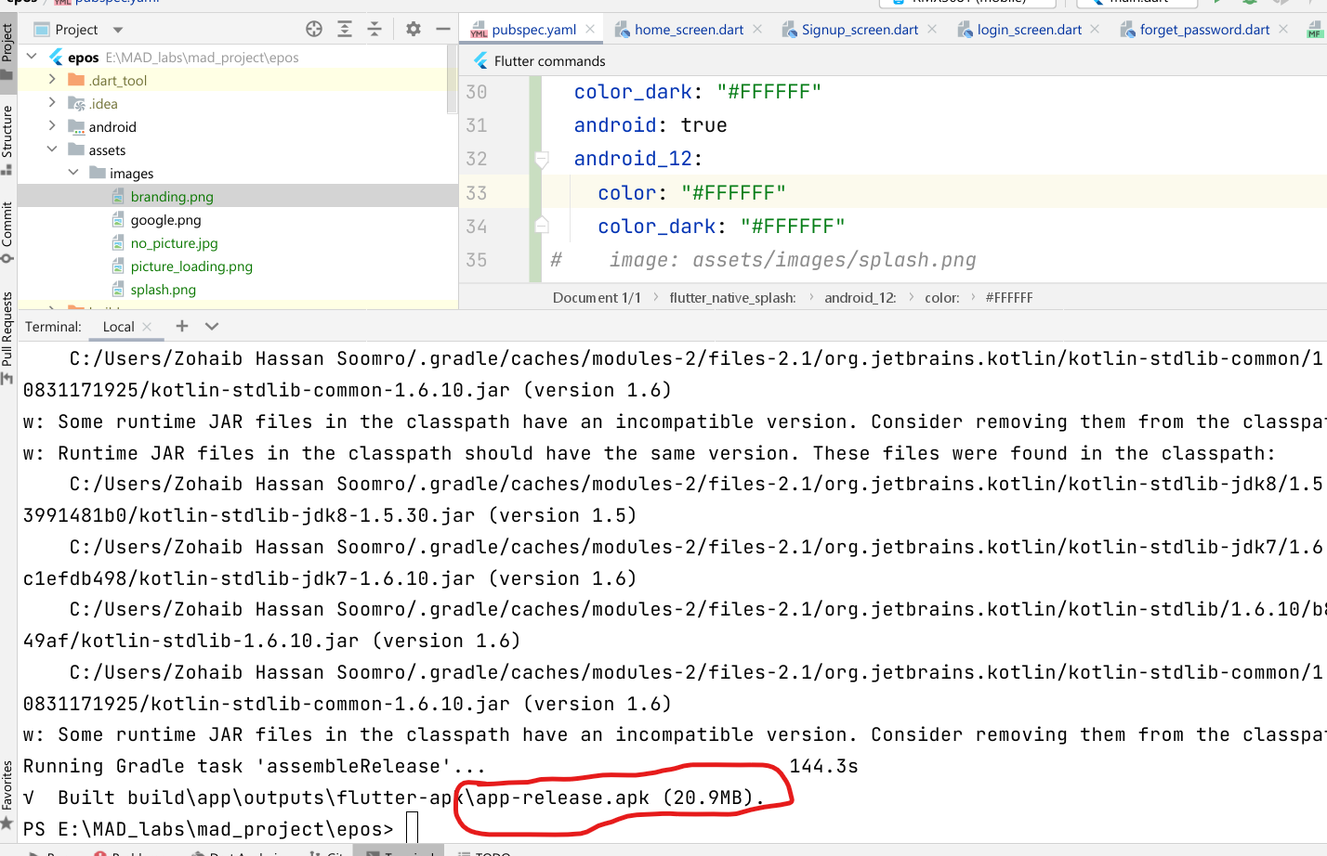

The very first step to generate a signed apk is to create a keytore file. Run the command that is running in following picture to generate it(You will need to create a 6 digit password):

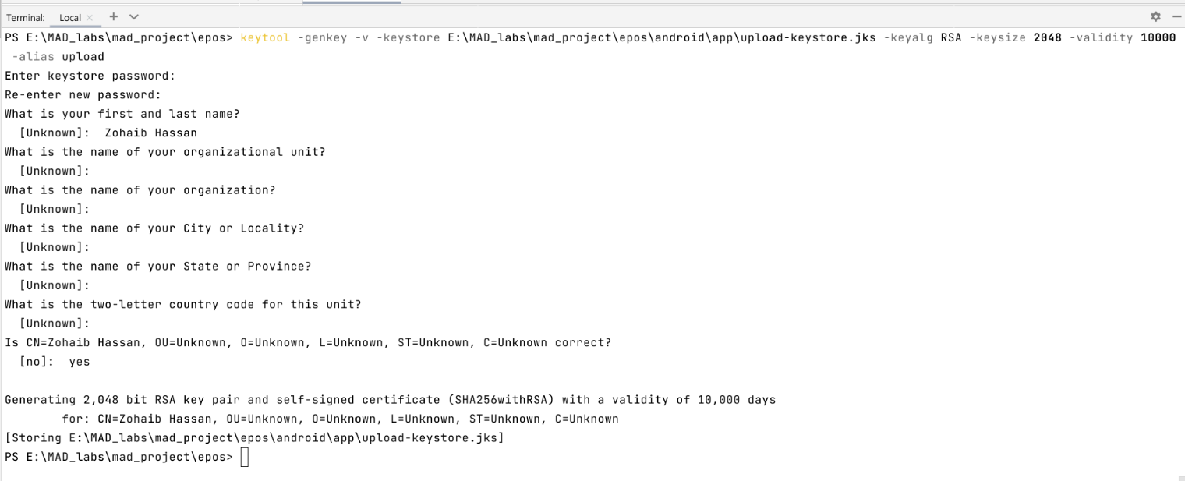

Now move to android directory and create a new file with name key.properties like in image show below:

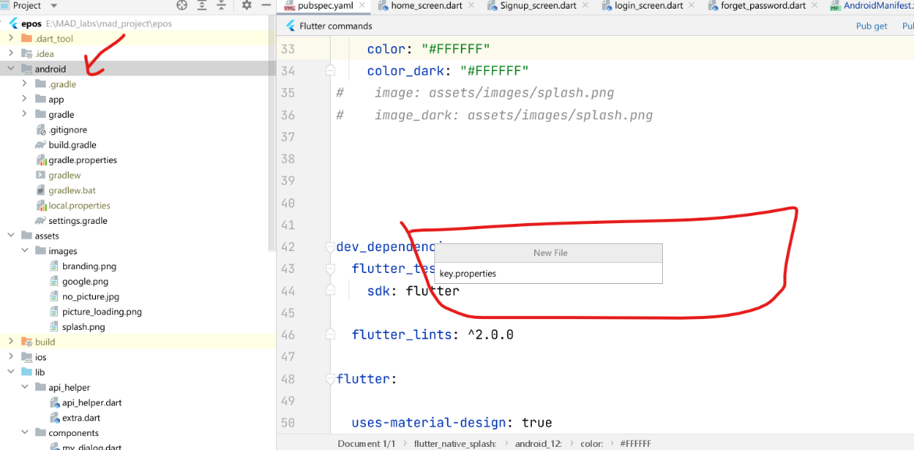

Now paste the following content into it, replace 123456 with the password you created in earlier step:

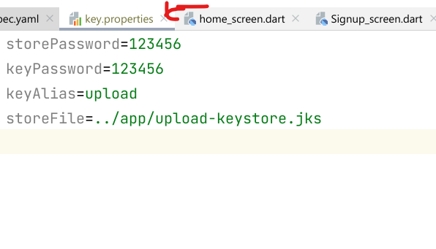

Open build.gradle file of app level and paste the highlighted content before android block as shown below:

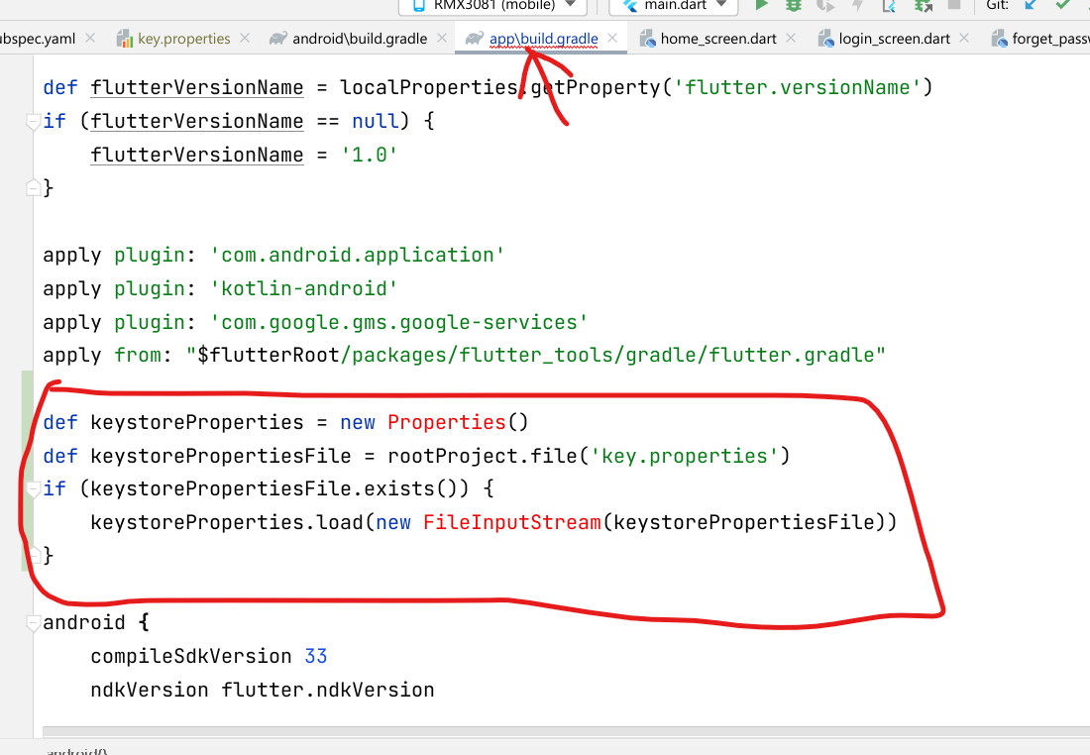

Look for the buildTypes block in the same file and replace that whole block with the content highlighted in below image:

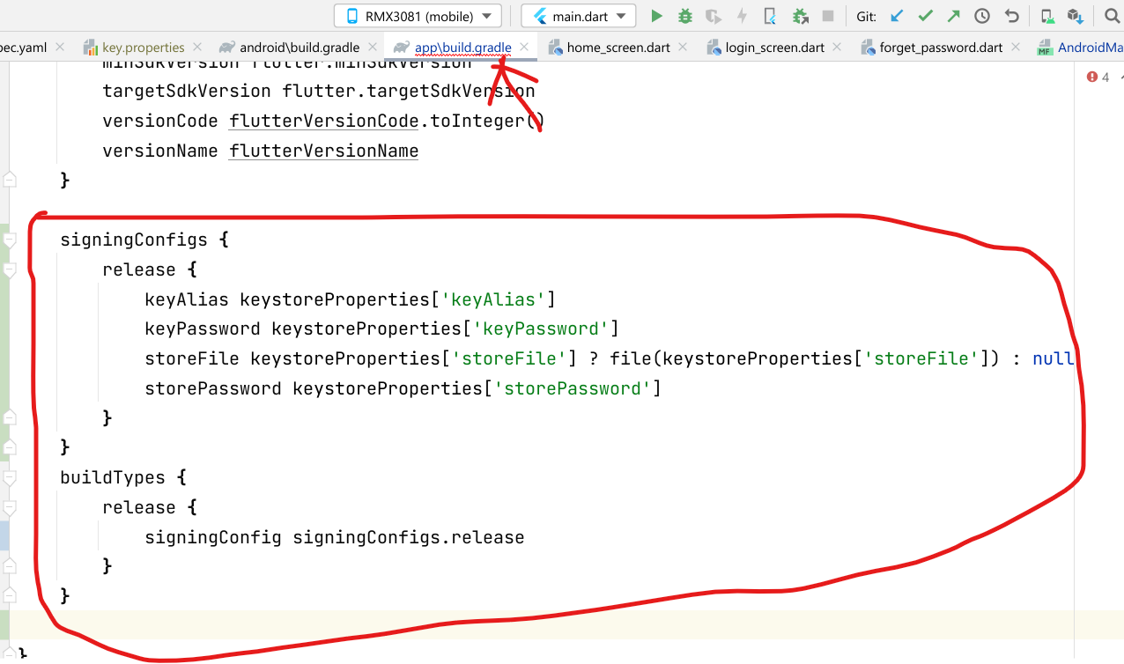

And now run the following once again to build an APK:

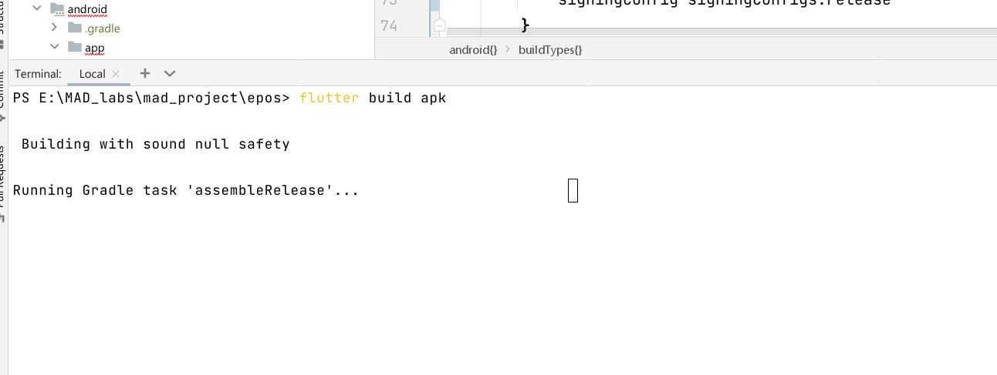

And the APK file will be generated within some moments, in the directory shown below in image:

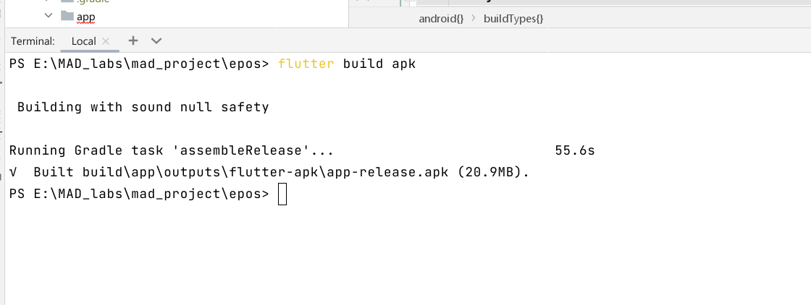

And that’s all this is a signed APK file, which can be distributed to play store.