
QUAID-I-AZAM UNIVERSITY, ISLAMABAD

Department of Computer Sciences

Course Registration and Timetable

Scheduler

Software Construction Project Members

No. | Name | Roll No.
1 | Faizan Ahmad | 04072213038
2 | Zohaib Zafar
3 | Aftab Shaban

Contents
- Project Overview 2
  - Project Summary . . . . . . . . . . . . . . . . . . . . . . . . . . . . . . . 2
  - Purpose, Scope and Objectives . . . . . . . . . . . . . . . . . . . . . . . 2
  - Assignment and Constraints . . . . . . . . . . . . . . . . . . . . . . . . . 3
  - Project Deliverables . . . . . . . . . . . . . . . . . . . . . . . . . . . . . . 4
  - Schedule Overview . . . . . . . . . . . . . . . . . . . . . . . . . . . . . . 4
  - Project Libre Schedule . . . . . . . . . . . . . . . . . . . . . . . . . . . . 5
- References 7
- Definitions 7
- Project Context 8
  - Process Model . . . . . . . . . . . . . . . . . . . . . . . . . . . . . . . . . 8
  - Methods, Tools and Techniques . . . . . . . . . . . . . . . . . . . . . . . 8
  - Product Acceptance Plan . . . . . . . . . . . . . . . . . . . . . . . . . . 9
- Project Planning 10
  - Project Work Plan 10
  - Work Activities 10
  - Schedule Allocation 11
  - Resource Allocation 11
- Supporting Process Plans 12
  - Risk Management 12

Project Overview

Project Summary
The Course Registration and Timetable Scheduler is a standalone two-tier desktop application designed to support student course registration and timetable management. The system provides facilities for students to register for available courses, drop regis-tered courses, and view their timetable. Administrators can manage the course catalog,
student records, timetables, and registration-related reports.
The application uses the following main technologies:

    - Java Swing for the graphical user interface.
    - MySQL 8.0 for data storage.
    - JDBC for database connectivity.
    - Java / JDK 17+ for application development.
    - Eclipse IDE as the development environment.

The system is intended to provide a centralized approach to course registration and timetable management while reducing manual work and scheduling errors.

Purpose, Scope and Objectives

Purpose
The main purpose of the project is to provide a centralized and efficient system for managing course registration and timetable scheduling.
The system is designed to reduce manual registration work, maintain accurate course information, and reduce scheduling conflicts.

Scope
The scope of the system includes:

    - Student and administrator login.
    - Course addition by administrators.
    - Course editing by administrators.
    - Course deletion by administrators.

    - Student course registration.
    - Student course dropping.
    - Timetable clash detection.
    - Timetable generation.
    - Student timetable viewing.
    - Registration-related reports.
    - Timetable-related reports.

Objectives
The major objectives of the project are:

- Provide secure role-based access for students and administrators.
- Maintain accurate and centralized course information.
- Prevent timetable conflicts during course registration.
- Generate a clear timetable for registered courses.
- Provide useful registration summaries and administrative reports.

Assignment and Constraints
The project is developed as a Software Construction course project. It applies software engineering concepts including:
    - Requirements specification.
    - Functional and non-functional requirements.
    - Use cases.
    - System modeling.
    - System Sequence Diagrams.
    - Domain modeling.
    - Sequence diagrams.
    - Design Class Diagram.

    - Database design.
    - Project planning.
    - Software implementation and testing.

The main user classes identified for the system are:

    - Students
    - Administrators

The project is constrained by the selected desktop-based technology stack. The planned implementation uses Java Swing for the GUI, MySQL for data storage, and JDBC for database connectivity.
The project schedule is organized into nine weeks.

Project Deliverables
The major deliverables of the project are listed below.

No. | Deliverable
1 | Project requirements and project documentation
2 | Use Case Diagram and Use Case Descriptions
3 | System Sequence Diagrams for major use cases
4 | Domain Model
5 | Sequence Diagram
6 | Design Class Diagram
7 | Java Swing based application interface
8 | MySQL database and JDBC connectivity
9 | Course registration functionality
10 | Timetable scheduling and clash detection functionality
11 | Registration and timetable reporting functionality

Schedule Overview
The project follows a nine-week development schedule.

Phase | Main Activities | Duration
1 | Requirements and Planning: requirements, scope and objectives | Week 1
2 | Analysis and Modeling: use cases, SSDs, domain model and sequence diagram | Weeks 2–3
3 | Design: class design, database structure and interface design | Week 4
4 | Implementation: Java Swing, MySQL and JDBC im-plementation | Weeks 5–7
5 | Testing and Refinement: functional testing, clash checking and corrections | Week 8
6 | Documentation and Review | Week 9

Project Libre Schedule
The project schedule was prepared using Project Libre.
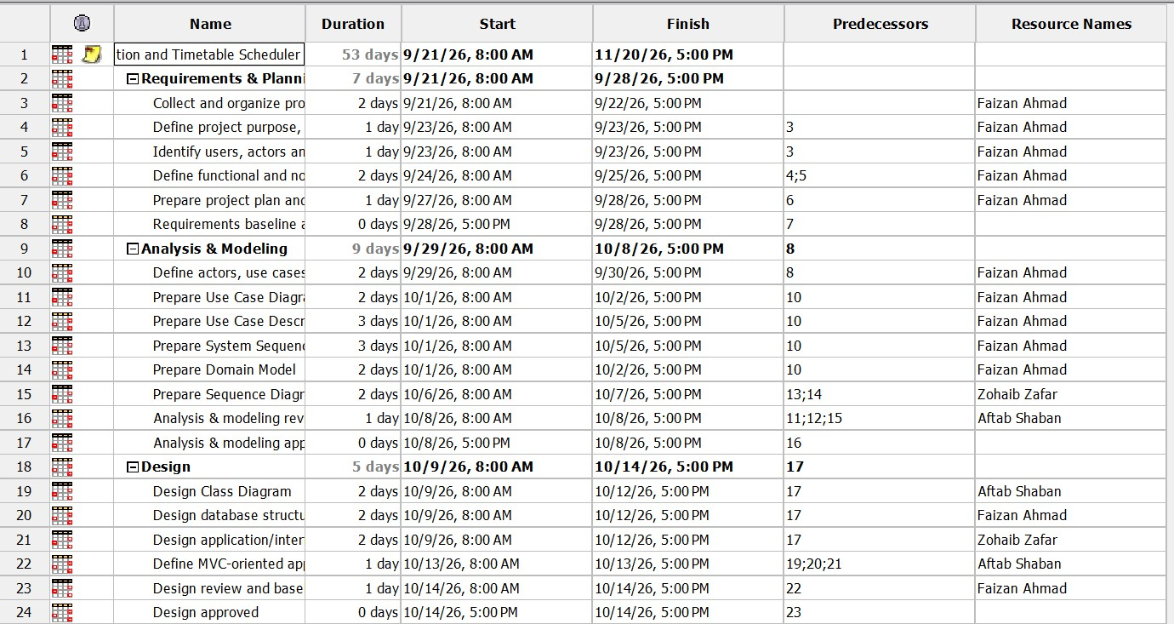

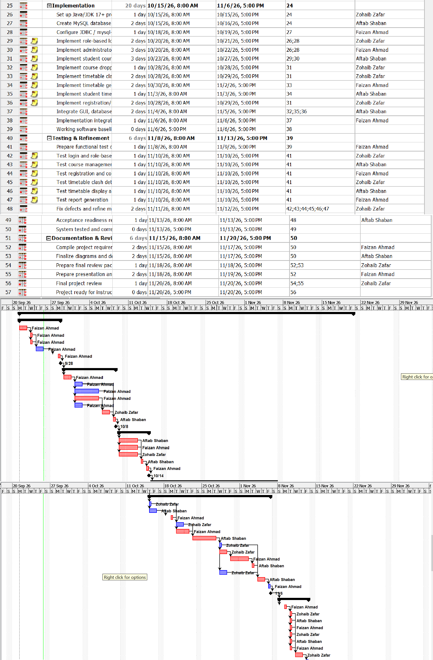

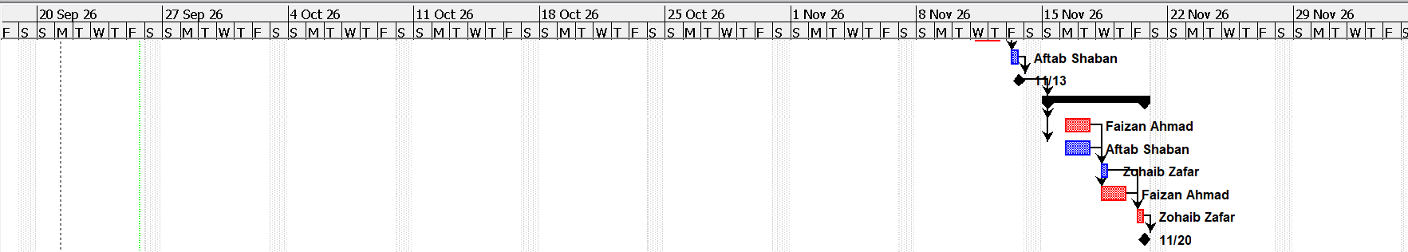

References
The project documentation is based on the following references and technical resources:

- IEEE Std 830-1998, IEEE Recommended Practice for Software Requirements Spec-ifications.
- Oracle Java Swing API Documentation.
- MySQL 8.0 Developer Reference Manual.
- Quaid-i-Azam University, CS322: Software Construction Course Manual.

