SRS – Chapters 10, 11 and 12
Course Registration and Timetable Scheduler

Table of Contents
10. Design Class Diagram
11. Other Nonfunctional Requirements
11.1 Performance Requirements
11.2 Safety Requirements
11.3 Security Requirements
11.4 Software Quality Attributes
11.5 Business Rules
12. Other Requirements

10. Design Class Diagram
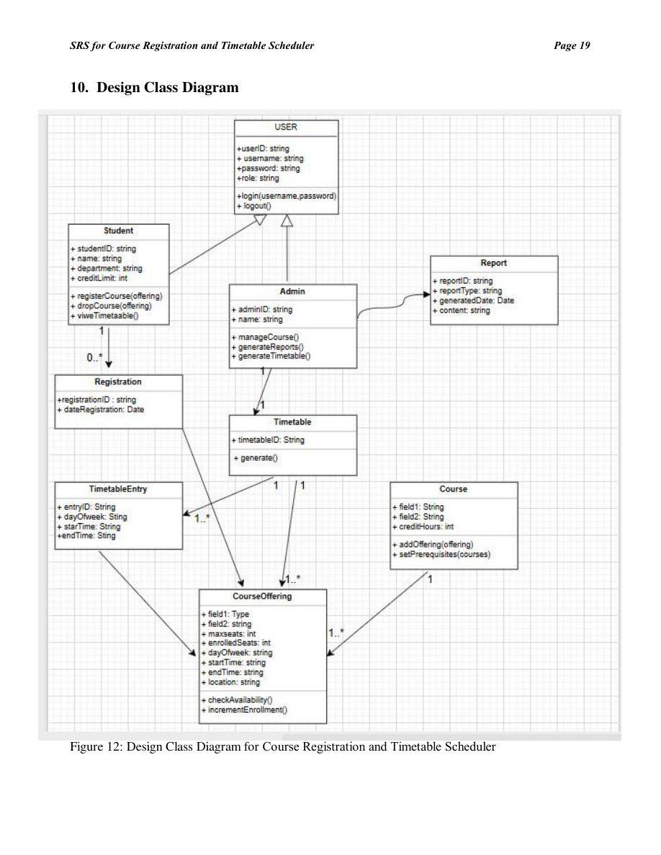
Figure 12: Design Class Diagram for Course Registration and Timetable Scheduler

11. Other Nonfunctional Requirements

11.1 Performance Requirements
- Query responses must complete within 2 seconds.
- Timetable generation must process within 3 seconds.
- System should support at least 200 concurrent users.

11.2 Safety Requirements
- Data loss prevention via daily backups.
- Recovery mechanism for incomplete transactions.

11.3 Security Requirements
- Password encryption using SHA algorithm.
- Role-based access (Student vs. Admin).
- SQL injection prevention via prepared statements.

11.4 Software Quality Attributes
- Usability: Simple, intuitive UI.
- Reliability: Data consistency ensured through atomic transactions.
- Maintainability: Follows MVC structure for easy updates.
- Portability: Runs across multiple OS.

11.5 Business Rules
- Students cannot exceed credit hour limits.
- Course conflict automatically blocks registration.
- Drop period limited to university policy timeline.

12. Other Requirements
- Daily database backup at 00:00 hrs.
- Logging for all transactions and errors.
- Optional REST API support for future web-based version.

