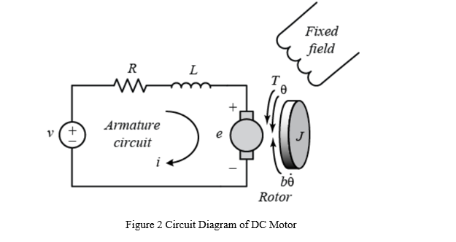
Governing Differential Equation
- The Electrical System (KVL)
Applying Kirchhoff's Voltage Law (KVL) to the armature circuit loop:
$$V\left(t\right)=V_{R}\left(t\right)+V_{L}\left(t\right)+e\left(t\right)$$
Where:
- $V_{R}=i\left(t\right)R$ (Voltage drop across armature resistance)
- $V_{L}=L\frac{di\left(t\right)}{dt}$ (Voltage drop across armature inductance)
- $e\left(t\right)=K_{e}ω\left(t\right)=K_{e}\frac{dθ\left(t\right)}{dt}$ (Back EMF produced by the rotating coil)
Substituting these values into the KVL equation yields Equation (1):
$$L\frac{di\left(t\right)}{dt}+Ri\left(t\right)=V\left(t\right)-K_{e}\frac{dθ\left(t\right)}{dt}$$
- The Mechanical System (Newton's 2nd Law)
The sum of torques acting on the rotor inertia must equal its angular acceleration:
$$\sum{T}=Jα\left(t\right)=J\frac{dω\left(t\right)}{dt}=J\frac{d^{2}θ\left(t\right)}{dt^{2}}$$
The acting torques are:
- Driving Motor Torque ($T_{m}$): Proportional to armature current, $T_{m}=K_{t}i\left(t\right)$
- Opposing Friction Torque ($T_{f}$): Due to bearing viscous damping, $T_{f}=bω\left(t\right)=b\frac{dθ\left(t\right)}{dt}$
Setting up the balance equation:
$$T_{\text{driving}}-T_{\text{opposing}}=J\frac{dω\left(t\right)}{dt}$$
$$K_{t}i\left(t\right)-bω\left(t\right)=J\frac{dω\left(t\right)}{dt}$$
Rearranging gives us Equation (2) in terms of angular velocity ($ω$):
$$J\frac{dω\left(t\right)}{dt}+bω\left(t\right)=K_{t}i\left(t\right)$$
Or substituting $ω\left(t\right)=\frac{dθ\left(t\right)}{dt}$ to express it in terms of angular position ($θ$):
$$J\frac{d^{2}θ\left(t\right)}{dt^{2}}+b\frac{dθ\left(t\right)}{dt}=K_{t}i\left(t\right)$$

Transfer Function Development
Transforming to the Laplace Domain ($s$-Domain)
Assuming zero initial conditions ($i\left(0\right)=0,θ\left(0\right)=0,\dot{θ}\left(0\right)=0$), we apply the Laplace Transform ($\frac{d}{dt}→s$):
From the Electrical Equation (1):
$$LsI\left(s\right)+RI\left(s\right)=V\left(s\right)-K_{e}sΘ\left(s\right)$$
$$\left(Ls+R\right)I\left(s\right)=V\left(s\right)-K_{e}sΘ\left(s\right) \text{--- (3)}$$
From the Mechanical Equation (2) (using the position form):
$$Js^{2}Θ\left(s\right)+bsΘ\left(s\right)=K_{t}I\left(s\right)$$
$$s\left(Js+b\right)Θ\left(s\right)=K_{t}I\left(s\right)$$
Isolate current $I\left(s\right)$ so we can substitute it out:
$$I\left(s\right)=\frac{s\left(Js+b\right)Θ\left(s\right)}{K_{t}} \text{--- (4)}$$
Algebraic Substitution & Simplification
Substitute Equation (4) into Equation (3):
$$\left(Ls+R\right)\left[\frac{s\left(Js+b\right)Θ\left(s\right)}{K_{t}}\right]=V\left(s\right)-K_{e}sΘ\left(s\right)$$
To eliminate the fraction, multiply the entire equation by $K_{t}$:
$$s\left(Js+b\right)\left(Ls+R\right)Θ\left(s\right)=K_{t}V\left(s\right)-K_{t}K_{e}sΘ\left(s\right)$$
Move all terms involving $Θ\left(s\right)$ to the left-hand side:
$$s\left(Js+b\right)\left(Ls+R\right)Θ\left(s\right)+K_{t}K_{e}sΘ\left(s\right)=K_{t}V\left(s\right)$$
Factor out $sΘ\left(s\right)$ on the left side:
$$\left[\left(Js+b\right)\left(Ls+R\right)+K_{t}K_{e}\right]sΘ\left(s\right)=K_{t}V\left(s\right)$$
Final Transfer Functions:
A. Angular Position Transfer Function: $\frac{Θ\left(s\right)}{V\left(s\right)}$
Isolating $Θ\left(s\right)$ relative to input voltage $V\left(s\right)$:
$$\frac{Θ\left(s\right)}{V\left(s\right)}=\frac{K_{t}}{s\left[\left(Js+b\right)\left(Ls+R\right)+K_{t}K_{e}\right]}$$
B. Angular Velocity Transfer Function: $\frac{Ω\left(s\right)}{V\left(s\right)}$
Since angular velocity is the derivative of position, its Laplace relationship is $Ω\left(s\right)=sΘ\left(s\right)$. Substituting this directly into our last factored step gives:
$$\left[\left(Js+b\right)\left(Ls+R\right)+K_{t}K_{e}\right]Ω\left(s\right)=K_{t}V\left(s\right)$$
Dividing both sides yields the velocity transfer function:
$$\frac{Ω\left(s\right)}{V\left(s\right)}=\frac{K_{t}}{\left(Js+b\right)\left(Ls+R\right)+K_{t}K_{e}}$$

$$\frac{Ω\left(s\right)}{V\left(s\right)}=\frac{K_{t}}{JLs^{2}+\left(JR+bL\right)s+\left(bR+K_{t}K_{e}\right)}$$

