MovieBooker – Online Cinema Booking System

Cover Page
Project Title:
MovieBooker- Online Cinema Booking System
Project Type:
Full-Stack Web Application
Submitted By:
Hammad Khawar (SP23-BSE-006)
Aniqa Fatima (SP23-BSE-002)
Submitted To:
Ma’am Sania Iram
Degree Program:
Bachelor of Software Engineering
Institution:
COMSATS University Islamabad Vehari Campus
Submission Date:
12/16/2025


Project Report

1. Introduction
MovieBooker is a full-stack web application designed to digitize and streamline the cinema ticketing process. It replaces traditional box-office queues with a modern, web-based platform that allows users to browse movies, select specific seats in real-time, and manage their bookings. The system provides a seamless experience for moviegoers while offering cinema administrators robust tools to manage movies, showtimes, screens, and customer data. Developed as an academic project, MovieBooker utilizes the Laravel framework to ensure security, scalability, and a responsive user experience.

2. Objectives of the Project
The primary objectives of the MovieBooker project are:
- To develop a fully functional online ticketing platform with a "Dark Cinematic" aesthetic.
- To implement a real-time Seat Selection System that prevents double-booking.
- To enable administrators to efficiently manage movie catalogs, theater screens, and show schedules.
- To provide users with a secure authentication system and a personal dashboard for booking history.
- To demonstrate practical implementation of MVC architecture and complex database relationships.

3. Scope of the Project
The scope of the MovieBooker system includes:
- Movie Management: Adding, updating, and categorizing "Now Showing" films.
- Cinema & Showtime Management: Scheduling movies for specific dates, times, and theater screens.
- Seat Booking: Interactive interface for users to choose specific seats (e.g., Row A, Seat 1).
- Ticket Generation: Automatic generation of digital PDF tickets upon booking confirmation.
- User Management: Registration, login, and profile management for customers.
- Admin Dashboard: A centralized panel for overseeing total bookings, revenue, and system users.
- Responsive Design: Optimized for usage on both desktop monitors and mobile devices.

4. Technologies Used
Front-End Technologies:
- HTML5 & CSS3: For structural layout and styling.
- Tailwind CSS / Bootstrap 5: For responsive design and the custom "Dark Mode" theme.
- JavaScript: For dynamic seat selection logic and UI interactions.
- Blade Templates: Laravel’s templating engine for rendering views.
Back-End Technologies:
- PHP: Server-side scripting language.
- Laravel Framework (v10/v11): For handling routing, controllers, and business logic.
- DomPDF: Library used for generating downloadable PDF tickets.
Database:
- MySQL: Relational database management system.
Development Tools:
- Visual Studio Code (VS Code): Primary code editor.
- XAMPP/Laragon: Local server environment.
- Git & GitHub: For version control.

5. Project Directory Structure
The project follows standard Laravel conventions, organizing code into logical directories for the frontend views and backend logic.
5.1 Backend Folder Structure
The backend logic is contained primarily within the app directory, utilizing Controllers and Models to handle data processing.
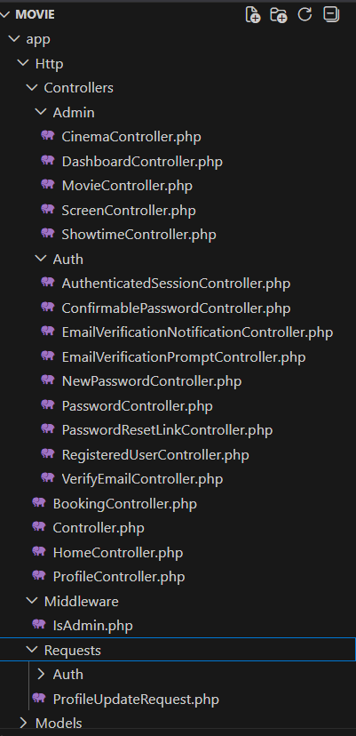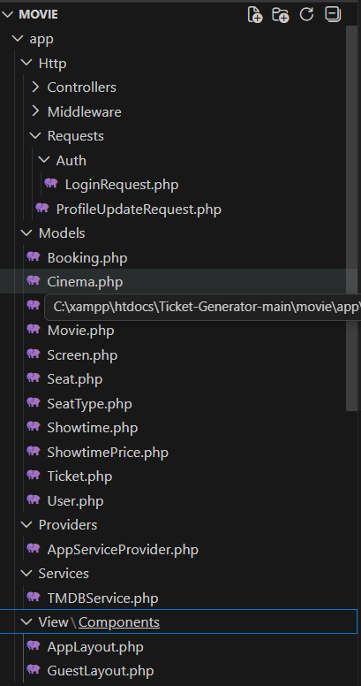
5.2 Frontend Folder Structure
The frontend resources, including Blade templates, JavaScript, and CSS assets, are organized within the resources directory.
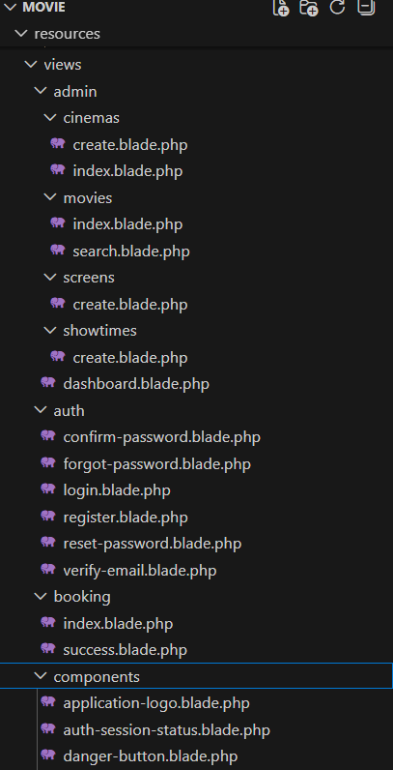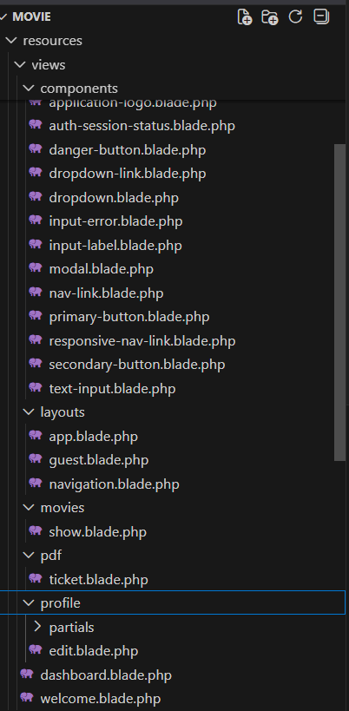

6. System Architecture
MovieBooker follows the standard Model-View-Controller (MVC) architecture provided by Laravel:
- Model: Represents the database structure (e.g., Movie, Showtime, Booking).
- View: The user interface (Blade files) that presents data to the user.
- Controller: Handles user requests (e.g., BookingController), processes logic, and returns the appropriate view.

7. Key Integrations
7.1 Laravel Breeze (Authentication)
We utilized Laravel Breeze to implement a secure and modern authentication system.
- Role: Breeze provides the boilerplate code for Login, Registration, Password Reset, and Email Verification.
- Customization: While Breeze provides the logic, the views (login.blade.php, register.blade.php) were completely redesigned to match the project's "Cinematic Dark Theme," replacing the default white layouts with custom dark components.
7.2 TMDB API (Movie Data)
To ensure the application looks professional and content-rich, we integrated The Movie Database (TMDB) API.
- Role: Instead of manually uploading images for every test, the system fetches high-quality poster URLs (poster_path) and backdrops directly from TMDB.
- Usage: This allows the "Now Showing" grid to display industry-standard visuals and accurate movie descriptions automatically.

8. Key Features and Functionalities
8.1 User Module
- Authentication: Custom-styled Login and Registration pages.
- Movie Discovery: Dynamic grid display of current movies with high-resolution posters.
- Booking Flow: A step-by-step process: Select Movie $\rightarrow$ Select Showtime $\rightarrow$ Select Seats $\rightarrow$ Confirm.
- My Bookings: A dashboard where users can view past history and download PDF tickets.
8.2 Admin Module
- Dashboard: Displays key metrics like Total Users and Recent Bookings.
- Movie Management: CRUD (Create, Read, Update, Delete) operations for the movie catalog.
- Schedule Management: Assigning movies to specific screens and time slots.
- Booking Oversight: Ability for admins to view all global bookings and cancel them if necessary.
8.3 Booking Module
- Visual Seat Map: Users click on specific seats to select them.
- Validation: System prevents selecting seats that are already sold.
- Price Calculation: Automatic total calculation based on the number of seats selected.

9. Database Design
The database is designed to handle the complex relationships between movies, times, and seats.
Key Entities:
- User: Stores customer and admin data (name, email, is_admin).
- Movie: Stores film details (title, description, poster, duration).
- Cinema/Screen: Defines the physical location and auditorium.
- Showtime: Links a Movie to a Screen at a specific Time.
- Seat: Represents physical seats in a screen (row, number).
- Booking: The main transaction record linking a User to a Showtime.
- Ticket: A pivot entity linking a Booking to specific Seats.
Relationships:
- A Movie has many Showtimes.
- A Showtime belongs to one Screen.
- A Booking belongs to one User and one Showtime.
- A Booking has many Tickets (Seats).

10. User Interface Design
The User Interface (UI) is built with a strict "Cinematic Dark Theme":
- Backgrounds: Deep black (#0f0f0f) and dark gray (#1a1a1a) to mimic a theater environment.
- Accents: Vibrant Red (#dc3545) is used for primary buttons and call-to-action elements.
- Layout: Uses "Glassmorphism" (semi-transparent layers) for forms and cards to add depth and a modern premium feel.

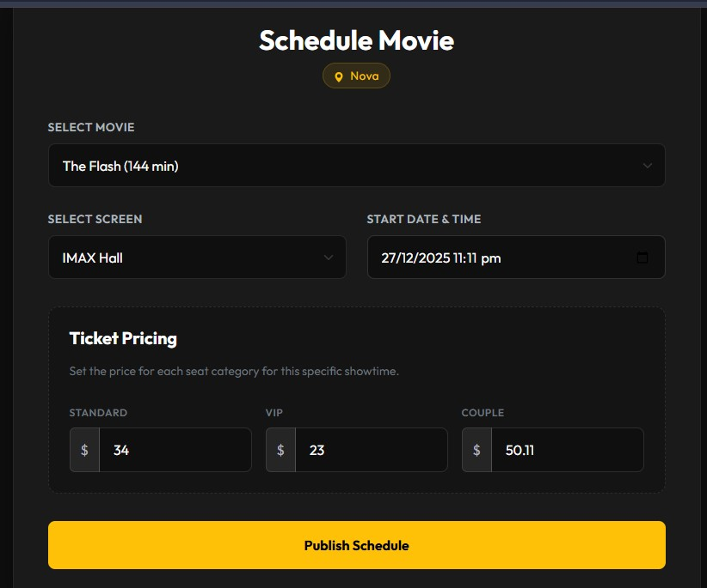

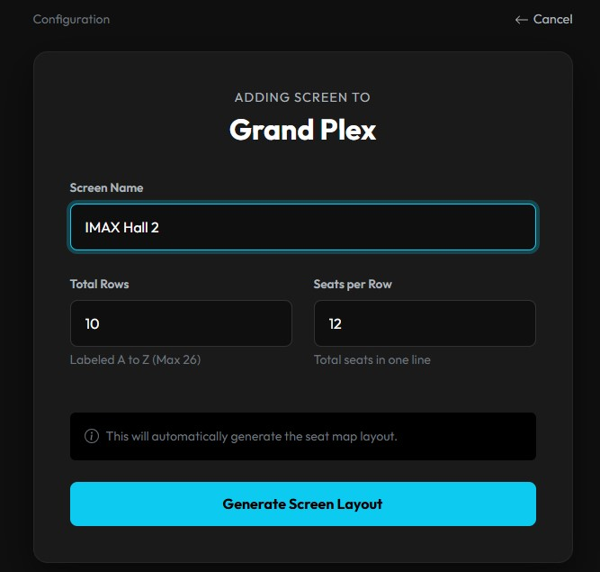
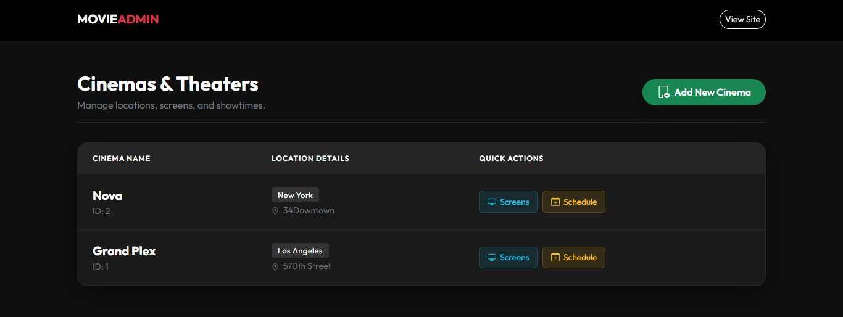

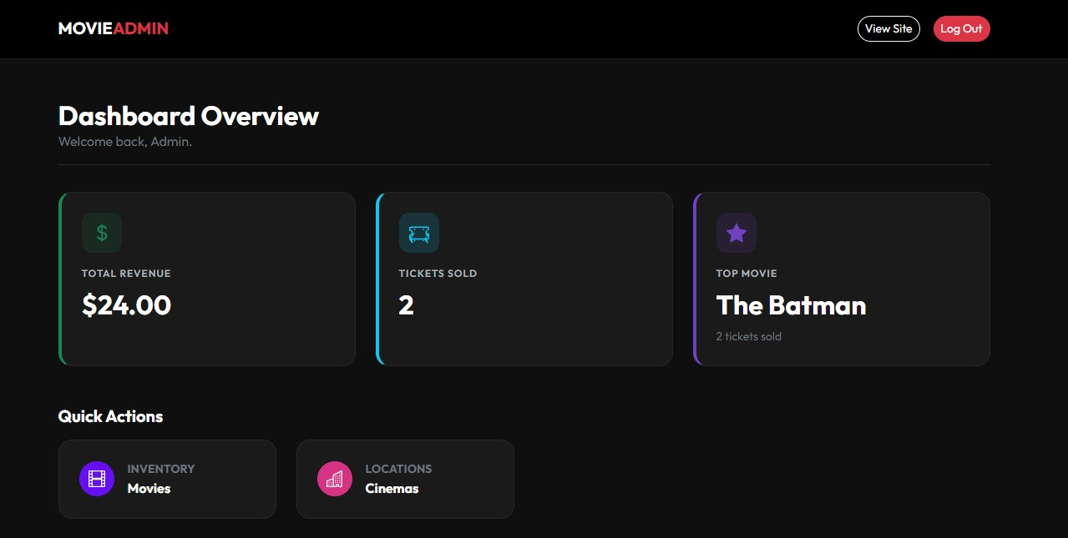

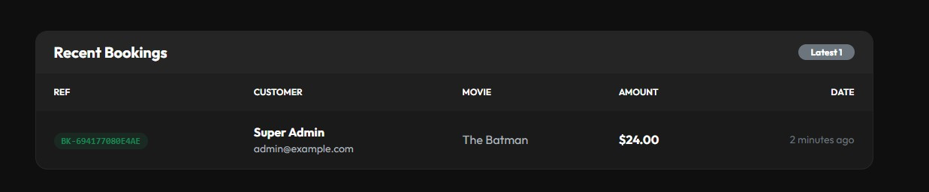
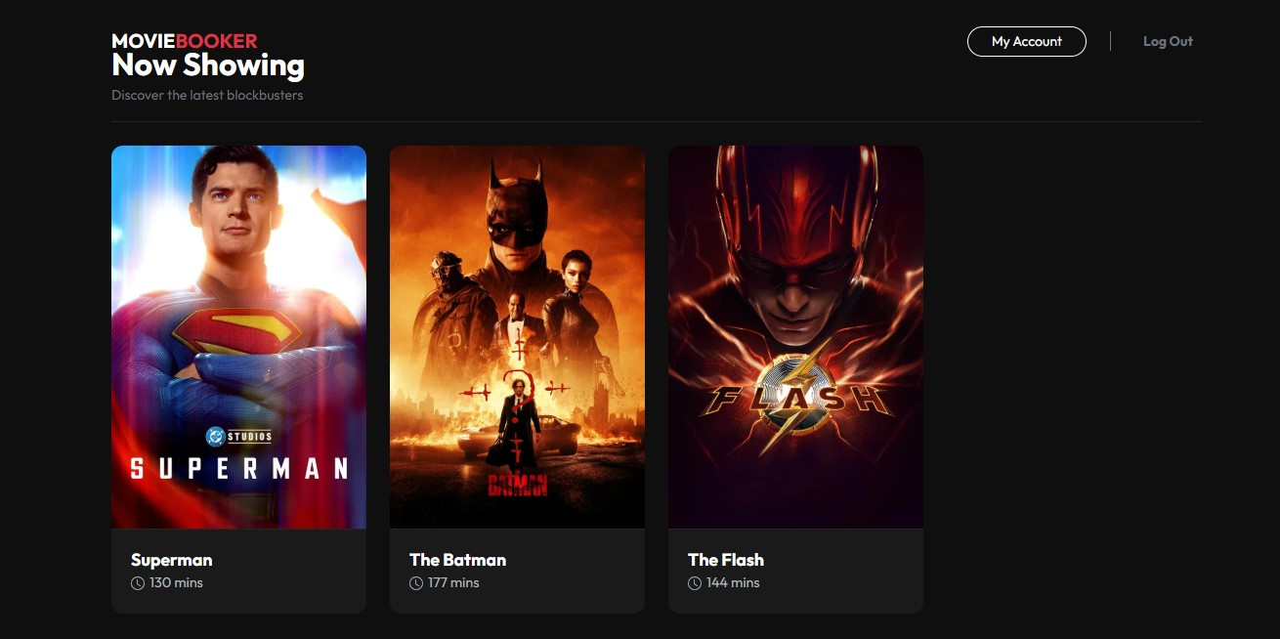

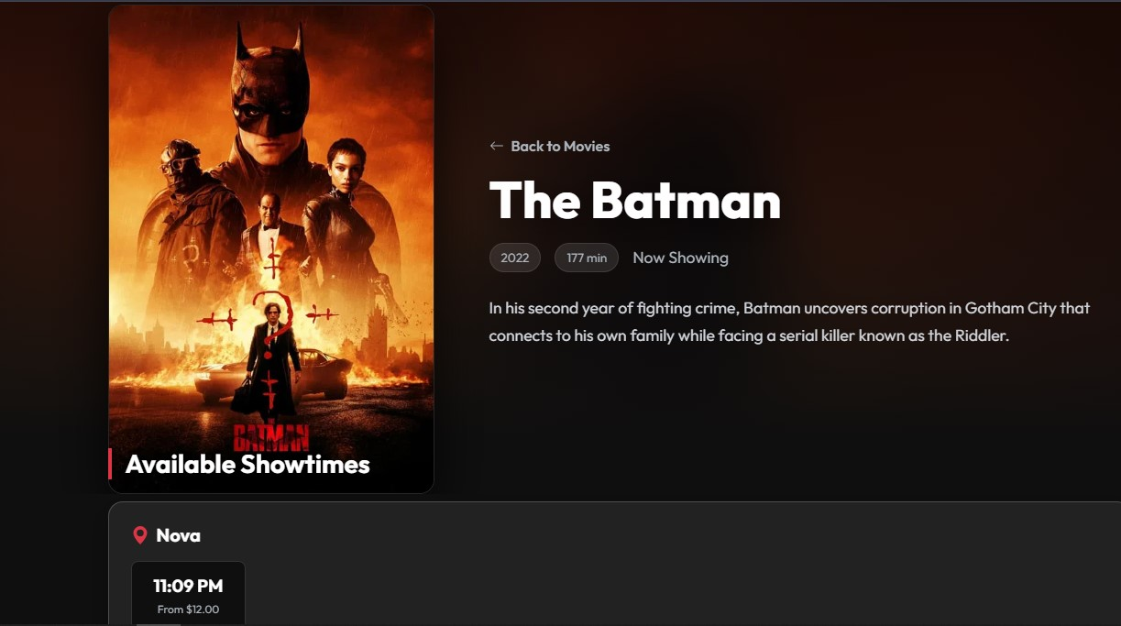
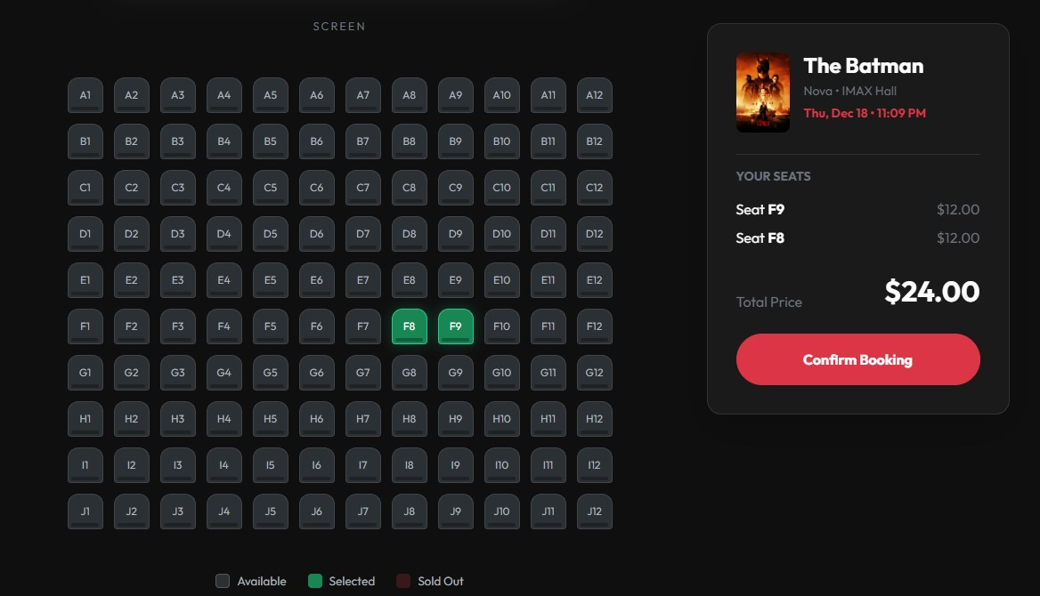
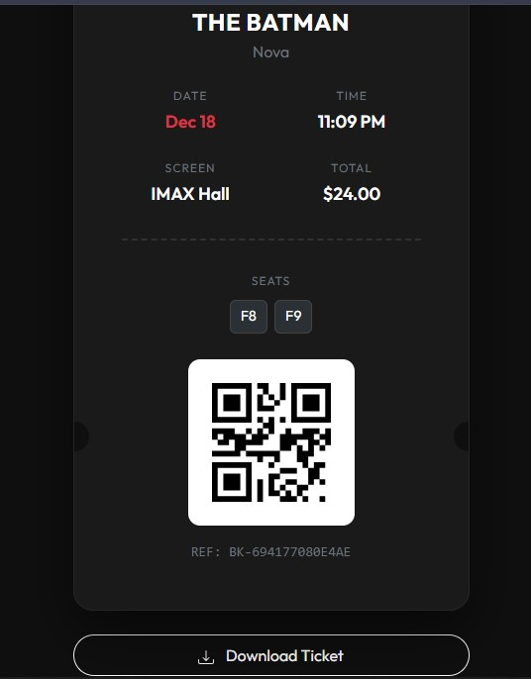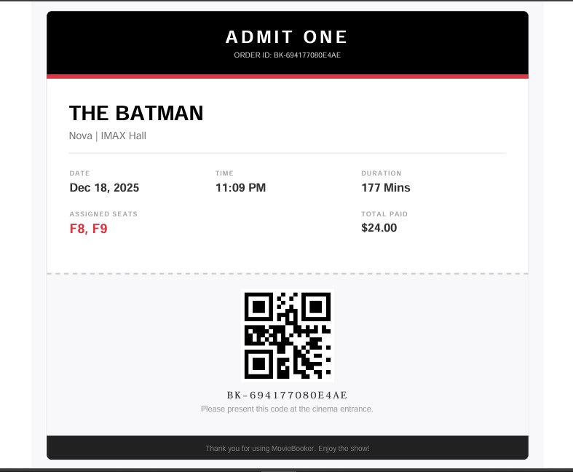

11. System Flow Explanation
11.1 User Flow
- Registration: User creates an account.
- Selection: User clicks on a movie poster from the home page.
- Scheduling: User picks a cinema location and a time slot.
- Seat Selection: User interacts with the visual map to pick available seats.
- Confirmation: Booking is saved to the database, and the user is redirected to the "Success" page.
- Ticket: User downloads the PDF ticket from their dashboard.
11.2 Admin Flow
- Login: Admin logs in via the secure portal.
- Management: Admin adds a new movie release to the database.
- Scheduling: Admin creates showtimes for the new movie.
- Monitoring: Admin checks the dashboard to see how many tickets have been sold.

12. Testing and Validation
The system underwent rigorous testing phases:
- Unit Testing: Verifying that seat availability logic works (booked seats cannot be re-selected).
- Integration Testing: Ensuring the booking flow connects correctly from the movie page to the final receipt.
- Security Testing: verifying that non-admins cannot access /admin routes and that users cannot view other users' bookings.

13. Challenges Faced
- Seat Logic: Handling the logic to check if a specific seat is "taken" for a specific showtime was complex.
- PDF Generation: Configuring the DomPDF library to correctly style the digital tickets.
- Date/Time Handling: managing time zones and ensuring past showtimes do not appear in the booking list.

14. Future Enhancements
The system is ready for the next phase of development (Version 2.0), which will include:
- Concessions Module: Allowing users to order popcorn and drinks during the ticket booking process.
- Role-Based Access Control (RBAC): Introducing a "Sub-Admin" role (e.g., Cinema Staff) who can manage schedules but cannot delete users or view financial reports.
- Payment Gateway: Integration of Stripe or PayPal for real-world payments.

15. Conclusion
MovieBooker successfully provides a robust foundation for online cinema ticketing. It solves the core problem of seat reservation and schedule management with a user-friendly, aesthetically pleasing interface. The project demonstrates a strong grasp of Full-Stack development using Laravel and prepares the groundwork for advanced commercial features in future updates.

