**Lab4 CS171**

Meer Akbar Zohair Moosavi

13.11.2022

**Part 1:** Creation of a Sine Graph

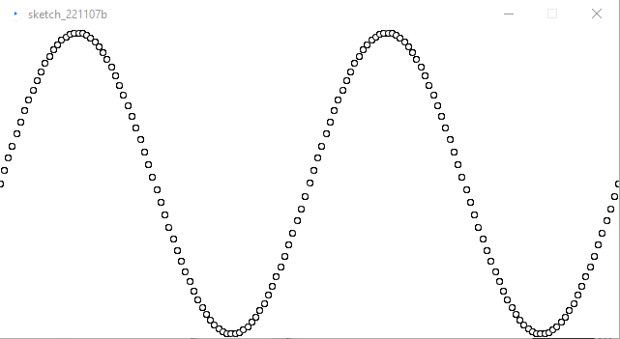

**Figure 1.1** Sine Wave with two cycles, 150 pts and no clipping

**Figure 1.2** Sine and Cosine vs theta (red and green) and sine vs cosine (purple/magenta)