CS171 Lab 3 – Stats and Probability
Student Answer Sheet

Your Student ID: | 22925002
Your Student Name: | Meer Akbar Zohair Moosavi

You must upload this sheet AND your code PDE file to Moodle as your Lab Solution (see the upload widget in Topic 3) Please fill in this answer sheet carefully.

QUESTION A

Given that red, green, blue and white discs are equally likely (same probability) in the original version of our Processing program in Lab 3 calculate probability that a user could guess the four randomly chosen colours correct?

Your answer: | One colour probability: ¼  Overall probability of guessing correctly: ¼ * ¼ * ¼ * ¼ = 1/256

QUESTION B – TASK 1
After running the original game in the PDE file 20 times – record your scores here.
Calculate the MEAN score for your 20 attempts.

Your answer: | Score: 1,0,2,2,2,0,1,1,3,1,1,2,0,1,1,1,2,2,0,0.  Total Score: 1+0+2+2+2+0+1+1+3+1+1+2+0+1+1+1+2+2+0+0 = 23  Mean: 23/20 = 1.15

QUESTION C – TASK 2

Task 2 asks you to adapt the probabilities so that RED and GREEN are both TWICE more likely than BLUE or WHITE at being selected by Processing.

Take a SCREENSHOT of your code (just the int pickRandomColor() function to show your changes). Paste the screenshot into the box below.

Your answer: (screenshot) | 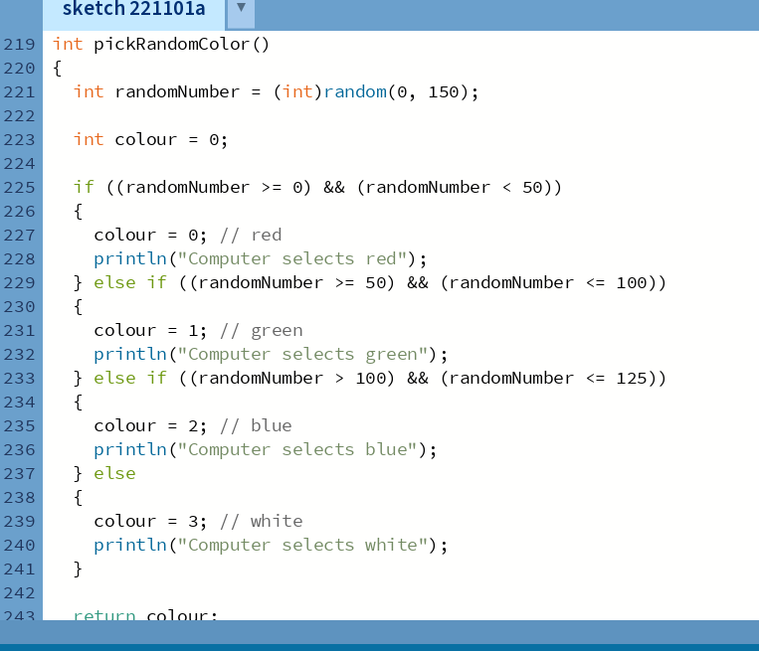

Your answer: (description) | Describe your observations of the game when you exectute the code. Can you see the changes? Describe what you observed.

QUESTION D – TASK 3

In this question you must change the colour used for one of the circles. When you have completed this task – exectute the game again. Take a screenshot when your newly coloured circle appears.

Paste your screenshot in here in the box below. Ensure that your screenshot shows the whole output panel (including your student name and student number in the title bar)

Your answer: | 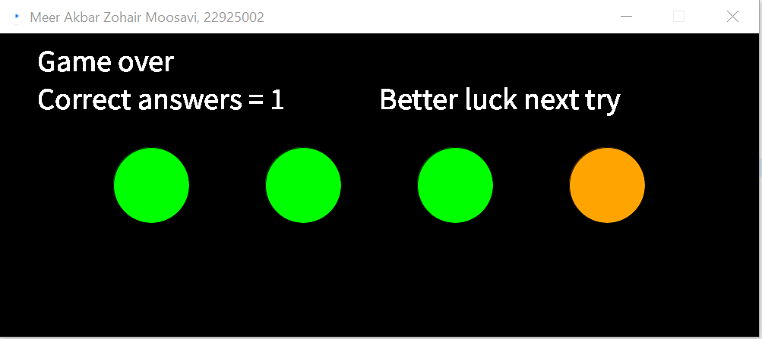

QUESTION E – TASK 4

Take a SCREENSHOT of your code – just the place where you made the change to save the image of your game panel.

Paste your screenshot in here in the box below.

Your answer: | 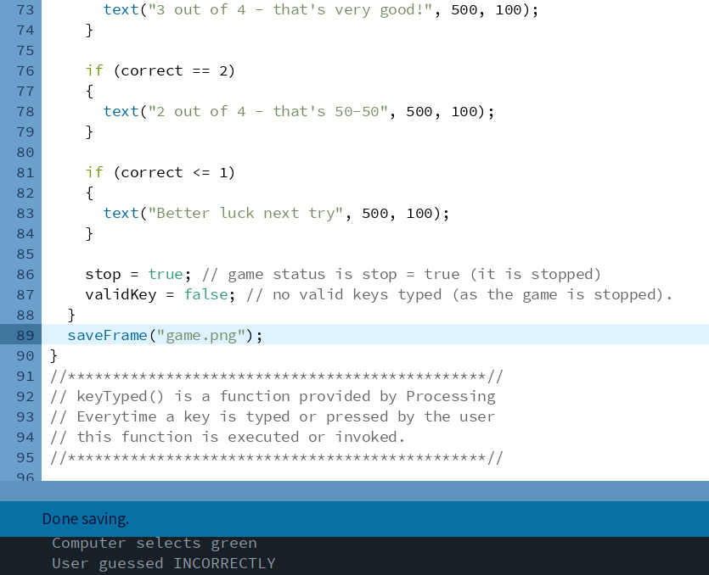

QUESTION F – TASK 5

After running the modified game (now using randomGuassian) in the PDE file 20 times – record your scores here. Calculate the MEAN score for your 20 attempts.

Give a short explanation of what you have observed. For example, is it easier for the user to win the game? Are the four colours equally probable to be selected by Processing.

Note: Different usage of the randomGuassian() function will lead to different behaviours. Try out different values. Lecture 8 in the Topic 3 Stats and Probability lectures (available on Moodle) has a good example of the randomGuassian() function in use.

Your answer: | Scores: 3,0,2,3,3,3,2,3,3,3,4,3,3,3,3,3,2,4,4,3.  Total Scores: 3+0+2+3+3+3+2+3+3+3+4+3+3+3+3+3+2+4+4+3 = 57  Mean: 57/20 = 2.85  Explanation: As seen from the results, the mean for the results is higher than before and which means there is a higher probability (easier) for the user to win the game. This is because some colours appear more frequent than others and all four colours don’t have an equal probability, this means that the user is able to guess the most frequent colours.

