**Faculty: Sir Abdul Bari**

**Batch Code: 2401G1**

**Project Name: A1**

**Group Members Name**

|  |  |
| --- | --- |
| **Student1539774** | **MUHAMMAD ZOHAIR** |
| **Student1535315** | **MEMONA NAEEM** |
| **Student1547408** | **MUHAMMAD TALHA** |
| **Student1546756** | **ALISHA** |
| **Student1551157** | **ABDUL KABIR** |
| **Student1536816** | **MUHAMMAD DANIYAL ALI KHAN** |
| **Student1549364** | **UMAIR REHAN** |

**ACKNOWLEDGEMENT:**

We've worked hard on this project. But without our mentor's gracious assistance and encouragement, it would not have been feasible. We want to sincerely thank her for everything. (Aptech North Nazimabad Center II) has our gratitude for their direction,

ongoing oversight, provision of project-related information, and assistance in seeing the project through to completion. We would

like to thank everyone in my group for their wonderful support and cooperation, which allowed us to finish our assignments.

**HOME PAGE** :

The **Products Home Page** is designed to showcase the company's product offerings in an engaging and user-friendly way. It features a clean layout with key elements like a navigation menu, featured product banners, and categorized listings to help users easily find what they need.

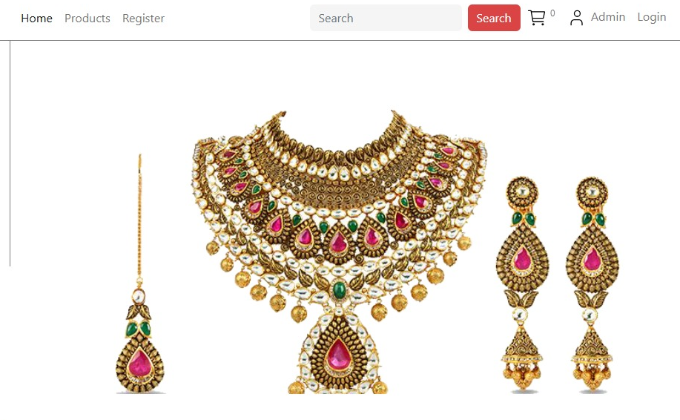

**BROWSE BY CATEGORY:**

**Browse by Category** helps users quickly find products grouped into categories.It includes sections like Smart Watch, Gaming, Computer, Phone, and Headphone. Users can click on any category to view related products. Ensure all categories are clear, visually appealing, and easy to navigate.

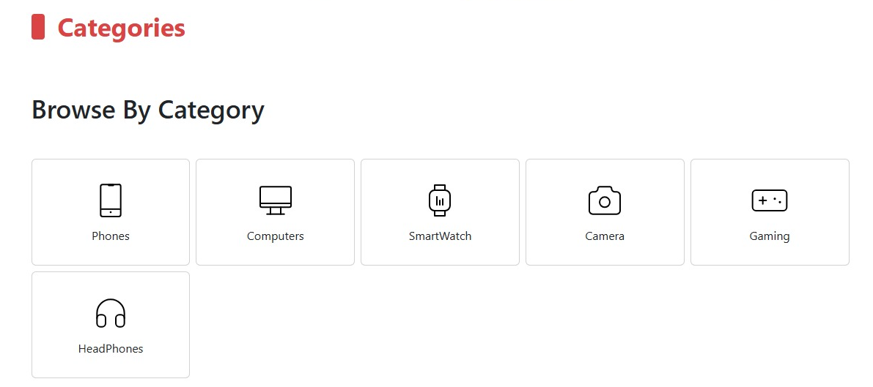

**Our Products**:

Explore our exclusive makeup collection, featuring high-quality foundations, lipsticks, eyeshadows, and more. Designed to enhance your beauty with vibrant colors and lasting formulas.

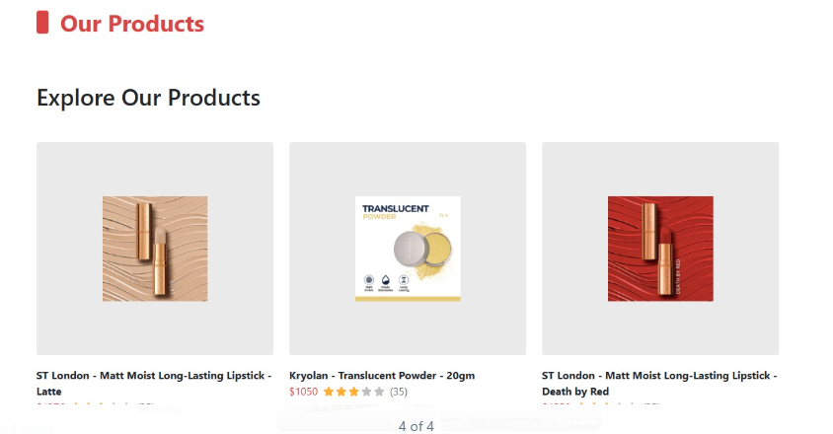

**Browse by Category & Brand**:

Discover products organized by brands like Gosh, Kryolan, ST London, Maybelline, and L’Oréal Paris, as well as categories like jewelry and makeup. Click on any item to explore further.

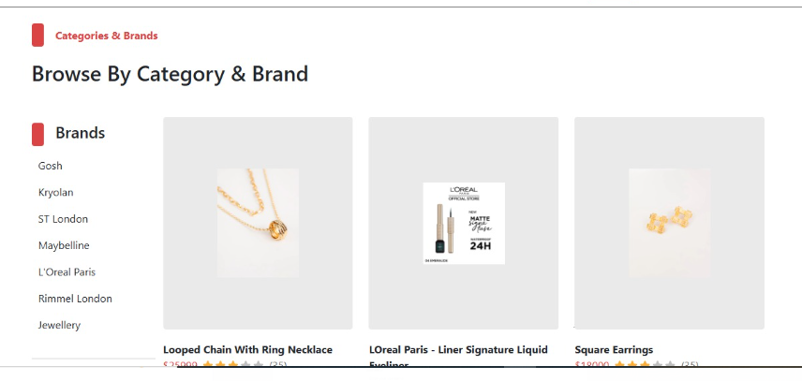

**REGISTERATION FORM**:

The New User Registration Form is designed to collect essential information for creating an account in a system or application. It includes fields such as Username, Email, Password, and Address, ensuring secure access and personalization. Users can also upload a profile picture. The form is user-friendly, with features like password confirmation and validation to prevent errors.

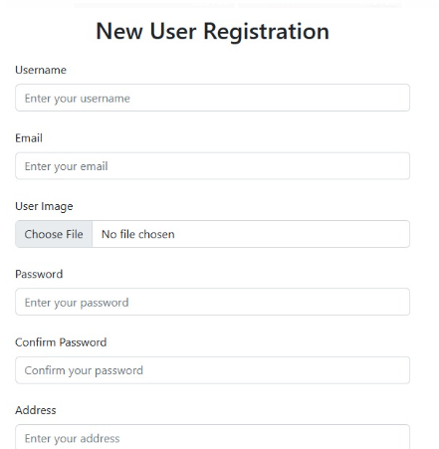

LOCAL HOST :

"Local host users have been successfully added."

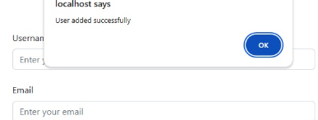

LOG IN:

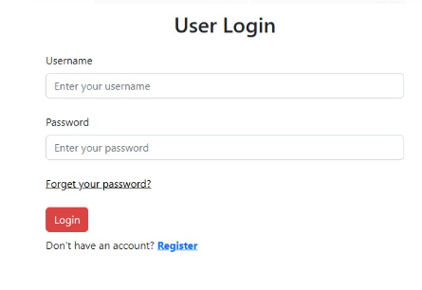"Please enter your username and password to log in."

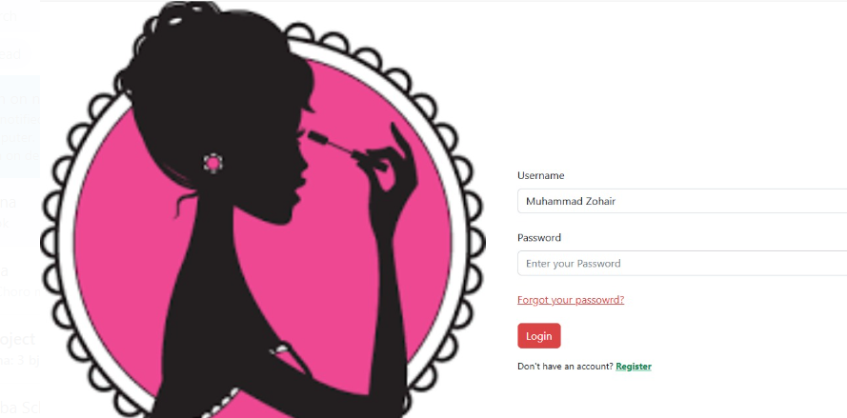

**LOCAL HOST** :

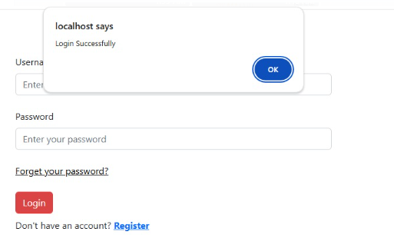"Login successful. Welcome to the system!"

**ADMIN DASHBOARD** :

THIS dashboard provides several key functionalities, including options to insert and view products, manage categories and brands, process orders and payments, and maintain a list of users. It offers a centralized and user-friendly interface, enabling the administrator, Muhammad Zohair, to efficiently oversee and control the operations of the e-commerce system.

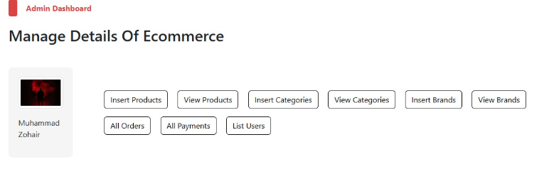

**Insert Products Section:**

This form allows the admin to add new products to the e-commerce platform by providing details such as the product title, description, ,category, brand, And images .

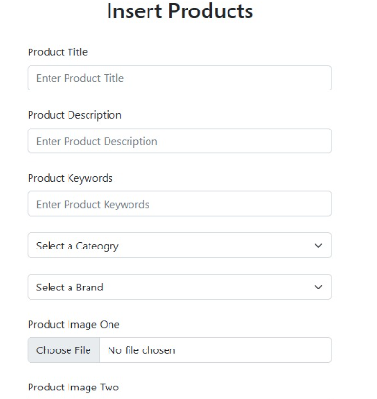

**Product List Table:**

This table displays all added products with details like ID, title, image, price, total sold, status, and options to edit or delete entries. It offers a clear overview for efficient product management.

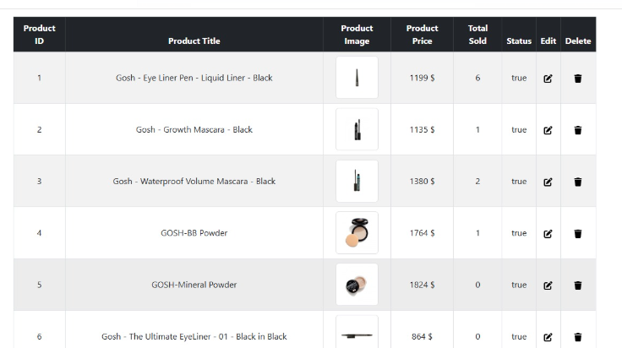

**ALL CATEGORIES :**

This section displays all categories, each with an associated category number. Users can edit or delete categories as needed. The category number is visible for easy reference and management.

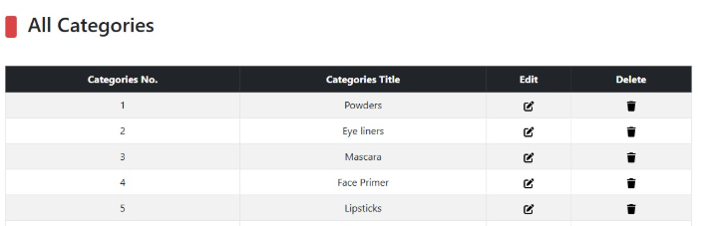

**ALL ORDERS** :

The "All Orders" section displays key details for each order, including Order Number, Due Date, Ordered Product, Order Date, Invoice Number, Total Products, and their status (Complete or Incomplete). Users can also delete orders if needed.

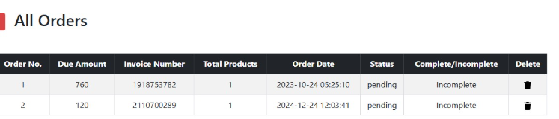

**ALL USERS :**

The "All Users" section lists important details for each user, including User Number, Name, Email, Profile Image, Mobile Number, Address, and an option to delete users.

