**Assignment 01: Parth Chandgadhiya**

# 300986134

**Answer 1**

Query:

**List the name of each officer who has reported more than the average number of crimes officers have reported.**

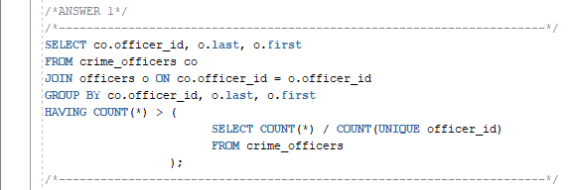

Output:

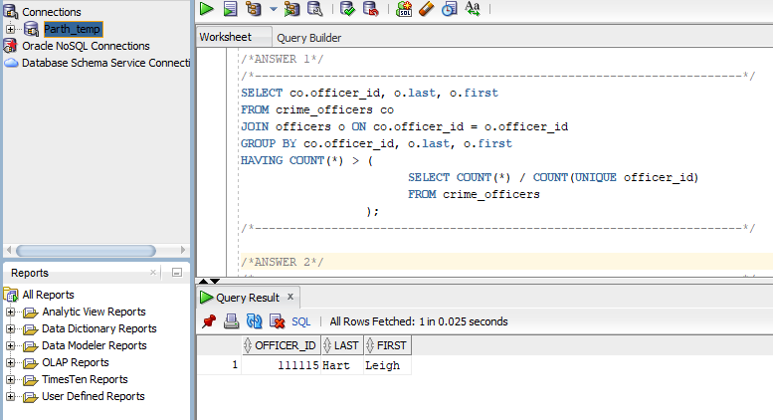

**Answer 2**

Query:

**List the criminal names for all criminals who have a less than average number of crimes and are not listed as violent offenders.**

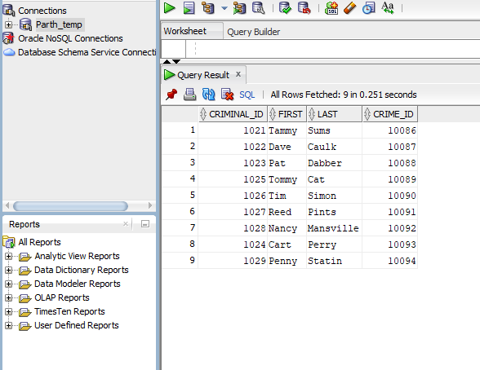

Output:

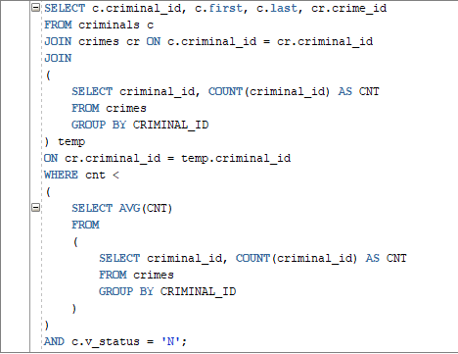

**Answer 3**

Query:

**List appeal information for each appeal that has a less than average number of days between the filing and hearing dates.**

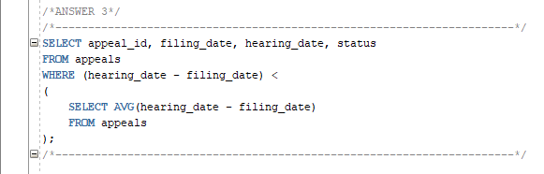

Output:

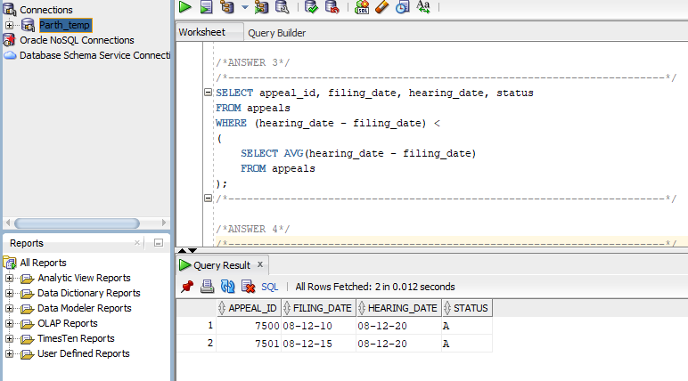

**Answer 4**

Query:

**List the names of probation officers who have had a less than average number of criminals assigned.**

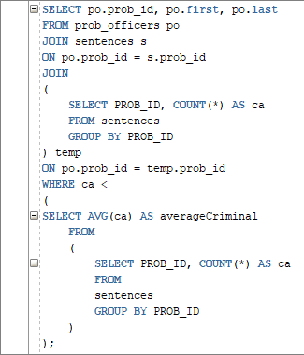

Output:

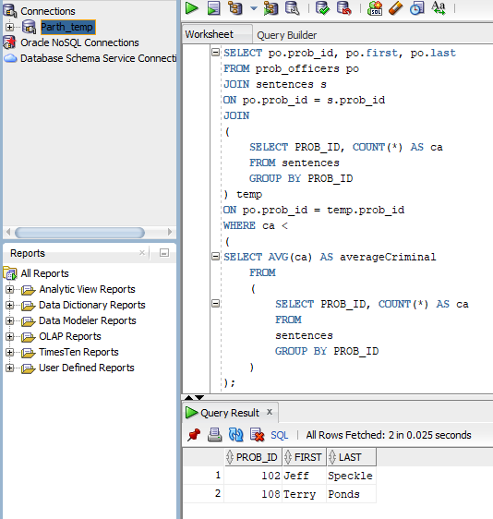

**Answer 5**

Query:

**List each crime that has had the highest number of appeals recorded.**

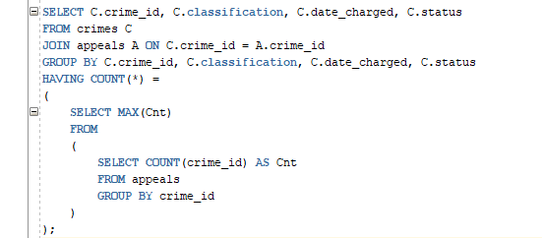

Output:

