Student Id: 300986134

Name: Parth Chandgadhiya Lab 6(Javafx GUI)

**Screenshots**

# Normal Screen

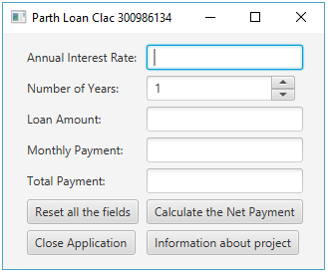

# Calculate The Payment

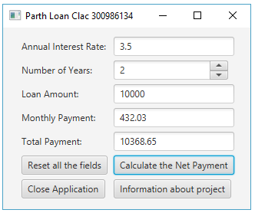

# Reset All Fields

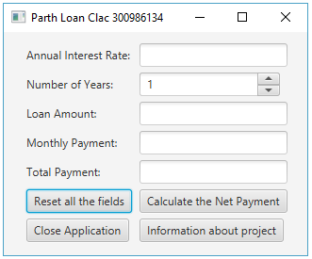

# Exit Button

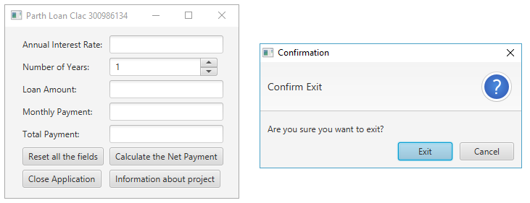

# Info Button

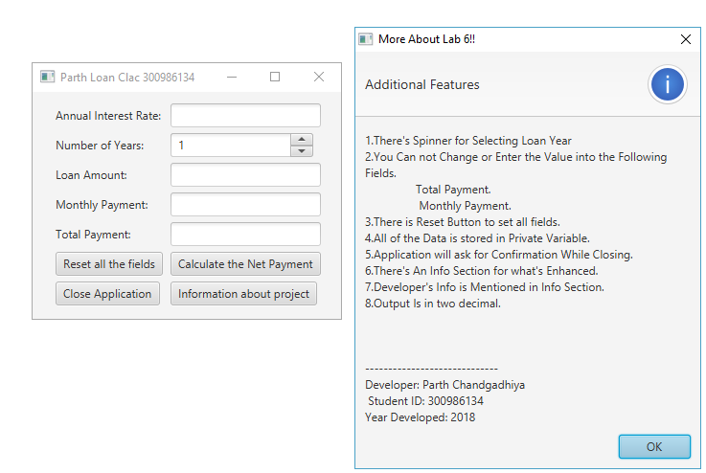

**Code**

**import** javafx.application.Application;

**import** javafx.geometry.Insets;

**import** javafx.geometry.Pos;

**import** javafx.scene.Scene;

**import** javafx.scene.control.Alert;

**import** javafx.scene.control.Alert.AlertType;

**import** javafx.scene.control.Button;

**import** javafx.scene.control.ButtonType;

**import** javafx.scene.control.Label;

**import** javafx.scene.control.Spinner;

**import** javafx.scene.control.TextField;

**import** javafx.scene.layout.GridPane;

**import** javafx.stage.Modality;

**import** javafx.stage.Stage;

**import** javafx.stage.WindowEvent;

**import** javafx.event.ActionEvent;

**import** javafx.event.EventHandler;

**import** java.text.DecimalFormat;

**import** java.util.Optional;

**public** **class** LabSix **extends** Application

{

**double** numberOfYears;

**double** monthlyPayment;

**double** totalPayment;

**double** annualInterestRate;

**double** loanAmount;

**double** monthlyInterestRate;

**private** **static** DecimalFormat *outputFormatter* = **new** DecimalFormat(".##");

TextField Mp = **new** TextField();

TextField Tp = **new** TextField();

TextField Air = **new** TextField();

TextField La = **new** TextField();

Button Calc = **new** Button("Calculate the Net Payment");

Button Clear = **new** Button("Reset all the fields");

Button Info = **new** Button("Information about project");

Spinner<Integer> spinner1 = **new** Spinner<>(1, 100, 1);

@Override

**public** **void** start(Stage primaryStage)

{

primaryStage.setOnCloseRequest(confirmCloseEventHandler);

Button closeButton = **new** Button("Close Application");

closeButton.setOnAction(event ->

primaryStage.fireEvent(

**new** WindowEvent(

primaryStage,

WindowEvent.***WINDOW_CLOSE_REQUEST***

)

)

);

GridPane pane = **new** GridPane();

pane.setAlignment(Pos.***CENTER***);

pane.setPadding(**new** Insets(11.5,12.5,13.5,14.5));

pane.setHgap(5.5);

pane.setVgap(5.5);

pane.add(**new** Label("Annual Interest Rate: "), 0, 0);

pane.add(Air, 1, 0);

pane.add(**new** Label("Number of Years: "), 0, 1);

pane.add(spinner1, 1, 1);

pane.add(**new** Label("Loan Amount: "), 0, 2);

pane.add(La, 1, 2);

pane.add(**new** Label("Monthly Payment: "),0,3);

pane.add(Mp,1,3);

pane.add(**new** Label("Total Payment: "),0,4);

pane.add(Tp,1,4);

pane.add(Clear,0,5);

pane.add(Calc,1,5);

pane.add((closeButton), 0, 6);

pane.add((Info), 1, 6);

//Avoid User Tempering With Data

Mp.setEditable(**false**);

Tp.setEditable(**false**);

//Create a scene and place it in the stage

Scene scene = **new** Scene(pane);

primaryStage.setTitle("Parth Loan Clac 300986134");

primaryStage.setScene(scene);

primaryStage.show();

CalculateListenerClass listener1 = **new** CalculateListenerClass();

Calc.setOnAction(listener1);

ClearListenerClass listener2 = **new** ClearListenerClass();

Clear.setOnAction(listener2);

InfoListenerClass listener4 = **new** InfoListenerClass();

Info.setOnAction(listener4);

}

**public** **static** **void** main(String[] args)

{

Application.*launch*(args);

}

**class** CalculateListenerClass **implements** EventHandler<ActionEvent>

{

@Override

**public** **void** handle(ActionEvent e)

{

annualInterestRate = Double.*valueOf*(Air.getText());

numberOfYears = Double.*valueOf*(spinner1.getValue());

loanAmount = Double.*valueOf*(La.getText());

monthlyInterestRate = annualInterestRate / 1200;

monthlyPayment = loanAmount * monthlyInterestRate / (1 - (1 / Math.*pow*(1+ monthlyInterestRate, numberOfYears * 12)));

totalPayment = monthlyPayment * numberOfYears * 12;

Tp.setText(String.*valueOf*(*outputFormatter*.format(totalPayment)));

Mp.setText(String.*valueOf*(*outputFormatter*.format(monthlyPayment)));

}

}

**class** ClearListenerClass **implements** EventHandler<ActionEvent>

{

@Override

**public** **void** handle(ActionEvent e)

{

Mp.setText("");

Tp.setText("");

Air.setText("");

spinner1.getValueFactory().setValue(1);

La.setText("");

}

}

**class** InfoListenerClass **implements** EventHandler<ActionEvent>

{

@Override

**public** **void** handle(ActionEvent e)

{

Alert alert = **new** Alert(AlertType.***INFORMATION***);

alert.setTitle("More About Lab 6!!");

alert.setHeaderText("Additional Features");

alert.setContentText

(

"1.There's Spinner for Selecting Loan Year"

+ "\n2.You Can not Change or Enter the Value into the Following Fields. "

+ "\n\t\tTotal Payment. "

+ "\n\t\t Monthly Payment."

+ "\n3.There is Reset Button to set all fields."

+ "\n4.All of the Data is stored in Private Variable."

+ "\n5.Application will ask for Confirmation While Closing."

+ "\n6.There's An Info Section for what's Enhanced."

+ "\n7.Developer's Info is Mentioned in Info Section."

+ "\n8.Output Is in two decimal."

+ "\n"

+ "\n"

+ "\n"

+ "\n-----------------------------"

+ "\nDeveloper: Parth Chandgadhiya"

+ "\n Student ID: 300986134"

+ "\nYear Developed: 2018"

);

alert.showAndWait();

}

}

**private** EventHandler<WindowEvent> confirmCloseEventHandler = event -> {

Alert closeConfirmation = **new** Alert(

Alert.AlertType.***CONFIRMATION***,

"Are you sure you want to exit?"

);

Button exitButton = (Button) closeConfirmation.getDialogPane().lookupButton(

ButtonType.***OK***

);

exitButton.setText("Exit");

closeConfirmation.setHeaderText("Confirm Exit");

closeConfirmation.initModality(Modality.***APPLICATION_MODAL***);

Optional<ButtonType> closeResponse = closeConfirmation.showAndWait();

**if** (!ButtonType.***OK***.equals(closeResponse.get())) {

event.consume();

}

};

}