Real Estate Market Analysis: Property Availability and Pricing Trends Across Major Cities
Prepared by: Zohan Hussain
Date: 29/12/2025
Data: Zameen.com

Executive Summary:
This report analyses real estate property listings across multiple cities with a focus on property availability and pricing trends. Using data-driven visualizations, the analysis examines the distribution of key property types, including Flats, Houses, Penthouses, Lower Portions, and Upper Portions, to identify market patterns and city-wise variations.
The findings indicate that Flats and Houses dominate the market supply in most cities, reflecting higher demand and broader affordability. Heatmap analysis reveals significant variation in property availability across cities, highlighting areas of high concentration as well as markets with limited supply. Additionally, pricing analysis shows notable differences in average property prices by both city and property type, with premium properties such as Penthouses consistently commanding higher prices, particularly in major urban centres.

- Business Objective
The objective of this analysis is to evaluate property availability and pricing trends across major cities to support informed decision-making for investors, developers, and buyers.

Variable Description (Data Dictionary)
Variable Name | Description | Data Type | Purpose in Analysis
City | Represents the city where the property is located. | Categorical (Nominal) | Used for city-wise analysis of property availability, pricing comparison, and identification of high-demand urban markets.
Property Type | Indicates the category of the property, such as Flat, House, Penthouse, Lower Portion, or Upper Portion. | Categorical (Nominal) | Helps analyse market composition, compare availability across property categories, and assess price variation by property type.
Price (Million PKR) | Listed price of the property, standardized and expressed in million Pakistani Rupees (PKR). | Numerical (Continuous) | Used to evaluate pricing trends, calculate average prices, and identify premium versus affordable property segments.
Listing Count (Derived) | Total number of property listings for each city and property type combination. | Numerical (Discrete) | Used to measure property availability and supply concentration in bar charts and heatmaps.
Average Price (Derived) | Mean property price calculated for each city and property type. | Numerical (Continuous) | Used in price heatmaps to compare market value across cities and property categories.

Visual Insights:
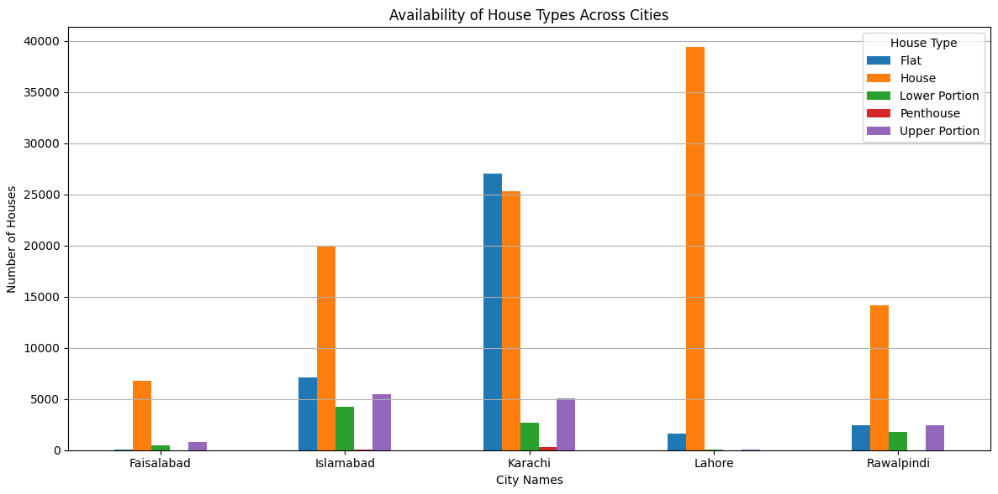
This chart illustrates the availability of different property types across the dataset, including Flats, Houses, Penthouses, Lower Portions, and Upper Portions. The visualization highlights how frequently each property category appears in the market, providing a clear view of overall housing supply and market composition.
Key Insights
Flats and Houses represent the largest share of available listings, indicating that they form the core of the residential real estate market.
The high availability of Flats reflects growing urbanization and a strong preference for compact, affordable housing options in major cities.
Houses also show substantial availability, suggesting sustained demand for family-oriented and independent living spaces.
Lower and Upper Portions occupy a moderate share of the market, serving as cost-effective alternatives to full houses and appealing to budget-conscious buyers.
Penthouses show the lowest availability, confirming their niche positioning and limited supply within the luxury housing segment.
The distribution highlights a clear imbalance between mass-market and premium properties, with the market heavily skewed toward more affordable housing types.
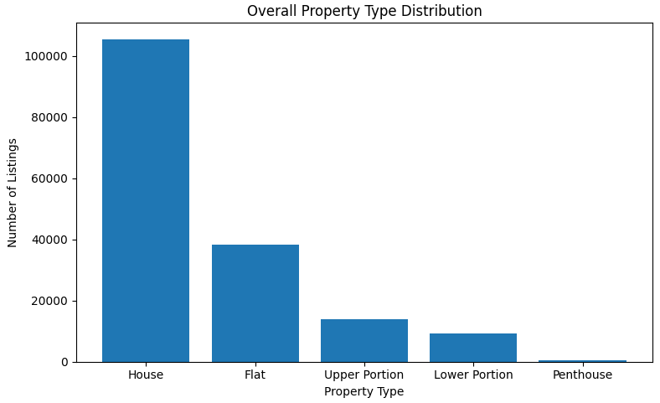
This chart illustrates the overall distribution of property types across the entire dataset. It shows the relative proportion of Flats, Houses, Penthouses, Lower Portions, and Upper Portions available in the market. The visualization clearly indicates that Flats and Houses dominate the listings, suggesting they are the most common and in-demand property types. Penthouses account for a much smaller share, highlighting their limited availability and premium nature. This chart provides a high-level overview of market composition and helps stakeholders quickly identify dominant property categories.
Key Insights:
Flats and Houses account for the majority of property listings, indicating strong market demand and widespread availability.
The high proportion of Flats suggests urbanization trends and preference for vertical living in major cities.
Penthouses form a very small segment of the market, highlighting their exclusivity and premium positioning.
Lower and Upper Portions occupy a mid-level share, reflecting demand for more affordable alternatives to full houses.

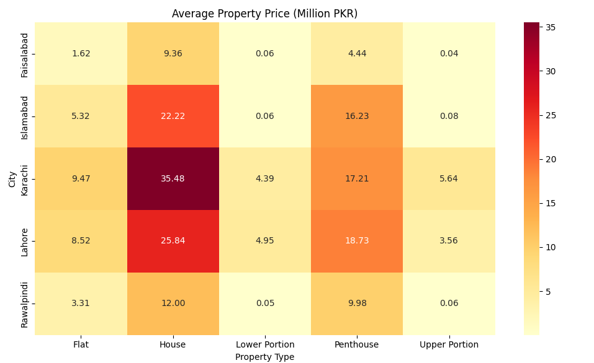
This heatmap displays the average property prices (in million PKR) across different cities and property types. The colour gradient represents price intensity, allowing for easy comparison of pricing trends. The chart shows that premium property types such as Penthouses generally command higher prices, particularly in major urban centers. Differences in pricing across cities reflect variations in demand, location value, and property characteristics. This visualization supports pricing analysis and helps identify high-value real estate markets.
Key Insights:
Penthouses consistently show the highest average prices, confirming their premium market status.
Major urban centers record higher property prices across most property types.
Significant price variation across cities suggests differences in location value, economic activity, and demand levels.
More affordable property types, such as Flats and Portions, offer relatively lower price points, appealing to mid-income buyers.

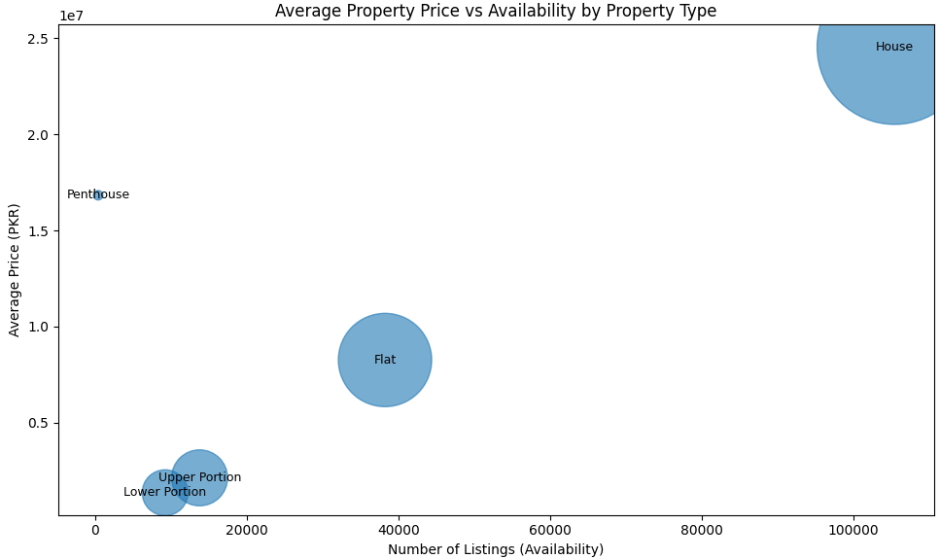
This bubble chart illustrates the relationship between property availability (number of listings) and average property price across different property types. The horizontal axis represents availability, while the vertical axis shows the average listed price. Each bubble corresponds to a specific property type, and the size of the bubble reflects the relative market size based on listing volume.
This visualization helps identify how pricing varies with supply and highlights distinct market segments ranging from mass-market housing to premium and niche property categories.

key insights:
Flats and Houses appear in the high-availability segment, indicating that they dominate the real estate market supply and cater to a broad range of buyers.
Penthouses are positioned in the low-availability, high-price region, confirming their status as premium and luxury properties with limited market supply.
Portion-based properties (Upper and Lower Portions) typically fall in the mid-price and mid-availability range, reflecting balanced demand among buyers seeking affordability and space.
Rooms and Farm Houses (where applicable) show relatively low availability, indicating niche market segments with specific buyer preferences.
The chart highlights a clear trade-off between price and availability, where property types with higher prices tend to have lower supply, while more affordable options are widely available.
Property types positioned closer to the center of the chart may represent optimal investment opportunities, offering a balance between demand (availability) and pricing.

“Together, these visualizations provide a comprehensive understanding of the real estate market by combining availability analysis with pricing trends, enabling data-driven insights and informed decision-making.”

