Early Detection of Interest Loss in Hebrew WhatsApp Sales Conversations:
Textual, Behavioral, and Prefix-Aware Modeling
[Roni Twito – 313221467 , Matan Zohar Cohen - 209225457]
Natural Language Processing — Final Project, Reichman University, 2026
Abstract.
Loss of customer interest in a sales conversation can surface not only in what participants say but in how their communication behavior changes over time. We study early detection of interest loss in Hebrew WhatsApp sales conversations, framed as binary classification (interested vs. losing_interest) over a synthetic, LLM-generated dataset of 3,055 conversations (2,137/459/459 train/validation/test, class-balanced, conversation-level split, seed 42). We compare purely behavioral, lexical, and semantic (AlephBERT) representations on complete conversations, then evaluate prediction quality at partial observation points (25/50/75/100% of the conversation). A model fine-tuned only on complete conversations degrades sharply on partial conversations (macro-F1 33.28/33.77/51.14% at 25/50/75%), motivating prefix-aware training, which raises early-stage macro-F1 to 62.64/74.84/86.93% at a modest cost to full-conversation performance (95.20% vs. 98.04%). Adding 26 non-lexical behavioral features to the prefix-aware model yields directional improvements, most notably at 75% observation (+2.18 percentage points, paired bootstrap 95% CI [+0.20, +4.36]), but paired McNemar tests do not reach significance at any prefix (all p > 0.05), and the effect reverses at 100% observation (-0.88 pp). A controlled ablation further shows that an apparent full-conversation gain from behavioral fusion (97.38% vs. 96.95%) is better explained by additional training than by behavioral information, since a text-only continued-training control reaches 98.04%. Our results support a nuanced conclusion: behavioral dynamics carry standalone predictive signal, prefix-aware training is essential for early detection, and explicit behavioral fusion provides directional but not conclusively significant value when textual evidence is incomplete.

1. Introduction
Interest loss in a sales conversation is typically framed as a text-classification problem: given what a customer says, predict whether they remain interested. This framing overlooks a second source of evidence — how communication behavior changes over the course of a conversation, independent of literal word content. Response latency, message length, participation balance, and shifts in these quantities across a conversation may signal disengagement even when the textual content is ambiguous. A second, practically more important limitation of standard framings is that they classify complete conversations, whereas a business needs to detect interest loss while a conversation is still ongoing, so that intervention is still possible.
We study early detection of interest loss in Hebrew WhatsApp sales conversations, a binary classification task (interested vs. losing_interest) evaluated both on complete conversations and on conversation prefixes representing 25%, 50%, and 75% of the observed messages. This paper is organized around four research questions:
RQ1. How effectively can textual and behavioral signals classify interest state in complete Hebrew WhatsApp conversations?
RQ2. Does a model trained only on complete conversations generalize to early prediction from partial (prefix) conversations?
RQ3. Does prefix-aware training — explicitly training on conversation prefixes — improve early detection relative to a full-conversation-trained model evaluated on prefixes?
RQ4. Do explicit, non-lexical behavioral signals provide additional predictive value beyond a prefix-aware AlephBERT model when textual evidence is incomplete?
We treat full-conversation classification and prefix-based early detection as two distinct evaluation regimes: the former (Section 6.1-6.2, RQ1) measures a representational ceiling — class separability given complete information — while the latter (Section 6.3-6.6, RQ2-RQ4) measures practical detectability while a conversation is still actionable. We adopt a strictly binary label (interested vs. losing_interest) because it is the only distinction present in the dataset's ground truth (Section 3); a finer-grained scale would require re-annotation and is left to future work. A correct prediction available only after a conversation ends cannot inform any intervention, so RQ2-RQ4 ask specifically whether useful signal is available earlier.
The contribution of this work is primarily one of problem framing, experimental methodology, and careful interpretation rather than new model architecture. Specifically: (1) we frame interest-loss detection as an early conversational prediction problem rather than only a full-conversation classification problem; (2) we systematically evaluate prediction quality at four observation points (25/50/75/100%); (3) we directly compare naive full-conversation training against prefix-aware training under an identical architecture; (4) we test whether explicit behavioral conversation dynamics add value beyond text when textual evidence is incomplete; (5) we run a controlled ablation showing that an apparent full-conversation fusion gain is explained by additional training rather than by behavioral information; (6) we validate early-detection comparisons with paired bootstrap and McNemar tests rather than point estimates alone; and (7) we decompose the E2-vs-E3 comparison by true class (Section 6.7), showing an aggregate macro-F1 gain can mask a class-asymmetric, sometimes overconfident error pattern. As detailed in Section 6, the evidence does not support the strong claim that behavioral fusion universally improves a text model; it supports a more specific, observation-dependent conclusion that we treat as a central finding rather than a null result to be minimized.

2. Related Work
Textual backbone. We build on AlephBERT (Seker et al., 2022), a Hebrew pretrained transformer, used here as a fixed architecture; HeRo (Shalumov & Haskey, 2023), a more recent Hebrew RoBERTa/Longformer model, is a plausible alternative we did not evaluate. Early and partial-evidence classification. Renault et al. (2024) survey early classification of time series, formalizing the earliness/accuracy trade-off our prefix evaluation instantiates in text. Dulac-Arnold, Denoyer, and Gallinari (2011) frame text classification as a sequential reading process that can stop once enough evidence accumulates. Closest to our setting, Chang and Danescu-Niculescu-Mizil (2019) forecast online-conversation derailment at successive points as it develops — the same early-vs-complete-observation contrast we study (RQ2-RQ3), in a different domain and without behavioral fusion. Song et al. (2019) and Burdisso, Errecalde, and Montes-y-Gómez (2019) detect rumors and depression risk from partial social-media streams, sharing our constraint of predicting from incomplete evidence. Han et al. (2026) show early-observation sufficiency for churn prediction is design-dependent, paralleling our finding that 75%, not 50% or 100%, is where behavioral signal helps most. Behavioral signals. Meng, Yue, and Glass (2021) and Nourbakhsh et al. (2026) predict dialogue engagement/failure from behavioral or trajectory signals combined with text — the combination we study (RQ4). Mufti et al. (2026) predict churn from purely behavioral features; our pure-behavioral baseline (65.07% macro-F1) is a direct analog.
Our work differs from this literature in domain (Hebrew sales dialogue vs. social media, forums, or task-oriented dialogue) and, more importantly, in method: unlike prior work reporting point-estimate gains from behavioral/trajectory signals, we run a controlled ablation ruling out a training-duration confound (Section 6.2) and paired bootstrap/McNemar testing (Section 6.6) before attributing any gain to behavioral information. To our knowledge, this combination has not been reported for Hebrew sales-conversation interest detection.

3. Dataset and Task Definition
Task. Given a chronologically ordered WhatsApp sales conversation (interleaved customer and business turns), predict a binary label — interested or losing_interest — from either the complete conversation or a prefix representing the first 25%, 50%, or 75% of its messages.
Origin and synthetic status. The dataset is entirely synthetic, including the original 300-conversation seed, which was itself synthetically generated for this project and then used to seed further LLM-based generation (GPT-4o-mini / GPT-4o / GPT-5-mini) with automated validation and duplicate/quality filters (documented in the generator's generation report). No real WhatsApp conversations or real customer data were used at any stage; every record is flagged synthetic: true, so there is no personally identifiable information from real users to expose, an important scope condition revisited in Section 7.
Size and splits. The dataset contains 3,055 conversations, split 2,137 / 459 / 459 (train/validation/test, ≈70/15/15), stratified by label with a fixed random seed (42). The split is performed at the conversation level, and overlap between splits is explicitly checked and rejected if found. Conversation-level splitting is essential here because the unit of prediction is the whole conversation: splitting at the message level would leak a conversation's own vocabulary, scenario, and identity across train and test, inflating apparent performance. The same split (persisted conversation-ID list) is reused by every experiment reported in this paper, so all comparisons in Section 6 are made on an identical, non-overlapping test set of 459 conversations.
Class balance. The dataset is close to balanced: 1,529 interested conversations (50.05%) and 1,526 losing_interest conversations (49.95%). Because the classes are balanced, macro-F1 and accuracy are both informative; we report macro-F1 throughout, following the project's documented metric choice, as it weights both classes equally regardless of any residual imbalance.

4. Methodology

4.1 Textual representation
We use AlephBERT (onlplab/alephbert-base; Seker et al., 2022), a Hebrew pretrained transformer, fine-tuned with a classification head (max sequence length 512 tokens, truncation).

4.2 Behavioral and lexical features
We compute 26 pure, non-lexical behavioral features directly from conversation structure and timing metadata, independent of message content. Grounded in the feature-extraction code, they fall into six groups: (i) participation/message counts — total, customer, and business message counts and their ratio; (ii) customer message-length statistics — mean, median, standard deviation, minimum, maximum, and total character count; (iii) response timing — mean/median/maximum customer response delay, mean business response delay, and the delay of the final response; (iv) session/gap structure — number of sessions and the maximum inter-message gap; (v) conversation-ending structure — whether the customer sent the final message; and (vi) temporal-change features — first-half vs. second-half differences in customer message length, response delay, and customer message count, capturing whether communication intensity or responsiveness shifts across the conversation. A separate handcrafted lexical feature set (25 features — counts and rates of customer questions, emojis, and Hebrew price/negotiation/objection/commitment/delay-signal keyword matches, and their presence in the first/second half or final message) is used only in the Behavioral+Lexical baseline (Section 6.1) and is not treated as behavioral. Historical note on Table 1: that baseline came from an intermediate, uncommitted extraction script containing only groups (i)-(v) (18 features — the current 26 minus the 8 temporal-change features in group vi) plus all 25 lexical features, for 43 total, confirmed by that run's saved feature-name manifest (see Section 7).

4.3 Prefix construction and leakage prevention
For a conversation with N total messages, the k% prefix retains the first max(1, ⌈N × k⌉) messages in chronological order. Customer text within that prefix is used for the text encoder, and behavioral features are recomputed from only the messages within the prefix — by construction, behavioral features at each prefix use exclusively information visible at that point, with no access to later messages. This is enforced in code (prefix truncation occurs before feature extraction) and covered by a unit test.

4.4 Prefix-aware training and fusion
Prefix-aware models (E2, E3) augment each training conversation into all four prefix fractions (25/50/75/100%), so the model is directly optimized to classify from partial evidence rather than only from complete conversations. In fusion models, standardized behavioral features are concatenated with the AlephBERT representation and passed through a small MLP head (hidden dimension 256, dropout 0.1) before the classification layer; in the prefix-aware fusion model (E3), the encoder and head use separate learning rates (1×10⁻⁵ and 1×10⁻³ respectively), mirroring the rationale documented for the continued-training control (Section 6.2): a small rate preserves the fine-tuned encoder, a larger rate lets the fresh fusion head adapt quickly. The StandardScaler used to normalize behavioral features is fit exclusively on training-split (or training-prefix) examples and applied unchanged to validation and test data, preventing test-statistic leakage into normalization.

4.5 Checkpoint selection and evaluation
Full-conversation models select the checkpoint with the best validation macro-F1. Prefix-aware models (E2, E3) select the checkpoint maximizing average macro-F1 across the 25/50/75% validation prefixes specifically — a rule documented in the training script as deliberately excluding the 100% fraction so that checkpoint selection favors early-detection quality rather than being dominated by the easier full-conversation case. We report accuracy, per-class precision/recall/F1 (positive class = losing_interest), macro-F1 (primary metric), and weighted-F1, computed once on the held-out test set; the test set is never used for model or checkpoint selection.

4.6 Statistical validation
For the RQ4 comparison (E2 vs. E3), we run a paired bootstrap (10,000 resamples, seed 42) over the shared 459 test conversations to estimate the macro-F1 delta and a 95% confidence interval, and a paired McNemar exact test on a per-conversation correct/incorrect contingency table, at each prefix. Both models' predictions were verified to share identical conversation IDs, true labels, and no duplicates before comparison.

5. Experimental Setup
AlephBERT fine-tuning uses 5 epochs, learning rate 2×10⁻⁵, weight decay 0.01, warmup ratio 0.1, gradient clipping 1.0, batch size 8 (train) / 16-32 (eval). Behavioral-only baselines compare logistic regression and a random forest (200 trees) on standardized features; the better validation performer (random forest, for both variants) is reported. Random seed 42 is used consistently for the split, all models, and the bootstrap analysis.

6. Results and Analysis

6.1 Full-conversation classification (RQ1)
Table 1 compares five full-conversation models. The pure behavioral baseline (26 features, random forest) reaches 65.07% macro-F1 — well above a degenerate single-class predictor (~33% macro-F1 on a balanced two-class set), showing that communication dynamics alone, independent of word content, carry meaningful signal about interest state. Adding handcrafted lexical cues (43 features total) raises macro-F1 to 86.69%, a substantial jump indicating that surface lexical markers (price, objection, commitment, negotiation, delay-signal cues) capture much more discriminative signal than structural/timing behavior alone. AlephBERT text-only reaches 96.95%, far above either feature-engineered baseline, confirming that a pretrained Hebrew transformer captures most of the discriminative content in this task. This answers RQ1: textual signal alone is already highly effective on complete conversations, while behavioral signal is a real but much weaker standalone signal, and is best understood as complementary to lexical/textual cues rather than a substitute for them.
Table 1. Full-conversation model comparison (test set, n = 459). *43 = 18 structural behavioral + 25 lexical features, predating the 8 temporal-change features added later (see §4.2, §7).
Model | Features | Feature count | Test Macro-F1
Pure Behavioral | Non-lexical behavioral only | 26 | 65.07%
Behavioral + Handcrafted Lexical | Structural + lexical keyword features | 43* | 86.69%
AlephBERT (text-only) | Full conversation text | — | 96.95%
AlephBERT + Behavioral Fusion | Text + 26 behavioral | 26 + text | 97.38%
AlephBERT, continued training (control) | Text only, same extra training as Fusion | — | 98.04%

6.2 Does explicit behavioral fusion help full-conversation classification?
Fusing AlephBERT with the 26 behavioral features reaches 97.38% macro-F1, a nominal +0.43 percentage-point improvement over the 96.95% text-only baseline (Table 1) — which, taken alone, would suggest that behavioral fusion helps. However, the fusion training procedure also involves additional fine-tuning steps beyond the original baseline checkpoint, so this comparison alone cannot separate a behavioral-information effect from a training-duration effect. We therefore ran a continued-training control: AlephBERT continued training with the same additional steps but without any behavioral features. This control reaches 98.04% macro-F1 — higher than the fusion model. This is a critical negative result: the apparent fusion improvement cannot be confidently attributed to behavioral features, since a text-only model given equivalent additional training outperforms the fusion model. For full conversations, behavioral fusion shows no demonstrated benefit over a well-trained text-only model; additional training, not behavioral information, best explains the original baseline-to-fusion gap.

6.3 Generalization to partial conversations (RQ2) — E1
We evaluated the continued-training AlephBERT model (98.04% on full conversations), without retraining, on prefixes of the test conversations (E1). Performance collapses at early stages: 33.28% macro-F1 at 25% observation, 33.77% at 50%, and 51.14% at 75% (Table 2, Figure 1), before returning to 98.04% at 100% by construction. Macro-F1 near 33% is close to what a degenerate single-class predictor would achieve on a balanced two-class set, indicating the model's predictions become highly degenerate at low observation levels. This is consistent with training only on complete conversations not preparing the model for the partial-observation distribution at test time; one plausible factor is reliance on cues more prevalent later in the conversation and absent from short prefixes, though our experiments do not isolate the mechanism. This directly answers RQ2: a full-conversation-trained model does not generalize to early prediction from partial conversations.

6.4 Prefix-aware training (RQ3) — E2
Training the identical architecture with prefix augmentation (E2) dramatically improves early detection: macro-F1 rises to 62.64% (25%), 74.84% (50%), and 86.93% (75%), reaching 95.20% at 100% (Table 2, Figure 1). Relative to E1, this is roughly +29, +41, and +36 percentage points at 25/50/75% respectively — a large and unambiguous gain. The trade-off is a modest full-conversation cost: 95.20% (E2) vs. 98.04% (E1's full-conversation ceiling), a ≈2.8 percentage-point reduction. This trade-off suggests that optimizing across multiple observation stages may reduce full-conversation specialization in exchange for substantially stronger partial-observation performance. This answers RQ3 affirmatively: prefix-aware training is necessary and highly effective for early detection, at a modest, quantified cost to full-conversation accuracy — one of the strongest findings of this project.

6.5 Adding behavioral fusion to the prefix-aware model (RQ4) — E3
E3 adds the same 26 pure behavioral features, computed leakage-safe per prefix, to the prefix-aware AlephBERT model. Point-estimate macro-F1 (Table 2): 64.45% at 25% (Δ +1.82 pp vs. E2), 74.92% at 50% (Δ +0.08 pp), 89.11% at 75% (Δ +2.18 pp), and 94.32% at 100% (Δ −0.88 pp). The largest and most consistent gain appears at 75% observation.
Table 2. Macro-F1 (%) by conversation prefix: E1 (full-conversation-trained, evaluated on prefixes), E2 (prefix-aware), E3 (prefix-aware + behavioral fusion).
Prefix | E1: full-conv. model on prefixes | E2: prefix-aware | E3: prefix-aware + behavioral
25% | 33.28% | 62.64% | 64.45%
50% | 33.77% | 74.84% | 74.92%
75% | 51.14% | 86.93% | 89.11%
100% | 98.04% | 95.20% | 94.32%
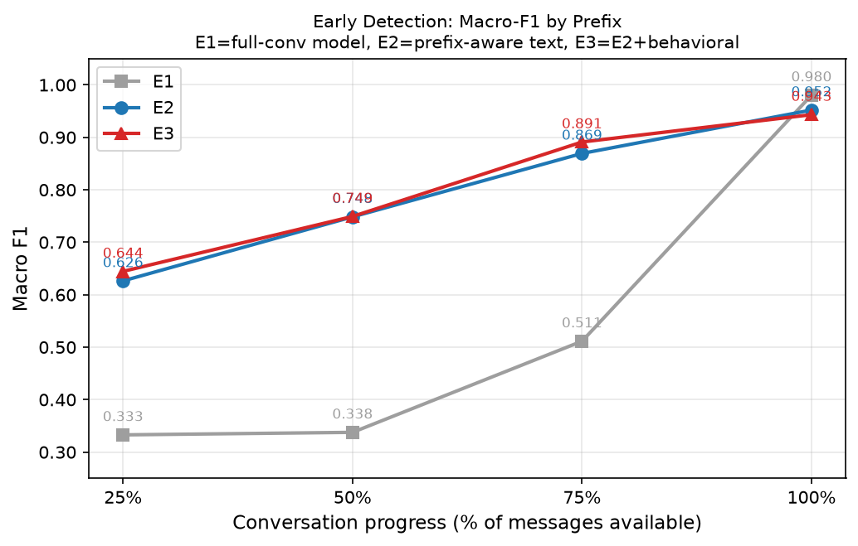
Figure 1. Macro-F1 vs. conversation prefix for E1, E2, and E3.

6.6 Statistical validation of E2 vs. E3
A paired bootstrap (10,000 resamples, seed 42) over the shared 459 test conversations and a paired McNemar exact test (Table 3) evaluate whether the E3 improvements in 6.5 are reliable. At 25%, the 95% CI for the delta is [-2.02, +5.88] pp (P(E3>E2) = 0.822); at 50%, [-2.94, +3.01] pp (P = 0.526, essentially a coin flip); at 75%, [+0.20, +4.36] pp — the only interval that excludes zero, though narrowly — (P = 0.981); at 100%, [-1.98, 0.00] pp, which excludes zero on the negative side (P(E3>E2) = 0.022, i.e., E2 is more likely to be better once the full conversation is available). McNemar p-values are 0.5052 (25%), 1.0000 (50%), 0.0639 (75%), and 0.2188 (100%) — none reach the conventional α = 0.05 threshold, though 75% comes closest. At 75%, E3 corrects 17 conversations that E2 got wrong while introducing 7 new errors, a net gain of 10 of 459 conversations — the most favorable point in the schedule, but still short of conventional significance.
Table 3. Paired bootstrap and McNemar statistics for E2 vs. E3 (test set, n = 459), plus per-prefix error counts.
Prefix | Δ E3−E2 (pp) | 95% Bootstrap CI (pp) | McNemar p | E3 fixes / regress. | Net
25% | +1.82 | [-2.02, +5.88] | 0.5052 | 44 / 37 | +7
50% | +0.08 | [-2.94, +3.01] | 1.0000 | 23 / 23 | 0
75% | +2.18 | [+0.20, +4.36] | 0.0639 | 17 / 7 | +10
100% | -0.88 | [-1.98, 0.00] | 0.2188 | 1 / 5 | -4
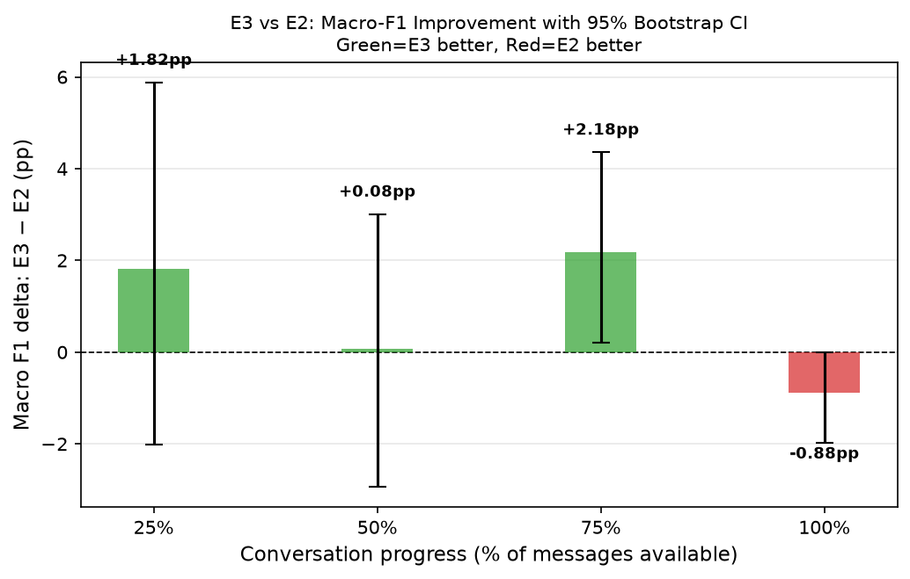
Figure 2. E3 − E2 macro-F1 delta with 95% bootstrap confidence intervals by prefix.
We therefore do not claim that behavioral features significantly improve early detection under the current test-set size. The evidence is directional: an improvement is observed at 25% and, most consistently, at 75% (bootstrap CI barely excludes zero; McNemar p closest to, but not below, 0.05), while at 50% the two models are statistically indistinguishable, and at 100% the observed direction reverses. This answers RQ4: explicit behavioral fusion provides modest, direction-consistent but not conclusively significant value specifically when textual evidence is incomplete, with the strongest — though still inconclusive — evidence at 75% observation; it provides no benefit, and possibly a small cost, once the full conversation is available. We can conclude that behavioral fusion does not universally help; we cannot conclude, at the current sample size, that it reliably helps at any single prefix.

6.7 Class-level error analysis of E2 vs. E3
Table 4 breaks the E3-vs-E2 comparison down by true label: the net gains are not evenly distributed across classes. On truly interested conversations, E3 nets +18/+7/+11 corrected conversations at 25/50/75% (0 at 100%); on truly losing_interest conversations, E3 is net-negative at every prefix (−11/−7/−1/−4). The aggregate macro-F1 gain in Section 6.5-6.6 is thus driven almost entirely by fixing false losing_interest predictions on conversations that were actually interested, while on genuinely disengaging conversations E3 introduces more new errors than it fixes at every prefix, a class-specific trade-off not apparent from aggregate macro-F1 alone. E3 is also usually more confident than E2 on its own new errors, not just its fixes: at 75%, mean confidence on E3's regressions (both classes combined) is 0.995 vs. E2's 0.749 on the same conversations, and losing_interest regressions specifically reach 0.94-1.00 mean E3 confidence at every prefix — an observed calibration pattern of confidently-wrong new errors on this class.
Table 4. E3 vs. E2 net outcome (fixes minus regressions) by true class and prefix (n = 459; 230 interested, 229 losing_interest), from existing E2/E3 prediction files, no retraining.
Prefix | Net (true = interested) | Net (true = losing_interest)
25% | +18 (32 fixes / 14 regr.) | −11 (12 fixes / 23 regr.)
50% | +7 (17 fixes / 10 regr.) | −7 (6 fixes / 13 regr.)
75% | +11 (14 fixes / 3 regr.) | −1 (3 fixes / 4 regr.)
100% | 0 (0 fixes / 0 regr.) | −4 (1 fixes / 5 regr.)

7. Discussion and Limitations
Taken together, the results support a more nuanced story than “behavioral features improve AlephBERT.” Behavioral dynamics alone carry real signal (65.07% macro-F1, far above a degenerate baseline), but once complete-conversation text is available, AlephBERT dominates and fusion adds nothing attributable to behavioral content — the ablation in Section 6.2 is decisive. Behavioral information plausibly matters most in the partial-observation regime, providing modest complementary signal beyond a prefix-aware text model, especially at 75%; but the 459-conversation test set lacks power to assert this beyond a directional trend, and Section 6.7 shows the gain is concentrated on one class. We frame behavioral fusion's value as observation- and class-dependent rather than universal.
Limitations. (1) The 459-conversation test set limits statistical power, especially per-prefix (E2/E3 disagreement as low as 23-61 conversations); a larger test set is needed to confirm the 75% effect. (2) The dataset is entirely synthetic, including the original 300-conversation seed; no real WhatsApp data was collected or used at any stage, so results may not transfer to noisier authentic conversations. (3) The task is strictly binary and specific to Hebrew sales conversations, so may not capture intermediate engagement states or generalize to other languages/domains. (4) Models used a single seed (though the split, classical models, and bootstrap fix seed 42 throughout); multi-seed replication and comparison against alternative design choices (e.g., a time-based prefix rule) are left to future work. (5) The Behavioral+Lexical baseline in Table 1 used 43 features (18 structural + 25 lexical, per that run's saved feature-name manifest) rather than the current 26 pure + 25 lexical = 51, predating the current feature set; this does not affect any other result in this paper. (6) The E3 gains are class-asymmetric (Section 6.7): driven almost entirely by correcting false losing_interest predictions on interested conversations, while fusion is net-negative on truly losing_interest conversations at every prefix — invisible in Table 2's macro-averaged numbers.

8. Conclusion
RQ1: both signals classify interest state effectively on complete conversations, with AlephBERT (96.95%) far exceeding behavioral-only (65.07%) and behavioral+lexical (86.69%) baselines. RQ2: a model trained only on complete conversations generalizes poorly to partial conversations (macro-F1 as low as ≈33% at 25-50% observation). RQ3: prefix-aware training substantially improves early detection (up to +41 pp at 50%) at a modest (≈2.8 pp) cost to full-conversation performance. RQ4: behavioral fusion on the prefix-aware model shows directional, class-asymmetric improvement, strongest at 75% (+2.18 pp, 95% CI barely excluding zero), but no prefix reaches significance under McNemar testing, and the gain is concentrated on correcting interested-class errors rather than improving disengagement detection (Section 6.7). Future work with a larger or real-world test set, multi-seed replication, and alternative prefix definitions could sharpen this picture; the present study supports an observation- and class-dependent, rather than universal, role for behavioral signals in early interest-loss detection.

References
Burdisso, S. G., Errecalde, M., & Montes-y-Gómez, M. (2019). A text classification framework for simple and effective early depression detection over social media streams. Expert Systems with Applications, 133, 182-197. arXiv:1905.08772.
Chang, J. P., & Danescu-Niculescu-Mizil, C. (2019). Trouble on the horizon: Forecasting the derailment of online conversations as they develop. In Proceedings of EMNLP-IJCNLP 2019, 4743-4754. arXiv:1909.01362.
Dulac-Arnold, G., Denoyer, L., & Gallinari, P. (2011). Text classification: A sequential reading approach. In Proceedings of the 33rd European Conference on Information Retrieval (ECIR 2011), 411-423. Springer.
Han, X., Xiao, Y., Wu, C., & Zhang, T. (2026). How early is early enough? Design-dependent observation-window sufficiency in subscription churn prediction. arXiv:2607.00473.
Meng, R., Yue, Z., & Glass, A. (2021). Predicting user engagement status for online evaluation of intelligent assistants. In Advances in Information Retrieval (ECIR 2021), 442-456. Springer. arXiv:2010.00656.
Mufti, M. J., Hammad, O., Saleh, H., & Gull, M. (2026). A rolling-window framework for churn prediction and behavioral driver identification. arXiv:2606.06776.
Nourbakhsh, E., Slavin, R., Yang, K., & Rios, A. (2026). TRACER: Early failure detection for task-oriented dialogue. In Proceedings of SIGDIAL 2026. arXiv:2607.03974.
Renault, A., Bondu, A., Cornuéjols, A., & Lemaire, V. (2024). Early classification of time series: A survey and benchmark. arXiv:2406.18332.
Seker, A., Bandel, E., Bareket, D., Brusilovsky, I., Greenfeld, R., & Tsarfaty, R. (2022). AlephBERT: Language model pre-training and evaluation from sub-word to sentence level. In Proceedings of the 60th Annual Meeting of the Association for Computational Linguistics (ACL 2022), Volume 1, 46-56.
Shalumov, V., & Haskey, H. (2023). HeRo: RoBERTa and Longformer Hebrew language models. arXiv:2304.11077.
Song, C., Tu, C., Yang, C., Liu, Z., & Sun, M. (2019). CED: Credible early detection of social media rumors. IEEE Transactions on Knowledge and Data Engineering. arXiv:1811.04175.

