**What this code will print?**

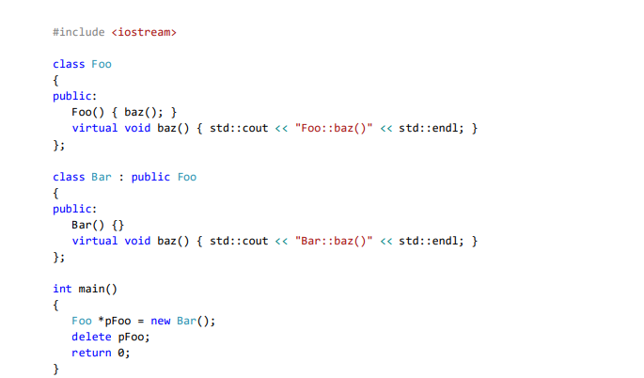

**The code will print:***Foo:baz()*

**Why?**

These are the lines that will be printed to the screen because the constructor of Bar triggers the constructor of Foo in the building of pFoo object.

The fact the baz is virtual not cause the baz of Bar to be called because the its called from inside the constructor of foo.  
If we call baz on the pFoo the baz of bar will be called because of the nature of virtual function in cpp.

Zohar Franco  
322892407