# Machine Learning – Task 3

## Submitters

* Ron Asual 208573139
* Zohar Simhon 211871868
* Git: <https://github.com/ZoharSimhon/Decision-Tree>

## Dataset Description

Using a dataset (vectors.txt) containing binary vectors where each row represents a data point, and the last column represents the class label (0 or 1).

## Brute Force Implementation

* **Optimized Brute Force Method**: A recursive approach with caching to explore all possible splits.
* **Methods**:
  + Recursive tree-building with caching to optimize performance.
  + Suitable for datasets with moderate size due to its exhaustive search approach.
* **Results:**
  + For k=3: success rate 80.00%
  + For k=4: success rate 91.33%
* 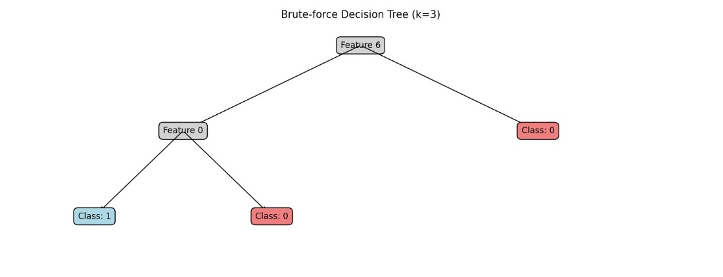**The Decision Tree:**

## Binary Entropy Implementation

* **Binary Entropy Method**: A heuristic approach based on minimizing binary entropy to determine feature splits.
* **Methods**:
  + Heuristic-based approach using binary entropy to determine optimal splits.
  + Generally faster but may sacrifice accuracy compared to brute force for complex datasets.
* **Results:**
  + For k=3: success rate 57.33%
  + For k=4: success rate 60.67%
* תמונה שמכילה טקסט, תרשים, קו, עיצוב

  התיאור נוצר באופן אוטומטי**The Decision Tree:**