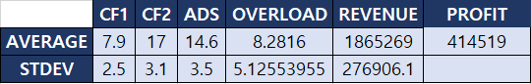

We ran the simulation with the rate of costumers they’ve had during 2018 with the labor constraints and measured average overload for the company. That is, how many customers will they not be able to take due to overload in labor. To maximize the annual revenue, the company needs to reduce overload. If we incorporate the labor constraints to our simulator with the same rate of customers from 2018, we get that there will be on average of 8 overloads (this is based on 1000 simulations) for each year..



(this table represents how many of each worker is available on average every month)

To minimize the overload, we want to come up with a strategy on hiring the right type of person. Using the simulator, we generate average available number of workers per month. In this case, since developer and copywriter seem to be the busiest, we tried simulating company revenue after hiring 1 developer and 1 copywriter. Annual cost of hiring both of them sums adds to $81,600; however, by taking this action, with the rate of clients they had during 2018, this would ultimately increase their annual revenue to $2,128,750 and profit to $596,440 and gives a more balances workload for each people.



