EMPLOYEE ATTRITION & RETENTION
Employee Attrition & Retention Intelligence
A Data Analytics Investigation Using the IBM HR Dataset

Prepared by: Zohra Sayyed Abed Ali
AICTE | IBM SkillsBuild Data Analytics with AI Internship 2026
September 2026

Table of Contents
1. Introduction
2. Dataset
3. Data Cleaning & Preprocessing
4. Exploratory Analysis & Attrition Drivers
5. High-Risk Compound Segment
6. Predictive Modelling — Logistic Regression
7. Business Recommendations
8. Limitations
9. Conclusion
10. References
Appendix A — Data Dictionary
Appendix B — Dashboard Screenshots

1. Introduction
1.1 Background
Employee attrition — the rate at which employees leave an organisation — is one of the most controllable and costly problems a business faces. Replacing an employee typically costs a significant multiple of their annual salary once recruitment, onboarding, and lost productivity are accounted for. Despite this, many organisations respond to attrition reactively rather than using available data to anticipate and prevent it.
1.2 Objectives
This project investigates the following questions using the IBM HR Analytics dataset:
- Which factors are most strongly associated with employees leaving?
- Do certain combinations of factors create disproportionate risk?
- Can a simple, explainable statistical model confirm and rank these drivers?
- What concrete, actionable recommendations can be made to management?
1.3 Scope and Constraints
This analysis is descriptive and diagnostic (explaining what is happening and why), not purely predictive. Given a two-day project timeline, the scope was deliberately kept focused: one well-understood dataset, a small set of meaningful KPIs, and one explainable model — in line with the guidance that project quality is judged by clarity of business thinking, not technical complexity.
2. Dataset
2.1 Source and Description
Dataset: IBM HR Analytics Employee Attrition & Performance
Source: Kaggle (uploaded by pavansubhasht) — https://www.kaggle.com/datasets/pavansubhasht/ibm-hr-analytics-attrition-dataset
This is a fictional dataset created by IBM's own data science team specifically for analytics practice. It contains 1,470 employee records across 35 original attributes, including demographic details, compensation, job role, satisfaction scores, and tenure information.
2.2 Key Features Relevant to This Investigation
- Demographic & role: Age, Department, JobRole, JobLevel, MaritalStatus
- Compensation: MonthlyIncome, PercentSalaryHike, StockOptionLevel
- Work conditions: OverTime, BusinessTravel, DistanceFromHome
- Satisfaction: JobSatisfaction, EnvironmentSatisfaction, WorkLifeBalance
- Tenure: YearsAtCompany, YearsInCurrentRole, TotalWorkingYears
2.3 Ethical Note
Because this dataset is synthetically generated, it contains no real individuals and raises no personal privacy concerns. Its use here is for analytical practice and demonstration of methodology; the same approach could be applied to a real organisation's data under appropriate data governance.
3. Data Cleaning & Preprocessing
3.1 Columns Dropped
Four columns were removed prior to analysis, as they carried zero analytical information:
- EmployeeCount — identical value for every row
- StandardHours — identical value for every row
- Over18 — identical value for every row
- EmployeeNumber — a unique identifier, not a behavioural or demographic attribute
3.2 Target Variable Engineering
A binary column, Left, was created from the original Attrition field (Yes = 1, No = 0) to simplify calculations across the analysis.
3.3 Data Quality Checks
The dataset was checked for missing values, duplicate rows, and invalid numeric ranges (e.g. negative income or age). None were found. This is expected given the dataset's curated, synthetic origin, and it allowed analytical effort to focus on deriving insight rather than repairing data.
4. Exploratory Analysis & Attrition Drivers
4.1 Overall Key Performance Indicators
TOTAL EMPLOYEES  1,470 | OVERALL ATTRITION RATE  16.1% | EMPLOYEES WHO LEFT  237

KEY FINDING: 16.1% company-wide attrition (237 of 1,470 employees) sets the baseline against which every driver and segment below is compared.

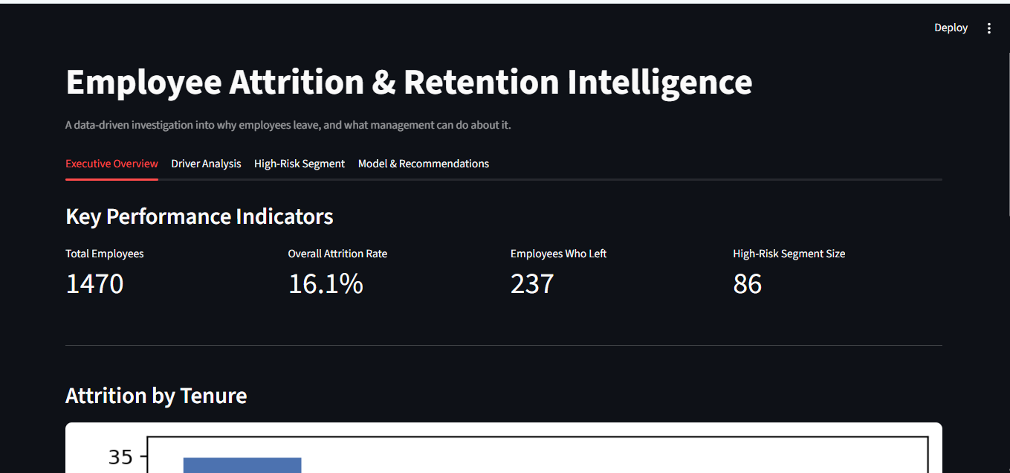
Figure 1 — Executive Overview tab of the dashboard, showing top-level KPIs.
4.2 Overtime
Employees who work overtime leave at nearly three times the rate of those who don't — 30.5% compared to 10.4%. This is the single strongest individual driver found in the dataset.
4.3 Income
Employees in the lowest income quartile leave at 29.3%, compared to roughly 10–14% across the top three quartiles. This suggests relative underpayment — being paid noticeably less than peers — is a stronger signal than low pay in isolation.
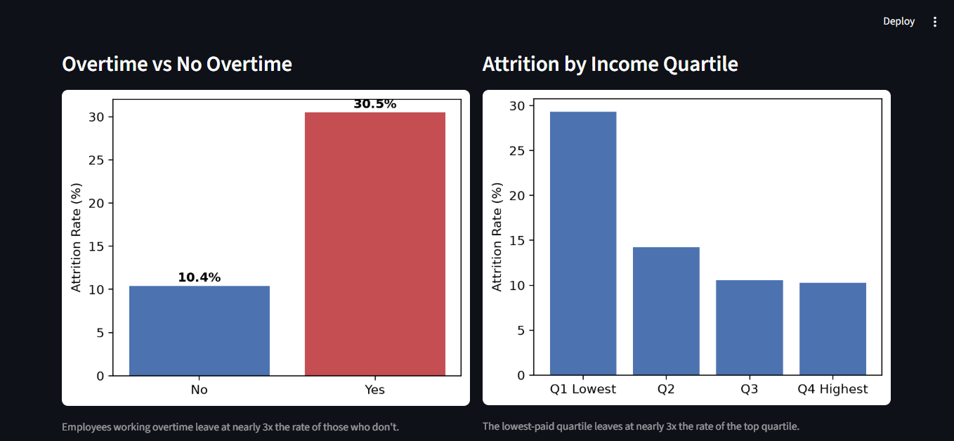
Figure 2 — Attrition rate by overtime status and by income quartile.
4.4 Job Role
Attrition is heavily concentrated by role. Sales Representatives show the highest attrition of any role at 39.8%, followed by Laboratory Technicians (23.9%) and Human Resources (23.1%). In contrast, Research Directors and Managers show attrition below 5%.
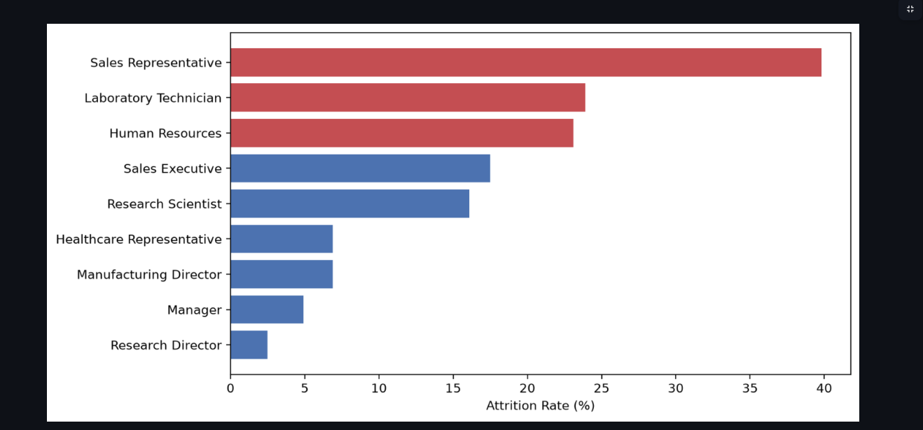
Figure 3 — Attrition rate by job role, sorted from highest to lowest.
4.5 Tenure
Attrition risk is heavily front-loaded: employees in their first year show a 34.9% attrition rate, falling steadily to 8.1% for employees with 10 or more years of tenure. This pattern reflects risk across the employee lifecycle rather than a change over calendar time, since the dataset is a single snapshot rather than multi-year tracking data.
5. High-Risk Compound Segment
5.1 Segment Definition
The individual drivers above were combined to test whether specific employees carry compounded risk. The segment was defined as employees who simultaneously: work overtime, have three years or less of tenure, and hold an entry-level position (Job Level 1).
5.2 Results
SEGMENT SIZE  86 (5.8%) | SEGMENT ATTRITION RATE  59.3% | COMPANY AVERAGE  16.1%

5.3 Disproportionate Impact
Of the 237 employees who left the company, 51 (21.5%) came from this single 86-person group — meaning just 5.8% of the workforce accounts for over a fifth of all attrition.
KEY FINDING: 86 employees (5.8% of the workforce) account for 21.5% of all attrition — the single highest-leverage group for a targeted retention intervention.

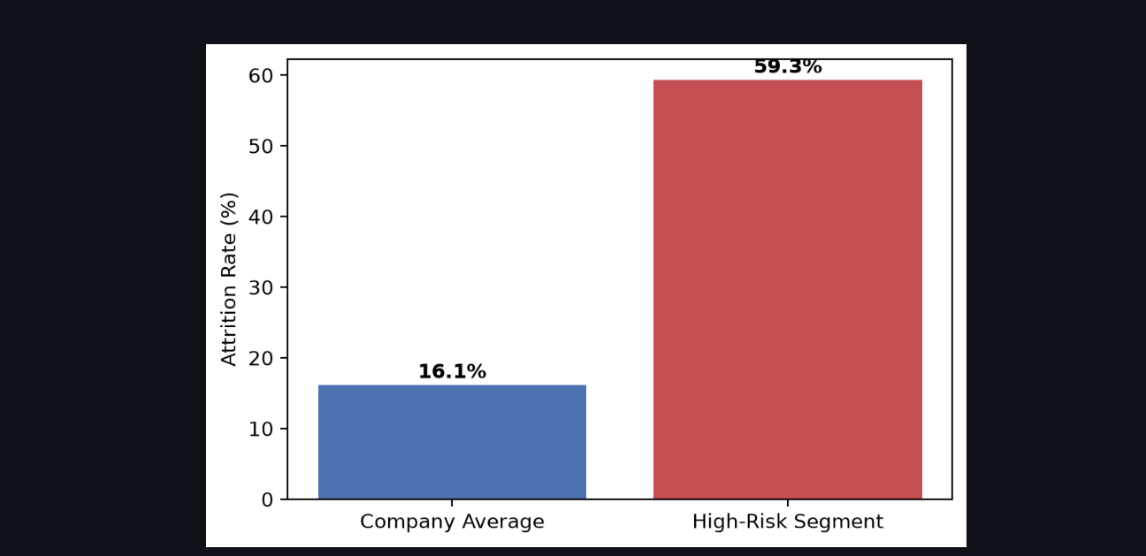
Figure 4 — Attrition rate: company average vs. the high-risk compound segment.
5.4 Business Significance
This finding reframes the retention problem from a broad, company-wide issue into a narrow, addressable one. Rather than a generic retention initiative, management can direct resources toward a specific, identifiable group with a very high concentration of risk — a far more efficient use of intervention budget and attention.
6. Predictive Modelling — Logistic Regression
6.1 Model Choice Rationale
Logistic Regression was selected specifically for its explainability. Since the goal of this project is to help management understand and act on drivers of attrition, a model whose coefficients can be directly interpreted is more valuable here than a more complex model that might achieve marginally higher accuracy at the cost of transparency.
6.2 – 6.4 Methodology
- Categorical variables were one-hot encoded; numeric features were standardised using StandardScaler.
- Data was split 75% train / 25% test, using stratified sampling to preserve the attrition rate in both sets, with a fixed random seed (random_state=42) for reproducibility.
- Because only ~16% of employees left, class_weight="balanced" was used so the model does not simply default to predicting "stays" for everyone.
6.5 Results
ACCURACY  77.7% | RECALL  64.4% | PRECISION  38.4% | F1 SCORE  48.1%

KEY FINDING: The model independently confirms the drivers found through direct analysis — Recall of 64.4% means nearly two-thirds of actual leavers would have been correctly flagged in advance.

Recall is the most business-relevant metric here: of all employees who genuinely left, the model correctly flagged 64.4% of them in advance. Precision is lower (38.4%), meaning the model over-flags some employees who ultimately stayed — an acceptable trade-off for a retention-screening tool, where missing a true leaver is costlier than a false alarm.
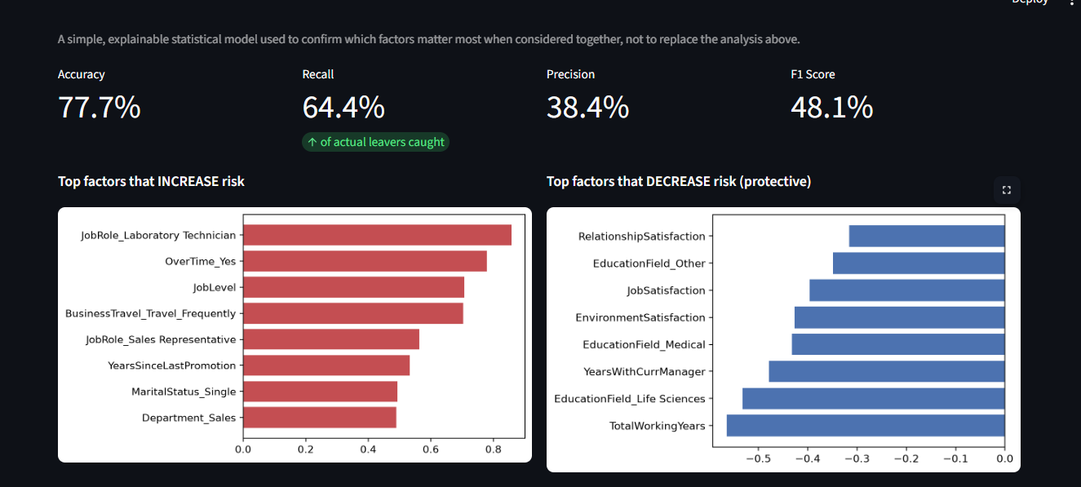
Figure 5 — Model performance metrics and top risk-increasing / protective factors.
6.6 Top Coefficients
The model independently confirmed several drivers already found through exploratory analysis — overtime, frequent travel, and Sales roles all appear among the top risk-increasing factors. It also surfaced Laboratory Technician as a notable risk factor once other variables are controlled for, worth flagging for further HR investigation. Protective factors include long tenure with a current manager, higher satisfaction scores, and greater total working experience.
6.7 Role of the Model
This model is used as a confirmation and ranking layer on top of the exploratory analysis, not as a replacement for it. Its purpose is to validate that the drivers identified through direct comparison remain significant when considered together, not to serve as a standalone forecasting tool for individual employees.
7. Business Recommendations
- Monitor and cap overtime for new, entry-level employees — this group drives disproportionate attrition; a workload review here likely has the highest return on investment of any single intervention.
- Audit the Sales Representative role — investigate whether workload, incentive structure, or role design is driving nearly 4 in 10 Sales Representatives to leave.
- Extend stock option eligibility earlier, especially to entry-level staff — the data shows a clear link between having any stock options and staying longer.
- Review bottom-quartile pay bands — being underpaid relative to peers tracks more closely with attrition than low pay in isolation.
- Formalise a first-3-year retention check-in programme — since risk is heavily front-loaded, early intervention has the greatest potential impact.
8. Limitations
- Correlation, not causation — findings show statistical association; no causal claim can be made without a controlled study.
- Fictional dataset — results should not be generalised to a real organisation without validation on real HR data.
- Static snapshot — the data has no timestamps beyond tenure fields, so trends over calendar time cannot be tracked.
- Class imbalance — only ~16% of employees left, which naturally limits precision even with balancing applied.
- Single model — Logistic Regression was chosen for explainability; a more complex ensemble model might predict marginally better but would be harder to interpret for business use.
- No demographic deep-dive — age and gender fields exist but were not the primary focus of this investigation; they may warrant separate, careful follow-up analysis.
9. Conclusion
This project set out to understand why employees leave and to translate that understanding into concrete action. The clearest finding is that attrition is not evenly spread across the workforce: a small, well-defined group — new, entry-level employees working overtime — carries nearly four times the average attrition risk and accounts for more than a fifth of all departures. This gives management a specific, high-leverage starting point rather than a vague company-wide concern.
Suggested next steps for an organisation acting on this analysis would include validating these patterns against real internal HR data, and running a small A/B test on one intervention (for example, an overtime cap for the identified high-risk segment) to measure its actual effect on retention before wider rollout.
10. References
- Dataset: IBM HR Analytics Employee Attrition & Performance, Kaggle (pavansubhasht).
- scikit-learn documentation — https://scikit-learn.org/
- Streamlit documentation — https://docs.streamlit.io/
Appendix A — Data Dictionary (Key Columns Used)
- Attrition / Left — whether the employee has left the company (target variable)
- OverTime — whether the employee regularly works overtime (Yes/No)
- MonthlyIncome — employee's monthly salary
- YearsAtCompany — tenure in years at the current company
- JobLevel — seniority level, 1 (entry) to 5 (executive)
- JobRole — specific job title / function
- BusinessTravel — frequency of work-related travel
- StockOptionLevel — level of stock options granted, 0 (none) to 3 (highest)
- MaritalStatus — Single, Married, or Divorced
- DistanceFromHome — commute distance in miles
Appendix B — Dashboard Screenshots
The screenshots below are preview captures from the live, interactive Streamlit dashboard (attrition_dashboard.py). Each tab's content is taller than a single screen, so two sequential screenshots — top and continued — are shown per tab to capture the complete tab without cropping mid-chart. These are not a single combined screenshot.
B.1 — Executive Overview Tab
Part 1 of 2 — Executive Overview (top)
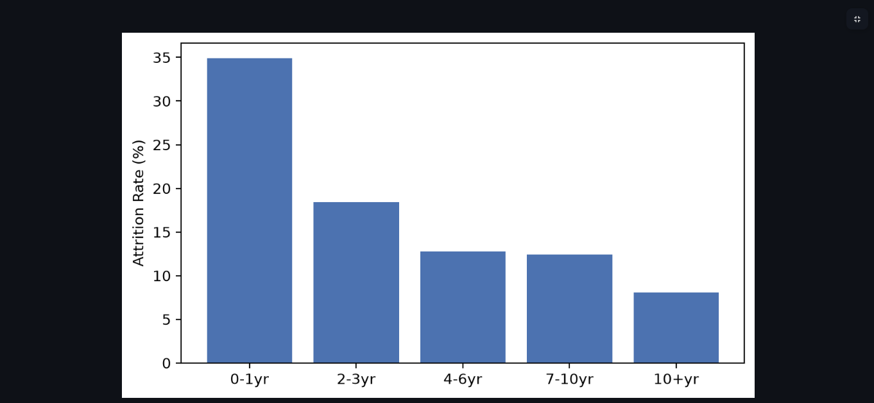
Part 2 of 2 — Executive Overview (continued)
B.2 — Driver Analysis Tab
Part 1 of 2 — Driver Analysis (top)
Part 2 of 2 — Driver Analysis (continued)
B.3 — High-Risk Segment Tab
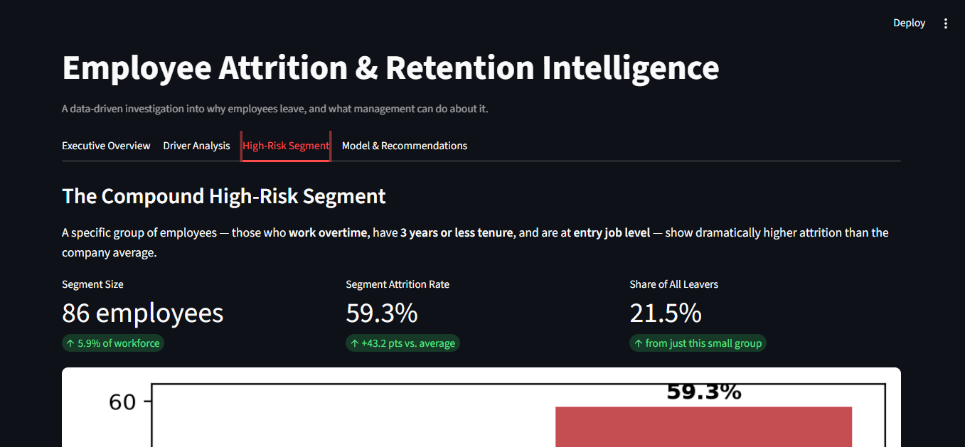
Part 1 of 2 — High-Risk Segment (top)
Part 2 of 2 — High-Risk Segment (continued)
B.4 — Model & Recommendations Tab
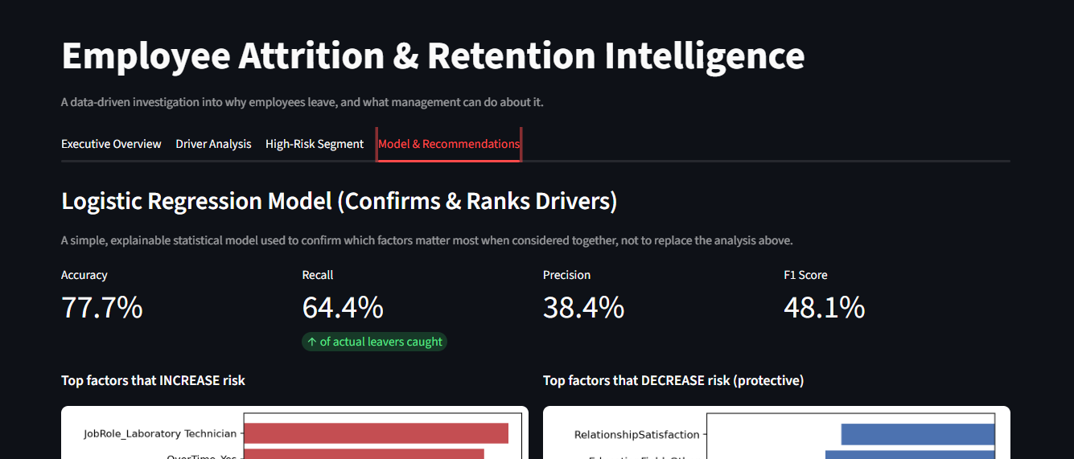
Part 1 of 2 — Model & Recommendations (top)
Part 2 of 2 — Model & Recommendations (continued)

