Space-for-time validation of M' against the National Biomass Library
Validation_M/National_biomass_library/Space_time_validation · generated 2026-09-21 · M' with every component of the ratio produced by the random forest · averaging order: Eq. (1) of the mean FPI (the method)

The test
Each National Biomass Library site has an observed above-ground biomass and a historical climate. Find the future grid cell whose FPI predictors most closely resemble that site's historical predictors, and check whether the M' projected for that cell matches the biomass the site actually carries. If it does, the chain climate → FPI → Eq. (1) → λ is transporting a climate signal correctly rather than interpolating inside the range it was fitted on.
Two dataframes, as specified. Dataframe 1 is the reference table: one row per NBL site, restricted to mature vegetation with good data, carrying X, Y and all 174 predictors that feed FPI at that location — 83 soil bands and 91 climate features on the 1985-2014 climatology. Dataframe 2 is the future table: one row per future grid cell with the same columns, built once per scenario-window, plus the M' projected there. A ninth table repeats the exercise on the historical climate, which supplies the standardisation, the principal components and the first control.

What this can and cannot show
M is the maximum biomass a mature undisturbed stand attains; an observed AGB is one stand at one moment. For any stand short of its maximum, observed < M. The filtering removes the worst of that — production estates, plantings, stands with high dead basal area, small plots — but the library records no stand age, so it cannot be removed entirely. The asymmetry that follows is the key to reading every number below: M' above the observation is expected and is weak evidence of a problem, while M' below the observation cannot be explained by immaturity and is the stronger signal.
There is also a circularity to name. λ is DCCEEW's Revised_M_Roxburgh ÷ Original_M_2004, and Revised_M_Roxburgh is itself the output of a random forest fitted to NBL plots. Sites in that fit are not independent of M', so this is a consistency check on the transport of a climate signal, not an independent validation of the level. The present-day control below is where that shows up most directly.

Dataframe 1 — the reference table
filter | surviving
all site visits | 15,904
biomass recorded and positive | 13,599
live basal area recorded | 13,580
dead basal area under 20% of total | 11,189
production estates removed | 4,482
planted projects removed | 4,297
measured 1985 or later | 3,778
sampled area at least 0.05 ha | 3,399
biomass at most 1500 Mg/ha | 3,319
one row per site (maximum measurement) | 2,121
inside the NLUM mask with M' and FPI | 2,120

Maturity is assigned from the tree-level table, since the site table carries no age or disturbance field: a site with at least one stem ≥ 50 cm DBH is verified mature, a largest stem of 30-50 cm is likely mature, below that is young or shrubby, and a site with no stems listed is unverified. The headline sample is verified + likely mature.
maturity class | sites | median AGB (Mg/ha) | median M' today | median FPI
likely mature | 279 | 102.96 | 36.71 | 5.42
unverified | 1274 | 62.68 | 139.52 | 7.42
verified mature | 409 | 70.21 | 77.66 | 7.08
young or shrubby | 158 | 80.18 | 34.88 | 6.01

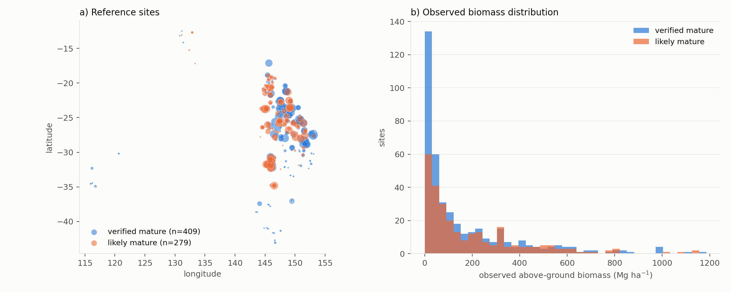
Figure 1. The reference sites: where they are, and what they carry.

The match
All 174 predictors are standardised by the historical land-cell mean and standard deviation, so the reference and the future sit in one comparable space, then projected onto the principal components of that same historical sample. PCA is not cosmetic: the raw predictors are strongly collinear — twelve monthly temperatures move together — so plain Euclidean distance would count one physical signal a dozen times and let 83 soil columns outvote the climate. Each site is then matched to its nearest future cell in that space with a k-d tree.
A site whose nearest future cell is further away than historical cells typically are from each other (the 99th percentile of within-historical nearest-neighbour distance) is flagged as having no analogue and is reported separately rather than silently matched. Forcing a match onto a climate the future does not contain would manufacture agreement or disagreement out of nothing.
run | no analogue | sites
present-day analogue | 5.1% | 688
random cells (null) | 0.0% | 688
the same cell, Eq. (1) footing | 0.0% | 688
SSP126 2035-2064 | 9.6% | 688
SSP126 2070-2099 | 12.4% | 688
SSP245 2035-2064 | 11.0% | 688
SSP245 2070-2099 | 55.8% | 688
SSP370 2035-2064 | 15.1% | 688
SSP370 2070-2099 | 90.0% | 688
SSP585 2035-2064 | 21.2% | 688
SSP585 2070-2099 | 97.7% | 688

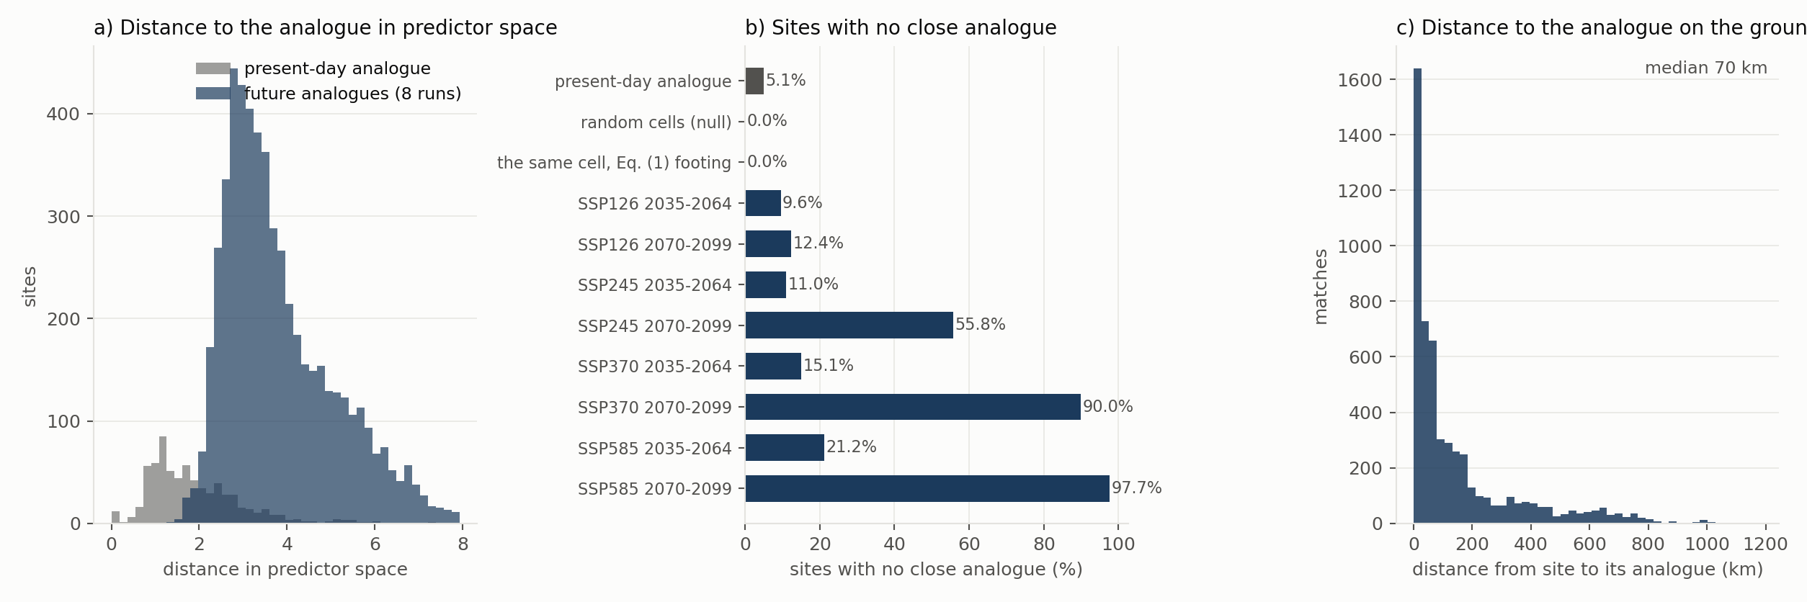
Figure 3. Match quality: how close the analogue is in predictor space, how often the future has no counterpart at all, and how far away on the ground the analogue sits.

The statistics, and why each is here
statistic | definition | what it is for
median ratio | median of M' ÷ observed AGB | the headline. Above 1 is expected; how far above is the question
bootstrap interval | 2.5-97.5 percentile of the median ratio | whether a difference between runs is worth discussing
Spearman ρ | rank correlation | does the projection rank sites correctly, independently of level
Pearson r / R² | linear correlation, variance explained | level-sensitive; read with the ratio, never alone
R² in logs | R² on log(AGB) vs log(M') | biomass spans three orders of magnitude; in logs every site counts, not only the largest
RMSE, MAE | error in Mg ha⁻¹ | absolute size of the disagreement; RMSE is dominated by big sites
MdAPE | median |ratio − 1| as a percentage | a robust relative error
Lin's CCC | concordance with the 1:1 line | penalises both poor correlation and systematic offset
Theil-Sen slope | robust slope of M' on AGB | whether the two scale together, resistant to outliers
% within 2× | share with 0.5 < ratio < 2 | a plain-language accuracy statement
match distance | distance in the PCA space | how good the analogue was; a large value weakens everything else

Results

The present-day gate
Before any climate analogue, M' at each site's own cell today against the biomass measured there: median ratio 0.61 (95% CI 0.53-0.74), Spearman ρ 0.15, 30% of sites within a factor of two, n = 688. M' sits below observed biomass at the median, which immaturity cannot explain and which needs investigating before the space-for-time result is used.
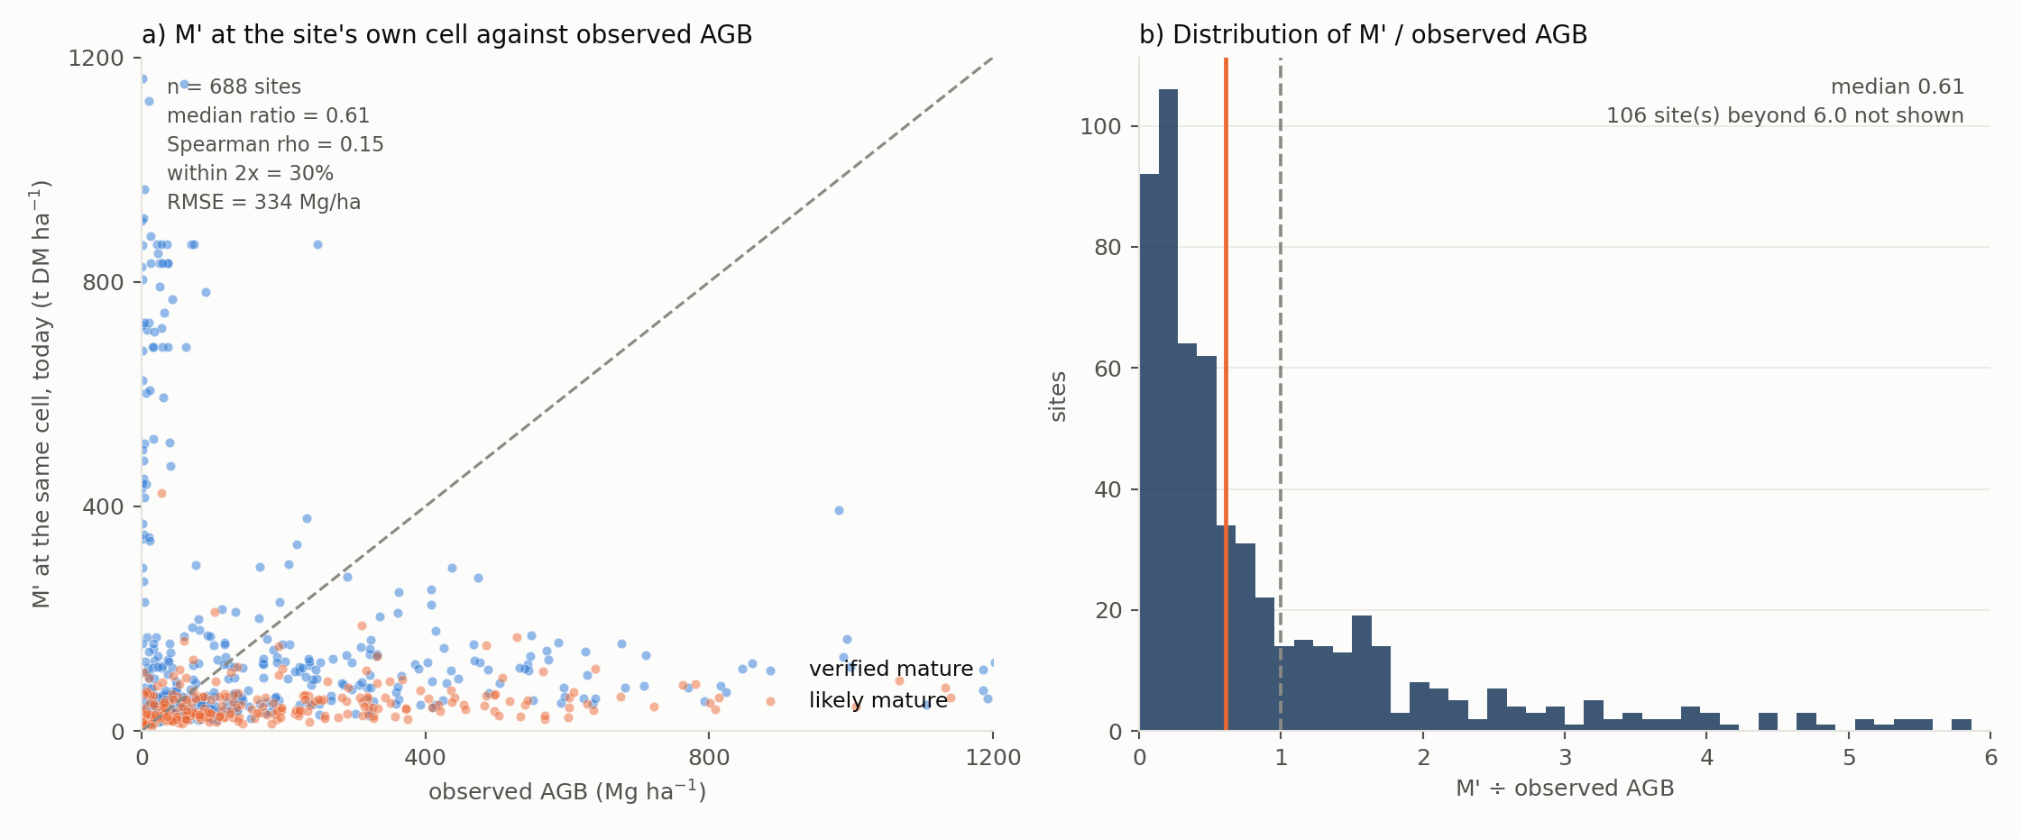
Figure 2. The present-day gate. Left: observed AGB against M' at the same cell, linear axes clipped just above the bulk of the data, 1:1 dashed, with n, median ratio, Spearman rho, the share within a factor of two and RMSE on the panel. Right: the distribution of the ratio, cut at 6 with the number of sites beyond it stated.
How much of that is the footing? Evaluating Eq. (1) on the same modelled FPI at the same cells — the unmatched, Eq. (1) footing — gives a median ratio of 1.21 against 0.61 on the matched footing, a factor of 1.99 between them. The two footings therefore straddle the observations: Eq. (1) M sits above observed mature biomass, which is the direction a maximum should err in, while λ × Original_M_2004 sits below it, which immaturity cannot explain. Rank agreement is poor either way (Spearman ρ -0.02 and 0.15), so the choice of footing moves the level and neither footing reproduces the ranking of these sites.
That is a finding about the footing decision, not about climate change, and it belongs beside the footing memo rather than in the projection. It does not favour one footing on its own: the NBL sample is a filtered mature subset with a median of 83 Mg ha⁻¹, well above the domain median, so a layer calibrated to the whole continent is expected to sit below it.

Controls
Three runs bracket what the method can do before any future is involved. Matching a site to a present-day analogue gives a median ratio of 0.64 — this is the matching method's own error, and the future runs should be read against it rather than against 1. Random cells give 0.59, which is the floor any real skill has to beat.

The eight scenario-windows
scenario | window | n | median ratio | 95% CI | Spearman ρ | R² (logs) | % within 2×
SSP126 | 2035-2064 | 622 | 0.61 | 0.50-0.76 | 0.07 | -0.36 | 27
SSP245 | 2035-2064 | 612 | 0.61 | 0.50-0.75 | 0.07 | -0.33 | 27
SSP370 | 2035-2064 | 584 | 0.61 | 0.50-0.74 | 0.07 | -0.32 | 28
SSP585 | 2035-2064 | 542 | 0.55 | 0.44-0.68 | 0.07 | -0.31 | 27
SSP126 | 2070-2099 | 603 | 0.56 | 0.48-0.67 | 0.04 | -0.37 | 26
SSP245 | 2070-2099 | 304 | 0.42 | 0.33-0.57 | 0.23 | -0.12 | 24
SSP370 | 2070-2099 | 69 | 0.67 | 0.33-1.12 | 0.01 | -0.23 | 35
SSP585 | 2070-2099 | 16 | 0.78 | 0.34-1.42 | 0.48 | 0.31 | 38

Across the eight runs the median ratio spans 0.42 to 0.78 and Spearman ρ 0.01 to 0.48. At least one run does not beat the random-cell control, which means the matching adds nothing there and the result should not be quoted as skill.
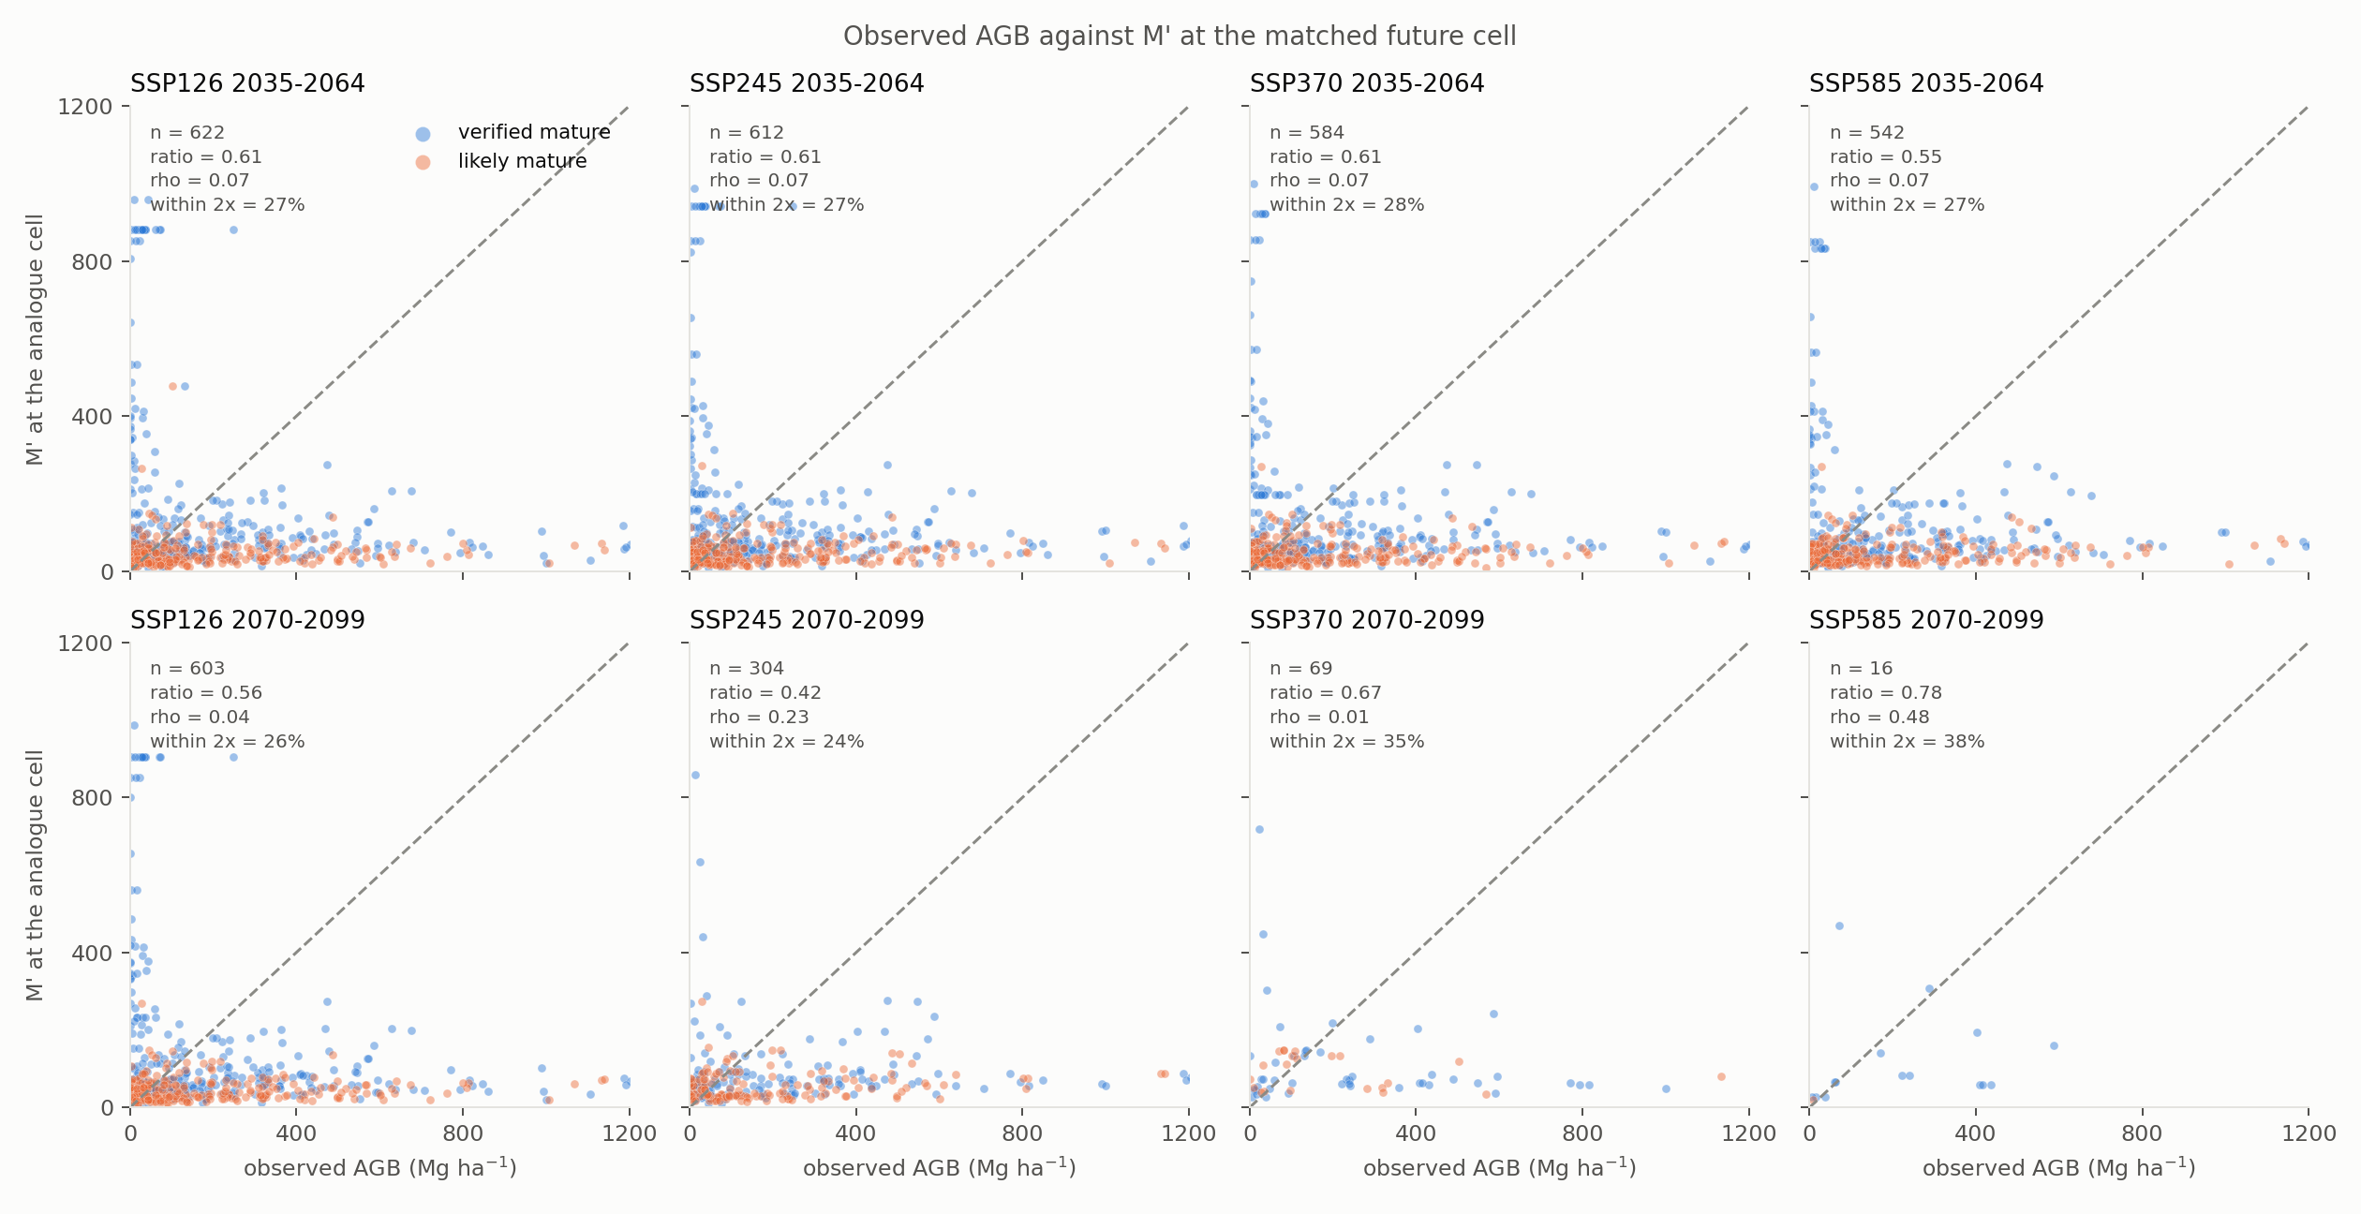
Figure 4. Observed AGB against the M' projected for each site's future climate analogue, one panel per scenario-window. Each panel carries n, the median ratio, Spearman rho and the share within a factor of two for that run; the same numbers, with the rest of the statistics, are in the tables above.
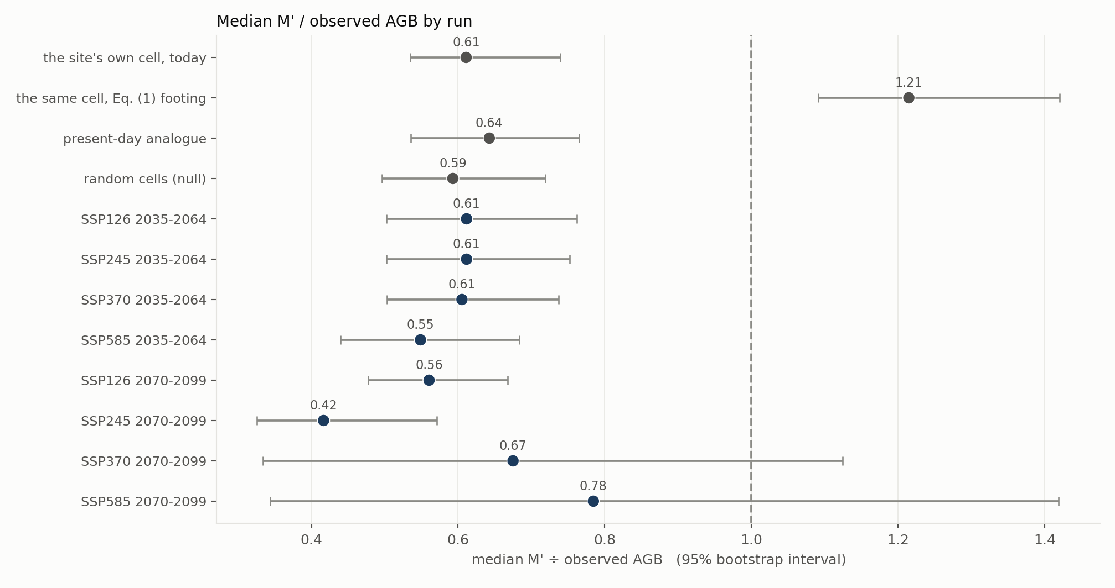
Figure 5. Median ratio with its bootstrap interval, controls in grey. This is the summary figure of the whole analysis.
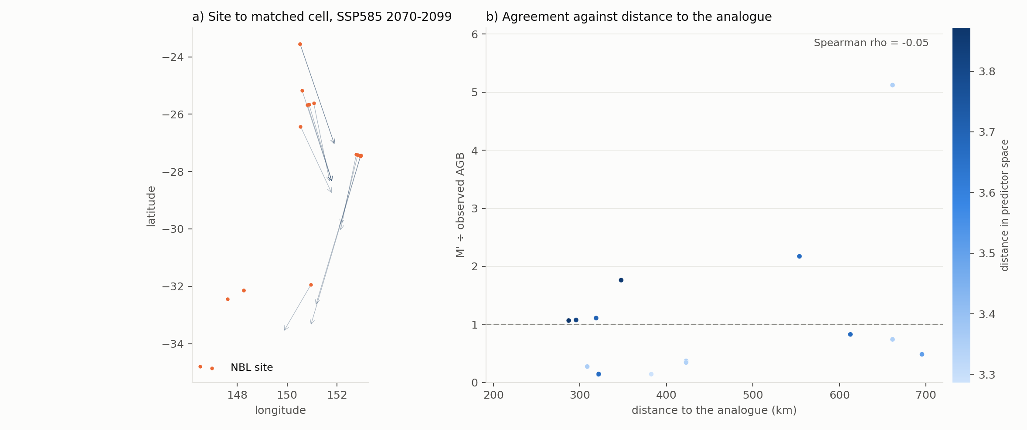
Figure 6. Where the analogues are, and whether a more distant analogue agrees less well. Panel (b) carries the Spearman correlation between the distance to the analogue and the ratio, which is the question it asks.

What the vegetation constraint changed
Running the same analysis without the NVIS constraint is instructive, and not in the direction one would hope. The random-cell null rises from 0.27 unconstrained to 0.59 once random means "a random cell of the same vegetation type" — because knowing the vegetation subgroup is itself most of what is needed to guess the biomass. Against that stronger null the eight future runs (0.42 to 0.78) are barely distinguishable: on this sample the climate matching adds little beyond the vegetation class.
That is the most useful thing this test has produced. It does not say the projection is wrong; it says this particular comparison cannot tell a correct projection from an incorrect one, because the observable it is judged against is dominated by vegetation type and by plot-scale variation rather than by climate. A test with power would need either stands whose biomass is known to be at its maximum, or an observable aggregated to the scale M' is defined on.

The other averaging order
M' exists in two averaging orders, and both have a random-forest historical denominator. This report validates the one built as the Eq. (1) of the mean FPI (the method); the other is built as the mean of the annual Eq. (1) M. Eq. (1) is convex, so the two are not the same layer — at the M level the gap is about 3%, and against Revised_M_Roxburgh it is the difference between ×0.944 and ×0.991. The question here is whether it changes the validation.
run | n | this order | other order | difference
present-day analogue | 653 | 0.643 | 0.643 | +0.00%
random cells (null) | 688 | 0.593 | 0.593 | +0.00%
SSP126 2035-2064 | 622 | 0.612 | 0.612 | +0.00%
SSP245 2035-2064 | 612 | 0.612 | 0.612 | +0.00%
SSP370 2035-2064 | 584 | 0.605 | 0.605 | +0.00%
SSP585 2035-2064 | 542 | 0.549 | 0.549 | +0.00%
SSP126 2070-2099 | 603 | 0.560 | 0.560 | +0.00%
SSP245 2070-2099 | 304 | 0.416 | 0.416 | +0.00%
SSP370 2070-2099 | 69 | 0.675 | 0.675 | +0.00%
SSP585 2070-2099 | 16 | 0.785 | 0.785 | +0.00%

The largest disagreement between the two orders is 0.00% of the median ratio, and the two controls are identical to four decimal places. That is the expected result and it is worth stating explicitly: the Jensen gap enters the numerator and the denominator in the same direction, so once both sides of the ratio are built in the same order it very largely cancels. The averaging order therefore still matters for the headline change against Revised_M_Roxburgh — where only the numerator carries it — but it does not move this validation at all, and no conclusion here rests on the choice.
The controls are identical for a structural reason, not a coincidence: averaged over the 30 historical years, both orders collapse to λ × Original_M_2004, which is Revised_M_Roxburgh. The present-day gate cannot distinguish them.

By maturity class
maturity | sites (median) | median ratio | Spearman ρ
likely mature | 279 | 0.39 | 0.14
verified mature | 409 | 0.92 | -0.04

Verified mature sites are the ones the test is really about: they are the closest thing the library has to a stand at its maximum, so their ratio is the least contaminated by immaturity.

Sensitivity: matching on climate alone
Soil does not change between now and 2100, so including its 83 columns mostly constrains the analogue to sit on similar soil — desirable, but not what is being validated. Repeating the match on the 91 climate columns alone gives a median ratio of 0.43 to 0.68 across the eight runs, against 0.42 to 0.78 with soil included. The two agree closely, so the conclusion does not rest on the choice.

What to conclude, and what not to
The honest headline is that the present-day gate does not pass. At the site's own cell, M' is 0.61 times the observed biomass at the median and ranks the sites barely better than chance (Spearman ρ 0.15 against 0.04 for random cells; R² in logs is negative). Everything downstream inherits that, so the eight scenario-window numbers below should be read as a description of how the matching behaves, not as evidence that M' predicts biomass at a point.
Three reasons that outcome is not, on its own, a verdict on the projection. A 1 km cell's M' is the potential of the whole cell while an NBL plot is a fraction of a hectare inside it, and the two are not the same quantity. The library records no stand age, so the sample still contains stands well short of their maximum. And no vegetation constraint was available when the plan was written — two cells can share a climate and a soil and carry different vegetation — although with the NVIS constraint in place that objection is now answered. What the test does establish is the ordering of the controls, and that ordering is informative in itself.
- Read the future runs against the present-day-analogue control, not against perfect agreement. The control carries the matching method's own error; only the difference between it and a future run is attributable to the projection.
- A ratio above 1 is the expected direction. M' is a maximum and the library records stands of unknown age, so some over-prediction is built in. Under-prediction is the finding that would matter.
- The absolute level is anchored, not tested. λ × Original_M_2004 is Revised_M_Roxburgh, which came from a random forest fitted to NBL plots, so agreement in level is partly circular. What is genuinely tested here is whether the projected climate change moves M' in a way consistent with the biomass observed under comparable climates today.
- The vegetation constraint is applied, and it raises the null more than it raises the runs. Matching within the pre-1750 NVIS subgroup is the right thing to do and it was the largest missing piece, but the result is that the random control becomes nearly as good as the climate matching. Report the null alongside every ratio; a ratio quoted on its own from this test would overstate what it demonstrates.
- Riparian and floodplain sites are unfiltered — the library has no field for them — so a residue of sites whose biomass is supported by water the climate does not explain remains in the sample.

Files
file | contents
outputs/reference_table.csv | Dataframe 1: sites × 174 predictors + AGB
outputs/tables/*.npz | Dataframe 2: nine tables of grid cells × 174 predictors + M'
outputs/matches*.csv | every site's match, per run, with distances
outputs/metrics_by_run*.csv | the statistics above, per run
outputs/metrics_by_maturity*.csv | the same, split by maturity class
outputs/no_analogue_summary*.csv | share of sites with no analogue
plots/fig_01..06 | the figures in this report

