Run 2 - lowering the plot-area threshold to 0.04 ha
Space_time_validation/New_proposal/Run_02 · generated 2026-09-23 · one constant in Step_01, reported as a sensitivity

The change
The parent's Step_01_build_reference_table.py carries MIN_AREA_HA = 0.05. This run rebuilds the reference table with 0.04 and changes nothing else: the same biomass and basal-area requirements, the same dead-basal-area limit, the same production and planted-project exclusions, the same 1985 cut-off, the same AGB-versus-basal-area consistency filter, the same one-row-per-site collapse. The matching is Run 0's throughout, and both nulls are computed in every configuration with every metric taken from the analogue-found stratum.

What it buys: southern coverage
threshold | mature sites | south of 37 S | furthest south | DELWP Victoria sites | median plot (ha) | median AGB
0.05 ha | 600 | 4 | -37.4 | 0 | 0.24 | 112.4
0.04 ha | 778 | 113 | -39.0 | 160 | 0.20 | 136.2

Table 1. What each threshold covers.
This is the argument for the change and it is a strong one. At 0.05 ha the mature sample contains four sites below 37 S - Victoria and Tasmania are effectively absent from the validation of a continental layer. At 0.04 ha there are 113. Every conclusion the space-for-time validation draws is currently a statement about Queensland and New South Wales; this is the only filter choice tested in this study that changes that.
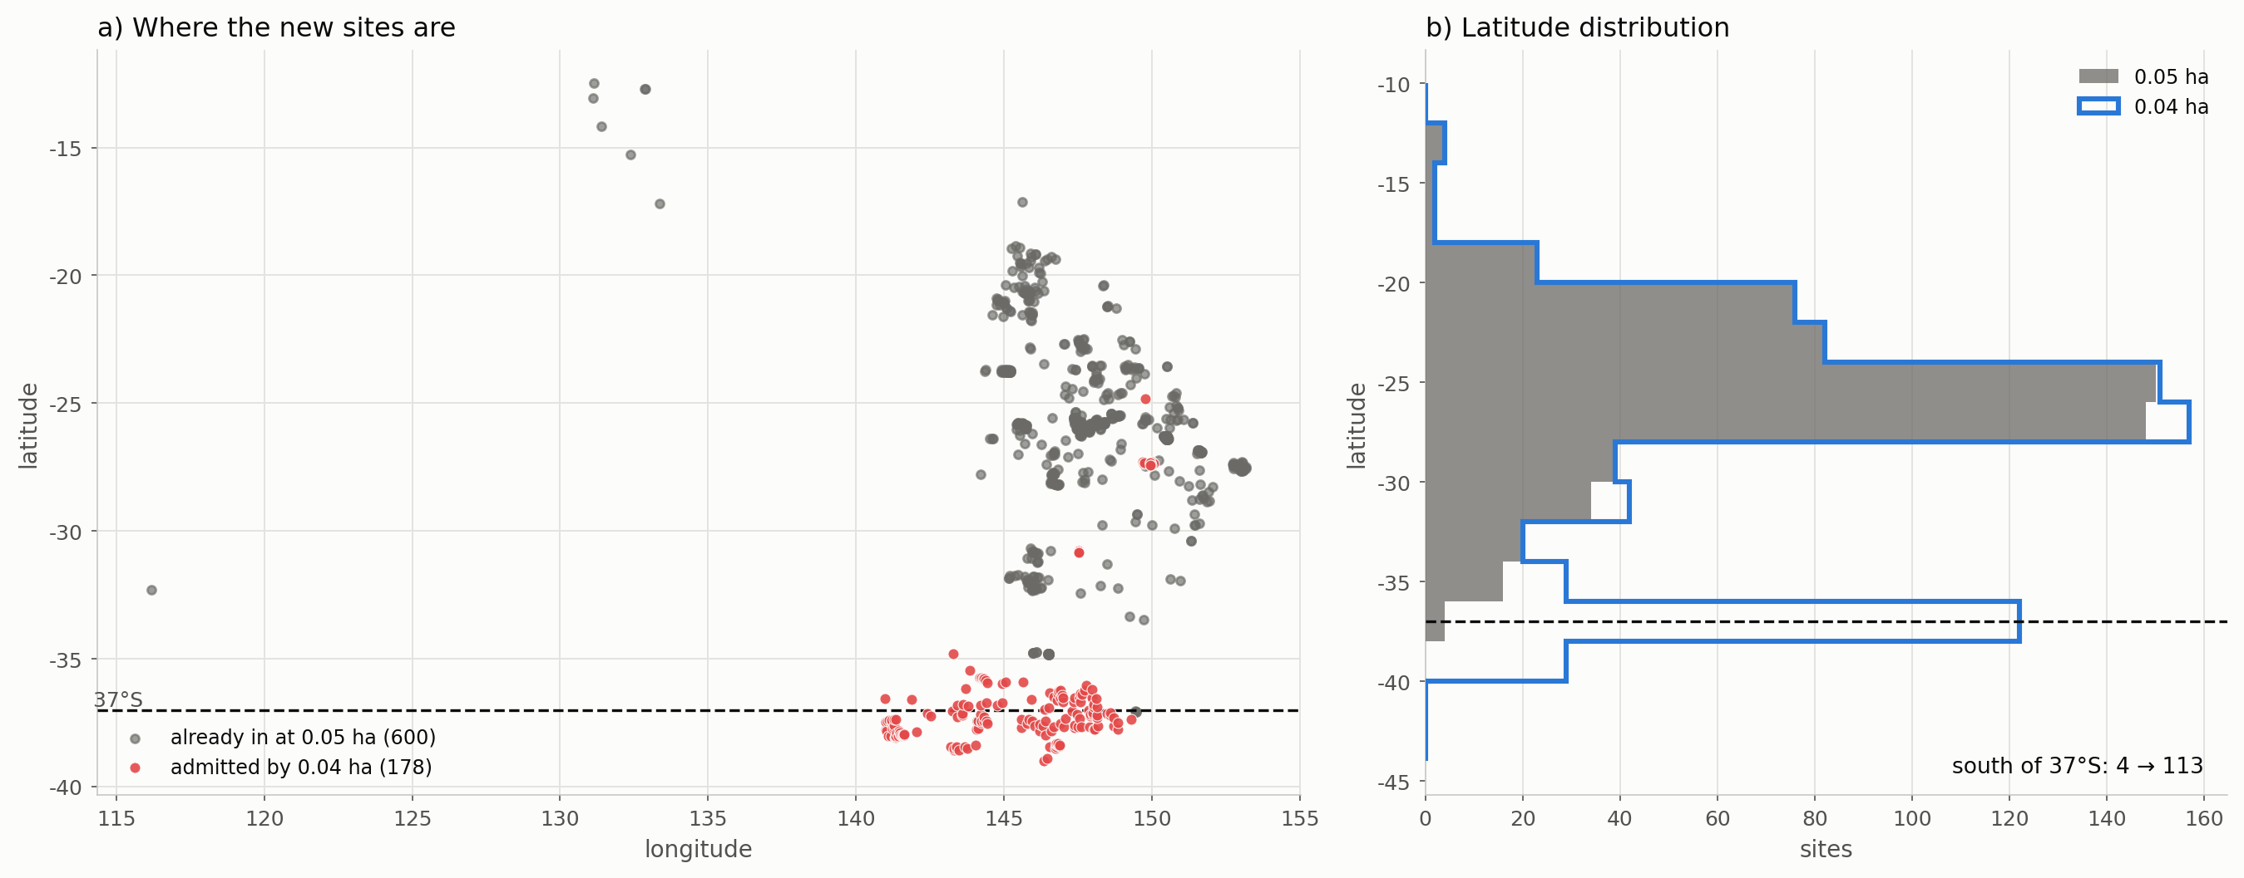
Figure 1. Where the new sites are. Panel (a) plots every mature site, with those admitted only by the change in red; panel (b) is the latitude distribution under each threshold.

Who supplies them
provider | visits admitted | median AGB | median basal area | AGB per m2/ha BA | plot area (ha) | south of 37 S
DELWP Victoria | 201 | 225 | 30.8 | 8.5 | 0.04-0.04 | 132
University of Queensland | 28 | 620 | 15.7 | 42.4 | 0.04-0.04 | 0
University of NSW | 27 | 68 | 0.6 | 73.8 | 0.04-0.04 | 0
DSITI Queensland Herbarium | 17 | 557 | 8.4 | 35.6 | 0.04-0.04 | 0
Department of Parks and Wildlife (WA) | 7 | 429 | 51.0 | 10.8 | 0.04-0.04 | 0
DSITI Queensland RSC | 3 | 757 | 8.4 | 61.3 | 0.05-0.05 | 0

Table 2. The visits admitted only by lowering the threshold.
The gain is concentrated rather than diffuse, which is what makes it checkable. DELWP Victoria supplies 201 of the 283 visits, all at exactly 0.04 ha, and their values are ordinary: a median 225 Mg/ha of biomass on 30.8 m2/ha of live basal area, a ratio of 7.3 that sits right on the library median. These are tall wet eucalypt forest plots that fail the 0.05 ha threshold by one hundredth of a hectare and by nothing else.
One provider in that list should be watched rather than trusted. University of NSW contributes 27 visits reporting a median 68 Mg/ha on 0.6 m2/ha of basal area - a ratio near 106. They pass the consistency filter only because that filter is a floor and not a ceiling. The analysis below is run with and without them.

What it does to the result
configuration | sites | south | ratio | rho | null rho | gap vs constrained null | no-analogue
floor_005 | 600 | 4 | 0.465 | 0.269 | 0.205 | +0.064 | 16.1%
floor_004 | 778 | 113 | 0.515 | 0.309 | 0.225 | +0.084 | 18.8%
floor_004_no_unsw | 770 | 113 | 0.514 | 0.309 | 0.262 | +0.047 | 19.0%
floor_004_south | 113 | 113 | 0.846 | 0.071 | 0.071 | +0.000 | 35.0%

Table 3. Every configuration, analogue-found sites only.
Unlike Run 1, this change gains sites AND metrics: 778 against 600, with the rank correlation rising from 0.269 to 0.309 and the gap to the constrained null from +0.064 to +0.084. There is no precision trade-off to weigh, because the sample got bigger.
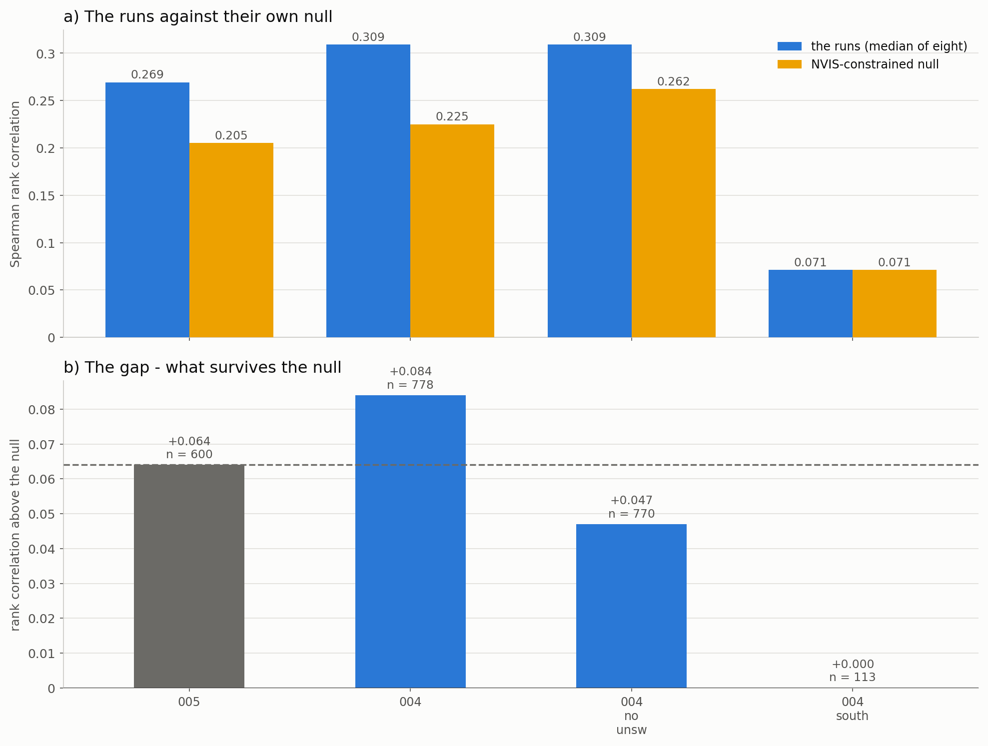
Figure 2. The runs against their own null, and the gap that survives it.

Two reasons not to over-read it
The southern sites carry no skill of their own. Matched alone, the 113 sites below 37 S give a rank correlation of 0.071 against a null of 0.071 - a gap of +0.000, which is to say none at all. They are underpowered at that size and 35 per cent of them have no analogue, so this is not evidence against them; but the improvement in the pooled result is not coming from the new southern sites ranking well. It comes from the sample being larger.
And the change in the metric is within the noise. Dropping the eight University of NSW sites - one per cent of the sample - moves the gap by 0.037, while the change from 0.05 to 0.04 ha moves it by +0.020. When removing one per cent of the sites shifts the statistic nearly twice as far as the intervention does, the intervention cannot be quoted as an effect on that statistic.
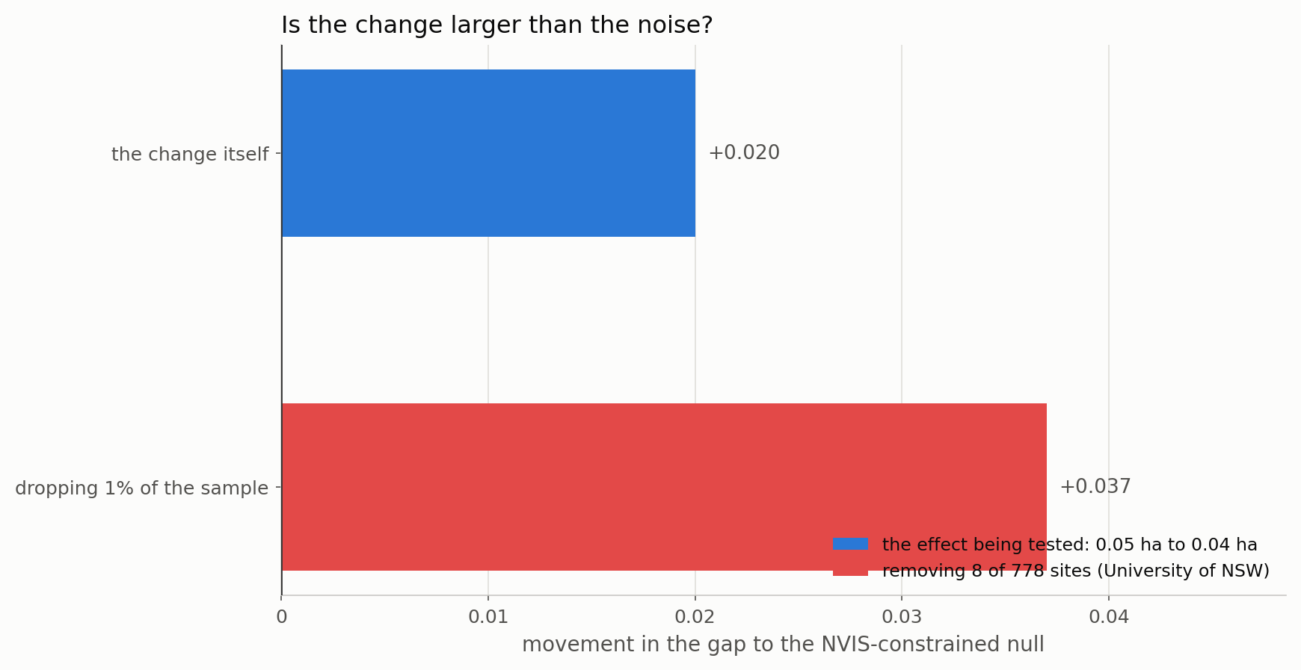
Figure 3. The effect being tested, against what one per cent of the sample does.

Why this stays a sensitivity
The original rationale for the threshold has not changed. Measured on this library, median biomass falls from 276 Mg/ha on plots under 0.05 ha to 11 over 0.5 ha, a gradient produced by sampling geometry rather than by vegetation. The companion study in Plot_area_floor_method pushes the same lever the other way and finds that RAISING the floor to 0.40 ha lifts M'/AGB from 0.465 to 1.275 and the gap to the constrained null from +0.064 to +0.128 - the largest improvement any single change in this study has produced.
So the two runs point in opposite directions on the same parameter, and they are not in conflict. The plot-size artefact is real and raising the floor removes it. Lowering the floor admits more of it, and is justified by coverage rather than by measurement quality. Both belong in the record; neither should be adopted silently.

What to conclude
- Quote the coverage gain, which is large and unambiguous: four southern sites become 113, and the validation stops being a statement about Queensland and New South Wales alone.
- Do not quote the metric gain. The rank correlation rises from 0.269 to 0.309 and the gap from +0.064 to +0.084, but one per cent of the sample moves the gap by 0.037. The change is not resolvable at this sample size.
- Name the provider. DELWP Victoria supplies 201 of the 283 admitted visits, all at exactly 0.04 ha. The sensitivity is really a sensitivity to including one provider, and should be described that way rather than as a threshold choice.
- Watch University of NSW. Twenty-seven visits at a ratio near 106 of biomass to basal area pass the consistency filter only because it is a floor. A ceiling on that ratio is worth its own one-change test.
- Keep 0.05 ha as the default. The plot-size rationale stands, and the companion study shows the gains lie in the other direction.

Files
file | what it holds
Step_01_build_004_table.py | rebuilds the reference table at 0.04 ha by patching the parent's constant
Step_02_run_and_compare.py | the four configurations
Step_03_plots.py | the figures
Step_04_write_report.py | this document
outputs/reference_table_min004.csv | the 0.04 ha table
outputs/admitted_by_the_change.csv | Table 2
outputs/coverage.csv | Table 1
outputs/run02_headline.csv | Table 3
plots/fig_01..03 | the figures in this report

