Projecting the Forest Productivity Index to 2099 with a random forest on CSIRO BARRA-R2 and QDC-CMIP6 climate
Training window 1985-2014 | projection 2035-2064 and 2070-2099 | four SSPs | 1 km NLUM grid
Generated 2026-08-26 from Random_forest_CSIRO/Step_01..Step_06.

Summary
A random forest was trained to predict the annual Forest Productivity Index (FPI) from that year's climate and from static soil properties, using the 30 observed years 1985-2014, and then applied to CSIRO's downscaled future climate to produce one FPI raster for each of the 60 future years in each of four emissions scenarios.
- The design differs in one important way from the earlier Step_01_RF_for_FPI model, which regressed a single 1970-2000 mean FPI map on a single 1970-2000 climate normal. That model saw only spatial variation and so could not, even in principle, say what FPI would be in one particular future year. Here every year is a separate training sample of every cell, so the fit sees interannual variation directly, and a year-by-year projection is a question the model was actually trained to answer.
- Soil is held constant into the future, as specified: the same 83 soil bands enter the training rows for all 30 historical years and every one of the 240 future predictions. Only the climate columns move.
- Skill is reported from cross-validation under three different fold definitions rather than from a single random split, because a random split of this table leaks badly - see Section 5.

1. Input data
Role | Product | Extent | Grid
Target | Forest Productivity Index (FPI), annual | 30 rasters, 1985-2014 | 1 km NLUM grid, 3364 x 4071, GDA94
Historical climate | BARRA-R2 reanalysis, daily, 7 variables | 7 x 30 = 210 NetCDF, 1985-2014 | AUS-11 grid, 0.11 deg, 646 x 1082
Future climate | QDC-CMIP6 (ACCESS-CM2 r4i1p1f1, quantile-delta change applied to BARRA-R2), daily, 7 variables | 7 x 4 SSP x 60 years = 1,680 NetCDF, 2035-2064 and 2070-2099 | AUS-11 grid, 0.11 deg
Soil | CSIRO Soil and Landscape Grid, 13 properties | 83 predictor rasters (11 gapfill-flag layers excluded) | 1 km NLUM grid, static

1.1 Climate variables
All seven delivered variables are used. Each is reduced from daily to twelve monthly values per year; rainfall accumulates and is summed, everything else is a state and is averaged.
Variable | Description | Monthly reduction
hurs | near-surface relative humidity (%) | mean
hursmax | daily maximum relative humidity (%) | mean
hursmin | daily minimum relative humidity (%) | mean
pr | precipitation (mm d-1 -> mm month-1) | sum
rsds | surface downwelling shortwave radiation (W m-2) | mean
tasmax | daily maximum air temperature (degC) | mean
tasmin | daily minimum air temperature (degC) | mean

1.2 Soil properties
Every soil raster supplied was used except the gapfill-flag layers, which record where the provider interpolated rather than measured and are provenance metadata rather than a soil property.
Code | Property | Bands used
AWC | Available water capacity | 6 depth slices
BDW | Bulk density, whole earth | 6
CEC | Cation exchange capacity | 6
CFG / CFP | Coarse fragments: dominant class and 6 class fractions | 3 + 18
CLY | Clay content | 6
DER | Depth of regolith | 1
DES | Depth of soil | 1
pHc | pH, CaCl2 | 6
SLT | Silt content | 6
SND | Sand content | 6
SOC | Soil organic carbon | 6
NTO | Total soil nitrogen | 6
Phos | Total soil phosphorus | 6

1.3 Grid audit
Soil is sampled by integer row and column index, which is exact when the grids match and silently reads the wrong cells when they do not, so every input was checked against the NLUM grid before any of it was used (Step_00_audit_inputs.py).
Table: distinct grids among all soil and FPI rasters. One row means they all agree.
height | width | res_x | res_y | origin_x | origin_y | rasters
3364.0000 | 4071.0000 | 0.0100 | -0.0100 | 112.9250 | -10.0150 | 136.0000

- All 136 rasters share a single grid - 3364 x 4071 at 0.01 degree, origin 112.925 / -10.015, GDA94 - and a single CRS. This includes soil_N and soil_P, the two directories whose file names lack the _NLUM suffix the others carry.
- The soil and FPI footprints are the same mask: 6,956,407 cells each, with no FPI cell lacking soil and none the other way round, in every training year and in 2022 (worst-case FPI loss 0.000%). Nothing needs gap-filling, and the projection has no holes the target does not have.
- Climate carries no missing data over the Australian crop (maximum 0.000000% NaN across the sampled variables, scenarios and years), and the crop strictly encloses the NLUM grid on both axes, so the bilinear interpolation always has four real corners and never clips at an edge.
Note that climate is resampled, not reprojected. It arrives on a regular latitude/longitude grid in the same geographic coordinates as NLUM, so 0.11 -> 0.01 degree is pure bilinear interpolation with no datum transformation involved.

2. Pipeline
Script | What it does
Step_00_audit_inputs.py | Checks every soil and FPI raster against the NLUM grid, measures whether the soil footprint is smaller than the FPI footprint, and confirms the climate crop encloses NLUM with no gaps. Run first; it reads nothing the rest of the pipeline writes.
common.py | Shared configuration: file locations, the fixed feature order, bilinear regridding, and the metric definitions. Both the training table and the prediction stack are built through the same functions, so their column order cannot drift apart.
Step_01_aggregate_climate.py | Reads all 1,890 daily NetCDF files (~1.5 TB), crops each to Australia, and reduces it to 12 monthly values per variable-year. This is the entire I/O cost of the project; every later step reads the ~6 MB monthly files instead. Resumable, and run on processes rather than threads because netCDF4 serialises HDF5 calls behind a global lock.
Step_02_build_training_table.py | Samples every 10th row and column of the NLUM grid, keeps the 69,564 cells with complete soil, and for each of the 30 historical years pairs that year's climate with that year's observed FPI. Result: 2,086,920 rows x 174 columns.
Step_02b_export_training_netcdf.py | Re-expresses the same training table as NetCDF, either flat (sample, feature) as fitted or gridded (year, feature, y, x) for GIS. Nothing is recomputed, so the exported file cannot disagree with what the model was fitted on.
Step_03_build_model.py | Cross-validates under three fold definitions, writes out-of-fold predictions and metrics, then refits on all 30 years and saves the model used for projection.
Step_04_predict_future.py | For each of 4 SSPs x 60 years, interpolates that year's climate onto the NLUM land cells, appends the unchanged soil block, predicts, and writes a GeoTIFF. Also writes the two window means per scenario.
Step_04b_export_netcdf.py | Re-expresses the projections as NetCDF cubes, one per scenario per window. Reads the GeoTIFFs and recomputes nothing, so the two forms cannot disagree. Kept as separate files per window because CSIRO separated 2035-2064 from 2070-2099 deliberately and a single 60-long year axis would invite interpolation across a gap the data does not support.
Step_05_plots.py | Validation and projection figures.
Step_07_scenario_diagnostic.py | Measures what the climate does in each scenario-window over the land cells, and correlates it against the projected FPI change - the test of whether the non-monotonic scenario ordering comes from the forcing or from the model (Section 7.2).
Step_06_write_report.py | This document.

2.1 Regridding
Climate arrives on the 0.11 deg AUS-11 grid and the target and soil are on the 0.01 deg NLUM grid, so climate is bilinearly interpolated onto NLUM coordinates. That interpolation is done at the point of use and never stored: one year of all seven variables on the NLUM grid is about 4.6 GB, and the projection walks 240 such years.
Interpolation is bilinear in both directions, identical in training and in prediction, through the same function. Points outside the source domain are clipped rather than extrapolated; with the Australian bounding box used here that case never arises.

3. Predictors
174 predictors: 83 soil and 91 climate. The climate block is, for each of the seven variables, the twelve monthly aggregates followed by one annual aggregate.
The annual term is redundant in principle - a tree could reconstruct it from the twelve monthly splits - but only through a deep chain of splits, because trees cannot add. Supplying it directly lets a single split key on 'a dry year' rather than on twelve separately dry months.
Example climate names: hurs_m01, hurs_m02, hurs_m03, hurs_m04 ... hurs_ann ... tasmin_ann.

4. Training set
One row per (cell, year). The 1985-2014 window is set by the CSIRO historical baseline, and the FPI raster for the matching year is used as the target - 1985 climate against 1985 FPI, 1994 climate against 1994 FPI, and so on. No climatological averaging is applied on either side.
Years | 30 (1985-2014)
Grid sampling | every 10th row and column of the 3364 x 4071 NLUM grid
Cells with complete soil | 69,564 of 137,496 candidates (50.6%)
Rows | 2,086,920
Columns | 174 (83 soil + 91 climate)

Roughly half the candidate cells are dropped because they are ocean or otherwise outside the soil coverage; the surviving fraction matches the 50.8% of the FPI grid that carries data.

4.1 Hyperparameters
Parameter | Value | Why
n_estimators | 64 | as in Step_01_RF_for_FPI
max_features | 1.0 (all) | sklearn default for regression, as in Step_01
min_samples_leaf | 5 | the one deliberate change. At 2 M rows a fully grown forest is ~17 GB of tree structure and its last splits separate individual cell-years; FPI is smooth and observationally noisy at that scale, so stopping at 5 costs almost no skill
random_state | 42 | reproducible

5. Cross-validation
Three fold definitions are used, because a single number would be misleading. Every cell contributes 30 rows that share all 83 soil values and differ only in one year's weather, so a plain random split puts 1994 and 1995 of the same cell on opposite sides and largely measures memorisation.
Scheme | Folds | What it measures
kfold_random | 5-fold over rows | The optimistic number, and the one comparable with Step_01_RF_for_FPI.
blockcv_space | 5-fold over contiguous 2 deg blocks | Can it predict an unseen region. Blocks rather than scattered cells: at 1 km FPI is strongly autocorrelated, so a randomly held-out cell sits ringed by its own neighbours in the training set and scores almost as high as no holdout at all.
groupcv_year | 5-fold over years, 6 years held out per fold | Can it predict an unseen year. This is the number to quote: projecting 2035-2099 is exactly the act of predicting years the model never saw.

Each scheme predicts every row exactly once, by the fold that did not train on it, so the metrics below are computed over the whole 30-year table rather than over a fifth of it.

5.1 Pooled out-of-fold metrics
Table: out-of-fold skill over all 2,086,920 rows.
Scheme | R2 (coefficient of determination) | RMSE | MAE | Mean bias (pred - obs) | Pearson r | Nash-Sutcliffe efficiency | Willmott index of agreement | MAPE (%)
Random 5-fold | 0.9775 | 0.4285 | 0.2486 | 0.0008 | 0.9888 | 0.9775 | 0.9942 | 5.6682
Spatial block CV (2 deg blocks) | 0.9321 | 0.7450 | 0.4462 | 0.0117 | 0.9657 | 0.9321 | 0.9818 | 10.9732
Year-group CV (6 years held out per fold) | 0.9305 | 0.7535 | 0.5483 | 0.0040 | 0.9650 | 0.9305 | 0.9812 | 17.4951

Metric definitions:
- R2 (coefficient of determination)
- RMSE
- MAE
- Mean bias (pred - obs)
- Pearson r
- Nash-Sutcliffe efficiency
- Willmott index of agreement
- MAPE (%)
R2 and the Nash-Sutcliffe efficiency are the same quantity, 1 - SSE/SST, reported under both names because the machine-learning and the ecology literatures each expect their own. Explained variance differs from them only by removing the mean bias first, so any gap between the two is exactly the bias term.

5.2 Fold by fold
Scheme | fold | n_train | n_test | R2 (coefficient of determination) | RMSE | MAE | Mean bias (pred - obs)
Random 5-fold | 0 | 1669536.0000 | 417,384 | 0.9775 | 0.4297 | 0.2492 | 0.0011
Random 5-fold | 1 | 1669536.0000 | 417,384 | 0.9778 | 0.4269 | 0.2478 | 0.0014
Random 5-fold | 2 | 1669536.0000 | 417,384 | 0.9773 | 0.4293 | 0.2484 | -0.0004
Random 5-fold | 3 | 1669536.0000 | 417,384 | 0.9775 | 0.4270 | 0.2479 | 0.0007
Random 5-fold | 4 | 1669536.0000 | 417,384 | 0.9776 | 0.4295 | 0.2495 | 0.0013
Spatial block CV (2 deg blocks) | 0 | 1669530.0000 | 417,390 | 0.9335 | 0.6844 | 0.4344 | 0.0029
Spatial block CV (2 deg blocks) | 1 | 1669560.0000 | 417,360 | 0.9342 | 0.6175 | 0.3859 | 0.0508
Spatial block CV (2 deg blocks) | 2 | 1669530.0000 | 417,390 | 0.9331 | 0.7875 | 0.4760 | -0.0134
Spatial block CV (2 deg blocks) | 3 | 1669500.0000 | 417,420 | 0.9247 | 0.6762 | 0.4164 | 0.0678
Spatial block CV (2 deg blocks) | 4 | 1669560.0000 | 417,360 | 0.9300 | 0.9209 | 0.5183 | -0.0493
Year-group CV (6 years held out per fold) | 0 | 1669536.0000 | 417,384 | 0.9336 | 0.7059 | 0.5222 | 0.0761
Year-group CV (6 years held out per fold) | 1 | 1669536.0000 | 417,384 | 0.9270 | 0.8086 | 0.5844 | -0.0547
Year-group CV (6 years held out per fold) | 2 | 1669536.0000 | 417,384 | 0.9306 | 0.7595 | 0.5476 | -0.0146
Year-group CV (6 years held out per fold) | 3 | 1669536.0000 | 417,384 | 0.9360 | 0.6859 | 0.5152 | 0.0800
Year-group CV (6 years held out per fold) | 4 | 1669536.0000 | 417,384 | 0.9256 | 0.7998 | 0.5719 | -0.0666

5.3 Year-group CV, year by year
Skill for each year, computed from the fold in which that year was held out. Weak years are the informative ones: they identify the climate conditions the model extrapolates into least reliably.
year | n | R2 (coefficient of determination) | RMSE | MAE | Mean bias (pred - obs) | Observed mean | Predicted mean
1985.0000 | 69564.0000 | 0.9447 | 0.7148 | 0.5644 | 0.2722 | 3.8221 | 4.0943
1986.0000 | 69564.0000 | 0.9350 | 0.7458 | 0.5613 | 0.1497 | 3.8571 | 4.0068
1987.0000 | 69564.0000 | 0.9397 | 0.6905 | 0.5400 | 0.3181 | 4.0022 | 4.3203
1988.0000 | 69564.0000 | 0.9210 | 0.8236 | 0.5868 | -0.1811 | 4.2900 | 4.1089
1989.0000 | 69564.0000 | 0.9331 | 0.7399 | 0.5663 | 0.3114 | 4.3173 | 4.6287
1990.0000 | 69564.0000 | 0.9192 | 0.7540 | 0.5830 | 0.3471 | 3.9529 | 4.3000
1991.0000 | 69564.0000 | 0.9371 | 0.6493 | 0.4795 | 0.3127 | 3.5689 | 3.8816
1992.0000 | 69564.0000 | 0.9284 | 0.7164 | 0.5327 | 0.0227 | 4.4261 | 4.4489
1993.0000 | 69564.0000 | 0.8885 | 0.9378 | 0.6523 | -0.0199 | 4.2993 | 4.2794
1994.0000 | 69564.0000 | 0.8938 | 0.7754 | 0.5611 | 0.3931 | 3.1657 | 3.5588
1995.0000 | 69564.0000 | 0.9264 | 0.7205 | 0.5458 | 0.0863 | 4.6272 | 4.7135
1996.0000 | 69564.0000 | 0.9378 | 0.7919 | 0.5546 | -0.1792 | 4.2583 | 4.0791
1997.0000 | 69564.0000 | 0.9055 | 0.7562 | 0.5676 | 0.0996 | 4.3444 | 4.4440
1998.0000 | 69564.0000 | 0.8978 | 0.9390 | 0.6686 | -0.3838 | 4.9014 | 4.5177
1999.0000 | 69564.0000 | 0.9375 | 0.7662 | 0.5616 | -0.1587 | 4.9565 | 4.7977
2000.0000 | 69564.0000 | 0.9064 | 0.7835 | 0.5706 | -0.1839 | 5.2919 | 5.1081
2001.0000 | 69564.0000 | 0.9241 | 0.7215 | 0.5390 | -0.2484 | 4.7265 | 4.4780
2002.0000 | 69564.0000 | 0.9346 | 0.6365 | 0.4776 | 0.1060 | 3.2040 | 3.3100
2003.0000 | 69564.0000 | 0.9387 | 0.6467 | 0.4667 | -0.0769 | 3.9810 | 3.9041
2004.0000 | 69564.0000 | 0.9418 | 0.6324 | 0.4649 | -0.0553 | 4.1230 | 4.0677
2005.0000 | 69564.0000 | 0.9506 | 0.6857 | 0.4804 | -0.0278 | 3.7778 | 3.7500
2006.0000 | 69564.0000 | 0.9099 | 0.7704 | 0.5604 | 0.1797 | 3.8891 | 4.0687
2007.0000 | 69564.0000 | 0.9467 | 0.6549 | 0.4821 | -0.0151 | 4.2551 | 4.2400
2008.0000 | 69564.0000 | 0.9515 | 0.6851 | 0.4928 | -0.0102 | 4.0453 | 4.0351
2009.0000 | 69564.0000 | 0.9389 | 0.6341 | 0.4797 | -0.0006 | 3.8045 | 3.8039
2010.0000 | 69564.0000 | 0.8851 | 1.1847 | 0.8978 | -0.5349 | 5.7226 | 5.1878
2011.0000 | 69564.0000 | 0.9057 | 0.8617 | 0.5912 | -0.3022 | 5.7742 | 5.4721
2012.0000 | 69564.0000 | 0.9444 | 0.6532 | 0.4910 | -0.0517 | 4.3665 | 4.3149
2013.0000 | 69564.0000 | 0.9568 | 0.5898 | 0.4290 | -0.0153 | 3.9230 | 3.9077
2014.0000 | 69564.0000 | 0.9314 | 0.6724 | 0.4997 | -0.0331 | 4.1153 | 4.0821

5.4 Figures
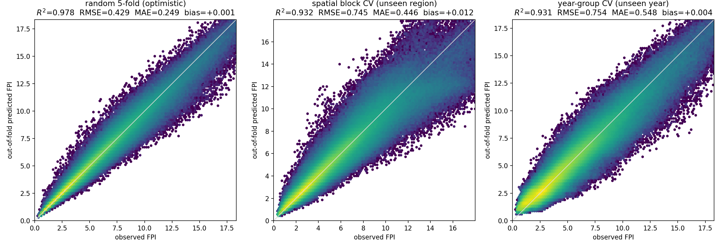
Out-of-fold predicted vs observed FPI under each scheme. Colour is point density on a log scale; the grey line is 1:1.
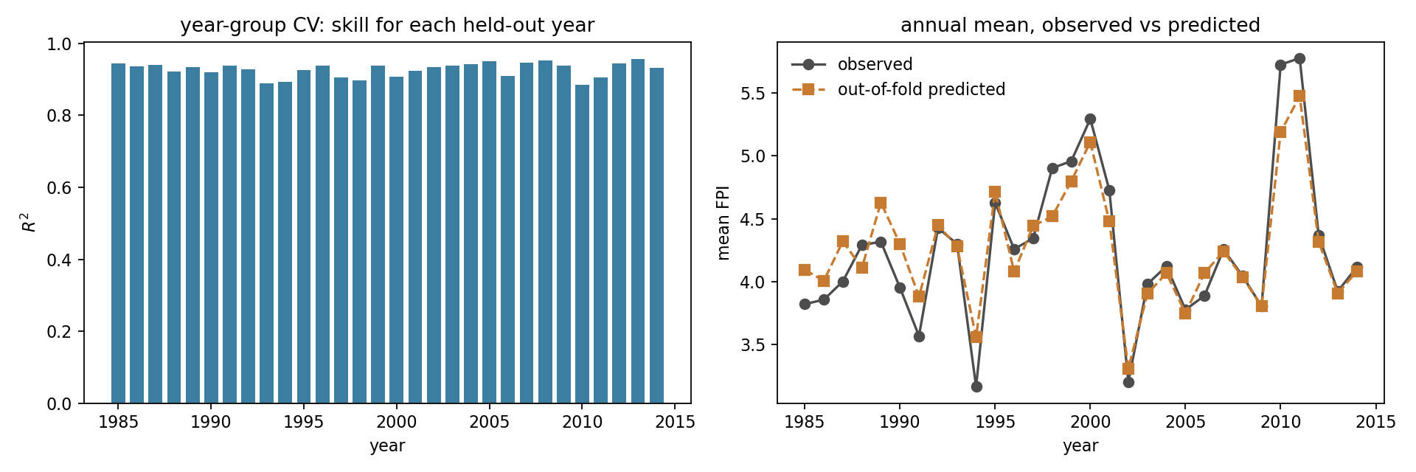
Left: skill for each held-out year. Right: annual mean FPI, observed against out-of-fold prediction.
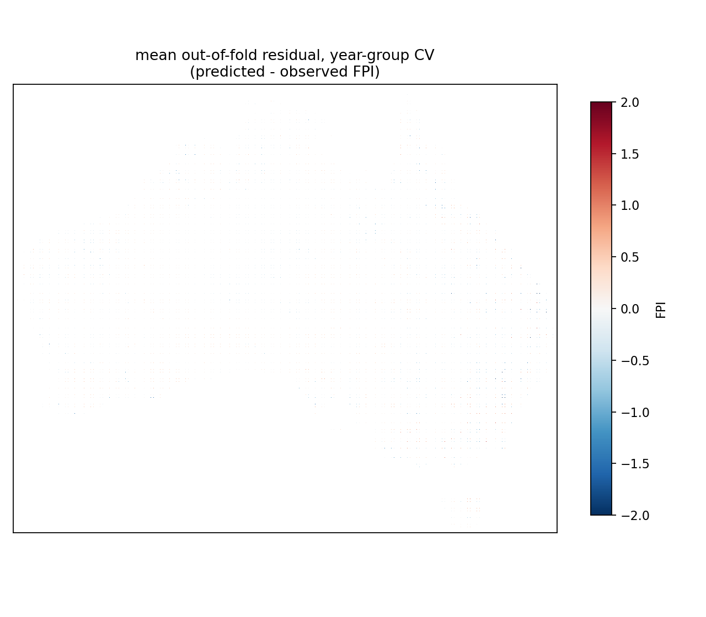
Mean out-of-fold residual in space, year-group CV. Systematic colour indicates a region the model is biased in, as distinct from noise.

6. Predictor importance
Impurity-based importance from the final model. Soil accounts for 0.390 of the total and climate for 0.610.
Impurity importance is biased toward high-cardinality continuous predictors and splits credit arbitrarily among correlated ones - and these predictors are heavily correlated, with six depth slices of every soil property and twelve months of every climate variable. Read the ranking as which groups matter, not as a precise ordering within a group.
Table: 20 most important predictors.
feature | kind | importance
SOC_000_005_NAT_N_20220727 | soil | 0.16799
hurs_ann | climate | 0.13304
pr_ann | climate | 0.10423
hursmin_ann | climate | 0.07731
hurs_m11 | climate | 0.06845
SOC_015_030_NAT_N_20220727 | soil | 0.05241
hursmax_ann | climate | 0.04845
BDW_000_005_NAT_C_20140801 | soil | 0.03165
hurs_m03 | climate | 0.02075
SOC_005_015_NAT_N_20220727 | soil | 0.01683
BDW_005_015_NAT_C_20140801 | soil | 0.01432
hursmax_m03 | climate | 0.01342
hursmin_m03 | climate | 0.01165
SLT_100_200_TRN_N_20210902 | soil | 0.01107
hurs_m12 | climate | 0.00734
hursmax_m11 | climate | 0.00712
hursmax_m02 | climate | 0.00705
pHc_060_100_NAT_C_20210913 | soil | 0.00603
pHc_030_060_NAT_C_20210913 | soil | 0.00550
SND_000_005_TRN_N_20210902 | soil | 0.00529

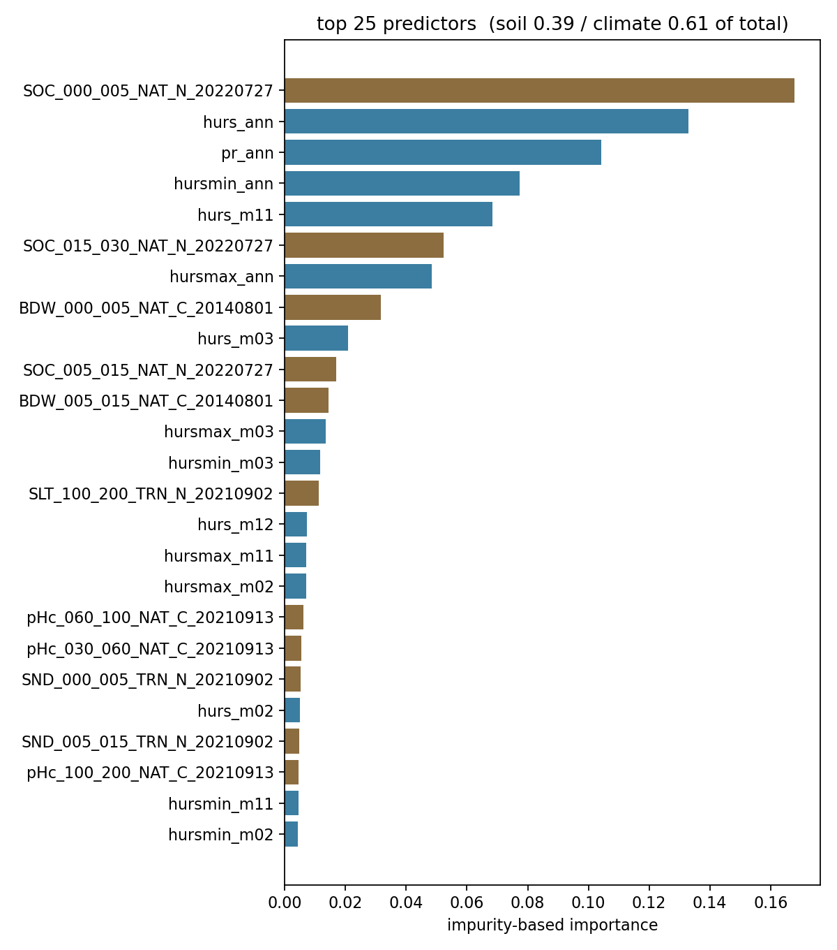
Top 25 predictors. Brown is soil, blue is climate.

7. Future projection
The refitted model is applied to each of 4 scenarios (ssp126, ssp245, ssp370, ssp585) for each of the 60 future years, giving 240 FPI rasters on the full NLUM grid, plus a mean raster for each scenario in each of the two windows.
Soil is unchanged from the historical rows. The land mask comes from soil coverage alone; the historical FPI footprint is deliberately not imposed on the projection, since masking a projection to where FPI happened to be observed in 1985-2014 would bake an observational footprint into it.
The two windows are 2035-2064 and 2070-2099 and are kept separate. CSIRO separated them deliberately so that users do not join them; the intervening years are not part of the delivered dataset and no trend is drawn across the gap.
Table: predicted FPI by scenario, averaged over all projected years.
Scenario | mean of yearly min | mean FPI | mean of yearly max
ssp126 | 0.8807 | 4.1032 | 21.8324
ssp245 | 0.9483 | 4.1472 | 21.8373
ssp370 | 0.9605 | 4.0316 | 21.8364
ssp585 | 0.9853 | 4.0191 | 21.5603

Table: window-mean FPI against the observed 1985-2014 mean.
Scenario | Window | Projected mean | Observed 1985-2014 mean | Change | Change (%)
ssp126 | 2035-2064 | 4.1944 | 4.2597 | -0.0653 | -1.5327
ssp245 | 2035-2064 | 4.0919 | 4.2597 | -0.1678 | -3.9390
ssp370 | 2035-2064 | 4.1685 | 4.2597 | -0.0913 | -2.1427
ssp585 | 2035-2064 | 4.1842 | 4.2597 | -0.0755 | -1.7733
ssp126 | 2070-2099 | 4.0119 | 4.2597 | -0.2478 | -5.8178
ssp245 | 2070-2099 | 4.2025 | 4.2597 | -0.0572 | -1.3432
ssp370 | 2070-2099 | 3.8948 | 4.2597 | -0.3650 | -8.5680
ssp585 | 2070-2099 | 3.8541 | 4.2597 | -0.4056 | -9.5229

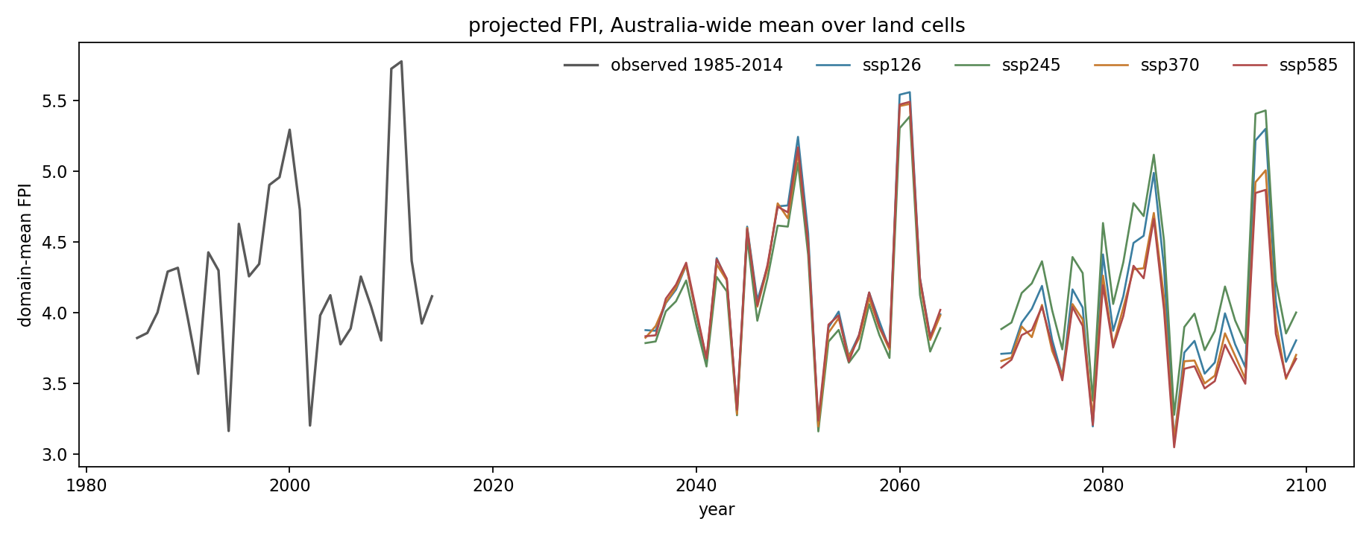
Australia-wide mean FPI: observed 1985-2014, then projected for each scenario across the two windows.
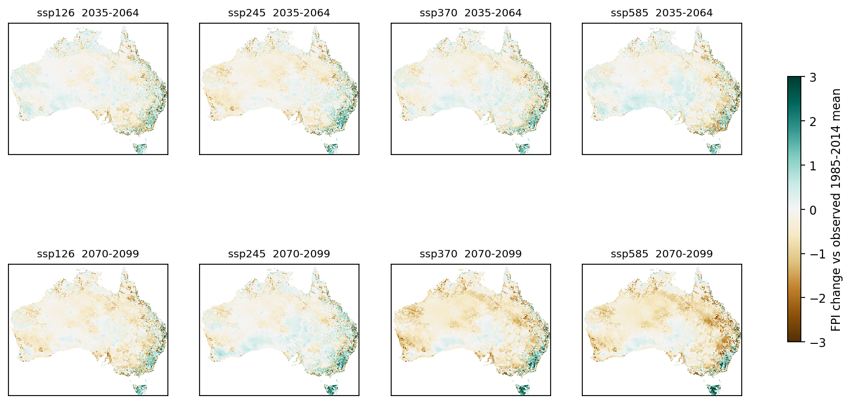
Window-mean projected FPI minus the observed 1985-2014 mean.

7.1 Projected 2035-2064 against observed FPI in 2022
A direct comparison of the first projection window's mean against the most recent observed year. Read it as a displacement rather than a validation: the left-hand quantity is a 30-year mean and the right-hand one a single year, so averaging has already removed interannual variance that 2022 still carries.
2022 is also a wet La Nina year and sits above the 1985-2014 norm, and the year-group cross-validation shows this model under-predicts precisely such years (2010 by -0.53, 2011 by -0.30). Part of any apparent decline against 2022 is therefore 2022 being unusually productive rather than the future being unproductive. The dashed line in each panel is the observed 1985-2014 mean against 2022: the gap between the two clouds is the projected change, while the gap between the dashed line and 1:1 is only how exceptional 2022 was. The comparison against the 30-year observed mean in the table above is the cleaner one.
Table: projected 2035-2064 mean against observed FPI 2022. An OLS slope below 1 means the projected change is proportionally larger in the more productive cells.
Scenario | Cells | Observed FPI 2022 | Projected mean 2035-2064 | Change | Change (%) | OLS slope | OLS intercept | r2 | pearson_r | rmse | mae
ssp126 | 6,956,407 | 5.3525 | 4.1944 | -1.1581 | -21.6362 | 0.3838 | 2.4397 | 0.6804 | 0.9036 | 1.9382 | 1.3980
ssp245 | 6,956,407 | 5.3525 | 4.0919 | -1.2606 | -23.5513 | 0.3782 | 2.4041 | 0.6845 | 0.9155 | 1.9258 | 1.4332
ssp370 | 6,956,407 | 5.3525 | 4.1685 | -1.1841 | -22.1216 | 0.3825 | 2.4314 | 0.6871 | 0.9106 | 1.9176 | 1.4005
ssp585 | 6,956,407 | 5.3525 | 4.1842 | -1.1683 | -21.8277 | 0.3813 | 2.4235 | 0.6655 | 0.8994 | 1.9828 | 1.4260

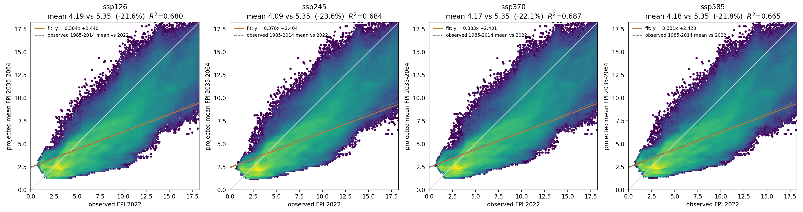
Projected 2035-2064 mean FPI against observed FPI 2022, one panel per scenario. Grey is 1:1, orange is the OLS fit, dashed grey is the observed 1985-2014 mean against 2022.
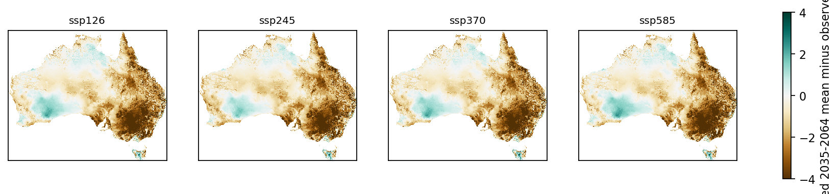
The same difference in space: projected 2035-2064 mean minus observed 2022.

7.2 Why the scenario ordering is not monotonic
The projections do not fall monotonically with forcing. ssp245 in 2070-2099 shows the smallest decline of any scenario-window (-1.3%), smaller than ssp126 over the same years (-5.8%) and smaller than its own earlier window (-3.9%); and in 2035-2064 there is no forcing signal at all, with ssp245 declining more than ssp585. A reader will notice this, so it was measured rather than explained away.
Step_07_scenario_diagnostic.py computes what the climate actually does in each scenario-window, in the variables the model keys on, over the same 6,956,407 land cells, weighting each coarse cell by the number of NLUM land cells inside it.
Table: change in each climate variable and in projected FPI, per cent against the 1985-2014 baseline, over the NLUM land cells.
Scenario | Window | hurs | hursmin | pr | rsds | tasmax | tasmin | FPI change (%)
ssp126 | 2035-2064 | -2.31 | -2.73 | -1.54 | 0.82 | 6.32 | 10.92 | -1.53
ssp126 | 2070-2099 | -5.19 | -6.38 | -9.77 | 1.67 | 7.78 | 12.39 | -5.82
ssp245 | 2035-2064 | -4.20 | -4.90 | -7.12 | 1.15 | 7.62 | 12.93 | -3.94
ssp245 | 2070-2099 | -3.47 | -3.47 | -0.81 | 1.21 | 11.50 | 20.65 | -1.34
ssp370 | 2035-2064 | -3.06 | -3.07 | -3.68 | 0.57 | 8.34 | 15.03 | -2.14
ssp370 | 2070-2099 | -9.04 | -10.18 | -13.85 | 1.39 | 17.41 | 30.46 | -8.57
ssp585 | 2035-2064 | -3.39 | -3.25 | -2.00 | 0.70 | 8.99 | 16.17 | -1.77
ssp585 | 2070-2099 | -9.71 | -10.17 | -12.52 | 1.49 | 20.52 | 36.62 | -9.52

- Across the eight scenario-windows, projected FPI change correlates +0.972 with hurs, +0.975 with pr, -0.807 with tasmax.
- The non-monotonicity is in the forcing, not the model. ACCESS-CM2 r4i1p1f1 under ssp245 in 2070-2099 is barely drier than the baseline - rainfall -0.8%, the smallest change of any late-century window and less drying than that scenario's own early window at -7.1% - while ssp126 over the same years is markedly drier at -9.8%. FPI follows, at a correlation of about 0.97. The model is reporting its input faithfully.
- The clinching detail is that temperature IS ordered by forcing: tasmax rises +6.3, +7.8, +7.6, +11.5, +8.3, +17.4, +9.0 and +20.5 per cent across the eight windows, essentially monotonic within each window. Rainfall and relative humidity are not. Because this model keys on humidity and rainfall rather than on temperature (Section 6), it inherits their non-monotonicity. The -0.81 correlation with tasmax is incidental - temperature co-varies with the drying, but contributed almost no importance to the fit.
What to claim, therefore: FPI declines in every scenario and every window, and strongly late-century under high forcing (ssp370 -8.6%, ssp585 -9.5%). What not to claim: the ordering of scenarios within 2035-2064, or ssp245's late-window value, as evidence of a forcing-response relationship. A single realisation of a single GCM does not average out internal variability, and relative humidity - the dominant predictor here - is the field in which that variability is largest and inter-model agreement weakest.
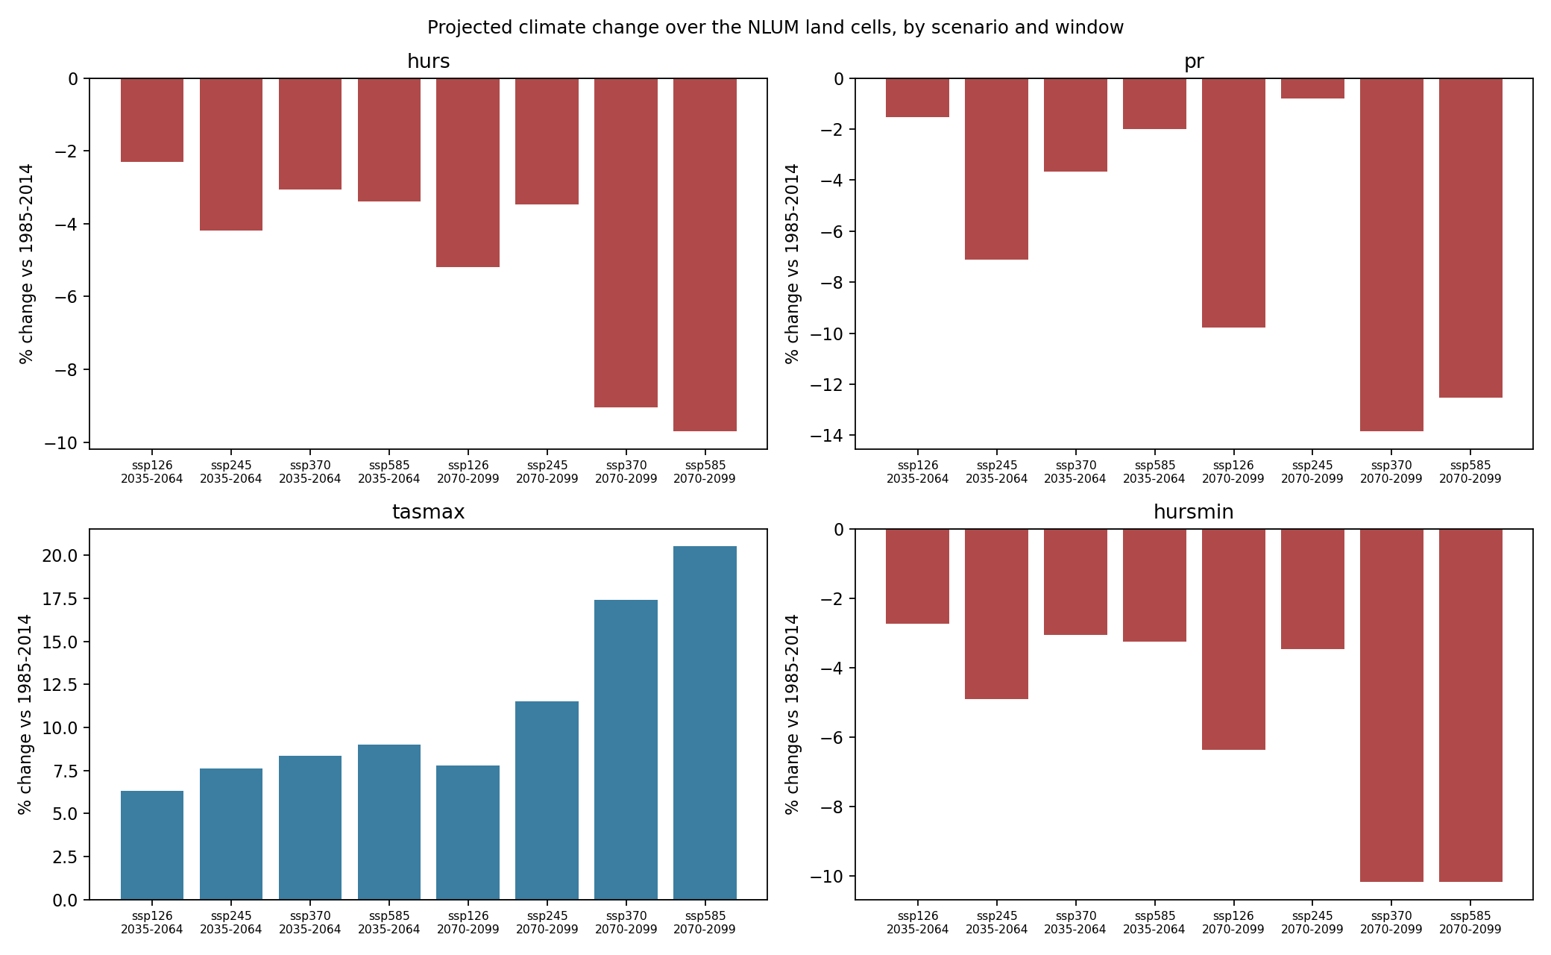
Projected change in each climate variable over the NLUM land cells, by scenario and window.
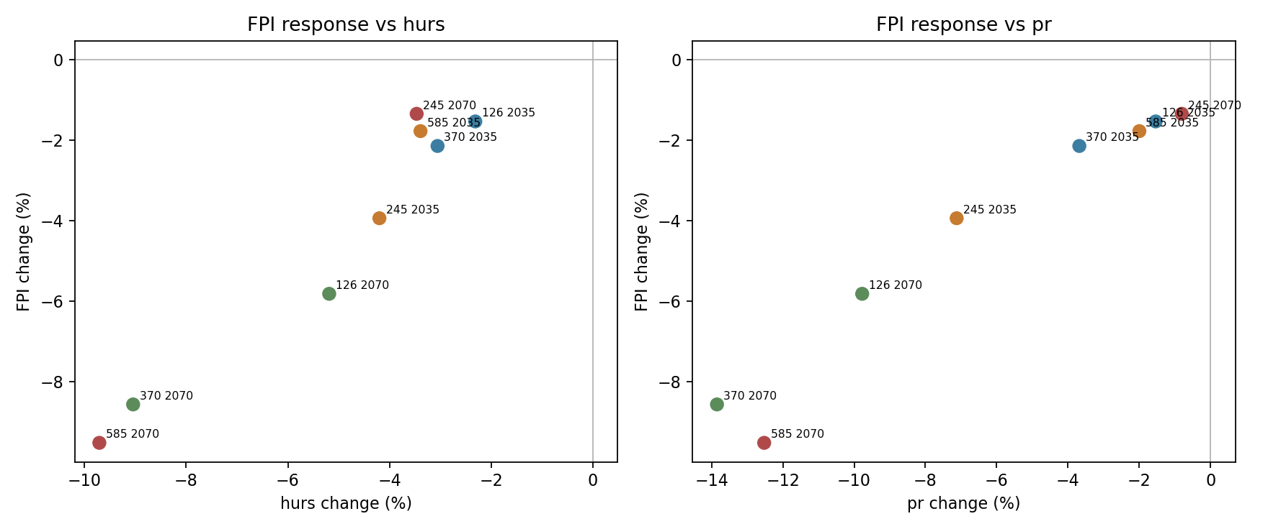
Projected FPI change against humidity and rainfall change, one point per scenario-window.

8. What this projection does and does not say
- The projection is a climate-response surface, not a forest growth model. It says what FPI the historical relationship implies for a future year's climate; it carries no CO2 fertilisation, no change in species composition, no disturbance, and no soil change.
- Soil is held constant by instruction. Soil organic carbon and nitrogen in particular do respond to a changing climate over 75 years, so any part of the future FPI signal that would have come through soil is absent by construction.
- The future climate is QDC-CMIP6: quantile-delta changes from ACCESS-CM2 applied multiplicatively to observed BARRA-R2 years. Each future year is an observed year rescaled, so the interannual variability in the projection is observed weather carrying a model-derived change signal, not model weather. Year-to-year wiggles in the projected series should not be read as predictions of particular years.
- Training and future climate share the same observational base - both are BARRA-R2, one directly and one rescaled - so the observational-product difference that affects the ANUClimate-based FullCAM inputs does not arise here.
- A random forest cannot extrapolate beyond its training range: it predicts a mean of training-set leaves, so a 2090 climate hotter than anything in 1985-2014 is answered with the response at the edge of the training envelope. Late-century, high-forcing projections are therefore conservative by construction, and the effect is strongest in ssp585.
- That compression is not hypothetical - the year-group cross-validation measures it inside the training window. The model under-predicts the most productive years and over-predicts the least productive ones: 2010 and 2011, the two strongest La Nina years and the two highest observed means (5.72 and 5.77), come out at -0.53 and -0.30; 1994, a strong El Nino and the lowest observed mean (3.17), comes out at +0.39. 2010 is also the weakest year in the record (R2 0.885, RMSE 1.18). Read the projected spread between scenarios and between years as a lower bound on magnitude rather than a central estimate.
- The fit leans on humidity, not on temperature. Relative humidity terms together carry about 0.38 of the total importance - more than three times rainfall at 0.104 - while tasmax, tasmin and rsds do not appear in the top 15 predictors at all. Part of that is impurity importance dividing credit among three correlated humidity variables, but the absence of temperature is not a splitting artefact. The practical consequence is that these projections are driven mainly by projected change in relative humidity, which is among the least well constrained fields in a climate projection, rather than by warming, which is among the most robust. Scenario differences inherit that weaker constraint.
- The year-group CV score is the honest measure of skill for this use, and it is the lowest of the three. The gap between it and the random 5-fold score is a measure of how much of the apparent skill comes from knowing the place rather than knowing the year.

9. Outputs
Path | Contents
data/audit_inputs.csv, audit_masks.csv, audit_climate.csv | the grid audit: per-raster grid signature, soil-vs-FPI footprint overlap, and climate coverage
data/monthly_climate/ | 1,890 monthly-aggregated climate NetCDF
data/training_table.npz | the 2,086,920 x 174 training table
data/X_train.nc, data/y_train.nc | the same training table as NetCDF, dimensions (sample, feature) and (sample), with year, cell_row, cell_col, lat and lon carried as coordinates on sample
data/X_train_gridded.nc, data/y_train_gridded.nc | the same numbers as (year, feature, y, x) and (year, y, x) rasters on the downsampled NLUM grid, NaN where soil coverage is incomplete
data/random_forest_model.pkl | the fitted model and its feature order
data/cv_metrics.csv | per-scheme and per-fold metrics
data/cv_metrics_by_year.csv | year-group CV skill, year by year
data/oof_*.npz | out-of-fold predictions for every row, per scheme
data/feature_importances.csv | impurity importance, all 174 predictors
output/fpi_<ssp>_<year>.tif | 240 projected FPI rasters, 1 km NLUM
output/fpi_<ssp>_<window>_mean.tif | 8 window-mean rasters
output/netcdf/fpi_<ssp>_<period>.nc | the same projections as 8 NetCDF cubes - fpi(year, lat, lon) for the 30 years of that window plus fpi_mean(lat, lon) - one file per scenario per window, so the two windows stay separate
output/netcdf/fpi_all_period_means.nc | the 8 window means in a single file, fpi_mean(scenario_period, lat, lon)
output/domain_mean_fpi_by_year.csv | Australia-wide mean per scenario-year
plots/scatter_future_vs_fpi2022.png, future_vs_fpi2022_map.png, future_vs_fpi2022_summary.csv | the 2035-2064 mean against observed FPI 2022, per scenario
data/scenario_climate_diagnostic.csv, scenario_climate_vs_fpi.csv | land-weighted climate change per scenario-window, and its relationship to the projected FPI change
plots/ | all figures reproduced in this document

Rasters are float32 GeoTIFF, LZW-compressed, on the 3364 x 4071 NLUM grid in GDA94, NaN outside the soil mask - the same convention as the rest of the project.

