Testing the future M' against GEDI
Validation_GEDI · generated 2026-09-22 · the eight future M' layers, every component of the ratio produced by the random forest, against 12,341,125 GEDI L4A footprints in 133,429 NLUM cells

What GEDI can and cannot settle
M' is a maximum: the above-ground biomass a site could carry at maturity. GEDI measures what actually stands there now, 2019-2024, after clearing, logging, fire and whatever else has happened. GEDI below M' is therefore the expected case and proves nothing at all. GEDI ABOVE M' is the only direct evidence against M', so every headline number in this report is an exceedance rate and never an R2.
Applied to a FUTURE M' the same test carries a sharper meaning. Present-day biomass exceeding a future maximum says a stand already carries more than the model claims its site will be able to support decades from now. That is not impossible - a drying climate can lower a ceiling below the standing stock, and the stand would then be expected to decline towards it - but it is a strong claim, it is checkable today, and if the projection is doing what it says the rate at which it happens should order with forcing.
What GEDI cannot do is see 2035-2100. Nothing here validates a projected level. Two things are genuinely testable and both are reported: whether the projected ceiling is already contradicted by measured biomass, and whether the MECHANISM behind the projection - Eq. (1) applied to a change in FPI - matches the way biomass and FPI actually co-vary across space today.

Why the anchor is the only fair reference
New_M_2019 is not a rival layer here, it is the control. Every future layer is built as M'_future = New_M_2019 x Eq1(mean FPI_future) / Eq1(mean FPI_1985-2014), which collapses to New_M_2019 exactly when the future FPI equals the historical one. The anchor is therefore the historical limit of all eight. A difference between a future layer's numbers and the anchor's is the projected climate change and nothing else: same cells, same footprints, same fire treatment, same footing.
The Eq. (1)-footing layer (baseline_M_1985-2014, the retired Option A) was dropped from this analysis in September 2026 along with the rest of that route. The older Validation_GEDI_report.docx still describes it.

The sample
GEDI L4A footprints | 12,341,125
NLUM cells with at least 30 footprints | 133,429 fire-excluded, 174,790 including burnt
acquisition window | 2019-04-18 to 2024-11-27
median footprint AGBD | 56.9 Mg ha-1
median relative standard error of a footprint | 14%
evergreen broadleaf footprints | 71%

Every number below is computed on the fire-excluded cells, which drop any footprint whose cell burned within the recovery window before acquisition. The all-footprints version is in outputs/analysis/overall_by_layer.csv and raises every exceedance rate by 1.9 to 2.2 percentage points, never changing the conclusions.

Result 1 - the projection does not make the ceiling problem worse
layer | median M' | cell MEAN exceeds M' | p95 of 30 footprints exceeds M' | p95 of the LOWER bounds exceeds M'
New_M_2019 (the anchor) | 189.7 | 16.7% | 48.1% | 45.6%
SSP126 2035-2064 | 192.2 | 16.4% | 47.8% | 45.3%
SSP245 2035-2064 | 193.1 | 16.1% | 47.9% | 45.2%
SSP370 2035-2064 | 193.3 | 16.0% | 47.6% | 45.0%
SSP585 2035-2064 | 189.2 | 16.7% | 48.5% | 45.9%
SSP126 2070-2099 | 191.4 | 16.4% | 48.1% | 45.5%
SSP245 2070-2099 | 197.6 | 15.7% | 46.7% | 44.3%
SSP370 2070-2099 | 195.9 | 15.8% | 47.4% | 44.8%
SSP585 2070-2099 | 192.2 | 16.2% | 48.5% | 45.7%

Table 1. Exceedance rates, fire-excluded cells. The three columns are increasingly demanding of M': the cell mean is the strongest evidence, the lower-bound p95 is what survives if every footprint is pushed to the bottom of its 90 per cent interval.
The cell mean already exceeds the anchor in 16.7% of cells, and exceeds the eight future layers in 15.7% to 16.7% - a range of 1.0 percentage points across four scenarios and two windows, straddling the anchor rather than moving away from it. On the upper envelope the same holds: 48.1% against the anchor, 46.7% to 48.5% against the future layers.
So the projection neither relieves nor aggravates the ceiling problem the anchor already has. That is a genuine finding and a limited one. It says the future layers are not contradicted by measured biomass any more than the layer they are built from is - and it says nothing about whether the projected change is the right size, because the change is far smaller than the exceedance rate is sensitive to.
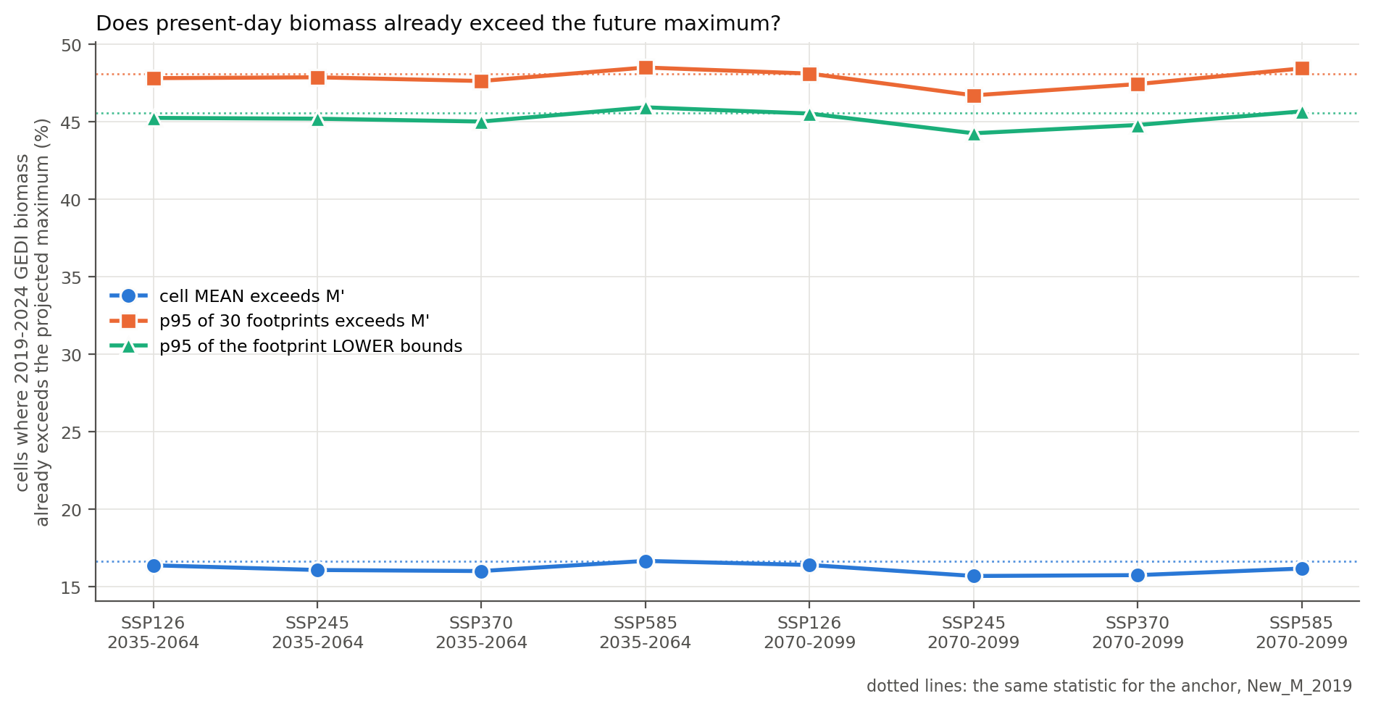
Figure 1. How often present-day GEDI biomass already exceeds each projected future maximum. Dotted lines are the same statistic for the anchor. The eight future layers sit on the anchor's lines rather than departing from them.
How to read it: each series is one of the three GEDI statistics, from least to most demanding of M'. A rising line from left to right would mean the projection lowers the ceiling into the standing biomass as forcing increases. No series does that; the ordering across scenarios is within the noise of the sample.

The exceedance that is already there
It is worth stating plainly what Table 1 also shows about the anchor, since the future layers inherit it: the upper envelope of GEDI exceeds M' in 48.1% of cells, and survives at 45.6% even when every footprint is pushed to the bottom of its 90 per cent interval. This is a pre-existing property of New_M_2019 in tall wet forest and is discussed in the present-day report. The future layers do not fix it, and no projection built by scaling that layer could.
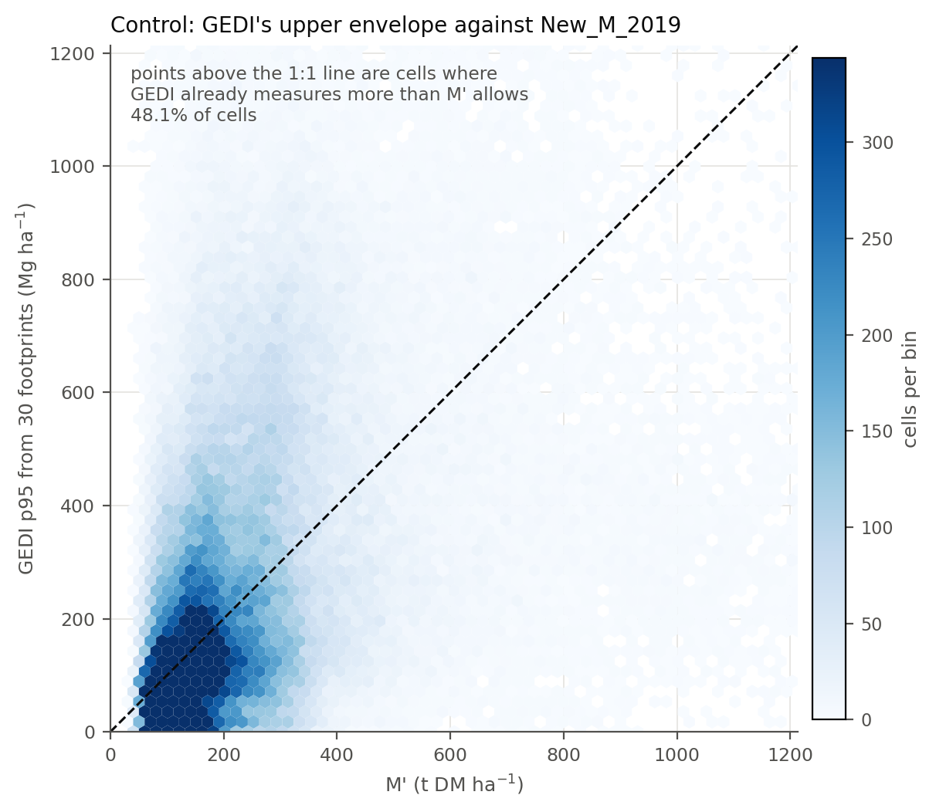
Figure 2. Control. GEDI's upper envelope against the anchor, cell by cell. Colour is cells per bin on a linear scale clipped at the 98th percentile. Cells above the dashed 1:1 line already carry more than M' allows.

Result 2 - the projected change is small where GEDI can see it, and it widens rather than shifts
layer | median future M' / anchor | 10th to 90th percentile | cells below the anchor
SSP126 2035-2064 | 1.003 | 0.954 to 1.081 | 45.4%
SSP245 2035-2064 | 1.010 | 0.882 to 1.127 | 38.8%
SSP370 2035-2064 | 1.008 | 0.911 to 1.129 | 41.2%
SSP585 2035-2064 | 0.991 | 0.920 to 1.103 | 58.5%
SSP126 2070-2099 | 0.996 | 0.925 to 1.104 | 54.2%
SSP245 2070-2099 | 1.016 | 0.952 to 1.199 | 39.3%
SSP370 2070-2099 | 1.008 | 0.877 to 1.224 | 43.9%
SSP585 2070-2099 | 0.987 | 0.843 to 1.221 | 56.7%

Table 2. Each future layer against the anchor, cell by cell, inside the GEDI domain.
The median cell moves by less than two per cent under any scenario - 0.987 to 1.016. What changes with forcing is the SPREAD: the 10th to 90th percentile band is 0.127 wide under SSP126 2035-2064 and 0.379 wide under SSP585 2070-2099. The projection is redistributing M' within this domain rather than shifting it, which is the same behaviour the comparison folder reports as a rising spatial coefficient of variation.
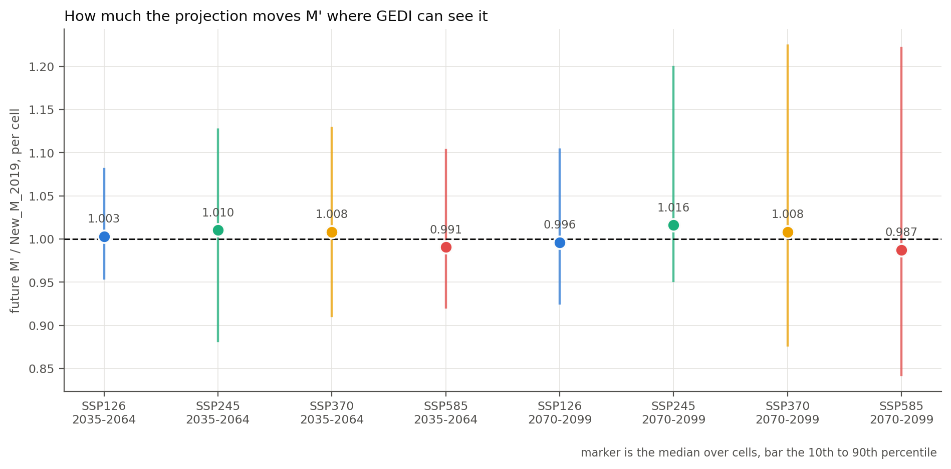
Figure 3. How much the projection moves M' where GEDI can see it. Marker is the median over cells, bar the 10th to 90th percentile, and the dashed line is no change.
This is the reason Result 1 could not have come out otherwise, and it is also this validation's main limitation. GEDI's footprints sit in tall wet forest along the east, the south-west and Tasmania - the part of the continent where the projected change is smallest. The deepest projected losses fall in low- and mid-biomass cells, which GEDI barely samples. A test that cannot see where the change is cannot be asked whether the change is right.

Result 3 - the mechanism, tested across space
This is the one part of the folder that speaks to whether the projected CHANGE is the right size. Future M' is present M' scaled by Eq1(FPI_future) / Eq1(FPI_hist), so the projection's whole assumption is how much biomass a change in FPI buys. GEDI cannot be asked about 2035-2100, but it can be asked the same question across space today: between two cells that differ in FPI, how much do they differ in biomass? The comparison is of log-log slopes, on closed evergreen-broadleaf cells only (79,527 of them), and it is a space-for-time substitution - reported as such, not as proof.
elasticity of biomass with respect to FPI | slope | what it is
Eq. (1), at the median FPI of 11.0 | 1.36 | the projection's own assumption
M' layers, across space | 1.11 to 1.18 | how the layers themselves vary with FPI
GEDI p95 from 30 footprints | 1.66 (95% CI 1.64 to 1.69) | the observed upper envelope
GEDI cell mean | 1.81 | the observed standing stock

Table 3. Log-log slopes. A slope of 1.4 means a 10 per cent rise in FPI goes with roughly a 14 per cent rise in biomass.
The observed gradient is STEEPER than the projection assumes. GEDI's upper envelope rises with FPI at 1.66 and its cell mean at 1.81, against 1.36 for Eq. (1) and 1.11 to 1.18 for the M' layers' own spatial variation. The confidence interval on the GEDI slope is narrow (1.64 to 1.69), so this is not a sampling artefact.
Read in the direction that matters, this says the projected change is more likely to be too SMALL than too large. Eq. (1) converts a given change in FPI into a smaller change in biomass than the observed spatial gradient would imply. If the space-for-time substitution holds, a future decline in FPI should move M' further than these layers move it.
Three reasons not to lean hard on that. A spatial gradient is not a temporal response: cells that differ in FPI also differ in species, soil and disturbance history, and a single site will not travel along the between-site curve as its own climate changes. GEDI's envelope is standing biomass, not a maximum, so its slope mixes the ceiling with how close stands have grown to it, and that closeness itself varies with productivity. And the comparison is restricted to closed evergreen-broadleaf forest, which is where the FPI range is narrowest.
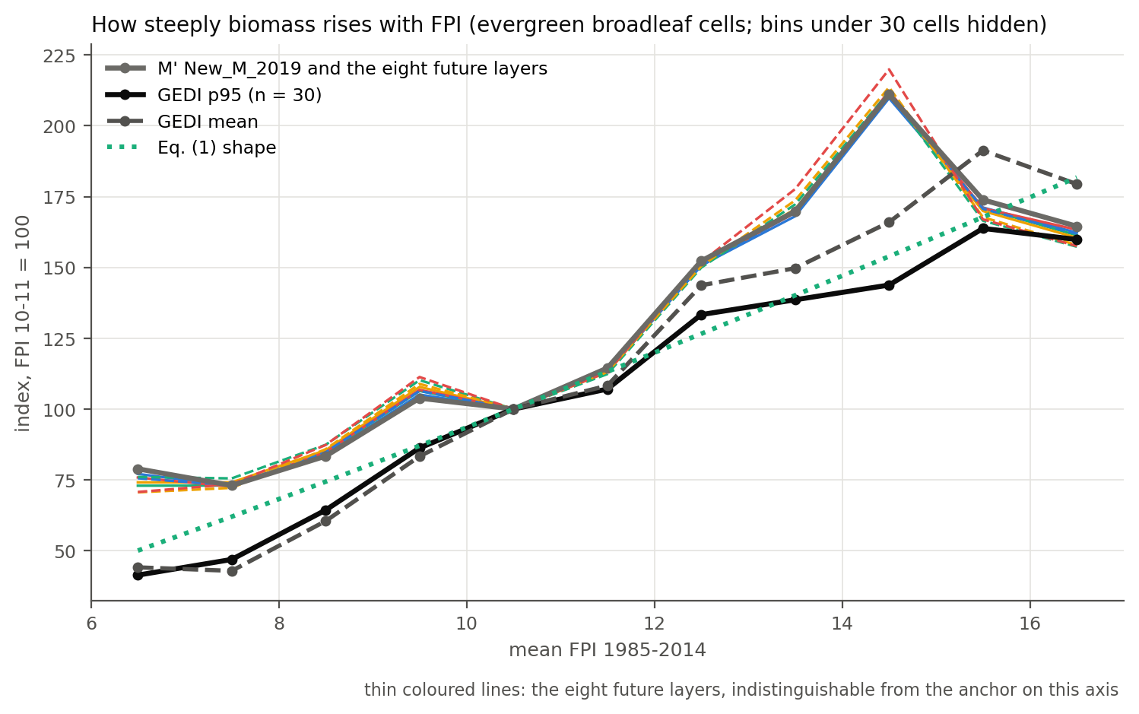
Figure 4. How steeply biomass rises with FPI, everything indexed to the FPI 10-11 bin so the comparison is of shape rather than level. The eight future layers are the thin coloured lines and sit on the anchor; GEDI is steeper than Eq. (1) throughout.

Where the exceedance falls
layer | FPI bin | cells | median M' | median GEDI p95 | mean exceeds | p95 exceeds
New_M_2019 (the anchor) | (0, 8] | 38,253 | 118 | 74 | 4.0% | 24.9%
New_M_2019 (the anchor) | (8, 10] | 31,084 | 163 | 174 | 16.5% | 48.2%
New_M_2019 (the anchor) | (10, 12] | 24,567 | 193 | 266 | 22.9% | 59.1%
New_M_2019 (the anchor) | (12, 14] | 17,587 | 265 | 375 | 23.6% | 59.9%
New_M_2019 (the anchor) | (14, 20] | 21,344 | 330 | 501 | 26.1% | 66.3%
SSP585 2070-2099 | (0, 8] | 38,253 | 111 | 74 | 4.4% | 27.8%
SSP585 2070-2099 | (8, 10] | 31,084 | 172 | 174 | 15.0% | 47.4%
SSP585 2070-2099 | (10, 12] | 24,567 | 193 | 266 | 22.2% | 58.8%
SSP585 2070-2099 | (12, 14] | 17,587 | 274 | 375 | 22.3% | 58.9%
SSP585 2070-2099 | (14, 20] | 21,344 | 330 | 501 | 26.4% | 65.7%

Table 4. By FPI bin, for the anchor and the most strongly forced future layer.
Exceedance rises steeply with FPI for every layer: the most productive cells are where GEDI most often measures more than M' allows. Between the anchor and SSP585 2070-2099 the pattern shifts slightly towards the least productive bin, where median M' falls and exceedance rises, while the top bins barely move. That is the same signature the continental comparison reports - the projected loss is concentrated in low- and mid-productivity cells - seen from inside the GEDI domain.
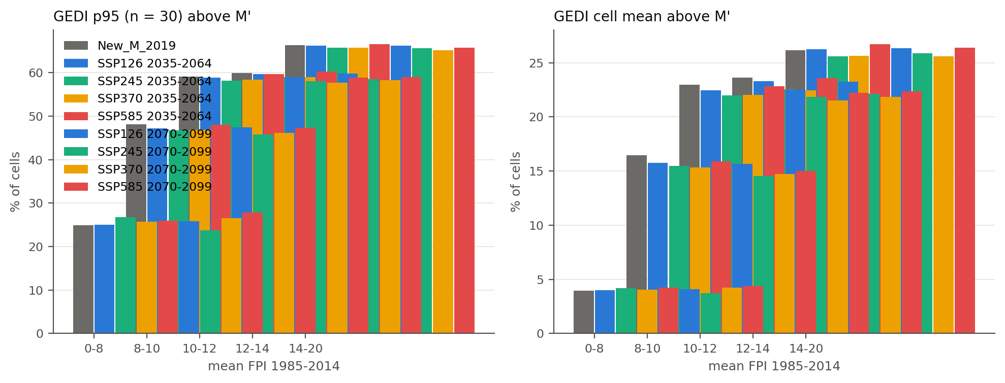
Figure 5. Exceedance by FPI bin, every layer.
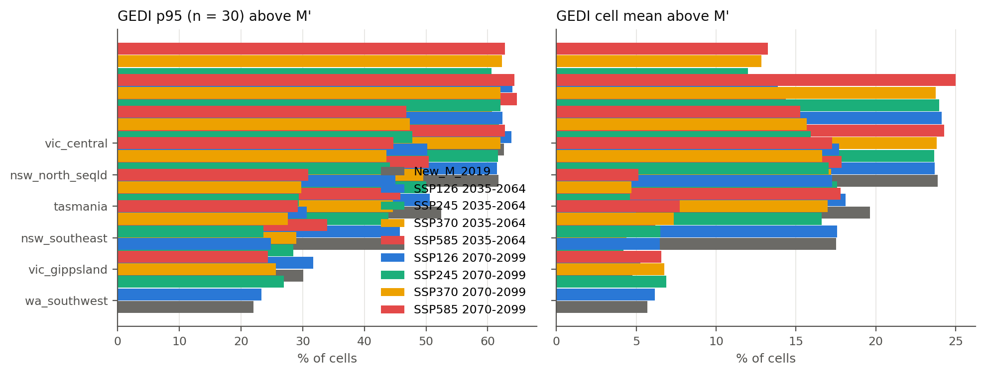
Figure 6. Exceedance by region, every layer.
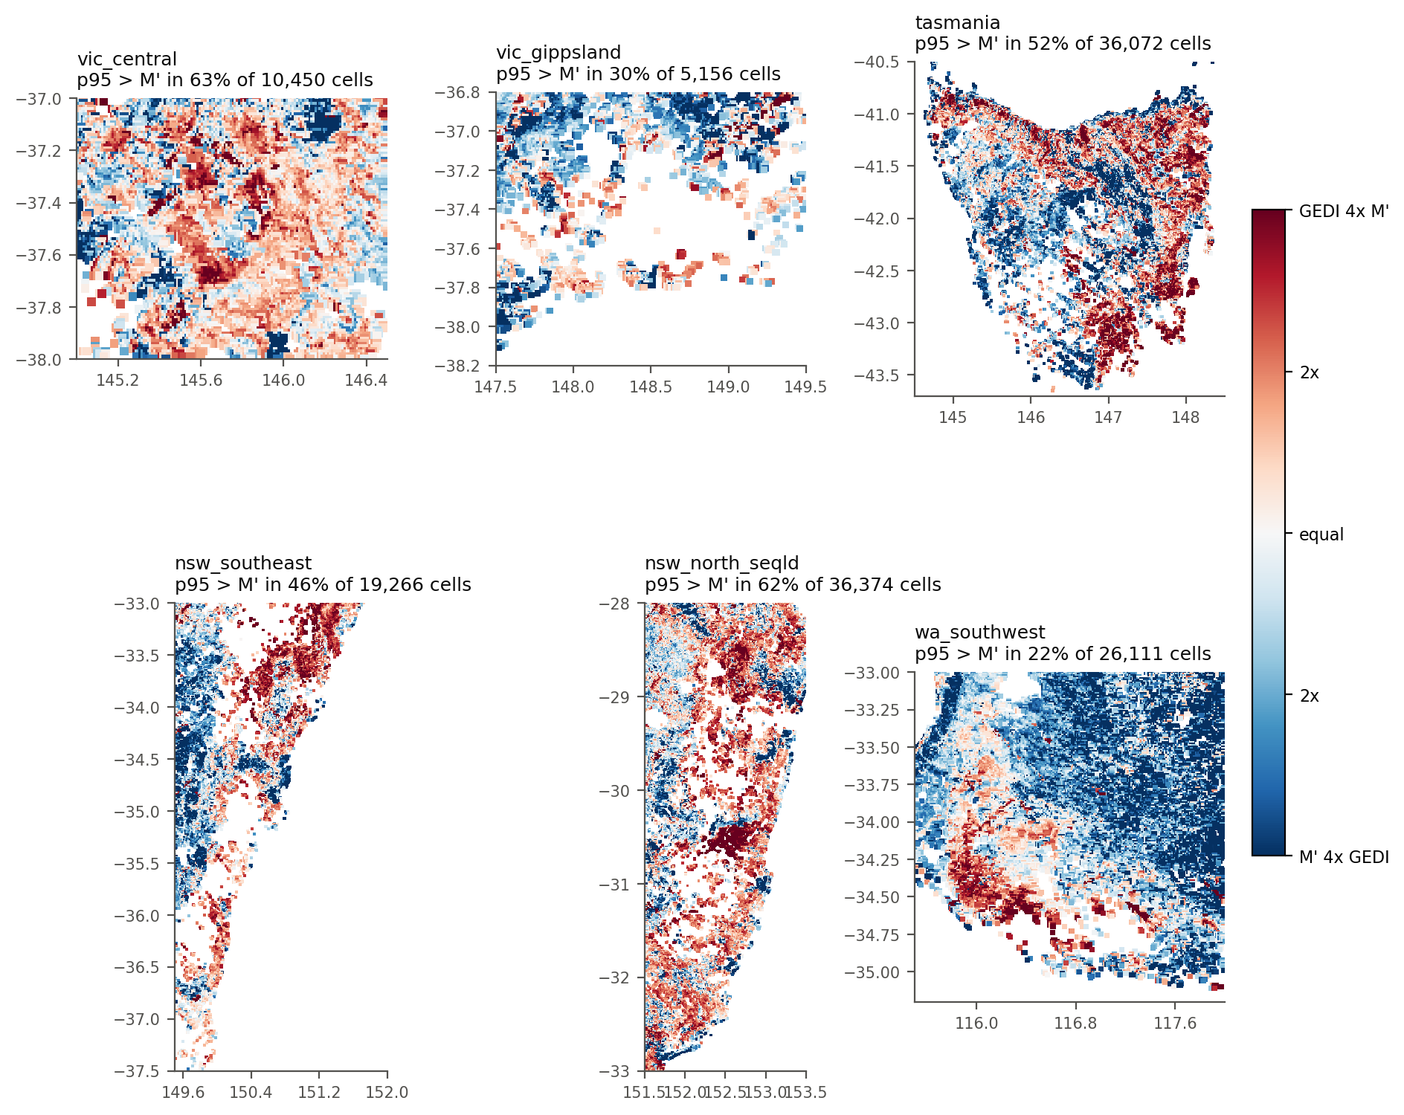
Figure 7. Where the exceedance is, mapped for the anchor.

What to conclude
GEDI does not contradict the future M' layers, and it cannot confirm them. What it does establish is that the projection inherits the anchor's existing ceiling problem without adding to it, and that the mechanism driving the projected change is conservative relative to the observed spatial gradient.
- Quote the exceedance rates as a statement about the anchor, not about the scenarios. They differ by about half a percentage point across eight layers, which is within what this sample can resolve.
- The projected change inside the GEDI domain is under two per cent in the median, and the domain is tall wet forest - the part of the continent where the change is smallest. This test is structurally unable to see the cells where the projection does most of its work.
- The elasticity comparison is the one result that bears on the size of the projected change, and it points towards the change being too small rather than too large. It is a space-for-time substitution and should be quoted with that caveat attached.
- The widening spread with forcing - a 10th-to-90th band that grows while the median barely moves - is consistent with the rising spatial coefficient of variation reported in FPI_Accuracy_check/Comparison_vs_New_M_2019, and is the clearest signal of the projection visible here.
- Nothing in this folder tests a projected level. It tests whether the projected ceiling is already contradicted by measured biomass, and whether the mechanism matches how biomass and FPI co-vary today.

Files
file | what it holds
Step_04b_attach_future_M.py | attaches the eight future layers to the cells Step 4 built
Step_05_analyse_vs_M.py | every statistic and figure
Step_06_write_future_M_report.py | this document
outputs/analysis/overall_by_layer.csv | Table 1
outputs/analysis/future_over_anchor.csv | Table 2
outputs/analysis/fpi_elasticity.csv | Table 3
outputs/analysis/by_fpi_bin.csv | Table 4
outputs/figures/fig1..fig6 | the figures in this report

