Run 3 - rebuilding biomass from the stem diameters
Space_time_validation/New_proposal/Run_03 · generated 2026-09-23 · the one run that needed new code

What was proposed, and what the data says
The proposal was that 12,505 Eucalyptus stems in 199 survey events carry the "single stemmed acacia trees" allometry, that their masses do not scale with diameter, and that recomputing those records with a eucalypt allometry would recover the Tasmanian Ausplots and part of the CSIRO set.
The first half checks out almost exactly. The second half does not survive testing, and the reason is more consequential than the proposal.
provider | stems | survey events | largest diameter (cm) | median mass (kg)
TERN Australia | 8985 | 49 | 479 | 3.7
CSIRO | 2857 | 133 | 148 | 28.1
Charles Darwin University (NT) | 609 | 6 | 40 | 6.7
Department of the Environment Australia | 17 | 8 | 45 | 111.8
OEH NSW | 2 | 2 | 21 | 42.5
Flinders University (SA) | 1 | 1 | 28 | 385.7

Table 1. Eucalyptus stems carrying the acacia model: 12,471 in 199 events, against the proposal's 12,505 in 199. The event count is exact.

Why the mis-assignment cannot be the cause
The correctly assigned stems fail exactly the same test.
test | value | note
Eucalyptus stems on the acacia model | 1.247e+04 | 199 survey events
spearman(diameter, mass), those stems | -0.169 | largest stem 479 cm assigned 0 kg
R2 of ln(mass) on ln(diameter), CORRECT eucalypt stems | 0.013 | slope -0.195 on 166,565 stems
median spearman within subplot | 0.0006 | 2435 subplots, 0.0% above 0.9
median spearman within subplot+model+species | -0.0044 | 2133 groups, 0.0% above 0.9
spearman(sum of stems / area, reported plot AGB) | 0.921 | a permutation preserves a sum

Table 2. The diagnosis.
Regressing log mass on log diameter for the 166,565 stems carrying the eucalypt model gives R2 = 0.013 and a negative slope. It is not a mixing artefact: holding the survey, the plot, the subplot, the allometric model AND the species all constant, the median Spearman between diameter and mass across 2,133 groups is -0.004, and not one group exceeds 0.9. In the largest single subplot a 0.89 cm stem is assigned 486 kg and a 98 cm stem 48 kg.
The library's own documentation says `diameter` is "the explanatory variable in the allometric model" and `agb_drymass` is the "above-ground dry standing biomass of tree/shrub (kg)". Within one model and one species, mass must therefore be an increasing function of diameter. In the delivered file it is not a function of diameter at all. The per-survey SUM is nevertheless sound - summed and divided by area it reproduces the site table at Spearman 0.92 - and a permutation preserves a sum. The mass column is not aligned, row for row, with the stem attributes beside it.
So the proposed fix cannot be carried out as specified. Identifying the mis-allometried records requires the model label to correspond to the species, and it does not: the same file assigns "Eucalypt trees" to Myrsine, Zanthoxylum and Ficus. No record's mass, model and diameter can be assumed to belong together, so there is no subset to recompute and merge back.
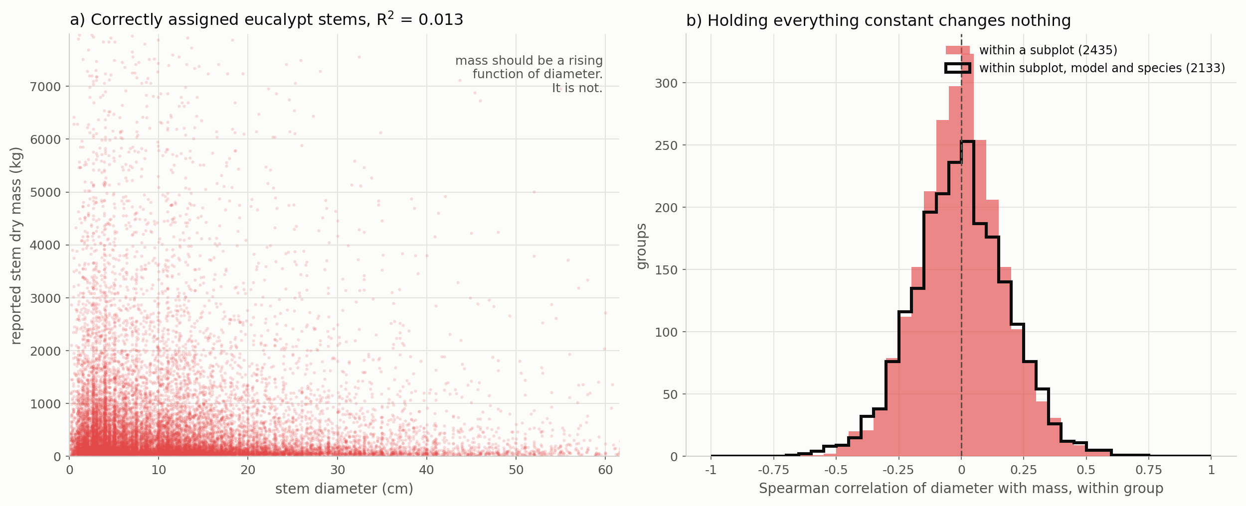
Figure 1. Panel (a) plots reported stem mass against diameter for the correctly assigned eucalypt stems. Panel (b) is the distribution of the within-group correlation, holding subplot, model and species constant.

What was done instead
The mass column is discarded and biomass is rebuilt from the diameters, which are a direct measurement, for all 2,009 surveys that carry stem data:
AGB(subplot) = a x sum(D^b) / subplot area, averaged over the subplots of the survey.
No external coefficients are imported, because none are needed. The exponent b sets the SHAPE - how strongly a plot's biomass is dominated by its largest stems, and therefore the order of plots - and it is varied across the plausible range for Australian trees, 2.3 to 2.7, rather than assumed. The constant a sets only the LEVEL, and is recovered from data already shown to be sound: it puts the median rebuilt plot biomass onto the median reported plot biomass. Shape from the stems, level from the library's own aggregate.

The check that matters
The rebuilt biomass is compared with `live_basal_area_ha`, which lives in the SITE table and was not used to build it. That is a genuine cross-file test - the tree list's diameters against the site list's basal area.
exponent | surveys | reported vs basal area | rebuilt vs basal area | rebuilt vs reported
2.3 | 1995 | 0.305 | 0.869 | 0.334
2.5 | 1995 | 0.305 | 0.868 | 0.297
2.7 | 1995 | 0.305 | 0.863 | 0.262

Table 3. The cross-file check.
The reported biomass tracks the independently measured basal area at Spearman 0.31. The rebuilt biomass tracks it at 0.87. And the two estimates agree with each other at only 0.30, so this is a substantial reordering of the observations, not a cosmetic one.
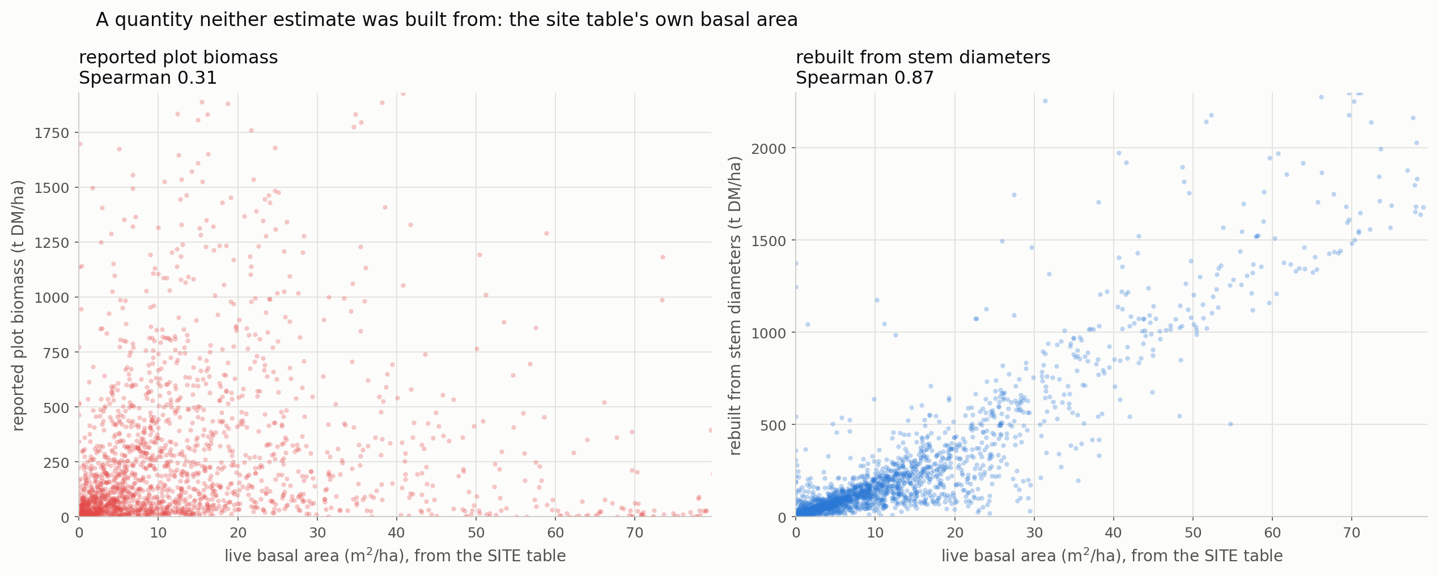
Figure 2. Both estimates against a quantity neither was built from.
The exponent is immaterial to the ordering: b = 2.3 and b = 2.7 rank the surveys identically at Spearman 0.989, and every result below moves by less than 0.003 across that range. The single assumption this rebuild makes does not carry the conclusion.

The result
The comparison is paired. `reported_stem_only` and `rebuilt_b2p5` contain the SAME 599 sites, matched the same way, against the same M'. The only difference is where the observed biomass came from.
configuration | sites | median AGB | present-day gate rho | ratio | future rho | null rho | gap
reported_all | 600 | 112.4 | 0.418 | 0.465 | 0.269 | 0.205 | +0.064
reported_stem_only | 599 | 112.6 | 0.416 | 0.464 | 0.268 | 0.207 | +0.061
rebuilt_b2p3 | 599 | 119.3 | 0.737 | 0.403 | 0.392 | 0.295 | +0.097
rebuilt_b2p5 | 599 | 124.3 | 0.732 | 0.386 | 0.390 | 0.292 | +0.098
rebuilt_b2p7 | 598 | 130.8 | 0.724 | 0.373 | 0.391 | 0.298 | +0.093

Table 4. Every configuration, analogue-found sites only.
The present-day gate - M' against observed biomass at the site's own cell, the most direct test in the whole validation - rises from a rank correlation of 0.416 to 0.732. The eight future runs rise from 0.268 to 0.390, and the gap to their own constrained null from +0.061 to +0.098. The paired control rules out the sample: restricting the published table to the same 599 sites reproduces the published numbers almost exactly.
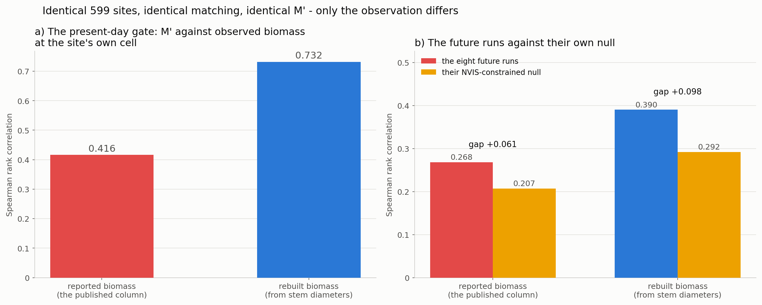
Figure 3. Identical sites, identical matching, identical M' - only the observation differs.
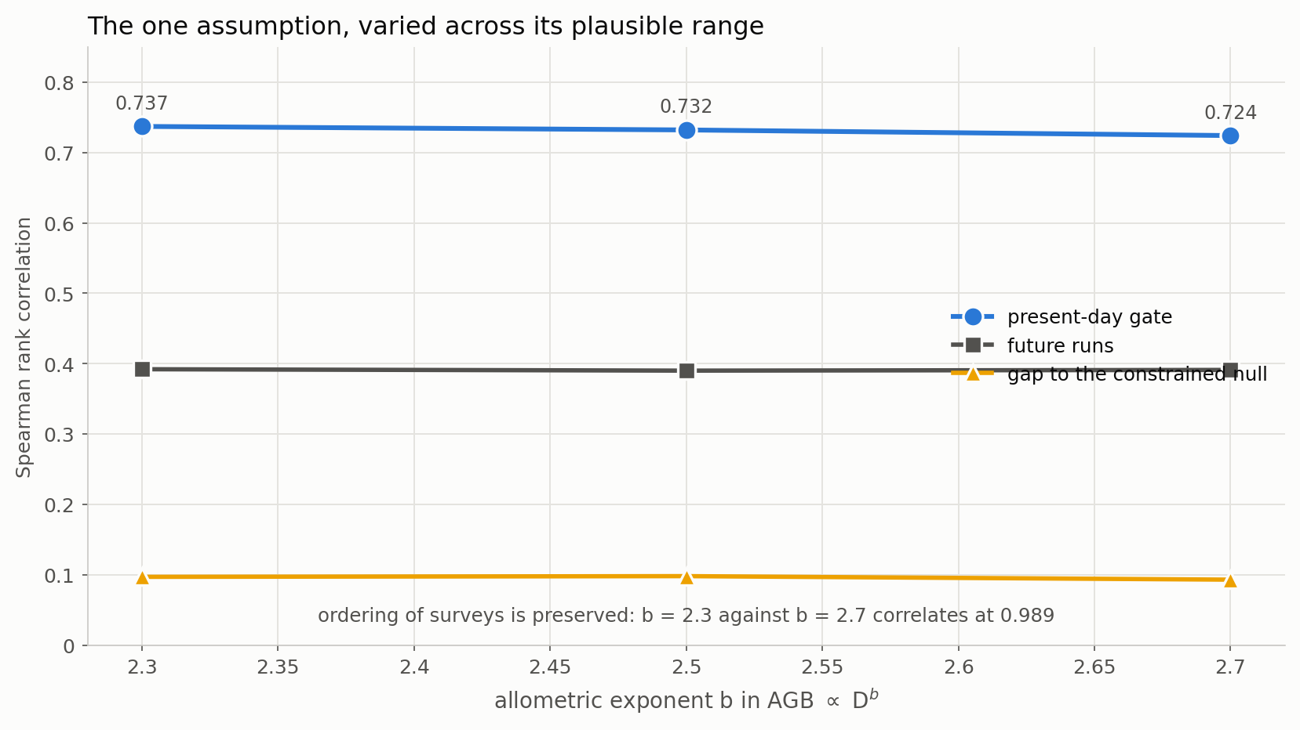
Figure 4. The one assumption, varied across its plausible range.

What it means for the published conclusion
The space-time validation reports that the present-day gate does not pass, on a rank correlation of about 0.42. On the same sites, with biomass rebuilt from the diameters, that correlation is 0.732. A substantial part of the failure was a property of the library's biomass column rather than of M'.

It also rescues the sources the filter was excluding
The AGB-versus-basal-area consistency filter was introduced because TERN Australia and CSIRO reported biomass that contradicted their own basal area. The rebuild removes the contradiction.
provider | surveys | AGB per m2/ha BA, before | after | passes before | passes after | median rebuilt AGB
DSITI Queensland Herbarium | 995 | 22.10 | 16.2 | 98% | 99% | 81
DELWP Victoria | 316 | 9.54 | 23.4 | 95% | 100% | 631
CSIRO | 246 | 15.22 | 16.2 | 75% | 100% | 167
University of Queensland | 105 | 36.90 | 13.9 | 99% | 100% | 230
Western Regeneration Pty. Ltd. | 73 | 51.07 | 18.5 | 100% | 100% | 197
Department of the Environment Aust | 54 | 13.07 | 40.0 | 98% | 100% | 89
TERN Australia | 53 | 0.08 | 31.6 | 6% | 98% | 2300
University of NSW | 35 | 87.25 | 8.6 | 100% | 100% | 6
OEH NSW | 31 | 3.44 | 25.4 | 77% | 100% | 283

Table 5. The consistency filter, before and after.
TERN Australia moves from 0.08 to 31.6 Mg of biomass per square metre per hectare of basal area, and from 5.7 per cent of its surveys passing the filter to 98.1. CSIRO moves from 74.8 to 100 per cent. The rebuild also repairs the anomaly Run 2 flagged: University of NSW falls from a ratio of 87 to 8.6, inside the plausible range.

One limitation this exposes
A single global scale constant does not suit every plot. TERN's rebuilt median is about 2,300 t DM/ha, which is at or beyond the top of anything Australian forest carries, because those are one-hectare plots holding stems up to 479 cm and a power law rewards them heavily. The ORDERING of those surveys is now sensible and they are no longer excluded wholesale, which is what the run set out to achieve; their absolute LEVEL should not be quoted. More generally, because the constant is calibrated to the library's own median, the ratio of M' to observed biomass is not independent of the library and the rank correlation is the robust result here.

What to conclude
- The proposal's premise was right and its diagnosis was wrong. The 12,471 stems are real, but the mis-assigned model is not the cause - the correctly assigned stems behave identically, so the fault is that the mass column is not aligned with the stem attributes.
- Rebuilding from diameters is the fix, and it works. Against the site table's independently reported basal area the rebuilt biomass scores 0.87 where the reported column scores 0.31.
- The present-day gate largely passes once the observation is sound: rank correlation 0.732 against 0.416 on identical sites. This is the single largest change any run in this study has produced, and it is attributable to the observation rather than to the sample.
- The consistency filter can be retired for these sources. It existed to exclude TERN and CSIRO wholesale; with the rebuild they pass on their own merits.
- Quote the ranking, not the level. The scale constant is calibrated to the library's own median, so the ratio is not independent of it, and TERN's rebuilt level in particular is not credible.
- This should be reported to the library's custodians. The defect is in the delivered file rather than in anything done here, and it affects every stem-level use of the National Biomass Library.

Files
file | what it holds
Step_01_diagnose_allometry.py | the diagnosis
Step_02_recompute_agb.py | the rebuild and the reference tables
Step_03_run_and_compare.py | the five configurations
Step_04_plots.py | figures 2 to 4
Step_05_write_report.py | this document
outputs/allometry_diagnosis.csv | Table 2
outputs/rebuild_checks.csv | Table 3
outputs/run03_headline.csv | Table 4
outputs/agb_rebuilt_by_survey.csv | the rebuilt biomass per survey
outputs/reference_table_rebuilt_b*.csv | one per exponent

