Run 2 - a plot-area floor instead of the maturity filter
Space_time_validation/New_proposal/Plot_area_floor_method · generated 2026-09-23 · six floors, against Run 0 and Run 1

Why this run follows from Run 1
Run 1 removed the likely-mature half and the result improved. But the diagnostic that motivated it found the mechanism, and the mechanism was not maturity. The two classes carried almost the same observed biomass - 117.5 against 109.8 Mg/ha - while the likely-mature group reported 17.4 Mg of biomass per square metre per hectare of its own live basal area against 7.3, from plots 40 per cent smaller. A per-hectare figure from a smaller plot is the same few trees divided by less ground. That group is not less mature; it is more inflated.
If that is right, the maturity threshold is a proxy and filtering on the thing itself should do better. It should also be cheaper: the maturity filter discards every site with no stem data at all - 1,088 of 1,688 - whether or not those sites are well measured. A plot-area floor keeps them.
Everything else is held at Run 0: NVIS-constrained matching, Eq. (1) of the window-mean FPI, all 174 predictors, PCA to 95 per cent of the historical variance, the 99th percentile no-analogue cutoff. Both nulls are computed in every configuration and every metric comes from the analogue-found stratum, as in every run of this study.

The floor does remove the inflation
floor | sites | median plot (ha) | median AGB per m2/ha basal area
none (Run 0, mature) | 600 | 0.24 | 10.2
0.10 ha | 1326 | 0.25 | 7.1
0.20 ha | 871 | 0.40 | 6.3
0.25 ha | 676 | 0.50 | 5.2
0.30 ha | 607 | 0.50 | 5.0
0.40 ha | 584 | 0.50 | 4.8
0.50 ha | 365 | 0.50 | 4.0

Table 1. What each floor does to the sample.
Biomass per unit basal area falls monotonically as the floor rises, from 10.2 with no floor to 4.0 at 0.50 ha. That is the inflation being removed, and it is removed directly rather than through a proxy. Note the sample sizes: at 0.25 ha the sample is LARGER than Run 0's 600 and carries half the inflation, because the floor keeps the unverified sites the maturity filter discards.

The ratio rises past 1 - and so does its null
Raising the floor does two things at once. It removes the inflation, which is the point. But it also lowers the observed biomass of whatever survives, because larger plots report less biomass per hectare. So any ratio of M' to observed biomass rises as the floor rises, for every M' INCLUDING a randomly chosen one.
configuration | sites | median ratio | its NVIS-constrained null | difference
mature_nofloor | 600 | 0.465 | 0.445 | +0.020
verified_nofloor | 327 | 0.557 | 0.478 | +0.079
area_010 | 1326 | 0.891 | 0.777 | +0.114
area_020 | 871 | 0.917 | 0.817 | +0.100
area_025 | 676 | 1.204 | 0.992 | +0.212
area_030 | 607 | 1.274 | 1.141 | +0.133
area_040 | 584 | 1.275 | 1.102 | +0.173
area_050 | 365 | 1.441 | 1.255 | +0.185

Table 2. The ratio against the null that moved with it.
The headline is striking: M'/AGB rises from 0.465 under Run 0 to 1.275 at the 0.40 ha floor, which puts M' ABOVE observed biomass - the direction a maximum should err in, and the opposite of the under-prediction the published gate reports. The failure of the present-day gate is largely an artefact of small plots, not a property of M'.
But the null does the same thing, from 0.445 to 1.102, so the ratio alone proves nothing. This is exactly why both nulls are carried through every run of this study.
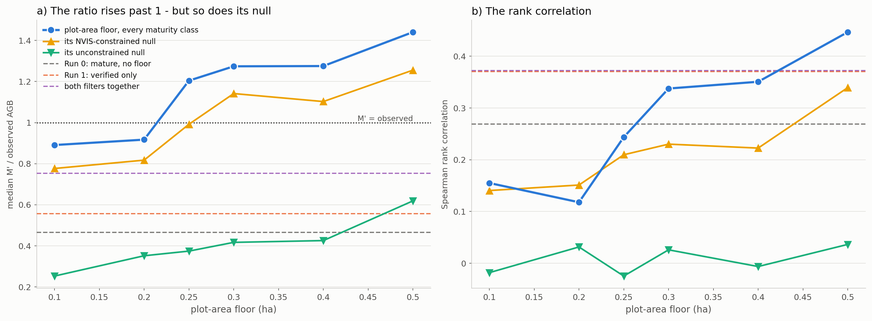
Figure 1. The sweep, with both nulls drawn in and Run 0, Run 1 and the combined filter as horizontal references.

The gap to the null is where the answer is
Subtracting each configuration's own null leaves what the matching actually contributes. On that axis the floor beats the maturity filter, and it does so while keeping far more sites.
configuration | sites | rho | null rho | gap vs constrained null | gap vs unconstrained null | no-analogue
mature_nofloor | 600 | 0.269 | 0.205 | +0.064 | +0.240 | 16.1%
verified_nofloor | 327 | 0.371 | 0.286 | +0.084 | +0.426 | 19.4%
area_010 | 1326 | 0.155 | 0.141 | +0.015 | +0.173 | 13.8%
area_020 | 871 | 0.118 | 0.151 | -0.033 | +0.086 | 14.1%
area_025 | 676 | 0.244 | 0.210 | +0.034 | +0.268 | 14.7%
area_030 | 607 | 0.338 | 0.230 | +0.107 | +0.312 | 14.6%
area_040 | 584 | 0.351 | 0.223 | +0.128 | +0.357 | 14.9%
area_050 | 365 | 0.447 | 0.339 | +0.107 | +0.410 | 16.8%
area_025_mature | 298 | 0.372 | 0.380 | -0.007 | +0.408 | 16.4%

Table 3. Both gaps, every configuration.
The best configuration is area_040: 584 sites, a gap of +0.128 to the constrained null against Run 0's +0.064 and Run 1's +0.084. It retains 79 per cent more sites than Run 1 and returns a gap half again as large.
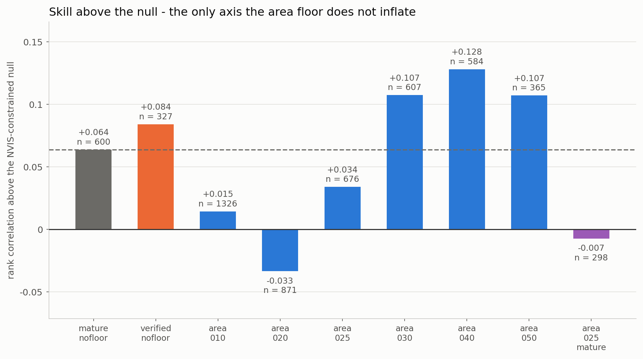
Figure 2. Skill above the constrained null - the only axis the area floor does not inflate. The dashed line is Run 0.
Two results in that figure deserve comment rather than celebration. The sweep is not monotone: the 0.20 ha floor falls BELOW its own null at -0.033 while 0.10 and 0.25 sit above it. With a few hundred sites and a rank correlation this small, differences of 0.03 to 0.05 are within what the sample can resolve, so the useful reading is the block from 0.30 ha upward, where the gap is consistently 0.107 to 0.128, rather than any single floor.
And applying BOTH filters together is worse than either alone: 0.25 ha plus the maturity filter leaves 298 sites and a gap of -0.007, below zero. The two are redundant, not complementary - they remove the same records - and stacking them removes the variation the matching needs in order to have anything to rank.
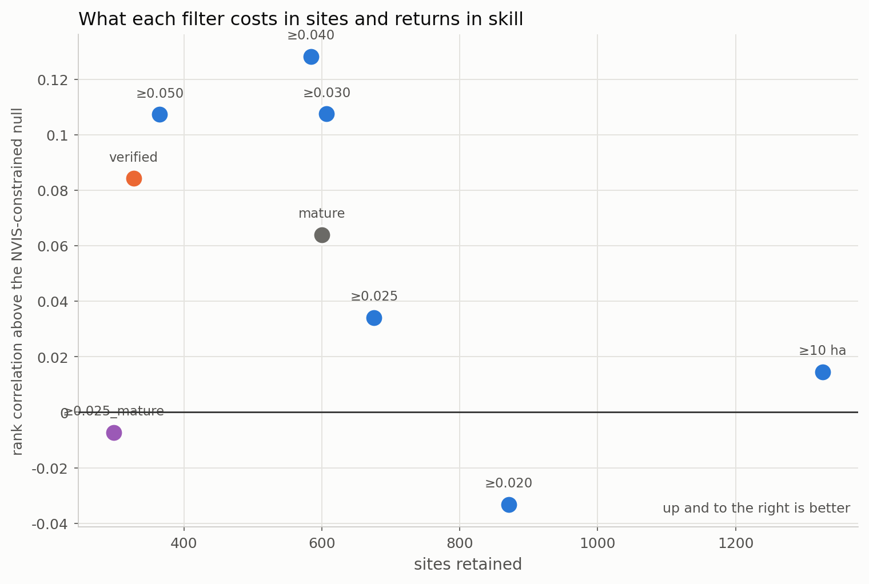
Figure 3. What each filter costs in sites and returns in skill.

What to conclude
- Run 1's hypothesis was right about the effect and wrong about the cause. The likely-mature half was dragging the numbers down, but because those plots are small, not because those stands are immature.
- A plot-area floor is the better filter. At 0.40 ha it keeps 584 sites against Run 1's 327 - 79 per cent more - and returns a gap to the constrained null of +0.128 against Run 1's +0.084.
- The present-day gate failure is largely an artefact. With a 0.40 ha floor M'/AGB is 1.275 rather than 0.465 - M' sits above observed biomass, which is what a maximum should do. That is a statement about the library's plot sizes, not a vindication of M', because the null moves the same way; but the published under-prediction should not be quoted without it.
- Do not stack the two filters. Together they leave 298 sites and no skill above the null at all.
- Choose the floor from the 0.30-0.50 ha block, not from a single value. The sweep is not monotone below 0.30 ha and the differences there are within what a few hundred sites can resolve.
- This remains a one-change test against Run 0 and inherits its limits: the late-century high-forcing windows are extrapolation under every configuration, and no floor repairs that.

Files
file | what it holds
Step_01_run_area_floors.py | the nine configurations
Step_02_compare.py | the comparison and the figures
Step_03_write_report.py | this document
outputs/config_matrix.csv | what each configuration is
outputs/area_floor_summary.csv | one row per configuration per run
outputs/area_floor_comparison.csv | Tables 1-3
outputs/<config>/matches.csv | site-level matches
plots/fig_01..03 | the figures in this report

