Validating M′ with GEDI L4A
The full chain from Step 0 (raw data) to future maximum aboveground biomass, and what GEDI lidar can and cannot say about it. Six forested regions of eastern and south-western Australia.
Built 17 September 2026 by make_validation_gedi_report.py. Every result number is read from the CSV outputs at build time.

Summary
M′ is the biomass a site can reach at maturity. The FullCAM future inputs are future M′ for four SSPs over 2035-2064 and 2070-2099. GEDI measured forest structure from 2019 to 2024, so it cannot observe future M′ directly. It can test the two things future M′ is built from: the present-day level of M′, and how steeply biomass rises with the Forest Productivity Index (FPI), which Eq. (1) turns into the projected change. This report does both, against two present-day M′ layers, in six forested regions: vic_central, vic_gippsland, tasmania, nsw_southeast, nsw_north_seqld and wa_southwest.
 | New_M_2019 | baseline_M_1985-2014
What it is | FullCAM historical input; matched footing (Option B) | Eq. (1) footing (Option A); used by the paper and current FullCAM future inputs
NLUM cells compared (fire-excluded) | 133,429 | 133,429
Median M′ in these cells (t DM/ha) | 189.7 | 223.2
Median GEDI p95, fixed n = 30 (t DM/ha) | 196.8 | 196.8
Cells where GEDI cell MEAN > M′ | 16.7% | 12.8%
Cells where GEDI p95 (n = 30) > M′ | 48.1% | 41.0%
Same, footprints pushed to lower 90% bound | 45.6% | 38.8%
Spearman rank correlation, M′ vs GEDI p95 | 0.52 | 0.52
Log-log slope vs FPI, M′ (GEDI p95: 1.66) | 1.16 | 1.00

Finding 1. The ranking of M′ is right, but only moderately. Pooled over the six regions, both layers rank cells the way GEDI does (Spearman 0.52 and 0.52), and the correlation is positive in every region, from 0.20 (nsw_southeast) to 0.74 (vic_central). The −0.60 once found in 77 library plots does not appear, but the vic_central pilot overstated how well M′ ranks cells elsewhere.
Finding 2. M′ is too low in productive closed forest, under either footing, and not in open or cleared country. GEDI's upper envelope (p95) is above M′ in 48.1% of cells for New_M_2019 and 41.0% for baseline_M, and the cell mean, which includes gaps, young regrowth and logged coupes, is above the supposed maximum in 16.7% and 12.8%. Exceedance rises with FPI, from 24.9% of cells at FPI ≤ 8 to 66.3% and 61.9% in the most productive cells, and it differs by region, from 22.0% in wa_southwest to 62.6% in vic_central. Pushing every footprint to the bottom of its 90% interval removes only 2.5 percentage points.
Finding 3. baseline_M fits GEDI better, but not for a reason that justifies choosing it. In these cells baseline_M is 1.17× New_M_2019 (median; ×1.46 nationally for Eq. (1) against Original_M_2004), and its extra height comes from mixing Eq. (1) with a lambda that was divided by a different M. A layer that is too high by construction happens to sit closer to a ceiling that GEDI says is too low. Both layers fail the envelope test in more than 40% of cells.
Finding 4. For future M′, the projected change is more likely conservative than exaggerated. Future M′ moves with Eq1(FPI), whose elasticity at the median FPI of closed evergreen broadleaf cells (11.0) is 1.36. Across space, GEDI p95 rises with FPI at a log-log slope of 1.66 [1.64, 1.69], about 1.2× as steep, and it is steeper than Eq. (1) in 5 of 6 regions. The gap sits mainly below FPI 10; above it GEDI follows the Eq. (1) shape closely (Figure 4). This is milder than the roughly twofold gap in vic_central alone, and in the same direction as the earlier national analysis (Option B Suggestion 4). Space-for-time is not proof: across space, FPI also tracks species, stand age, clearing and terrain.
Scope
Six regions chosen for tall and open eucalypt forest, not a sample of Australia: they cover 133,429 NLUM cells with at least 30 unburnt footprints, against 6,956,407 land cells nationally. Rates are pooled over these regions and must not be quoted as national rates. Each box also takes in cleared land (most of all the wheatbelt edge of wa_southwest), which lowers the pooled rates.

1. What is being validated
Roxburgh et al. (2019) Eq. (1) links M, the maximum aboveground biomass, to FPI:
M = (6.011 × √FPI − 5.291)² t DM/ha (Eq. 1)
M′ = λ × M (Eq. 3)
The projection in this repository makes future M′ by scaling a present-day M′ by the Eq. (1) ratio of future to historical FPI:
M′_future = M′_present × Eq1(FPI_future) / Eq1(FPI_1985-2014)
So future M′ is right only if two things are right:
- the present-day level M′_present, which GEDI can test directly, because 2019-2024 is 'present' to within the uncertainty of the layer; and
- the response, how much M′ moves when FPI moves. GEDI can test this only indirectly, by comparing how biomass varies with FPI across space with what Eq. (1) assumes.
Future FPI itself is validated separately, by the random forest's year-group cross-validation (Section 2.4). GEDI adds nothing there.

1.1 Why the test is an envelope, not a regression
M′ is a maximum. GEDI measures what stands today, after clearing, logging, fire and a century of disturbance. GEDI below M′ is expected and proves nothing. GEDI above M′ is the only direct evidence against it. So the headline statistics are exceedance rates, not R², and three GEDI statistics are used, from strongest to weakest evidence:
Statistic | Exceeding M′ means | Weakness
Cell mean AGBD | The whole 1 km cell, gaps and all, already carries more than its supposed maximum | Can be dragged down by clearing, so it understates exceedance
p95, fixed n = 30 | The upper envelope of stands in the cell is above M′ | Single-footprint error inflates upper percentiles
p95 of lower bounds | The same, with every footprint pushed to agbd − 1.645 × agbd_se | Conservative by construction

Units: M′ is t DM/ha of aboveground dry matter; GEDI L4A publishes AGBD in Mg/ha of aboveground dry biomass. 1 Mg (megagram) = 1 t, so the two are numerically identical, no conversion is applied, and every GEDI value in this report and its figures is written in t DM/ha. The same assumption was made in every earlier GEDI and ESA CCI comparison in this repository.

2. The pipeline from Step 0 to future M′
Paths are relative to 000_Zohreh_paper_1_refactor/. All rasters share the NLUM 2010-11 grid: 3364 × 4071 cells, 0.01°, GDA94 (EPSG:4283), 6,956,407 valid land cells.

2.1 Step 0: downloads and NLUM matching
Status
Step_0_download_data/ is deleted from the working tree. Its eight scripts survive in git HEAD (commit e82499f) and their outputs are on disk. Restore it before the pipeline can be re-run end to end.
Script | What it produced
download_CSIRO_historical_data.py | BARRA-R2 daily 1985-2014 from CSIRO DAP csiro:64206: 9 variables × 30 years, 270 files, 109 GB. Pre-signed S3 URLs, re-signed mid-download.
reproject_CSIRO_historical_to_NLUM.py | Daily → 12 monthly bands, then clip → aggregate → match to NLUM → nearest-fill → mask.
(CSIRO_future_data.md) | QDC-CMIP6, ACCESS-CM2 r4i1p1f1, 4 SSPs, 2035-2064 and 2070-2099 only: 2,160 files, 719.8 GB. Each future year is an observed BARRA-R2 year rescaled by a change factor. The download/reproject scripts it cites are not on disk or in git.
download_fpi.py | FPI v1.0 (DCCEEW, Sept 2024): 37 tiles × 53 years (1970-2022), URLs read from the CKAN API.
mosaic_match_fpi_NLUM.py | Mosaic per year, snap half a cell onto NLUM → Data/Processed/fpi/fpi_<year>.tif.
get_revised_MaxAbgM_and_lambda.py | New_M_2019 → Data/Processed/maxAbgM_v2/New_M_2019.tif (average resampling), plus the legacy transfer factor, now renamed transfer_Eq1M_to_NewM_1970_2002.tif.
download_worldclim_*.py, reproject_match_NLUM.py | The earlier WorldClim route, superseded by the CSIRO route.

Also on disk: Data/Raw/maxAbgM_v1_Ratio/Original_M_2004.tif and Ratio_OriginalM_to_NewM.tif (DCCEEW v1.0), and Data/Raw/maxAbgM_v2/New_M_2019.tif (v2.0).

2.2 Soil predictors (Download_soil_data/)
Step_01_download_SLGA.py to Step_05_soil_for_FPI_report.py: 11 SLGA attributes × 6 depths from CSIRO DAP, average-resampled to NLUM. 31,451 gap cells (0.45%, mostly salt lakes) are filled and flagged. In the soil test (soil_rf_results.json), spatial-CV R² rises from 0.940 with climate only to 0.953 with climate, N, P and aggregated soil.

2.3 Climate: climatologies, deltas and open pan
Folder | Role
Calculation_CSIRO_avg/ | 72 twelve-band monthly climatologies (8 variables; historical + 4 SSPs × 2 windows) → Data/Processed/CSIRO_avg/. CSIRO_avg_report.md.
Calcluation_ANUCLIM_avg_1985-2014/ | ANUClimate 1985-2014 averages for 6 variables on NLUM, the observational base FullCAM uses.
Step_02_Calculate_CSIRO_delta/ | Future − historical deltas, 64 layers. tasmax +1.78 °C (SSP126 mid) to +5.80 °C (SSP585 late); pr −0.8% to −13.9%. Reporting only, not an RF or M input.
Calculation_Open_pan_CSIRO_data/ | SILO pan → Kp → ETo → open pan; −0.9% against ANUClimate 1995-2014. FullCAM input only.

2.4 Random forest for FPI (Random_forest_CSIRO/)
Run order (README.md): Step_00_audit, 01_aggregate_climate, 02_build_training_table, 02b, 03_build_model, 04_predict_future, 04b, 05_plots, 07_scenario_diagnostic, 06_write_report, 08_scatter.
One row per cell-year over 1985-2014: 2,086,920 rows and 174 predictors. The predictors are 83 static soil bands plus 7 BARRA-R2 climate variables (hurs, hursmax, hursmin, pr, rsds, tasmax, tasmin), each as 12 monthly values and 1 annual. The target is observed FPI for the same year. Model (data/model_card.txt): RandomForestRegressor, 64 trees, max_features 1/3, min_samples_leaf 5.
CV scheme (data/cv_metrics.csv) | R² | RMSE | MAE | MAPE
Random k-fold | 0.9775 | 0.429 | 0.249 | 5.7%
Spatial blocks | 0.9321 | 0.745 | 0.446 | 11.0%
Year groups (quote this one) | 0.9305 | 0.754 | 0.548 | 17.5%

The year-group score is the honest one for projection: whole years are held out, so the model is scored on climate it did not train on. Top predictors are SOC 0-5 cm, annual relative humidity and annual rainfall. Future FPI is predicted for every year in both windows (output/fpi_<ssp>_<year>.tif, 240 files) and averaged per window. Two caveats from the RF report: scenarios are not ordered by forcing, because FPI tracks humidity and rainfall (r = +0.97) more than temperature, and a random forest cannot extrapolate beyond the training climate.

2.5 Future M from future FPI (Calculation_future_M_CSIRO/)
Script | What it does
Step_06_Calculating_Future_MAGB.py | Eq. (1) on each annual FPI. FPI below the root 0.7748 gives M = 0. Writes annual M, window means, and Eq. (1) of the window-mean FPI (Jensen gap about +0.9 to +1.2 t/ha, ~2%).
Step_07_export_netcdf.py | NetCDF cubes.
Step_08_apply_published_lambda.py | Eq. (3) with the published λ = New_M_2019 / Original_M_2004 (median 1, exactly 1 on 42.6% of cells, max 14.16). --footing eq1 (default) gives Option A; --footing original2004 gives Option B.
Step_09/10 | Maps; scatter against New_M_2019.

2.6 The two footings, and why both are tested here
λ is only valid against the M it was divided by. Published λ = New_M_2019 / Original_M_2004, but Eq. (1) of historical FPI overstates Original_M_2004 by a median factor of 1.46. So:
 | Option A: Eq. (1) footing | Option B: matched footing
Future M′ | λ × Eq1(FPI_fut) | λ × Original_M_2004 × Eq1(FPI_fut) / Eq1(FPI_hist)
Present-day layer it sits on | baseline_M_1985-2014.tif (Writing_paper_01/output/) | New_M_2019.tif, identical to historical M′ on this footing
Level | ×1.46 above B nationally | consistent with FullCAM's historical maxAbgMF
% change | identical to B | identical to A
Used by | Writing_paper_01 results; FullCAM_input_CSIRO_data/M/ | Option_B_matched_footing/fullcam_inputs/ (recommended in Footing_decision_M_prime.docx, not yet adopted)

Option B future M′ medians (fullcam_inputs_summary.csv): 16.2 to 21.1 t/ha across scenarios and windows. With Option A inputs, FullCAM would see a jump of +26% to +71% at the boundary between historical and future inputs, purely from the footing.
Unresolved: which historical baseline
Projected change depends on how the 1985-2014 baseline is built. Against Eq. (1) applied year by year and then averaged, change ranges from -23.2% to -3.1%. Against Eq. (1) of the mean FPI, it ranges from -18.6% to 1.1%, and two windows change sign (Option_B_matched_footing/outputs/baseline_orders.csv, Two_historical_baselines.docx). No decision is recorded.

2.7 What the paper reports
Writing_paper_01/output/results_summary.csv, area-weighted over the NLUM mask on the Option A footing: mean M falls 2.7% to 14.7% from a baseline of 61.5 t DM/ha, while FPI falls 1.5% to 9.7%. The loss in M is larger than the loss in FPI because Eq. (1) is convex. The paper makes no validation or GEDI claim.

2.8 Validations of M before GEDI
Validation | Result | Limitation
Level 1: FullCAM input = New_M_2019 | Max difference 0.0 | Identity check only
Level 2: FPI elasticity from library plots | 1.37 [0.73, 1.78] at τ = 0.75 against theory 1.49 (pass). Eucalypt tall/open forest: −2.62, ρ = −0.60 (n = 77) | Small sample; τ = 0.90 unstable
Validation_M: 1,009 National Biomass Library records | Verified mature stands above M′: 38.2% (Eq. 1 footing), 48.8% (Original_M_2004 footing) | Up to 98.9% possible overlap with Roxburgh's calibration plots; circular
GEDI L4B 1 km means, national (Option B Level 4) | Forest ≥ 50%, unburnt since 2009: 6.3% (New_M_2019), 2.7% (baseline) of cells above M′; up to ~50% in the top FPI bin | A cell mean, not an envelope; the 1 km L4B grid is not NLUM's grid
Option B Suggestions 1-4 (L4B forest-only, ESA CCI, L4A hotspots, elasticity) | L4A hotspots: fixed-n p95 above baseline M′ in 57.4% of cells. Every Spearman ρ positive (+0.35 to +0.73). Forest elasticity 1.9-2.3, steeper than Eq. (1) | Hotspots chosen where exceedance was already known; bootstrap intervals shown to be optimistic

The L4A footprint pipeline written for that work (Option_B_matched_footing/Validation/files/) was never run. Validation_GEDI/ is its corrected version. It was first run on vic_central alone and is reported here for all six regions.

3. The corrected GEDI pipeline (Validation_GEDI/)
Step | What it does | Output
common.py | NLUM grid from the mask's own transform; Earthdata credentials from .netrc; the six regions; PROJ database pinned to rasterio's own | —
Step_01_check_sources.py | Proves the grid and name fixes; counts granules and GB per region; needs no login | outputs/source_check.csv
Step_02_build_fire_mask.py | MODIS MCD64A1 v061 burned area, 2009-2025, one NLUM raster per year | fire/burn_year_<y>.tif, last_burn_year.tif
Step_03_fetch_gedi.py | GEDI L4A v2.1 footprints: download, filter, assign NLUM cell, delete granule; checkpoint per granule | outputs/gedi_parts/<region>/, gedi_l4a_footprints.parquet
Step_04_aggregate_cells.py | Fire flags; per-cell mean, median, p95, fixed-n p95, p99; sample M′ and FPI at the same cell | outputs/gedi_cells_{all,unburnt}_<tag>.csv
Step_05_analyse_vs_M.py | Exceedance, FPI bins, forest type, elasticity; figures | outputs/analysis/, outputs/figures/
make_validation_gedi_report.py | This document | Validation_GEDI_report.docx

3.1 Defects fixed relative to the unexecuted original
Defect | Effect | Fix
Cells on floor(lon / 0.01) | Cell edges at multiples of 0.01, NLUM's at 112.925 + 0.01k: every cell half a cell off, and M′ and FPI sampled on a cell boundary | Cell index from NLUM's transform; rasters sampled by row/column
Short name GEDI_L4A_AGB_Density_V2_1 | Zero granules found in every region | Collection resolved from CMR by keyword to C2237824918-ORNL_CLOUD (..._V2_1_2056)
No fire handling | Black Summer burned through three of the six regions; a burnt canopy reads as low biomass | Step_02 fire mask; footprints within 10 years of a burn excluded
p99 on 30 footprints | p99 of 30 values is the maximum | p99 only with ≥ 100 footprints
p95 rises with footprint count | Busy cells look taller for sampling reasons alone | p95 from 25 draws of exactly 30 footprints

3.2 Problems found and fixed while running it (17 Sep 2026)
Problem | Cause | Fix
Every MODIS file failed to open | JinzhuLuto's rasterio GDAL has no HDF4 driver; the environment must not be modified | Each HDF4 file converted to a temporary GeoTIFF by the existing zoenv environment's gdal_translate.exe (GDAL 3.6.2), run as a subprocess; zoenv is only executed
CRSError on every burnt pixel | Machine-wide PROJ_LIB points at a stale PostGIS proj.db | common.py points PROJ at rasterio's own proj_data before rasterio loads
Default fire record started 2010 | Black Saturday (Feb 2009) burned inside vic_central; a 2019 footprint needs history to 2009 | Default --start 2009-01-01; years follow the arguments
An all-failing run would still write rasters | Read failures were only printed | Stops after 5 consecutive failures
Step_03 needed earthaccess | Not installed in JinzhuLuto | Search via CMR and download via the same authenticated session as Step_02
An interrupted download looked complete | Size check only | Written to .part and renamed when Content-Length matches
Two M′ layers would overwrite one output | Fixed file names | --tag option on Step_04

3.3 Parameters
Parameter | Value
GEDI product | L4A Footprint Level AGBD v2.1, C2237824918-ORNL_CLOUD
Time | 2019-04-18 to 2024-11-27 requested; footprints 2019-04-18 to 2024-11-27
Beams | Power beams only: BEAM0101, 0110, 1000, 1011
Footprint filters | l4_quality_flag = 1, degrade_flag = 0, sensitivity > 0.95, agbd ≥ 0 and finite, inside region box
Cell | NLUM 0.01° cell (~1 km); ≥ 30 footprints
Fire | MCD64A1 v061, 500 m, nearest to NLUM; footprint excluded if its cell burned in the 10 years up to its acquisition year
FPI | Mean of observed FPI 1985-2014 (Random_forest_CSIRO/required_data/fpi), same cells
M′ layers | Data/Processed/maxAbgM_v2/New_M_2019.tif; Writing_paper_01/output/baseline_M_1985-2014.tif

4. Results for six regions

4.1 Data
2,919 of 4,559 L4A granules crossing the six boxes held at least one footprint that passed the filters (the rest were cloud or only clipped a corner). They gave 12,341,125 footprints in 267,863 NLUM cells. 70.7% of footprints are classed evergreen broadleaf trees. Median AGBD per footprint is 56.9 t DM/ha, the 95th percentile 526.4. The median relative standard error (agbd_se / agbd) is 14.1%.
Year | 2019 | 2020 | 2021 | 2022 | 2023 | 2024
Footprints | 2,064,663 | 2,799,474 | 2,697,012 | 2,727,761 | 574,382 | 1,477,833

2023 is thin because GEDI was stored on the ISS from March 2023 to April 2024.
Region | Box | Granules | Footprints | Median AGBD | % evergreen broadleaf | Cells ≥ 30 (all) | Cells ≥ 30 (unburnt)
vic_central | 145.0-146.5°E, 37.0-38.0°S | 282 | 801,459 | 119.9 | 78.9 | 10,901 | 10,450
vic_gippsland | 147.5-149.5°E, 36.8-38.2°S | 250 | 640,667 | 81.6 | 56.7 | 9,413 | 5,156
tasmania | 144.5-148.5°E, 40.5-43.7°S | 702 | 2,668,146 | 55.3 | 84.8 | 38,352 | 36,072
nsw_southeast | 149.5-152.0°E, 33.0-37.5°S | 618 | 2,224,494 | 73.2 | 72.3 | 31,724 | 19,266
nsw_north_seqld | 151.5-153.5°E, 28.0-33.0°S | 617 | 3,536,260 | 80.1 | 78.3 | 50,553 | 36,374
wa_southwest | 115.5-118.0°E, 33.0-35.2°S | 450 | 2,470,099 | 5.7 | 43.8 | 33,847 | 26,111

Fire: burnt within 10 years of acquisition: 23.0% of footprints; in a 2019-20 fire footprint 16.8%. Excluding burnt footprints leaves 133,429 cells with ≥ 30 footprints, against 174,790 without the exclusion. The loss is uneven: vic_gippsland loses 45.2% of its cells and nsw_southeast 39.3%, both largely to Black Summer, while vic_central loses 4.1%. Black Saturday (2009) falls outside the 10-year window for footprints after 2019.

4.2 Both layers against GEDI
 | New_M_2019 all | New_M_2019 unburnt | baseline all | baseline unburnt
Cells | 174,790 | 133,429 | 174,790 | 133,429
Median M′ (t DM/ha) | 200.1 | 189.7 | 232.9 | 223.2
Median GEDI mean (t DM/ha) | 86.6 | 70.9 | 86.6 | 70.9
Median GEDI p95, n = 30 | 229.2 | 196.8 | 229.2 | 196.8
Median GEDI p95 of lower bounds | 214.9 | 183.5 | 214.9 | 183.5
Median M′ / p95 | 0.96 | 1.05 | 1.14 | 1.26
Spearman M′ vs mean | 0.52 | 0.52 | 0.52 | 0.52
Spearman M′ vs p95 | 0.51 | 0.52 | 0.51 | 0.52
% cells mean > M′ | 18.6% | 16.7% | 14.3% | 12.8%
% cells median > M′ | 14.1% | 12.7% | 10.8% | 9.8%
% cells p95 lower bound > M′ | 49.1% | 45.6% | 42.7% | 38.8%
% cells p95 (n = 30) > M′ | 51.6% | 48.1% | 44.9% | 41.0%
% cells naive p95 > M′ | 52.7% | 49.3% | 46.0% | 42.1%
% cells p99 > M′ (n ≥ 100) | 68.6% | 67.1% | 60.8% | 58.3%

Read down the rows from the strictest statistic to the weakest. The mean row is the most damaging to M′: a 1 km cell cannot average more than its maximum unless the maximum is too low or GEDI reads too high. The naive p95 and p99 rows are shown only to demonstrate the inflation that the fixed-n statistic removes; do not quote them. Fire exclusion removes a quarter of the cells but moves the p95 exceedance rate by only 3.5 percentage points (51.6% to 48.1% for New_M_2019).
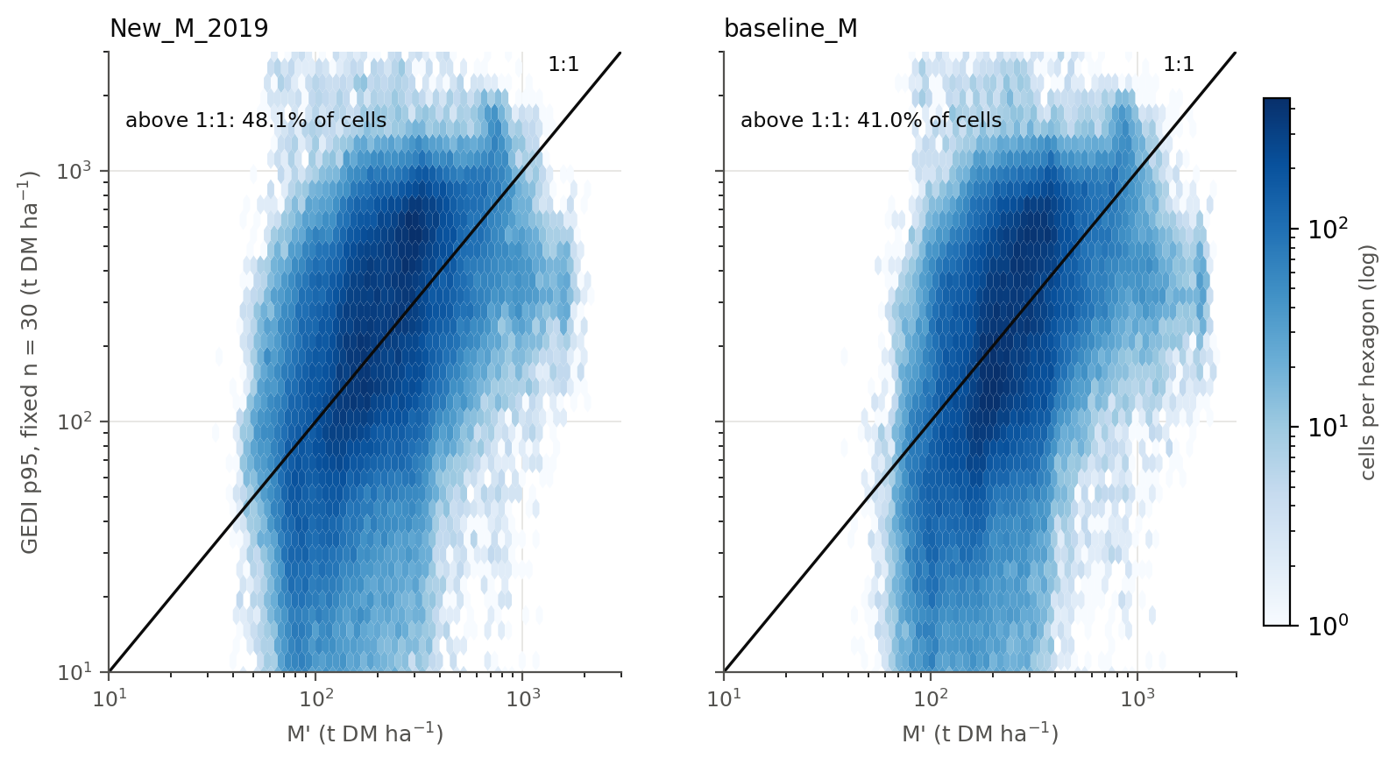
Figure 1. GEDI p95 (fixed n = 30) against M′ per NLUM cell, fire-excluded, log axes. Left New_M_2019, right baseline_M_1985-2014. Cells above the 1:1 line contradict M′.

4.3 By productivity
FPI | Cells | GEDI p95 | M′ New | M′ base | p95>M′ New | p95>M′ base | mean>M′ New | mean>M′ base
0-8 | 38,253 | 74.1 | 118.4 | 147.4 | 24.9% | 17.1% | 4.0% | 2.3%
8-10 | 31,084 | 174.4 | 162.5 | 202.9 | 48.2% | 38.8% | 16.5% | 11.1%
10-12 | 24,567 | 266.0 | 192.5 | 231.0 | 59.1% | 52.6% | 22.9% | 17.6%
12-14 | 17,587 | 375.4 | 265.5 | 289.3 | 59.9% | 54.2% | 23.6% | 20.2%
14-20 | 21,344 | 501.4 | 330.2 | 356.5 | 66.3% | 61.9% | 26.1% | 22.2%

Exceedance grows with FPI under both layers: M′ falls furthest behind GEDI in the most productive forest. This is the same shape as the national L4B analysis and the L4A hotspot analysis found. baseline_M's advantage is largest below FPI 12 and shrinks in the most productive forest.
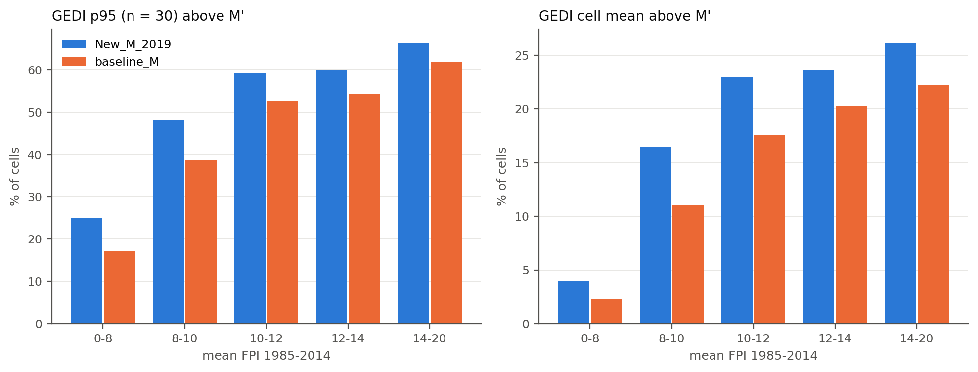
Figure 2. Share of cells where GEDI exceeds M′, by mean FPI 1985-2014. Left: fixed-n p95. Right: cell mean.

4.4 By forest type
Evergreen broadleaf share of footprints | Cells | GEDI mean | GEDI p95 | p95>M′ New | p95>M′ base | mean>M′ New | mean>M′ base
<50% evergreen broadleaf | 44,363 | 19.1 | 78.9 | 17.1% | 11.0% | 1.5% | 0.9%
50-90% | 9,605 | 47.1 | 151.1 | 42.2% | 33.0% | 7.0% | 4.2%
>=90% | 79,461 | 131.8 | 333.2 | 66.1% | 58.7% | 26.3% | 20.5%

Forest type comes from each footprint's pft_class (the MODIS land-cover class carried in L4A), not from NVIS. In cells that are mostly not evergreen broadleaf (cleared land, pasture, plantations), the mean rarely exceeds M′, as it should. Exceedance concentrates in closed forest.

4.5 By region
Region | Cells | FPI | % cells ≥ 90% EBF | M′ New | GEDI p95 | M′/p95 | ρ | p95>M′ New | p95>M′ base | mean>M′ New | mean>M′ base
vic_central | 10,450 | 11.1 | 72.3 | 305.4 | 363.4 | 0.82 | 0.74 | 62.6% | 51.4% | 12.9% | 7.8%
nsw_north_seqld | 36,374 | 12.3 | 63.2 | 195.7 | 243.2 | 0.76 | 0.52 | 61.7% | 52.8% | 23.9% | 19.5%
tasmania | 36,072 | 9.4 | 78.1 | 181.9 | 255.2 | 0.93 | 0.41 | 52.5% | 46.6% | 19.6% | 14.7%
nsw_southeast | 19,266 | 10.3 | 54.5 | 203.6 | 199.2 | 1.10 | 0.20 | 46.5% | 41.1% | 17.5% | 14.4%
vic_gippsland | 5,156 | 10.6 | 27.4 | 267.8 | 168.2 | 1.56 | 0.36 | 30.1% | 23.3% | 4.8% | 2.5%
wa_southwest | 26,111 | 6.0 | 34.1 | 135.5 | 76.4 | 1.88 | 0.70 | 22.0% | 16.2% | 5.7% | 4.0%

Fire-excluded cells; FPI, M′, GEDI p95 and M′/p95 are medians; ρ is Spearman M′ (New_M_2019) against GEDI p95; EBF is evergreen broadleaf. Sorted by p95 exceedance against New_M_2019.
The regions differ more than the layers do. In vic_central and nsw_north_seqld, GEDI p95 exceeds New_M_2019 in more than 60% of cells and the typical cell's M′ is only 0.82 and 0.76 of its GEDI p95. In vic_gippsland and wa_southwest, exceedance is 30.1% and 22.0%, and M′ is 1.56× and 1.88× GEDI p95: these boxes hold the fewest closed evergreen broadleaf cells (27.4% and 34.1%), and wa_southwest's median GEDI cell mean is only 20.2 t DM/ha, because most of it is cleared wheatbelt or open woodland. The ranking of cells is weakest in nsw_southeast (ρ = 0.20), where M′ and GEDI p95 have almost the same median but agree poorly cell by cell. baseline_M lowers exceedance in every region, by 5.4 to 11.2 percentage points, without changing the order of the regions.
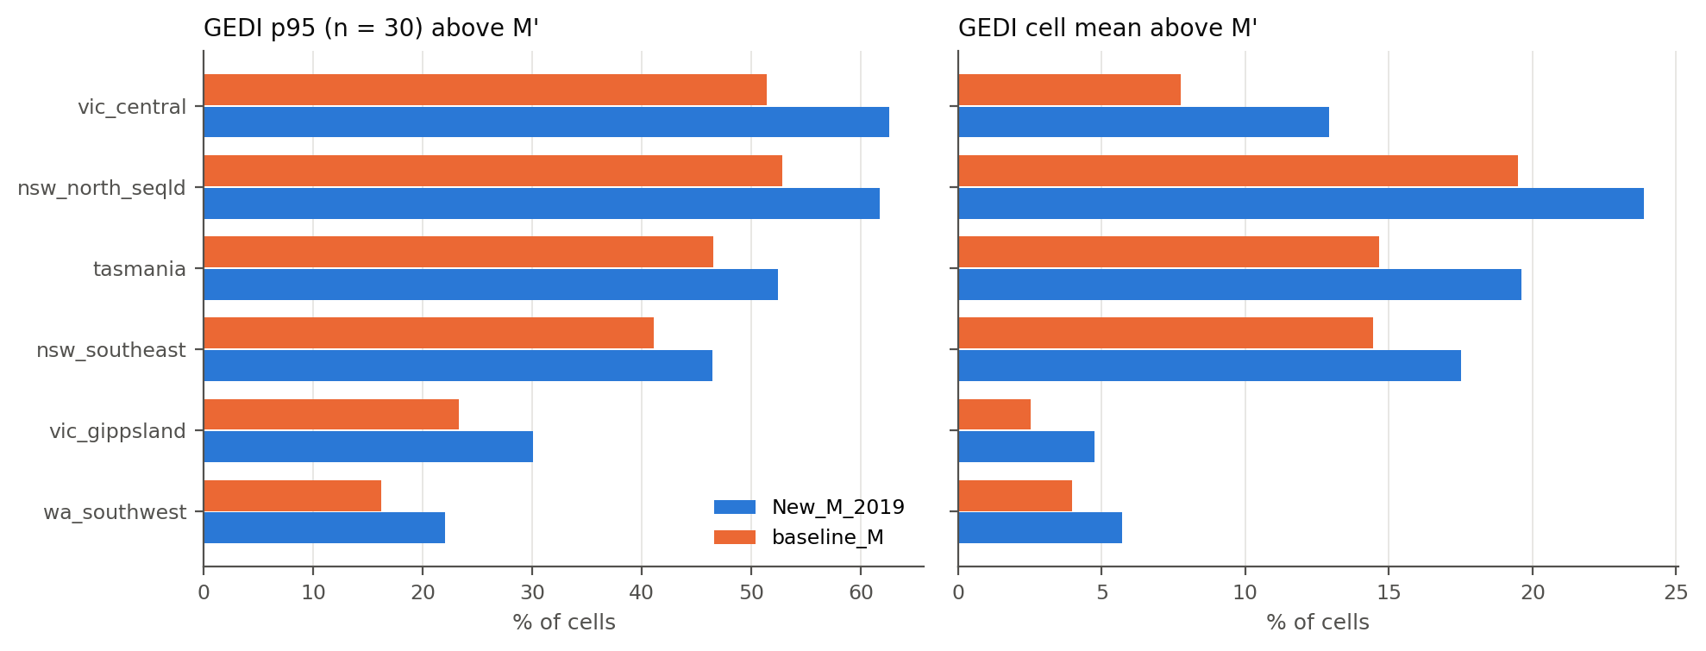
Figure 5. Share of fire-excluded cells where GEDI exceeds M′, by region. Left: fixed-n p95. Right: cell mean.

4.6 Where
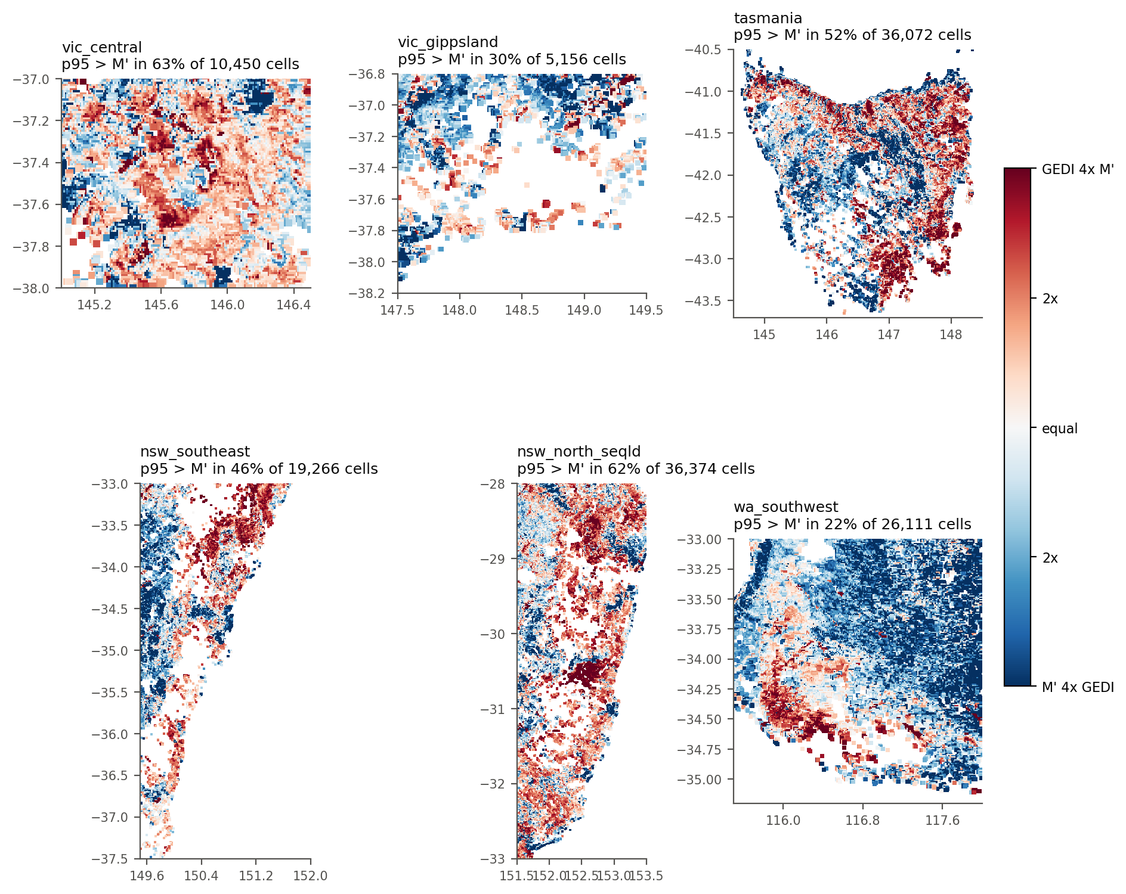
Figure 3. log2(GEDI p95 / New_M_2019) per cell, one panel per region at its own scale. Red: GEDI above M′. Blue: GEDI below. Blank: fewer than 30 unburnt footprints, or outside NLUM. baseline_M gives the same pattern, paler.
Within every region the red cells follow the forest, and the blue follows cleared land. In vic_central the red core lies over the Central Highlands and the Dandenong Ranges. In tasmania it lies over the north-west, the north-east and the southern forests, with blue over the Midlands and the Central Plateau. In wa_southwest only the far south-west corner, the karri and jarrah country, is red; the wheatbelt to the east is blue. In nsw_north_seqld the red is concentrated on the escarpment forests, and in vic_gippsland and nsw_southeast the blanks are the Black Summer fire scars. These place descriptions are read from the map, not computed.

4.7 Response to FPI: the part that matters for the future
Layer | Cells | M′ slope | GEDI p95 slope | GEDI mean slope | Eq. (1) at median FPI
New_M_2019 | 79,527 | 1.16 [1.15, 1.17] | 1.66 [1.64, 1.69] | 1.81 [1.78, 1.84] | 1.36
baseline_M_1985-2014 | 79,527 | 1.00 [0.99, 1.01] | 1.66 [1.64, 1.69] | 1.81 [1.78, 1.84] | 1.36

Slopes are ordinary least squares of ln(y) on ln(FPI) across cells where at least 90% of footprints are evergreen broadleaf, with 500-resample bootstrap 95% intervals. These intervals ignore spatial autocorrelation and are too narrow; the national analysis showed such intervals can be disjoint between runs. Compare them only to one decimal place.
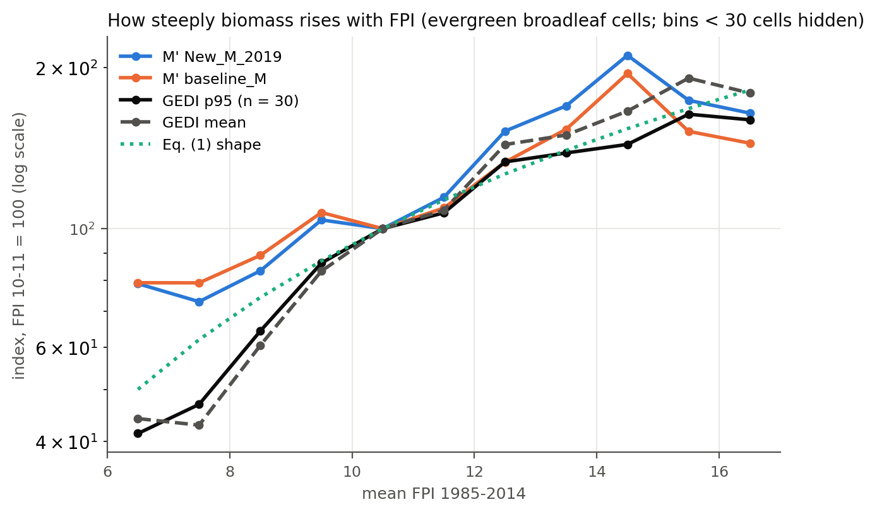
Figure 4. Median of each quantity by 1-unit FPI bin, indexed to 100 at FPI 10-11, log scale, in cells where at least 90% of footprints are evergreen broadleaf, all six regions pooled. The dotted line is the shape Eq. (1) imposes on future change.
Region | EBF cells | New_M_2019 slope | baseline_M slope | GEDI p95 slope | Eq. (1) at median FPI
vic_central | 7,558 | 2.63 | 2.31 | 2.81 | 1.34
vic_gippsland | 1,412 | 1.74 | 1.65 | 2.62 | 1.36
tasmania | 28,164 | 1.78 | 1.67 | 2.21 | 1.39
nsw_southeast | 10,498 | 1.38 | 1.26 | 1.27 | 1.35
nsw_north_seqld | 22,998 | 1.60 | 1.26 | 1.83 | 1.31
wa_southwest | 8,897 | 1.48 | 1.40 | 2.54 | 1.47

Pooled over the regions, GEDI p95 rises with FPI at a log-log slope of 1.66 and the cell mean at 1.81, against 1.36 for Eq. (1) at the median FPI. Both M′ layers are flatter still (1.16 and 1.00), because their low-FPI cells sit high relative to GEDI (Figure 4). Within regions, GEDI is steeper than Eq. (1) in 5 of 6, from about equal in nsw_southeast to about twice as steep in vic_central. Figure 4 shows where the gap comes from: below FPI 10 GEDI falls away much faster than Eq. (1), and above FPI 10 the GEDI p95 curve follows the Eq. (1) shape closely. That matters because future change comes only from Eq. (1): a cell whose FPI falls 10% loses about 13.4% of M′ in the projection, while across space a 10% lower FPI goes with roughly 16.1% less GEDI p95 biomass.
How far this can be pushed
Across space, high FPI also means different species, deeper soils, less clearing and older stands, and pooling six regions adds differences between regions on top. A space-for-time slope mixes all of them with the effect of productivity, and the low-FPI end, where the gap is, is also where clearing is most common. The result supports two claims: Eq. (1)'s response is not too steep, and the projected change is more likely conservative than exaggerated. It does not support replacing Eq. (1)'s elasticity with 1.7.

5. What this means

5.1 For present-day M′
Whether M′ is too low depends on the forest. Pooled over the six regions, the typical (median) cell's M′ is 1.05 of its GEDI p95 for New_M_2019 and 1.26 for baseline_M, so on average M′ sits near the envelope. That average hides the split: in closed evergreen broadleaf cells GEDI p95 exceeds New_M_2019 in 66.1% of cells and the cell mean in 26.3%, while in cells that are mostly not evergreen broadleaf the figures are 17.1% and 1.5%. This agrees with every earlier independent comparison: L4B cell means, ESA CCI, and the L4A hotspots all found M′ too low as productivity rises. Three explanations remain open for the closed forest, and GEDI alone cannot separate them:
- M′ really is too low in the most productive forests. Eq. (1) is a curve fitted across all of Australia, and tall wet eucalypt and rainforest are its extreme tail.
- GEDI L4A reads high in this forest type. The L4A models for Australian evergreen broadleaf trees rest on a limited calibration set, and their bias in very tall eucalypt forest has not been checked here.
- Definitions differ at the margin. M′ is maximum biomass of mature native vegetation per NLUM cell; a single 25 m footprint in a 70 m tall stand can exceed any area-average maximum without contradiction. That is why the cell-mean result, not the p95 result, is the stronger evidence.
What would separate them: airborne lidar or field plots measured in the same cells (for example the Victorian Central Highlands long-term plots, Warra in Tasmania, or TERN sites), against which both M′ and L4A can be checked.

5.2 Choosing between the two layers
baseline_M exceeds GEDI less often, by about 7.1 percentage points at p95 and 3.8 on the mean. That should not decide the footing. baseline_M is higher because it combines Eq. (1) M with a λ that was divided by a different M. The footing memo shows this is a methodological inconsistency, not a better estimate. The ratio of the two layers is Eq1(FPI) / Original_M_2004, and in the compared cells it is ×1.17 (p10-p90 0.99-1.46; ×1.10 to ×1.18 by region), against ×1.46 nationally, so Eq. (1) overstates Original_M_2004 less in these forested regions than across Australia. The better fit here comes from a known error pointing the same way as GEDI's disagreement. The defensible choice remains Option B (New_M_2019 footing). The GEDI finding, that M′ is too low in tall forest, should be reported as a limitation of M′ on either footing.

5.3 For future M′
- Level: whatever is wrong with present-day M′ carries unchanged into every scenario, because the projection multiplies it. If M′ is too low by a factor k in tall forest today, future M′ is too low by about the same k. The projected percentage change is not affected.
- Response: GEDI gives no sign that Eq. (1) exaggerates the response of biomass to FPI. GEDI is steeper in 5 of 6 regions and about equal in the other, so projected losses under drying scenarios are more likely to be understated than overstated, most of all in low-FPI forest.
- Sign: M′ and GEDI agree on which cells hold more biomass in every region (ρ 0.20 to 0.74, pooled 0.52), so no projected change is built on a relationship running the wrong way. The agreement is weak in nsw_southeast.
- Not tested: whether future FPI is right. That rests on the RF year-group cross-validation (R² 0.93) and on the QDC-CMIP6 climate inputs.

6. Limitations
- Six regions, chosen for forest, not a sample of Australia. The pooled rates depend on how much cleared land each box happens to contain, and pooled correlations and slopes mix differences between regions with differences within them. Inland woodland, the tropics and the arid zone are not tested.
- Fire exclusion is not neutral: it removes 45.2% of cells in vic_gippsland and 39.3% in nsw_southeast, so the burnt forests of Black Summer are under-represented in the unburnt results.
- GEDI L4A v2.1 is used; V3 (C4212593885-ORNL_CLOUD) now exists and may revise AGBD.
- No protected-area mask. Logged and cleared cells pull GEDI down, so exceedance is if anything understated, but the forest-type and FPI tables are affected by land use.
- The fire flag works at year resolution: a fire in December can flag a footprint from June of the same year, which is conservative. MODIS at 500 m misses small burns, and pre-2009 fires, including regrowth after 1983 and 1939, are not flagged.
- The median relative agbd_se is small (about 14%) because it is the L4A prediction standard error, not the full footprint error. The lower-bound statistic is therefore less conservative than it looks.
- Units are treated as equal (GEDI's Mg/ha AGBD = t DM/ha aboveground dry matter, since 1 Mg = 1 t). Neither product includes roots; stump and branch conventions are not reconciled.
- Cells with fewer than 30 footprints are excluded, and they are not a random subset: they are where GEDI tracks are sparse or cloud is frequent.
- Pipeline housekeeping: Step_0_download_data/ is deleted from the working tree, the CSIRO future download scripts are missing, and CLAUDE.md still names Step_0b_published_lambda/ and REVISED_ORIGINAL_M_2004/, which do not exist.

7. Next steps
- Replace the bootstrap intervals on the FPI slopes with a spatial block bootstrap, and fit slopes within regions before pooling, so that differences between regions do not drive the pooled slope.
- Add NVIS forest fraction and a CAPAD protected-area flag to Step_04, so that clearing and logging can be separated from the envelope.
- Repeat with GEDI L4A V3 on one region to measure the version effect.
- Extend beyond the six forested boxes (inland woodland, the tropics) before quoting any rate as national.
- Find an independent tall-forest reference (airborne lidar or plot biomass) to separate 'M′ too low' from 'L4A too high'.
- Decide the footing (Option A or B) and the historical baseline order. Both change the numbers FullCAM receives more than anything GEDI can currently resolve.

Appendix A. Reproducing this report
cd Validation_GEDI
set PY=C:\ProgramData\Anaconda3\envs\JinzhuLuto\python.exe
%PY% Step_01_check_sources.py
%PY% Step_02_build_fire_mask.py --start 2009-01-01
%PY% Step_03_fetch_gedi.py
%PY% Step_04_aggregate_cells.py --tag New_M_2019
%PY% Step_04_aggregate_cells.py --tag baseline_M_1985-2014 ^
--mprime ..\Writing_paper_01\output\baseline_M_1985-2014.tif
%PY% Step_05_analyse_vs_M.py
%PY% make_validation_gedi_report.py
Step_02 needs the zoenv environment present (only its gdal_translate.exe is used). Steps 02 and 03 need the Earthdata login in N:\Current-Users\ZOHREH-KALAHROUDI\.netrc. JinzhuLuto is used unmodified throughout.

Appendix B. Output files
File | Contents
fire/burn_year_2009..2025.tif, last_burn_year.tif | Fire mask, NLUM grid
outputs/gedi_parts/<region>/*.parquet | Per-granule footprint checkpoints, six regions (4,559 granules)
outputs/gedi_l4a_footprints.parquet | All filtered footprints with NLUM cell ids
outputs/gedi_fetch_manifest.csv | Footprints per granule
outputs/gedi_cells_{all,unburnt}_{New_M_2019,baseline_M_1985-2014}.csv | Per-cell GEDI statistics with M′ and FPI
outputs/analysis/*.csv | Every table in Section 4 (by_region.csv, footprints_by_region.csv and layer_ratio_by_region.csv per region)
outputs/figures/fig1-5*.png | Figures 1-5
outputs/step02_log.txt, step03_all_regions_log.txt, step04_*_log.txt, step05_log.txt | Run logs
outputs/_vic_central_only/ | Step 04-05 outputs from the earlier single-region pilot, kept for comparison

