Run 4 - a maturity rule on basal area instead of stem diameter
Space_time_validation/New_proposal/Run_04 · generated 2026-09-23 · the most expensive and most debatable of the runs, left last

The problem
Maturity is assigned from the tree list: a stem of 50 cm or more is verified mature, a largest stem of 30-50 cm is likely mature, below that is young or shrubby. That rule needs stem records, and only 2,047 of the library's 15,904 site visits have any. The four largest sources have none at all - Forestry Corporation NSW with 6,718 visits, Queensland NFPP with 3,158, Forestry Tasmania with 2,201 and Parks and Wildlife WA with 898, every one of them at zero per cent coverage. So the rule caps the reference sample at 600 sites of the 1,688 that survive every other filter.
Live basal area is reported in the SITE table for almost every visit. A rule on it could reach the other 1,088. The question is what that costs.

Calibrating it
class | sites | median basal area (m2/ha) | interquartile range | median AGB
likely mature | 273 | 6.75 | 4.1 to 12.1 | 109.8
unverified | 932 | 15.72 | 8.9 to 26.5 | 113.1
verified mature | 327 | 14.75 | 9.2 to 20.4 | 117.5
young or shrubby | 156 | 2.99 | 0.9 to 7.0 | 87.6

Table 1. Basal area by maturity class.
The class medians separate about as the proposal expected - 14.75 m2/ha for verified mature, 6.75 for likely and 2.99 for young. Calibrated on the 756 reference sites that carry a DBH label, basal area reproduces the mature/not-mature distinction at an area under the ROC curve of 0.800. That is better than it had any right to be: 0.5 is a coin toss and 0.8 is usually called decent.
It should not be better, because the two quantities measure different things. Maturity is defined by the LARGEST STEM; basal area is the summed cross-section of ALL stems over the plot area. A sparse stand of huge old trees and a dense thicket of saplings can carry the same basal area, so the rule cannot separate an old stand from a crowded young one. The AUC of 0.80 says the confusion is less damaging than it might have been, not that it is absent.
threshold (m2/ha) | sensitivity | specificity | balanced accuracy | sites selected of 1,688
5 | 0.82 | 0.65 | 0.732 | 1377
7 | 0.70 | 0.75 | 0.727 | 1240
9 | 0.59 | 0.81 | 0.704 | 1083
10 | 0.55 | 0.85 | 0.700 | 1014
12 | 0.46 | 0.90 | 0.679 | 872
14 | 0.35 | 0.93 | 0.642 | 745
16 | 0.28 | 0.94 | 0.609 | 634
20 | 0.17 | 0.96 | 0.564 | 465

Table 2. The trade-off at each threshold.
One number in Table 1 should have been a warning. The 932 unverified sites - the ones with no stem record, which the rule exists to reach - have a median basal area of 15.72 m2/ha, ABOVE the verified mature group's 14.75. Either they really are mature, or basal area is not discriminating maturity among them. The labelled data cannot settle which, because the label those sites would be judged on is exactly what they lack.
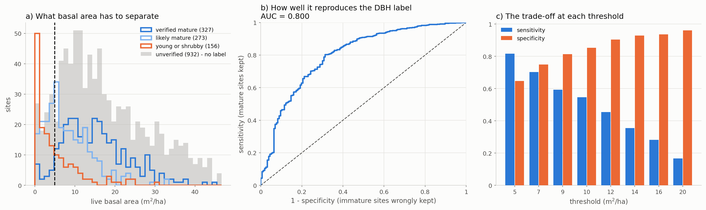
Figure 1. What the rule has to separate, how well it does it, and the trade-off at each threshold.

The result
The design separates the two things the rule does - change the criterion, and expand the sample - by running the criterion on the labelled sites alone as well as on everything.
configuration | sites | labelled | of which DBH-mature | gate rho | ratio | future rho | null rho | gap
dbh_rule | 600 | 600 | 100% | 0.418 | 0.465 | 0.269 | 0.205 | +0.064
ba_05 | 1377 | 545 | 90% | -0.038 | 0.757 | -0.058 | -0.033 | -0.025
ba_07 | 1240 | 461 | 92% | -0.023 | 0.809 | -0.044 | -0.049 | +0.005
ba_09 | 1083 | 385 | 92% | -0.036 | 0.897 | -0.052 | -0.040 | -0.012
ba_14 | 745 | 224 | 95% | -0.075 | 1.063 | -0.084 | -0.082 | -0.002
ba_07_labelled | 461 | 461 | 92% | 0.320 | 0.378 | 0.240 | 0.014 | +0.226

Table 3. Every configuration, analogue-found sites only.
The criterion is fine. Applied to the labelled sites alone it gives a present-day gate of 0.320 and a future rank correlation of 0.240, against 0.418 and 0.269 for the DBH rule - slightly lower, on 461 sites instead of 600, which is what a weaker criterion should look like.
The expansion destroys it. Adding the 779 sites with no stem record takes the gate from 0.320 to -0.023 and the future runs from 0.240 to -0.044 - both below zero. Every threshold behaves the same way: 5, 9 and 14 m2/ha all land between -0.04 and -0.08. This is not a dilution, it is a reversal.
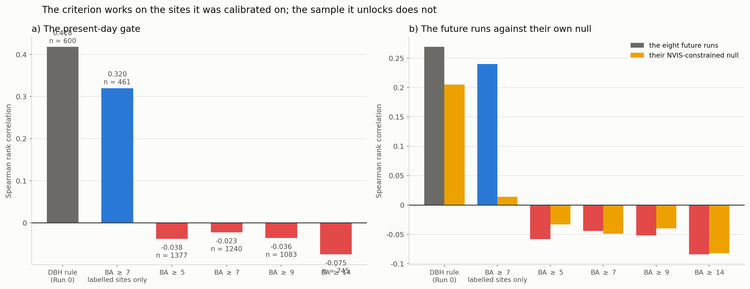
Figure 2. The criterion works on the sites it was calibrated on; the sample it unlocks does not.

Why
half of the expanded sample | sites | rho of observed AGB with M' | median plot (ha) | AGB per m2/ha BA
labelled (has stem data) | 461 | +0.320 | 0.24 | 10.2
unlabelled (added by the rule) | 779 | -0.109 | 0.13 | 5.2

Table 4. The two halves.
The 461 labelled sites give a rank correlation with M' of +0.320. The 779 the rule adds give -0.109. They do not merely carry less signal - they carry the opposite sign, which is why the pooled result falls below zero rather than towards it.
provider | sites added | rho with M' | median plot (ha) | AGB per m2/ha BA
Department of Parks and Wildlife (WA | 365 | -0.06 | 0.13 | 4.2
Queensland NFPP | 280 | -0.06 | 0.40 | 4.3
Darwin Centre for Bushfire Research | 134 | +0.15 | 0.08 | 44.6

Table 5. Who the unlabelled sites come from.
All three are providers this repository has already flagged. Parks and Wildlife WA and Queensland NFPP both return a negative correlation with M'; the Roxburgh folder found the same for Queensland NFPP on its 1,647 records at uniform 0.4 ha plots. Darwin Centre for Bushfire Research reports 601 Mg/ha of biomass on 0.08 ha plots, an AGB-to-basal-area ratio of 44.6 - savanna measured on eighth-hectare plots, which is the small-plot inflation the whole study keeps returning to.
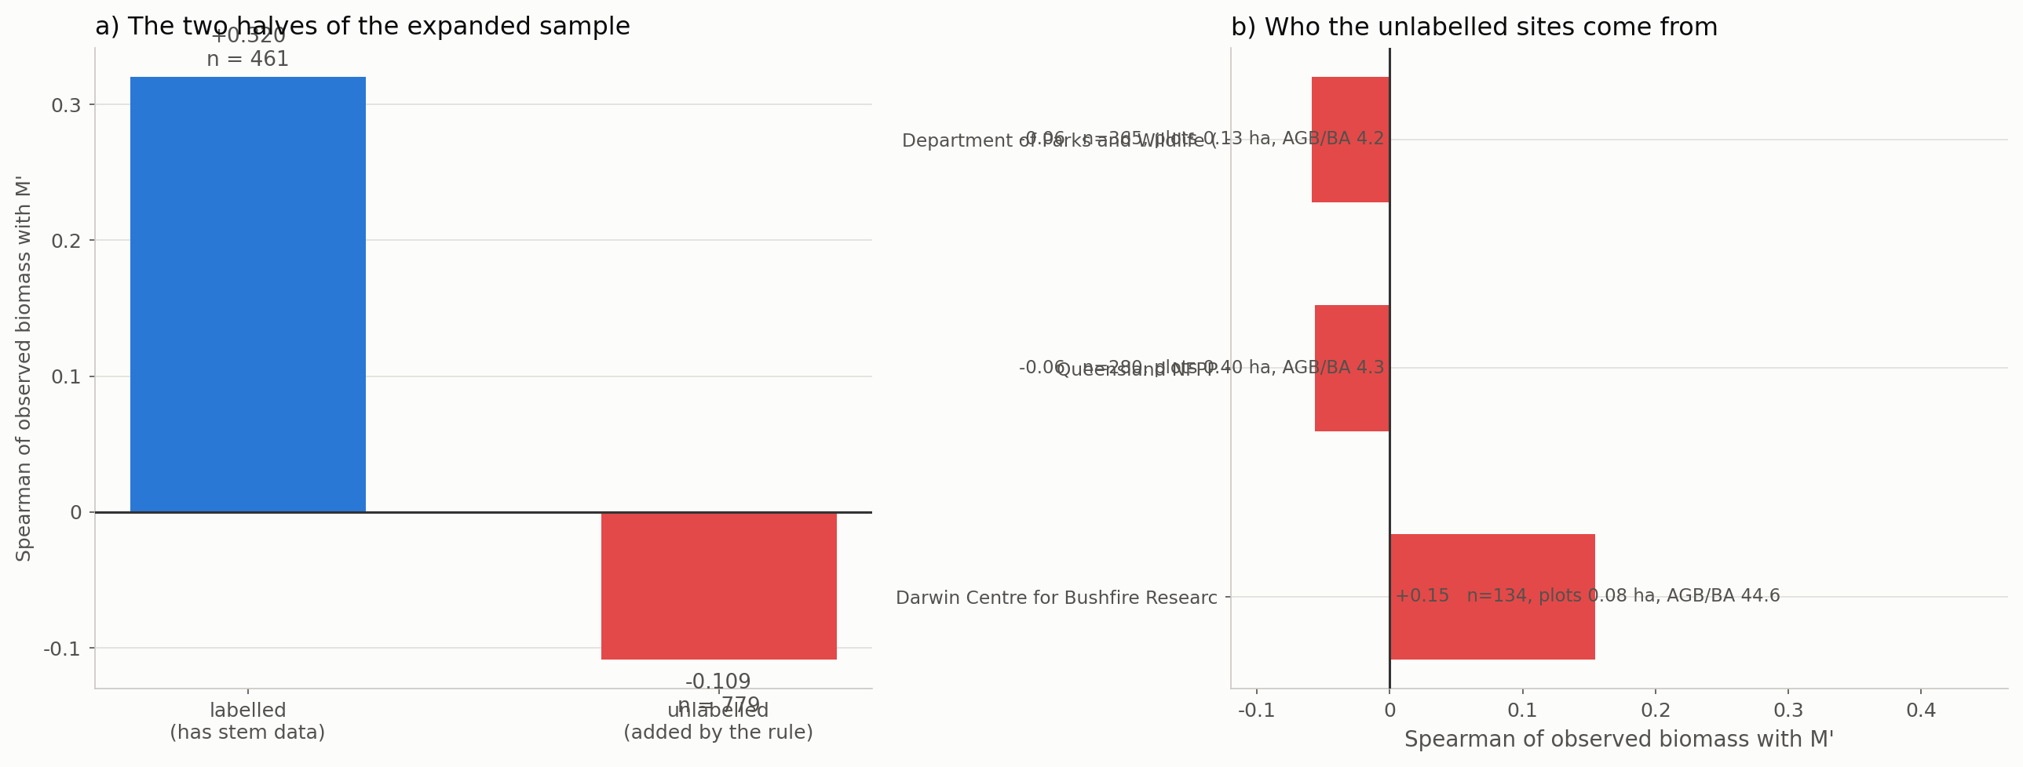
Figure 3. The two halves of the expanded sample, and the providers the unlabelled half comes from.

What to conclude
- The rule is sound and the sample is not. Basal area reproduces the DBH label at AUC 0.80 and performs comparably on the sites where both exist. The problem is entirely in what it unlocks.
- Do not adopt it. On every threshold tested the expanded sample gives a present-day gate at or below zero, against 0.418 for the DBH rule. Nearly doubling the sample is worth nothing if the added half correlates negatively with what is being validated.
- The 1,088 sites without stem records are not simply unmeasured, they are differently measured. They come from providers whose plot sizes and biomass values this study has repeatedly found unusable, and no maturity rule can repair that - the defect is in the biomass, not in the maturity.
- The stem-record requirement is doing more than it appears to. It looks like a maturity filter and is also, incidentally, a data-quality filter: the providers that record stems are the providers whose biomass behaves. That is worth stating explicitly wherever the 600-site cap is described as a limitation.
- If the sample must grow, grow it on measurement quality rather than on maturity. Run 3 showed that rebuilding biomass from stem diameters lifts the gate from 0.42 to 0.73 - but it needs stem records, so it reaches the same 600 sites. Reaching further requires providers to supply stem data, not a different rule applied to what they did supply.

Files
file | what it holds
Step_01_calibrate_rule.py | the calibration and its skill
Step_02_run_and_compare.py | the six configurations
Step_03_plots.py | figures 2 and 3
Step_04_write_report.py | this document
outputs/calibration.csv | Table 2
outputs/class_summary.csv | Table 1
outputs/run04_headline.csv | Table 3
outputs/expansion_halves.csv | Table 4
outputs/expansion_providers.csv | Table 5

