Modelling the reference FPI, and what it does to M'
FPI_Accuracy_check/ · generated 2026-09-21 · every number read from the step that computed it

Why
The delta-change ratio behind future M' mixed two sources: the numerator was FPI from the random forest, the denominator was FPI downloaded from DCCEEW. Any bias in the forest sat in the numerator only, so it did not cancel, and it was read downstream as climate change. Both sides are now modelled by the same fitted forest:
M'_future = λ × Original_M_2004 × Eq1(FPI_future, RF) ÷ Eq1(FPI_1985-2014, RF)
This is the rule already applied to temperature and rainfall, where every delta is CSIRO-minus-CSIRO and never CSIRO-minus-ANUClimate. FPI was the one input where it had not been applied.
The averaging order is fixed and stated once here, because the two possible orders are easy to confuse. THE METHOD IS: predict each year's FPI with the random forest, average the FPI over the period, then apply Eq. (1) to that mean — on both sides of the ratio. Calculation_future_M_CSIRO/Step_06 names this the layer to use "when feeding a single period value to FullCAM". Applying Eq. (1) to each year and averaging the results afterwards is a different number, because Eq. (1) is convex; it is reported throughout as the sensitivity, never as the headline.

What Roxburgh et al. (2019) actually specify
Roxburgh, S.H., Karunaratne, S.B., Paul, K.I., Lucas, R.M., Armston, J.D., Sun, J. (2019). A revised above-ground maximum biomass layer for the Australian continent. Forest Ecology and Management 432, 264-275. https://doi.org/10.1016/j.foreco.2018.09.011 — Section 2, p. 265, the paragraph that introduces Eq. (1):
“… the forest growth model 3-PG … to derive a dimensionless index (the Forest Productivity Index, or FPI) that summarises potential site productivity for any given location based on the Normalised Difference Vegetation Index (NDVI), soil fertility, vapour pressure deficit, soil water content, and temperature (Kesteven and Landsberg, 2004).”
“This relationship is used to calculate the parameter M (the predicted maximum AGB for a given FPI), and is given by M = (6.011 × √FPI − 5.291)²” (Eq. 1)
“Parameter M is constant for any location in Australia, and is embedded within the FullCAM database as a spatial input layer at a resolution of 0.0025° (or approximately 250 m).”
Three things follow, and together they settle the averaging order. FPI is defined as a property of a LOCATION — "potential site productivity for any given location" — not of a location in a particular year. Eq. (1) is written for "a given FPI", one value in, one value out. And M is "constant for any location in Australia", a single static layer in the FullCAM database. Nowhere does the paper evaluate Eq. (1) on a series of annual FPI values, because in FullCAM no such series exists: the FPI layer Eq. (1) was calibrated against is itself a long-term climatological index (Kesteven and Landsberg, 2004; the empirical relationship is Richards and Brack, 2004).
So the faithful reading is one FPI value per location entering Eq. (1) — which, for a 30-year projection window, means the window-mean FPI. That is the method used here. Applying Eq. (1) to each projected year and averaging the resulting M afterwards is an extension the paper does not describe, and because Eq. (1) is convex above its root it returns a systematically larger number (a median factor of 1.0295 on this domain). It is reported as a sensitivity for exactly that reason.
One honest qualification: the paper does not state an averaging rule, because it never faces the question — it had no time-varying FPI to average. The rule above is inferred from how FPI and M are defined, not quoted from a sentence that settles it. What can be said without inference is that the per-year route has no support in the paper, while the mean-FPI route matches the quantity Eq. (1) was calibrated on.
No retraining was involved. The saved model is loaded, its feature order is asserted against the pipeline's own definition, and it is applied to the BARRA-R2 historical climate through the same soil block, land mask and bilinear regrid the 240 future predictions use. Only the climate year changes.

Accuracy of the modelled historical FPI
 | R² | RMSE | MAE | bias
Out of fold, year-group CV — quote this | 0.931 | 0.754 | 0.548 | +0.004
In sample, full grid, 30 years | 0.968 | 0.513 | 0.262 | +0.002

The two rows answer different questions. Out of fold, every row was predicted by a forest that never saw that year, which is the same act as projecting 2035-2099; that is the accuracy figure. In sample measures fit, not skill — but it is the relevant number for the denominator swap, because it says how far the modelled denominator sits from the observed one. Per-year in-sample R² runs 0.953 to 0.973 with no trend across the 30 years, and per-year bias stays within ±0.08 FPI units.
Comparing a future projection against observed history would be neither of these: that is a trend comparison, and the two are not supposed to agree.
Figure 1a plots the random forest's FPI against the observed DCCEEW FPI. The x axis is the observed value for one 1 km cell in one year, the y axis the forest's prediction for that same cell and year, and each hexagon counts how many cell-years fall in it — 60,000 cells drawn at random within each of the 30 years, 1.8 million points in total. It is NOT a comparison of 30-year averages; that is Figure 2. The dashed line is 1:1, so a point above it means the forest predicted more productivity than was observed. The statistics printed on the panel are in sample, meaning these 30 years are the years the forest was trained on, so the figure shows how faithfully it reproduces its own training data.
How it is computed: for each year, the saved forest predicts FPI at every land cell; 60,000 of those cells are drawn at random and paired with the observed value at the same cell and year; the 30 years are pooled and binned into hexagons, each shaded by how many pairs it holds. The accompanying statistics over all 6,956,407 cells and 30 years are R² 0.968, RMSE 0.51 FPI units, MAE 0.26 and bias +0.002 — the bias being the mean of (modelled - observed), so a value this close to zero says the forest is not systematically high or low. They are printed here rather than on the figure so that the figure stays readable.
How to read it: the band should hug the dashed 1:1 line. It does so tightly below about FPI 4, which is most of the continent, and fans out above it, where fewer cells and larger values make each prediction harder. Points above the line are years and places where the forest predicted more productivity than was observed.
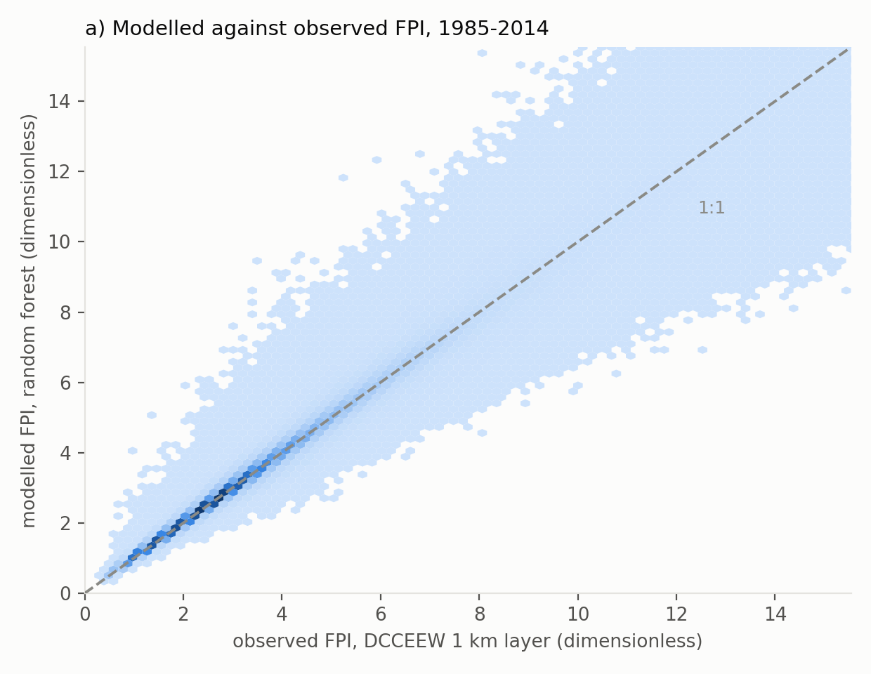
Figure 1a. Random forest FPI against observed DCCEEW FPI, all 30 years, linear axes and linear hexbin density.
Figure 1b splits that by year and adds the number that matters. The blue line is the same in-sample fit, one R² per year. The orange line is the out-of-fold result: for each year, the prediction comes from a forest trained on the other 24 years, so that year was unseen. The vertical gap between the lines is the cost of predicting a year the model has not met, which is exactly what the projection to 2035-2099 asks of it. The orange line is therefore the accuracy to quote, and it is the lower one.
How it is computed: the blue point for a year is the R² of the saved forest's prediction against the observed layer for that year, over the full grid. The orange point comes from the year-group cross-validation already run in Random_forest_CSIRO/Step_03, where the 30 years are split into five folds of six years; each year is predicted by the forest fitted to the other 24. Pooled, blue gives R² 0.968 and orange 0.931, and no year departs from its line by enough to change that reading.
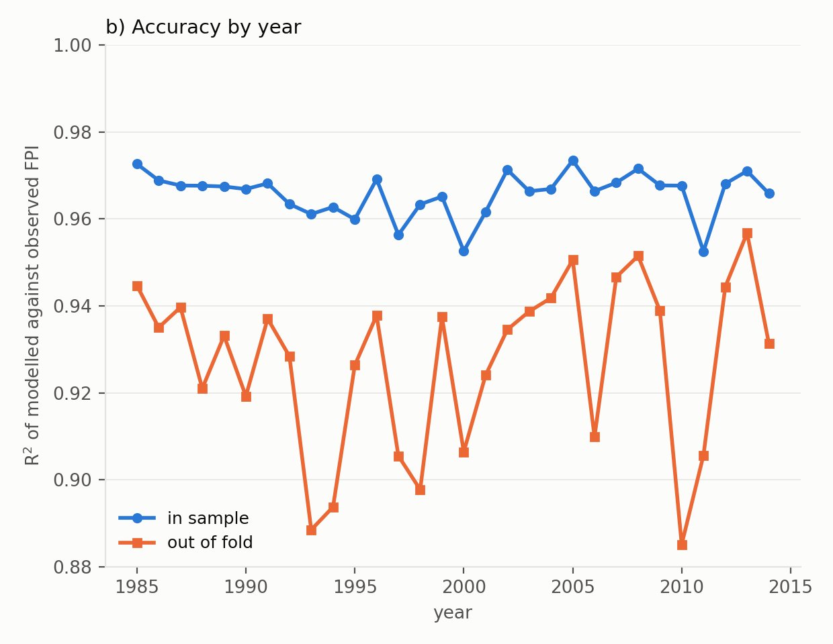
Figure 1b. Accuracy year by year, in sample against out of fold.
Figure 1b. Accuracy year by year. The gap between the two lines is the cost of predicting an unseen year.
Figure 2 is the same comparison in space rather than in points. Panel (a) averages the 30 observed annual FPI layers, panel (b) averages the 30 modelled ones, and both use one colour scale so they can be read against each other directly. Panel (c) subtracts one from the other: red means the forest sits above the observation at that cell, blue below, and the scale is symmetric about zero so the two directions cannot be confused. What to look for is whether the residual has structure. It does not: the difference is fine-grained and scattered along the forested east, south-west and Tasmania rather than forming large regions of one sign, which is what a systematic failure would look like.
How it is computed: panel (a) is the cell-wise mean of the 30 observed annual FPI rasters, panel (b) the cell-wise mean of the 30 modelled ones, and panel (c) is (b) minus (a). Panels (a) and (b) share one colour scale so they can be compared directly; panel (c) uses a diverging scale centred on zero, symmetric so that equal errors in either direction look equally large.
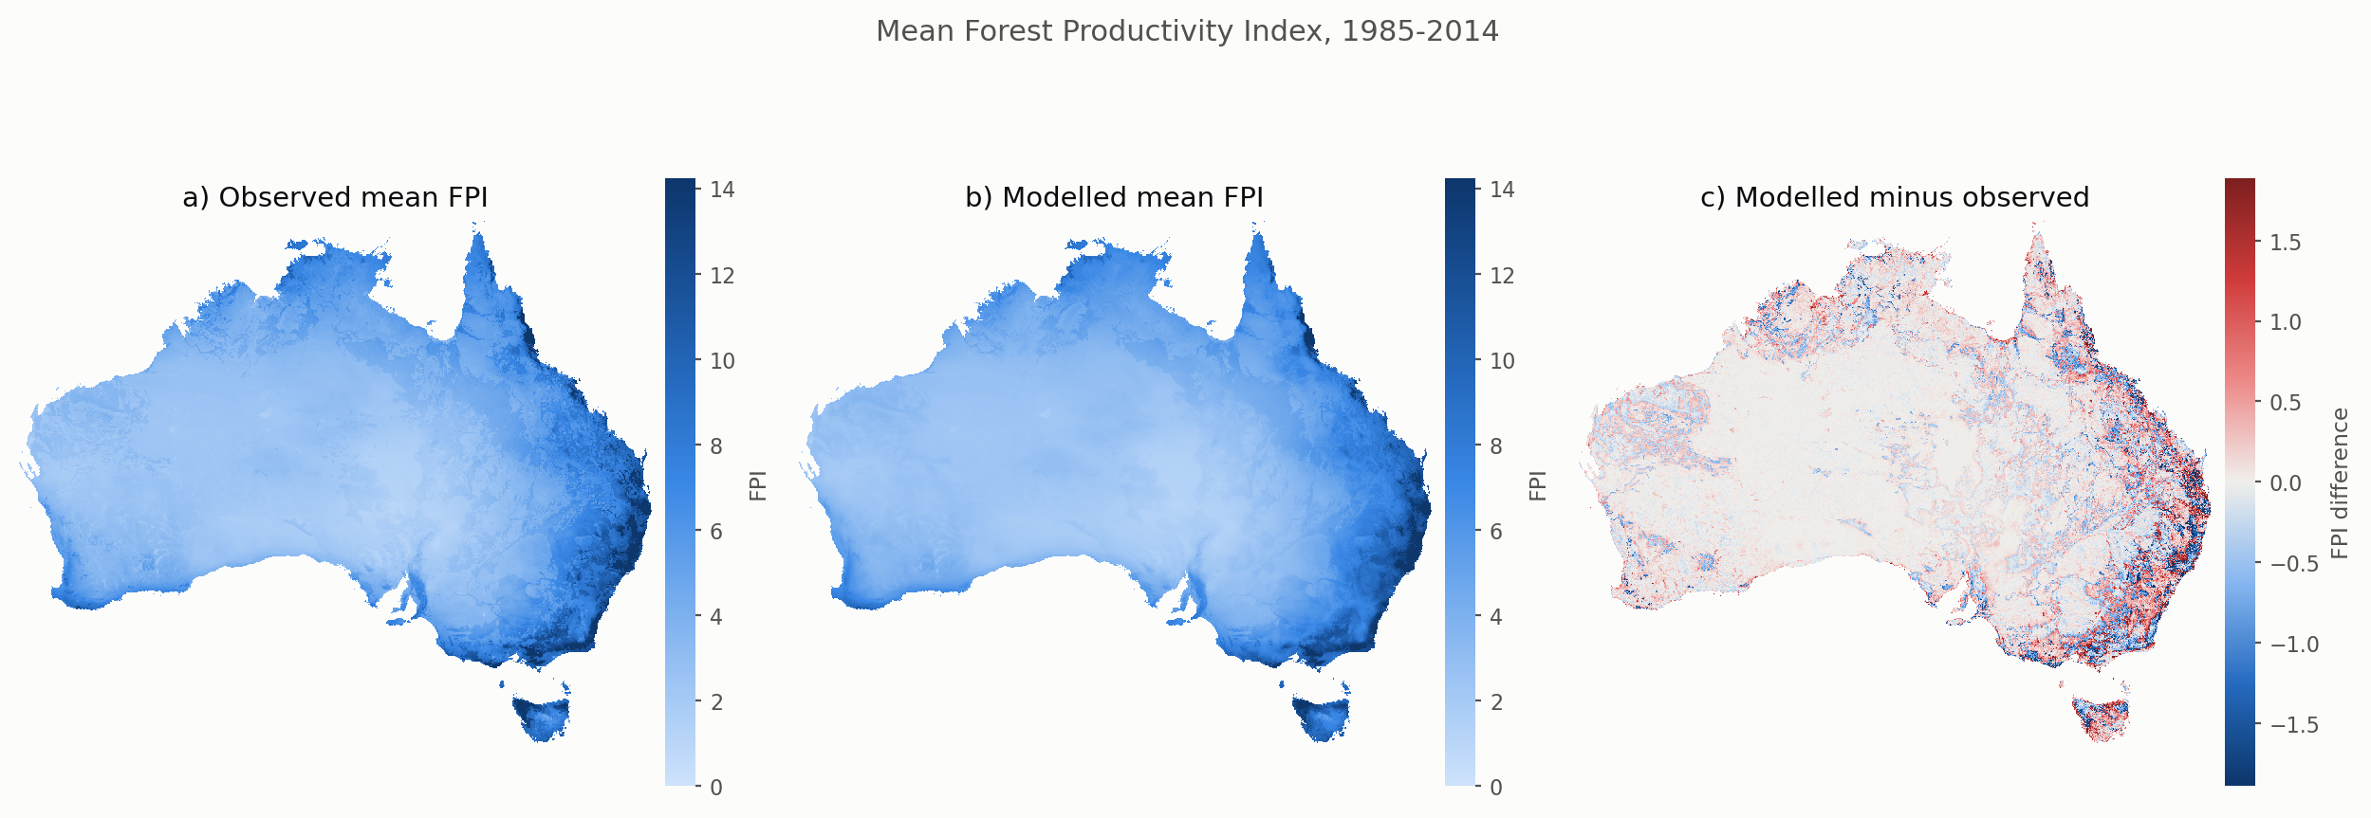
Figure 2. Mean FPI 1985-2014: observed (a), modelled (b), and their difference (c).

What the modelled denominator changes
Modelled ÷ observed historical M has a median of 1.0066 (p05-p95 0.818-1.228). The forest's historical bias was small, so M' moves by well under a percent on that account. The change is methodological rather than numerical — which is the point: the bias now cancels by construction instead of by luck.

The averaging order, which matters more
Eq. (1) is convex above its root, so mean_y[Eq1(FPI_y)] ≥ Eq1(mean_y FPI_y); the median gap is 1.0319 on the observed layers and 1.0295 on the modelled ones. The pipeline wrote the numerator in both orders but only ever built the denominator in one, so a per-year numerator was being divided by a mean-FPI denominator and the gap entered the ratio as a climate signal. Both orders are now built and paired like with like.
denominator | FPI source | averaging order | mean | median
RF_mean_of_annual | random forest | mean_y Eq1(FPI_y) | 56.82 | 31.87
RF_eq1_of_mean | random forest | Eq1(mean_y FPI_y) | 55.64 | 30.70
OBS_mean_of_annual | observed DCCEEW FPI | mean_y Eq1(FPI_y) | 57.04 | 32.17
OBS_eq1_of_mean | observed DCCEEW FPI | Eq1(mean_y FPI_y) | 55.77 | 30.84

Units t DM ha⁻¹, over the 6,956,407 cells of the NLUM mask.

Effect on future M'
The M' rasters were produced by the repository's own Step_08 with the modelled denominator passed in, not by a second implementation of Eq. (3). The measured shift against Option B is identical in every scenario and window, as it must be, since the denominator is a per-cell constant: ×0.9908 where only the source changed, ×0.9441 where the averaging order was corrected as well.
scenario | window | METHOD: Eq.(1) of mean FPI | sensitivity: per-year | Option B (published)
SSP126 | 2035-2064 | -2.6 | -3.2 | +1.1
SSP245 | 2035-2064 | -10.2 | -11.2 | -6.4
SSP370 | 2035-2064 | -4.3 | -5.1 | -0.7
SSP585 | 2035-2064 | -3.6 | -4.3 | +1.0
SSP126 | 2070-2099 | -12.3 | -13.1 | -8.9
SSP245 | 2070-2099 | -4.0 | -5.1 | -0.8
SSP370 | 2070-2099 | -20.1 | -21.9 | -17.4
SSP585 | 2070-2099 | -21.2 | -22.8 | -18.6

Median change in M' against New_M_2019, per cent — the step FullCAM sees from its historical maxAbgM to the future input. On the method every window is negative, from -2.6% to -21.2%; the per-year sensitivity gives -3.2% to -22.8%, slightly deeper throughout. Option B's column pairs a per-year numerator with a mean-FPI denominator, which is the mismatch described above, and two of its eight windows come out positive.
Figure 4 compares New_M_2019 — the revised maximum biomass layer of Roxburgh et al. (2019), which is the historical maxAbgM input FullCAM reads — against the future M' this work produces. Each bar is the median over the NLUM mask of 100 x (M' - New_M_2019) / New_M_2019 for one scenario and one 30-year window, so a bar at -10 means the typical cell carries ten per cent less potential biomass than the layer FullCAM uses today. The two colours are two different historical denominators: blue divides by Eq. (1) of the FPI downloaded from DCCEEW, orange by Eq. (1) of the FPI the random forest models for the same 30 years. Orange is what this work uses, because then the historical and the future FPI come from one model and its bias cancels out of the ratio.
Figure 4a is the method: the 30 annual FPI are averaged first and Eq. (1) is applied to that mean, on both sides. The two colours nearly coincide, which is the expected result — the denominator swap is worth less than a per cent — and it doubles as a check on the arithmetic. Figure 4b repeats it with Eq. (1) applied per year and the results averaged; the bars deepen by about one percentage point throughout, which is the Jensen gap of Figure 3c arriving in the answer.
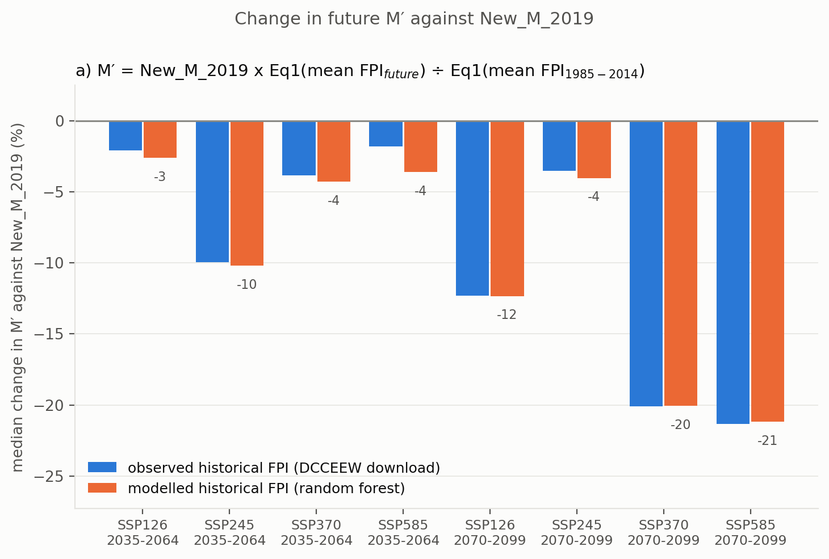
Figure 4a. The step FullCAM sees, on the method. Blue is the observed historical FPI (the DCCEEW download), orange the modelled historical FPI from the random forest — the layer this work uses, since both the historical and the future FPI come from the forest. The orders already matched on both sides here, so the bars barely move: the expected result, and a check on the arithmetic.
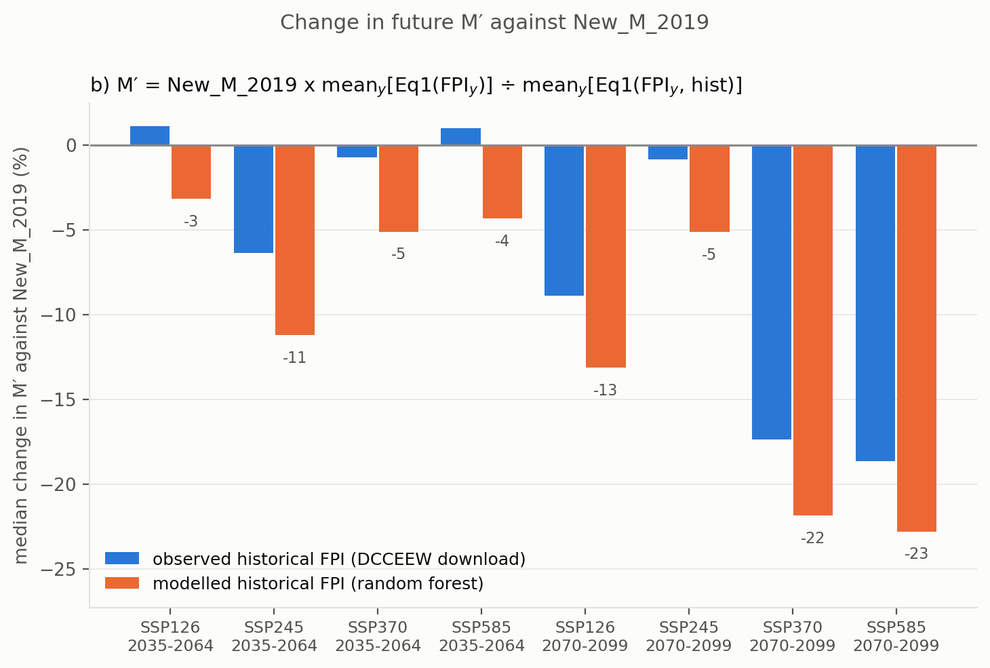
Figure 4b. The same on the per-year sensitivity, where the two positive bars of the observed-denominator route turn negative.
Figure 5 is the same quantity as Figure 4, cell by cell instead of summarised to a median: 100 x (M' - New_M_2019) / New_M_2019 for each of the eight scenario-windows, on one diverging scale centred on zero, so blue is a loss of potential biomass against today's layer and red a gain. The rows are the two windows and the columns the four scenarios, which makes the two readings easy to separate: down a column is the passage of time under one scenario, across a row is the choice of scenario at one time. Losses dominate the forested east, the south-west and Tasmania. The red patches are arid interior cells where M' is only a few tonnes per hectare, so a large percentage is a small absolute change — which is why Figure 4 quotes medians and the comparison section also reports totals in Mt DM.
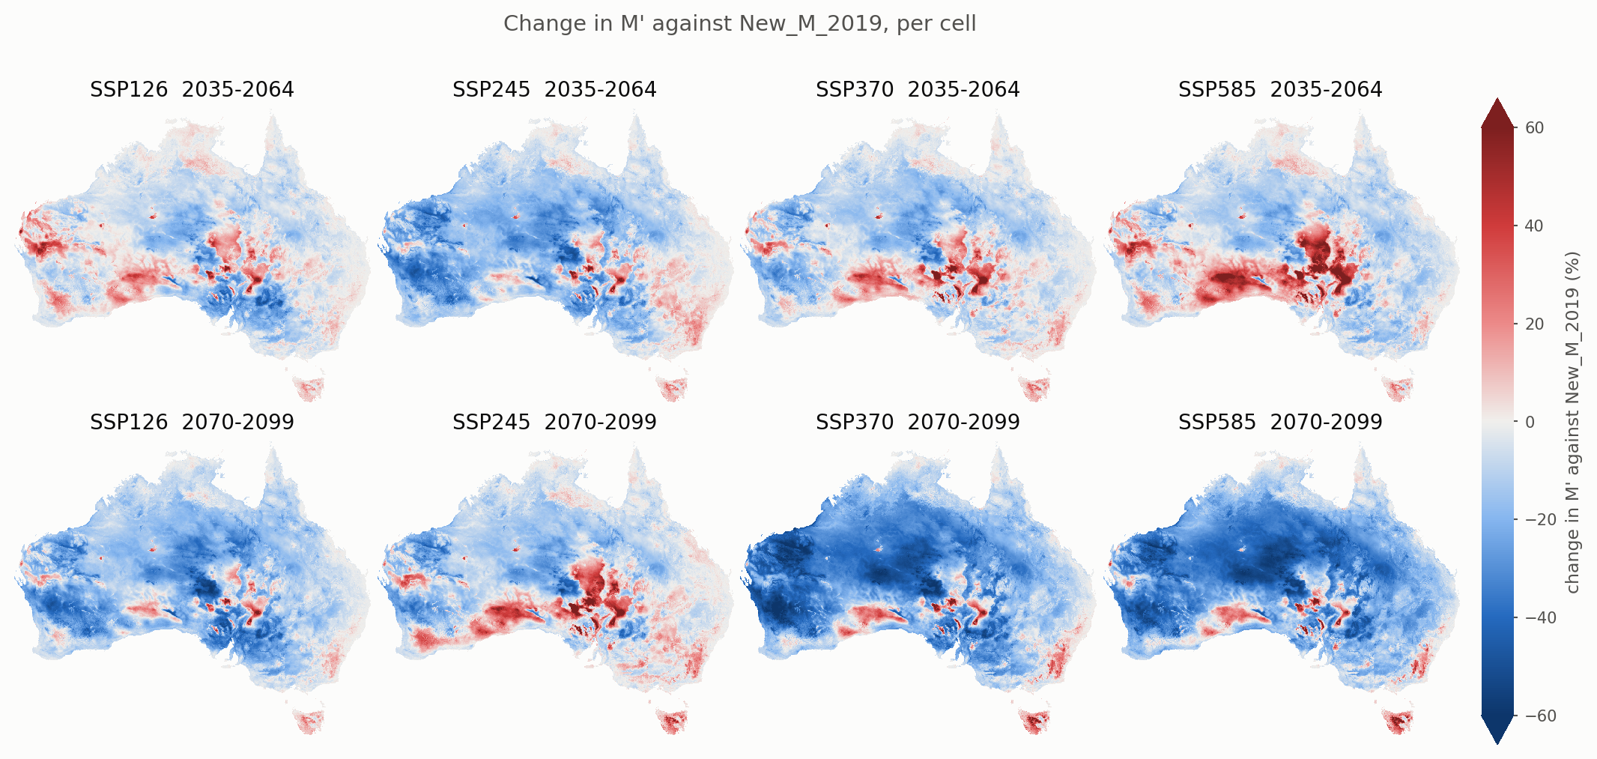
Figure 5. Projected change in M' against New_M_2019, per cell, for each scenario and window.

Checks
- The rebuilt observed denominator reproduces the pipeline's cached Eq1_M_hist_1985-2014.tif to 3.1e-05 t DM ha⁻¹, so these layers sit on the same arithmetic as the existing pipeline.
- The Jensen gap measured here on the observed layers, 1.0319, is exactly the figure recorded independently in Option_B_matched_footing/README.md.
- The shift in M' equals the ratio of the denominators, cell for cell, in all eight scenario-windows — so nothing else moved.
- Every written raster was verified on the NLUM grid: no non-finite value inside the mask, no data outside it, no negative M'.

Future M' against New_M_2019
New_M_2019 is the layer FullCAM ships as its historical maxAbgM, so it is the reference the future inputs step away from. Its mean over the NLUM mask is 46.21 t DM ha⁻¹ and its area-weighted national total is 34,363 Mt DM.
The comparison is anchored rather than independent, and it is worth being explicit about why. λ × Original_M_2004 IS New_M_2019, so averaging the 30 modelled historical years of M' must return the reference exactly. It does, to a median relative error of 2.8e-08 (max 1.9e-07) — float32 rounding. That is a strong check that the chain from FPI through Eq. (1) and Eq. (3) does what it claims, but it also means these figures measure the projected *change*, not whether the absolute level is right. For the level, see Validation_GEDI/.

The statistics, and what each one is for
statistic | definition | what it answers
bias | mean(M' − New_M_2019), t DM ha⁻¹ | average level shift; sign tells the direction, and it can be near zero while individual cells move a lot
RMSE | √mean((M' − New_M_2019)²), t DM ha⁻¹ | typical size of a cell's change, squaring so that large movers dominate; always ≥ MAE
MAE | mean|M' − New_M_2019|, t DM ha⁻¹ | typical size of a change without that weighting; the gap to RMSE says how skewed the changes are
Pearson r | correlation across cells | whether the spatial pattern is preserved. It cannot detect a level shift, so it is read with bias, never alone
OLS slope | regression of M' on New_M_2019 | whether the change is proportional. >1 means high-biomass cells change less in relative terms than low-biomass ones
median % change | median over cells of 100(M'−ref)/ref | the typical cell's fate, robust to the long right tail of M'
% cells declining | share with M' < New_M_2019 | how widespread the change is, independently of its size
spatial CV | sd over cells ÷ mean over cells | how uneven the map is as a whole; rises when the change is concentrated rather than uniform
interannual CV | sd over the 30 years ÷ their mean, per cell | year-to-year variability within one scenario
across-scenario CV | sd over the 4 SSPs ÷ their mean, per cell | how much the scenario choice matters
national total | Σ (M' × cell area), Mt DM | the aggregate that a carbon account cares about; area-weighted, since 0.01° cells shrink with latitude by cos(lat)

Interannual variability (CV within a window)
window | median CV (%) | vs historical (pp)
historical 1985-2014 | 48.3 | —
SSP126 2035-2064 | 46.2 | -2.1
SSP245 2035-2064 | 46.5 | -1.9
SSP370 2035-2064 | 45.5 | -2.8
SSP585 2035-2064 | 44.2 | -4.1
SSP126 2070-2099 | 47.5 | -0.8
SSP245 2070-2099 | 43.4 | -5.0
SSP370 2070-2099 | 44.5 | -3.8
SSP585 2070-2099 | 44.9 | -3.4

Two things follow. First, the level is high: a median near 48% means a cell's M' swings by about half its own mean from one year to the next. That is expected rather than alarming — Eq. (1) is quadratic in √FPI, so it amplifies a dry year — but it does mean no single future year should be quoted as the value for a site. Use the window mean, which is what the FullCAM inputs are built from.
Second, the future CV is lower than the historical one in every scenario-window. Two ways of saying it, because they are different quantities: the difference of the medians is 0.8 to 5.0 percentage points (table above), while the median of the per-cell difference is 1.4 to 4.7 (Figure 7). Either way the sign is the same everywhere. Projected M' does not become more erratic. Read that with the method in mind: the QDC change factors are applied to observed BARRA-R2 years, so the interannual sequence in the projections is observed weather rescaled, not model weather. The method can shift and stretch that variability but cannot invent new variability, so this result is evidence about the change factors, not an independent finding about future climate variability.
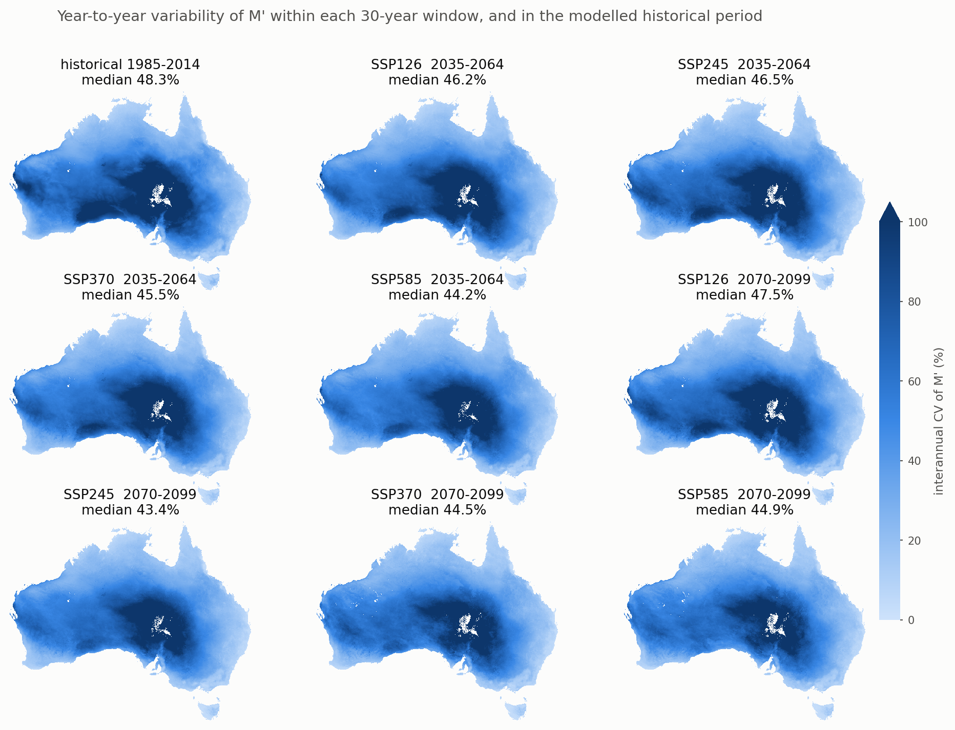
Figure 6. Interannual CV of M' in each scenario-window and in the modelled historical period. One colour scale throughout, set by the typical spread rather than the longest tail. The arid interior is most variable in relative terms because its mean is small; white cells are where the mean falls below 1 t DM ha⁻¹ and a ratio stops being meaningful.
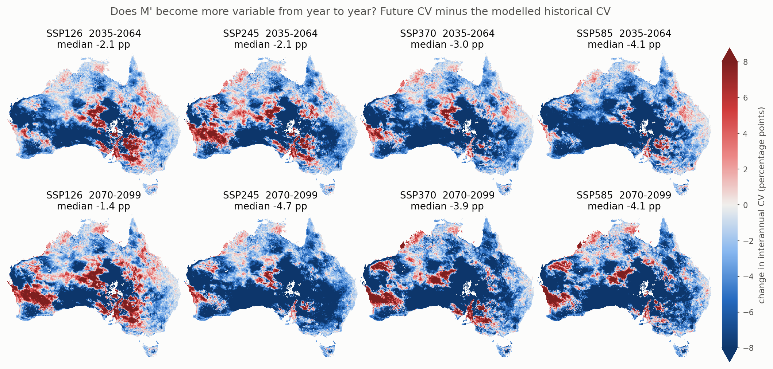
Figure 7. Future CV minus historical CV, in percentage points. Blue is less year-to-year variability than the historical period, red is more. The median is negative in all eight panels; the red patches are mostly in the north-west and the southern rangelands.

Scenario spread, and which uncertainty dominates
The four SSPs disagree with one another by a median CV of 5.9% in 2035-2064 and 12.4% in 2070-2099, against roughly 45% of year-to-year variability within any one of them. The scenarios separate late, as they should, but even then the choice of year inside a window is three to four times larger a source of spread than the choice of scenario. Anyone reading a single cell of a single future year is reading mostly weather.
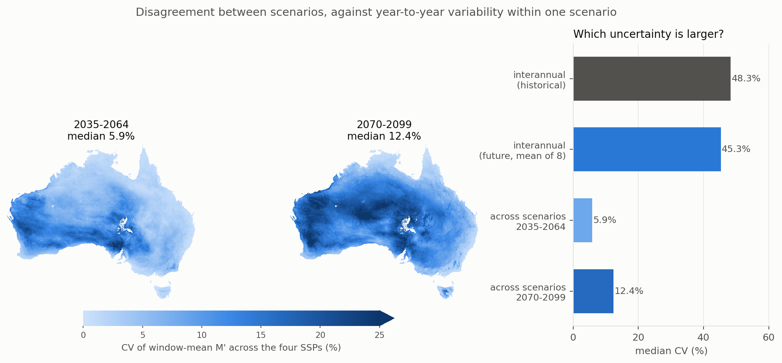
Figure 8. Across-scenario CV per window (left, centre) and the two kinds of variability side by side (right).

Cell by cell
scenario | window | r | slope | bias | RMSE | % cells down
SSP126 | 2035-2064 | 0.997 | 1.012 | -1.0 | 5.9 | 64
SSP245 | 2035-2064 | 0.996 | 1.036 | -2.0 | 8.3 | 79
SSP370 | 2035-2064 | 0.996 | 1.031 | -0.9 | 7.6 | 69
SSP585 | 2035-2064 | 0.995 | 0.998 | -1.2 | 7.7 | 64
SSP126 | 2070-2099 | 0.996 | 1.016 | -3.4 | 8.2 | 88
SSP245 | 2070-2099 | 0.994 | 1.054 | -0.0 | 10.3 | 65
SSP370 | 2070-2099 | 0.987 | 1.057 | -4.3 | 15.0 | 87
SSP585 | 2070-2099 | 0.983 | 1.042 | -5.0 | 16.2 | 88

r stays between 0.983 and 0.997: the spatial pattern of M' is almost entirely inherited from New_M_2019, which is what a delta-change method should produce — the projection rescales the reference rather than redrawing it. The slope above 1 in most windows says the rescaling is not uniform: low-biomass cells lose a larger *fraction* than high-biomass ones. Bias and RMSE grow together from the mid to the late window and from low to high forcing, and the share of declining cells rises from 64% to 88%, so the late-century high-forcing decline is both deeper and more widespread.
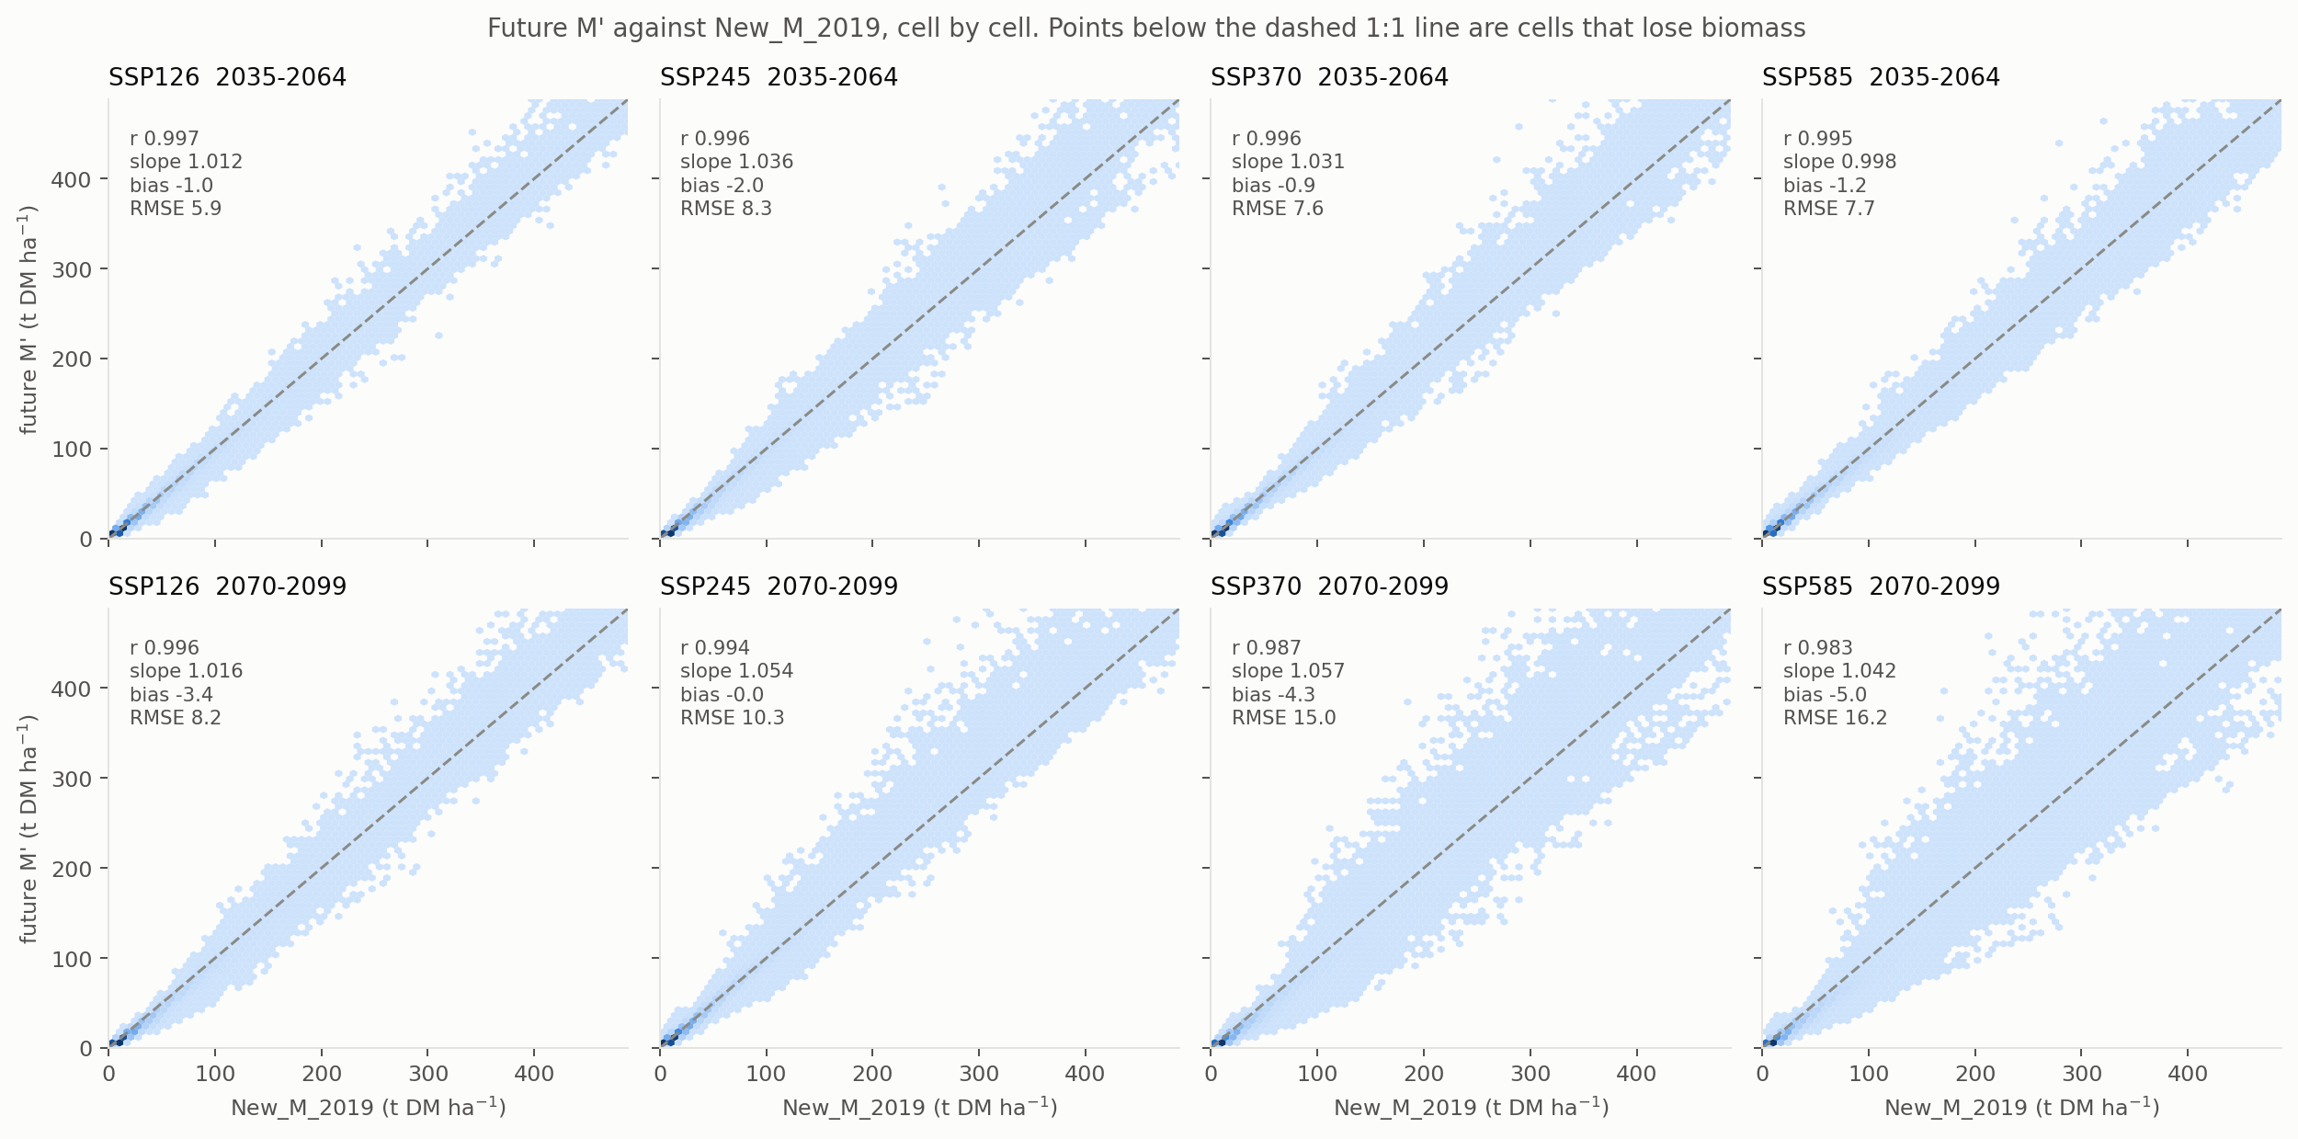
Figure 9. M' against New_M_2019, one hexbin per scenario-window. The dashed line is 1:1; cells below it lose biomass. The cloud tightens around the line at low biomass and fans out above ~200 t DM ha⁻¹, where a few large movers set the RMSE.

National total
Area-weighted, the national total falls in every scenario-window: from 34,363 Mt DM to between 30,446 and 34,209 Mt DM, i.e. -0.4% (SSP245 2070-2099) to -11.4% (SSP585 2070-2099). The totals fall less than the per-cell medians because the deepest relative losses are in low- and mid-biomass cells, which carry little of the total.
This is a carrying-capacity total, not an inventory: M' is what a site could carry at maturity, not what stands on it today.
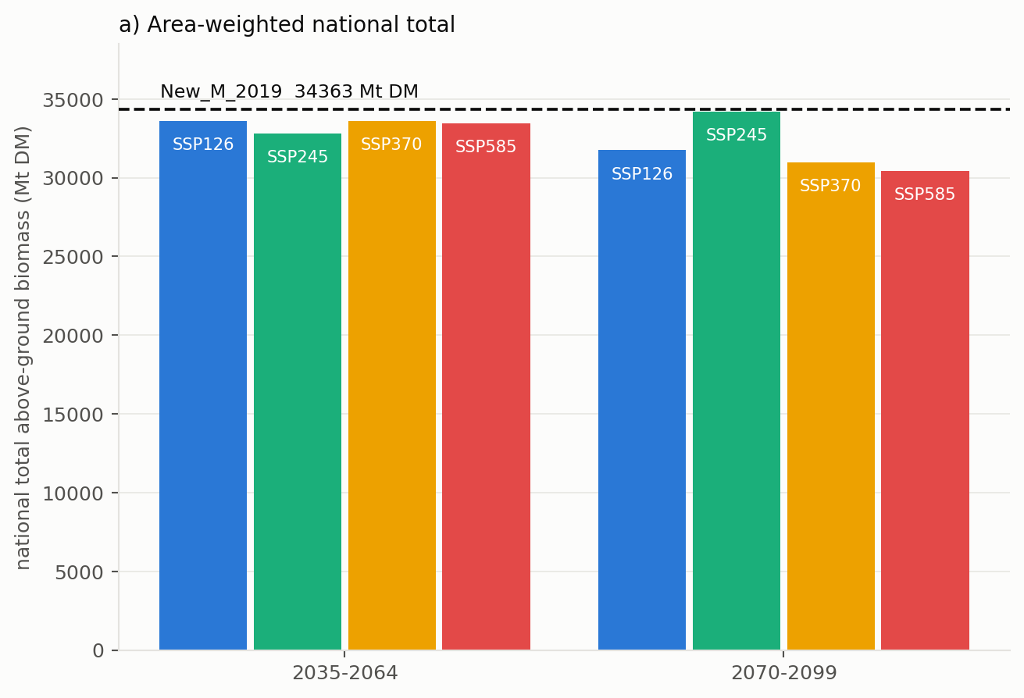
Figure 10a. National total above-ground biomass by scenario-window, against the New_M_2019 reference line.
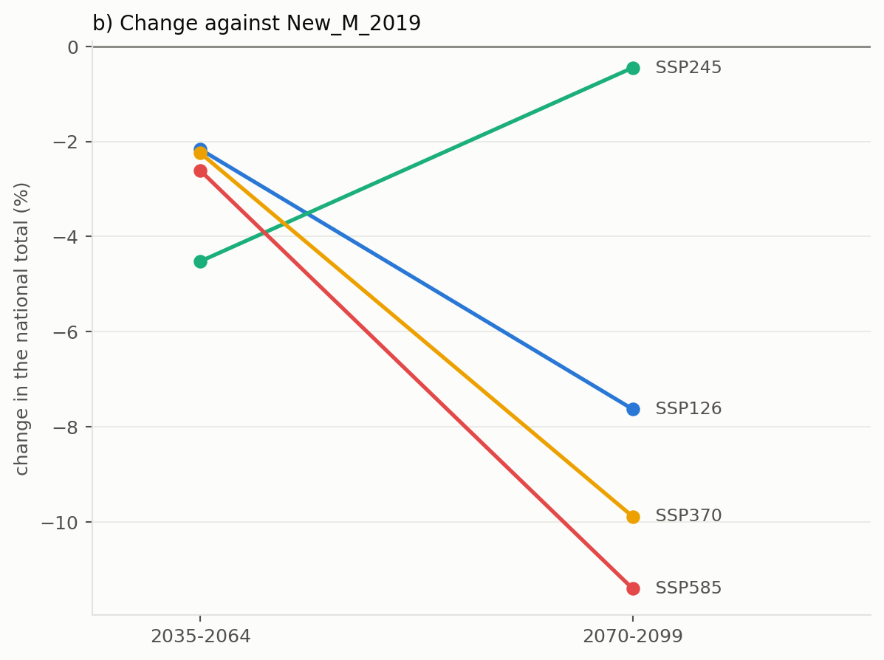
Figure 10b. The same as a percentage change. Note the non-monotonic ordering: SSP245 2070-2099 is the mildest of the eight, which the Random_forest_CSIRO report traces to ACCESS-CM2 r4i1p1f1 rainfall and humidity rather than to the forcing level.

A third CV: future M' against the reference map
The interannual and across-scenario CVs above have no counterpart in New_M_2019, which is a single static layer. The spatial CV does: sd over cells divided by the mean over cells, one number per map. It rises from 169.8% for New_M_2019 to 174.7-201.8% across the eight scenario-windows, so the projection makes the map more uneven rather than less — the losses are concentrated, not spread evenly, which is the same thing the decile figure says from the other direction.
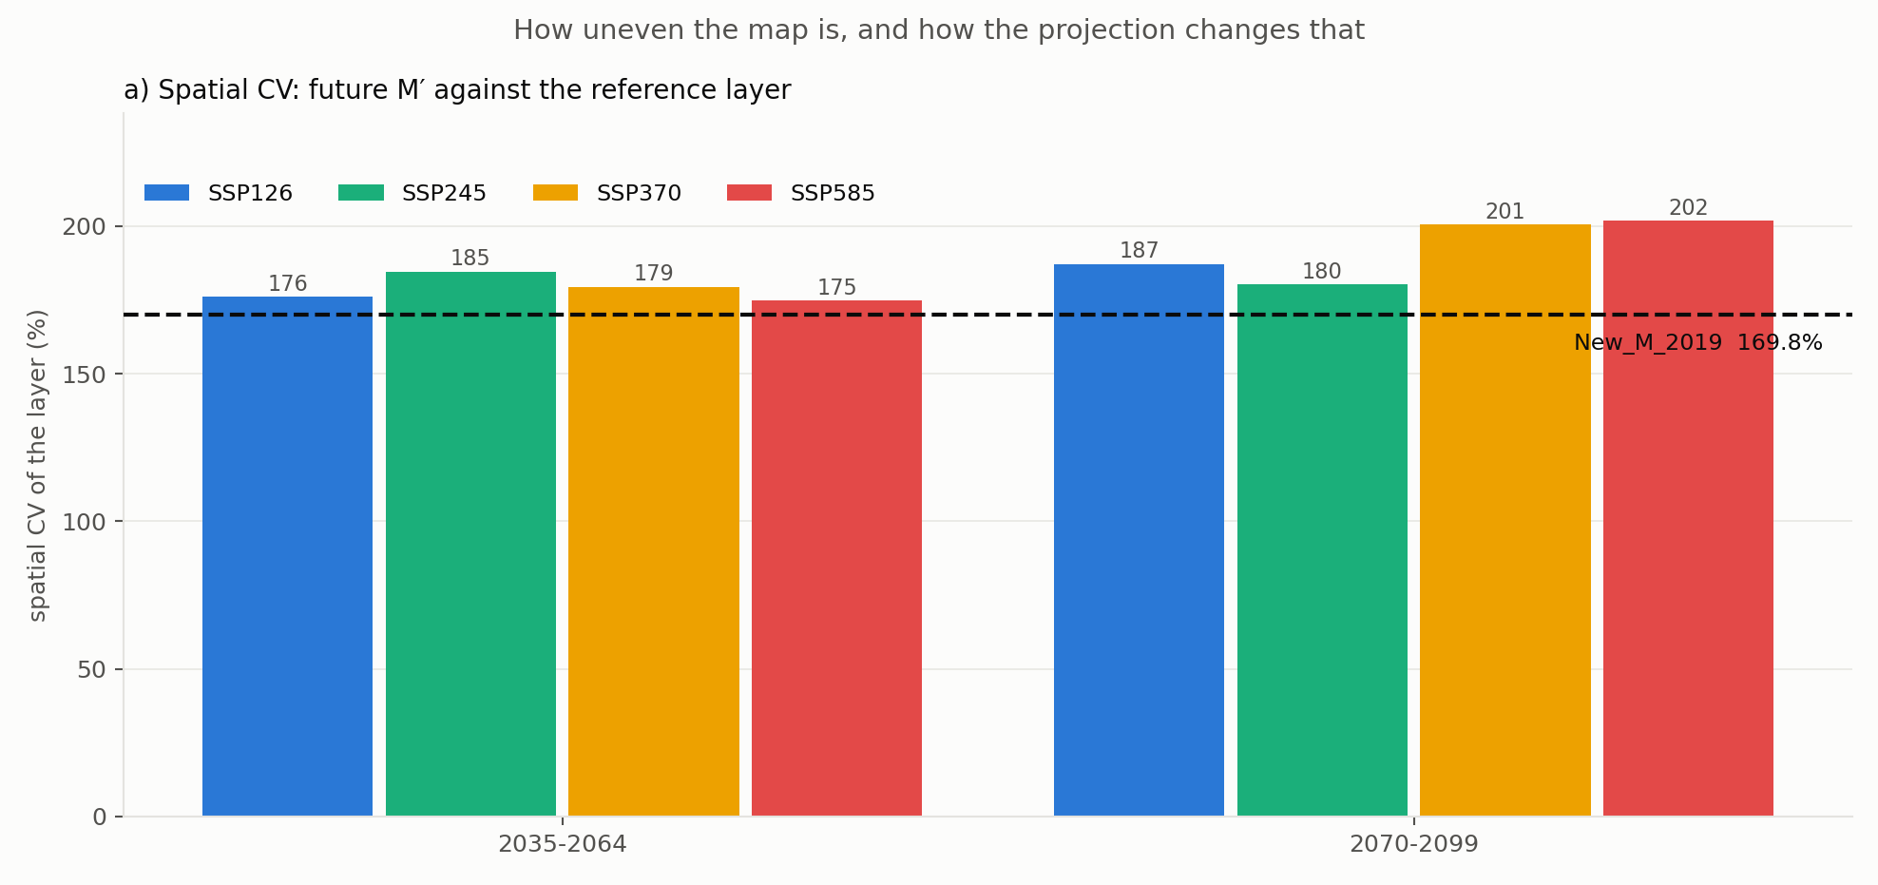
Figure 14a. Spatial CV of each future layer against the New_M_2019 reference.
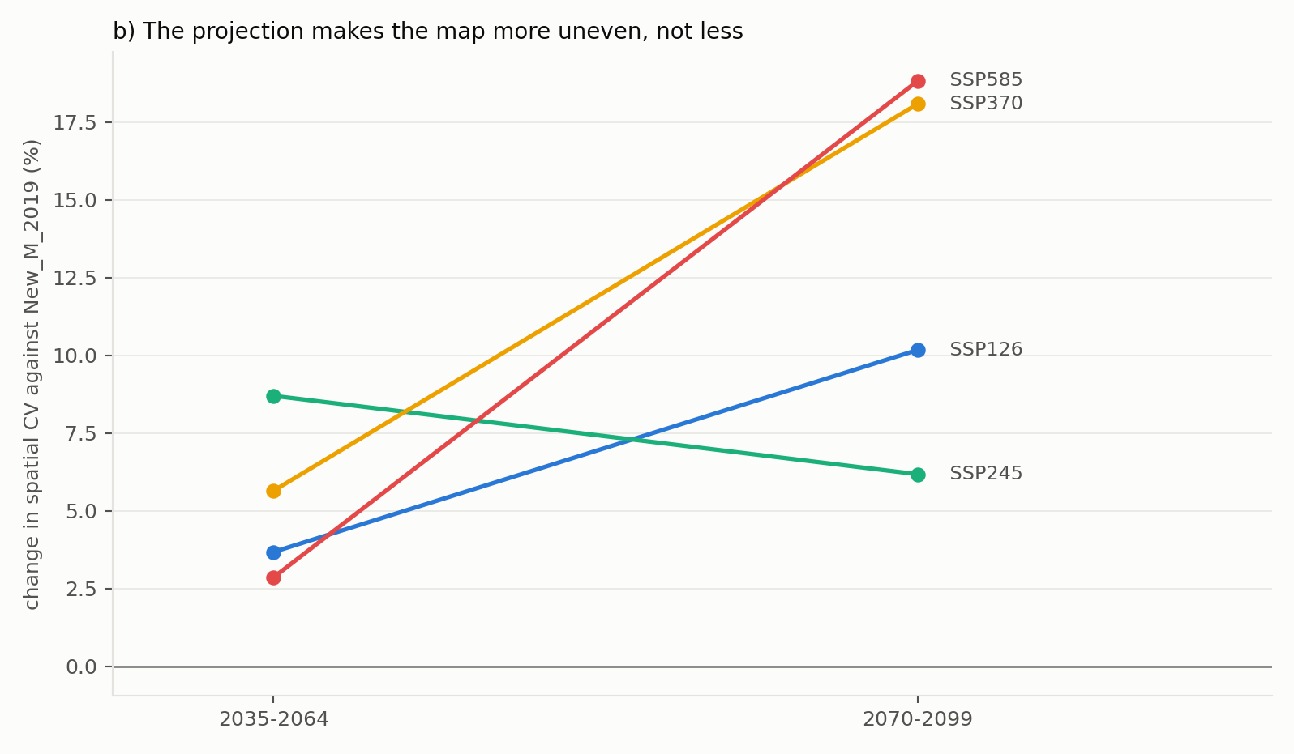
Figure 14b. The same as a change against the reference.

Where in the distribution the change falls
Cells were binned into deciles of New_M_2019 and the median change taken within each. The relative loss is deepest in the low and middle deciles - under SSP585 2070-2099 it reaches -32% in decile 4 - and shallowest in the top decile, at -6%. In absolute tonnes the ordering reverses, because the top decile holds most of the biomass. Both statements are true and they answer different questions; whichever is quoted, say which one it is.
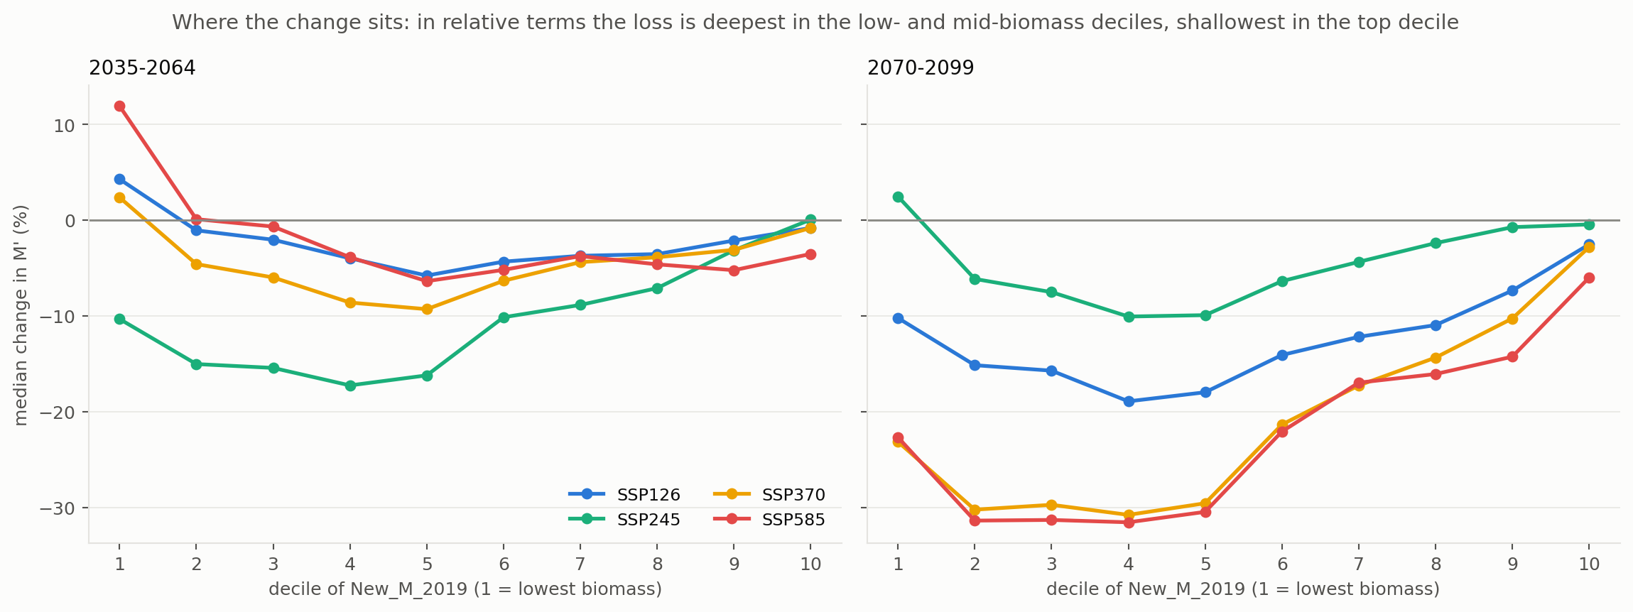
Figure 11. Median change in M' by decile of New_M_2019, per scenario and window. Decile 1 is the lowest-biomass tenth of the domain.

The result in one panel
Figure 13 is the headline: the median M' of each scenario-window with every component of the ratio modelled by the random forest, against the hatched 1985-2014 baseline and the New_M_2019 reference line. The baseline bar sits exactly on the line because averaging the modelled historical years returns New_M_2019 by construction; every other bar is a projection, and all eight fall below it, from 15.4 to 20.1 t DM ha⁻¹ against 20.43.
The percentages printed inside the bars are the shift in the median — median(M') against median(New_M_2019) — which is not the same statistic as the median of the per-cell changes tabulated earlier, because a median is not additive. The first answers "where does the middle of the map sit now", the second "what happens to a typical cell". Both are reported; say which one is being quoted.
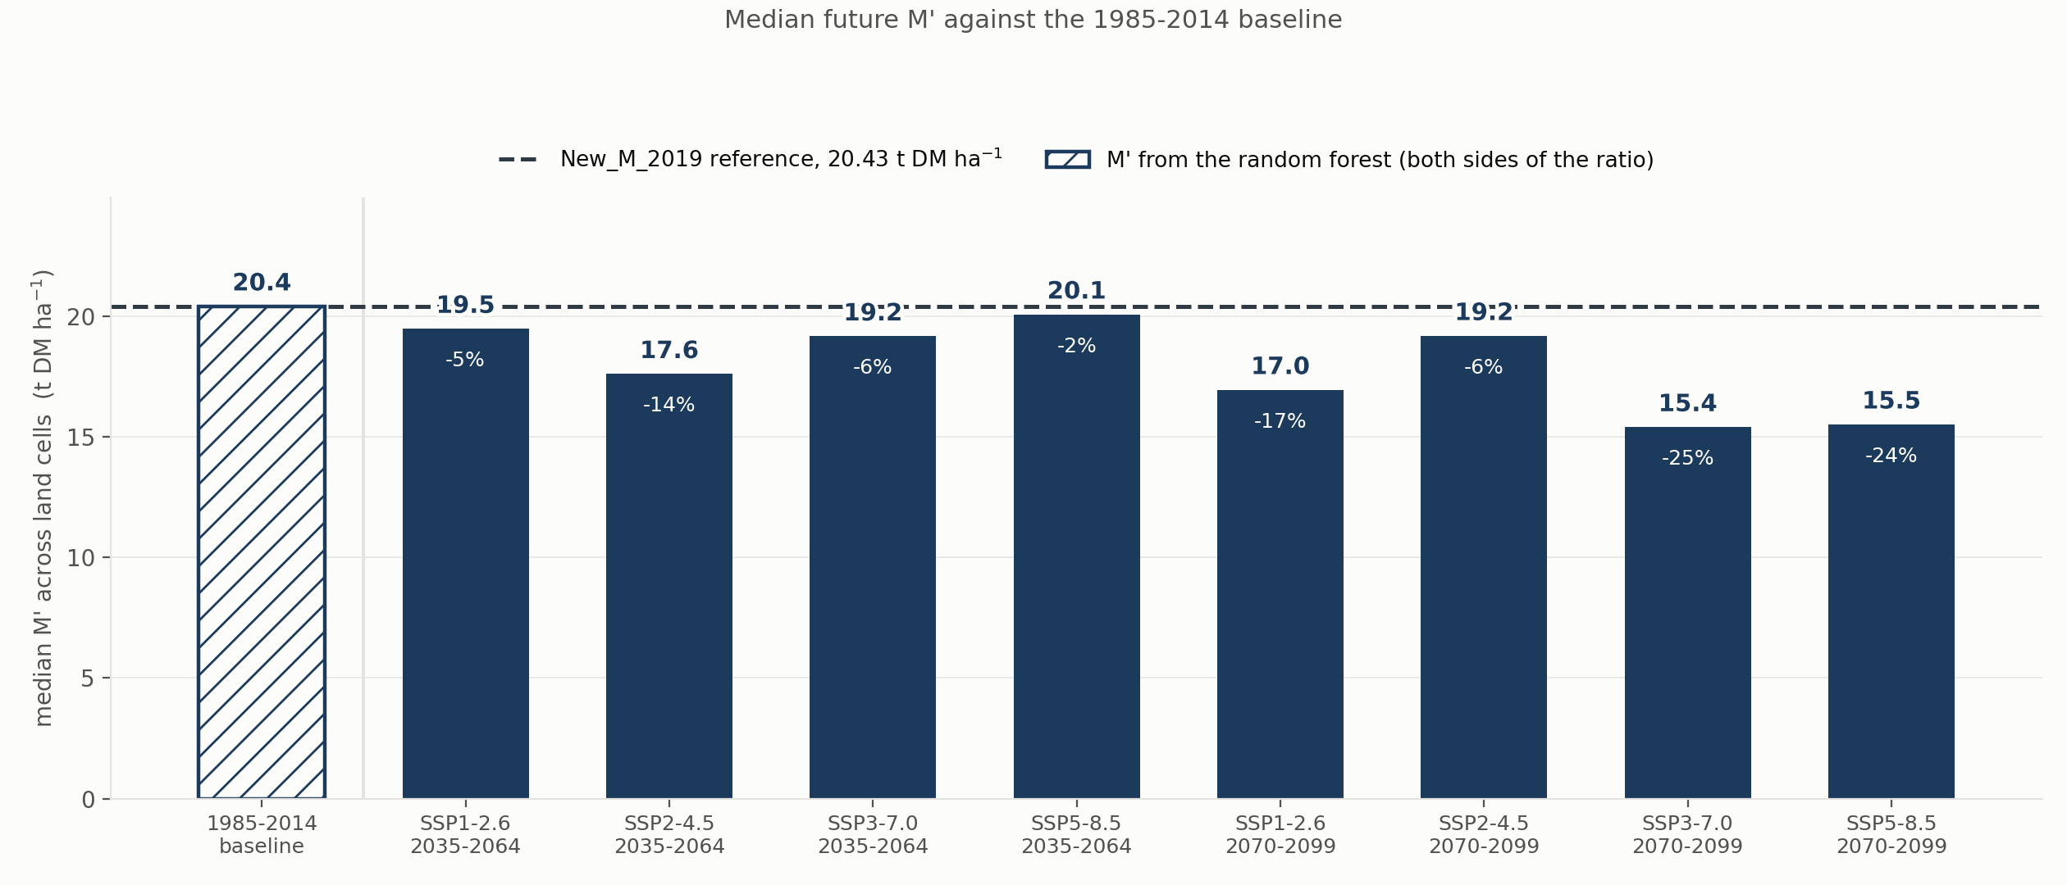
Figure 13. Median M' across land cells for each scenario-window, all components from the random forest. Hatched: the 1985-2014 baseline. Dashed: New_M_2019.

The two footings on one axis
Figure 12 puts the footing question and the climate signal in a single panel, because they are routinely confused. The orange bars are Eq. (1) M used as written; the navy bars are M' on the matched footing. The hatched pair on the left is 1985-2014, and the dashed line is the median of New_M_2019, 20.43 t DM ha⁻¹.
Read it vertically and the orange-to-navy gap is the footing: 31.87 against 20.43 t DM ha⁻¹ in the baseline pair, a factor of 1.56. That gap is arithmetic, not climate — Eq. (1) is the relationship reported in the paper, while Original_M_2004 is the layer the Richards & Brack (2004) procedure produced and the one FullCAM ships. Read it horizontally and the navy bars' distance from the dashed line is the projected change, which is the only part of the figure that carries a climate signal. The navy baseline bar sits exactly on the line, as it must.
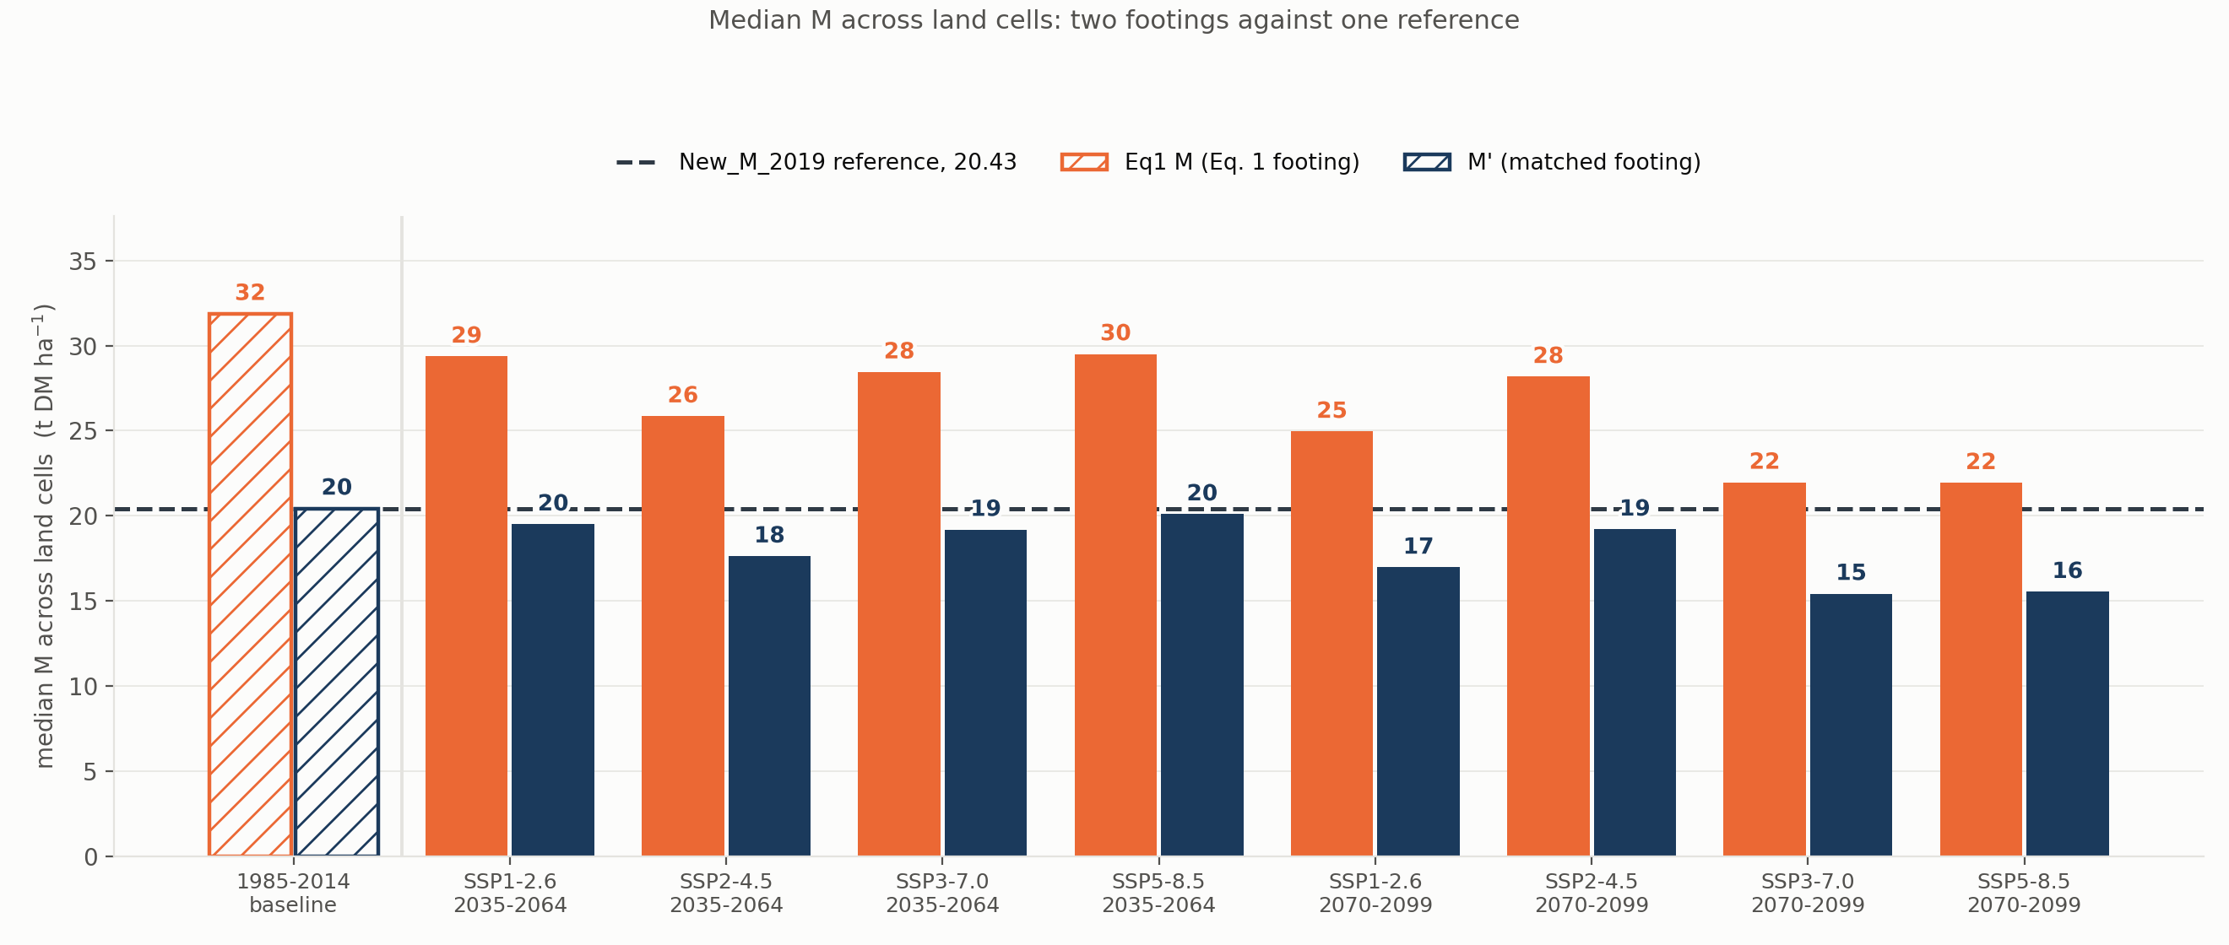
Figure 12. Median M across land cells: Eq. (1) M and matched-footing M' for each scenario-window, against the 1985-2014 baseline (hatched) and the New_M_2019 reference (dashed). Quoting an orange bar where a navy one belongs inflates M by roughly 56%.

What to do with this
Quote R² 0.931 (out of fold) as the model's accuracy, never the in-sample 0.968. Report the denominator change as methodological: the bias it removes was small, and saying so is stronger than implying it was large.
The averaging order is a decision that has not been made explicitly anywhere in this repository, and it moves the headline number more than the modelling change does. It should be settled before any change figure is published, and the same order used on both sides of the ratio thereafter. Nothing here has been adopted into FullCAM_input_CSIRO_data/; that remains a separate decision.
One file outside this folder was modified, backwards compatibly: Calculation_future_M_CSIRO/Step_08_apply_published_lambda.py gained the --hist-m, --out-dir and --layers flags, plus a guard for a run that contains no annual layers. Omit the flags and it behaves exactly as before, so Option B and the existing outputs are unaffected.

