The combined configuration
Space_time_validation/New_proposal/combined_Run · generated 2026-09-23 · the configuration the one-change tests point to

What this is, and what it is not
This is no longer a one-change test. It puts together the five decisions the earlier runs established, and it is reported as a configuration rather than as an experiment. To keep it decomposable, two intermediate configurations are run alongside it so that each ingredient's contribution can still be read off.
decision | from | why
1. Biomass rebuilt from stem diameters, b = 2.5 | Run_03 | the library's stem-mass column is not aligned with the stem attributes; rebuilding lifted the gate from 0.416 to 0.732 on identical sites
2. The AGB-versus-basal-area floor retired | Run_03 | it existed to exclude TERN and CSIRO wholesale; after the rebuild they pass on their own merits, 5.7 to 98.1 per cent and 74.8 to 100
3. Plot-area threshold 0.04 ha | Run_02 | readmits 201 DELWP Victoria visits at exactly 0.04 ha, median 225 Mg/ha on 30.8 m2/ha for a ratio of 7.3
4. A ceiling on the AGB-to-basal-area ratio | new here | replaces the plot-area floor as the inflation control, set at the 95th percentile of the verified-mature group rather than a round number
5. The DBH maturity filter kept | Run_04 | every basal-area threshold drove the gate to or below zero once the unlabelled sites entered; and M' is a ceiling, so validating it needs stands near their maximum

Building the table
step | sites
base table: 0.04 ha, no consistency floor | 2389
DBH maturity filter (verified or likely) | 877
rebuilt biomass available | 877
ratio at or below the ceiling (34.5) | 850

850 sites against Run 0's 600, and 147 south of 37 S against 4. The order matters: the ceiling is calibrated AFTER the rebuild, on rebuilt values, because the reported ratios are exactly what the rebuild exists to correct.

The ceiling did not do what it was asked to do
It was proposed to remove University of NSW at a ratio near 106 and Queensland Herbarium at 35.6. Those are REPORTED ratios, and the rebuild has already repaired them - University of NSW falls to 8.6 once biomass comes from the diameters. So the ceiling's stated targets no longer exist by the time it is applied.
It still earns its place, for a different reason. Set at the 95th percentile of the verified-mature group's rebuilt ratio - 34.5 Mg per m2/ha - it removes 27 sites, 17 of them TERN Australia with a median rebuilt biomass near 3,989 t DM/ha. That is precisely the over-estimation Run_03 flagged as its own main limitation: a single global scale constant rewards TERN's one-hectare plots with stems up to 479 cm far too heavily. The ceiling turns out to be the control for the rebuild's weakness rather than for the reported data's.
One consequence for reading: 34.5 is not comparable with the ratio figures quoted in the earlier runs, which were computed on reported biomass. The rebuild raises biomass, so the whole distribution of the ratio moves with it - the combined table's median is 17.5 where Run 0's was 10.2.
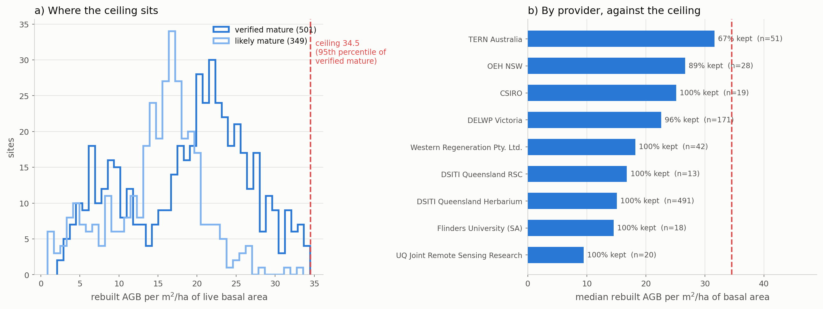
Figure 1. Where the ceiling sits in the rebuilt ratio, and how each provider stands against it.

The result
configuration | sites | south of 37 S | gate rho | ratio | future rho | null rho | gap
Run 0 as published | 600 | 4 | 0.418 | 0.465 | 0.269 | 0.205 | +0.064
+ biomass rebuilt | 599 | 4 | 0.732 | 0.386 | 0.390 | 0.292 | +0.098
+ floor retired + ceiling, 0.05 ha | 667 | 33 | 0.784 | 0.384 | 0.464 | 0.401 | +0.063
+ 0.04 ha, no ceiling | 877 | 161 | 0.857 | 0.351 | 0.624 | 0.505 | +0.119
all four combined | 850 | 147 | 0.844 | 0.356 | 0.602 | 0.473 | +0.129

Table 1. The ladder, analogue-found sites only.
The combined configuration reaches a present-day gate of 0.844 against Run 0's 0.418, a future rank correlation of 0.602 against 0.269, and a gap to the constrained null of +0.129 against +0.064 - on 850 sites rather than 600, with 147 of them south of 37 S rather than 4. It is the best configuration on every axis this study measures.
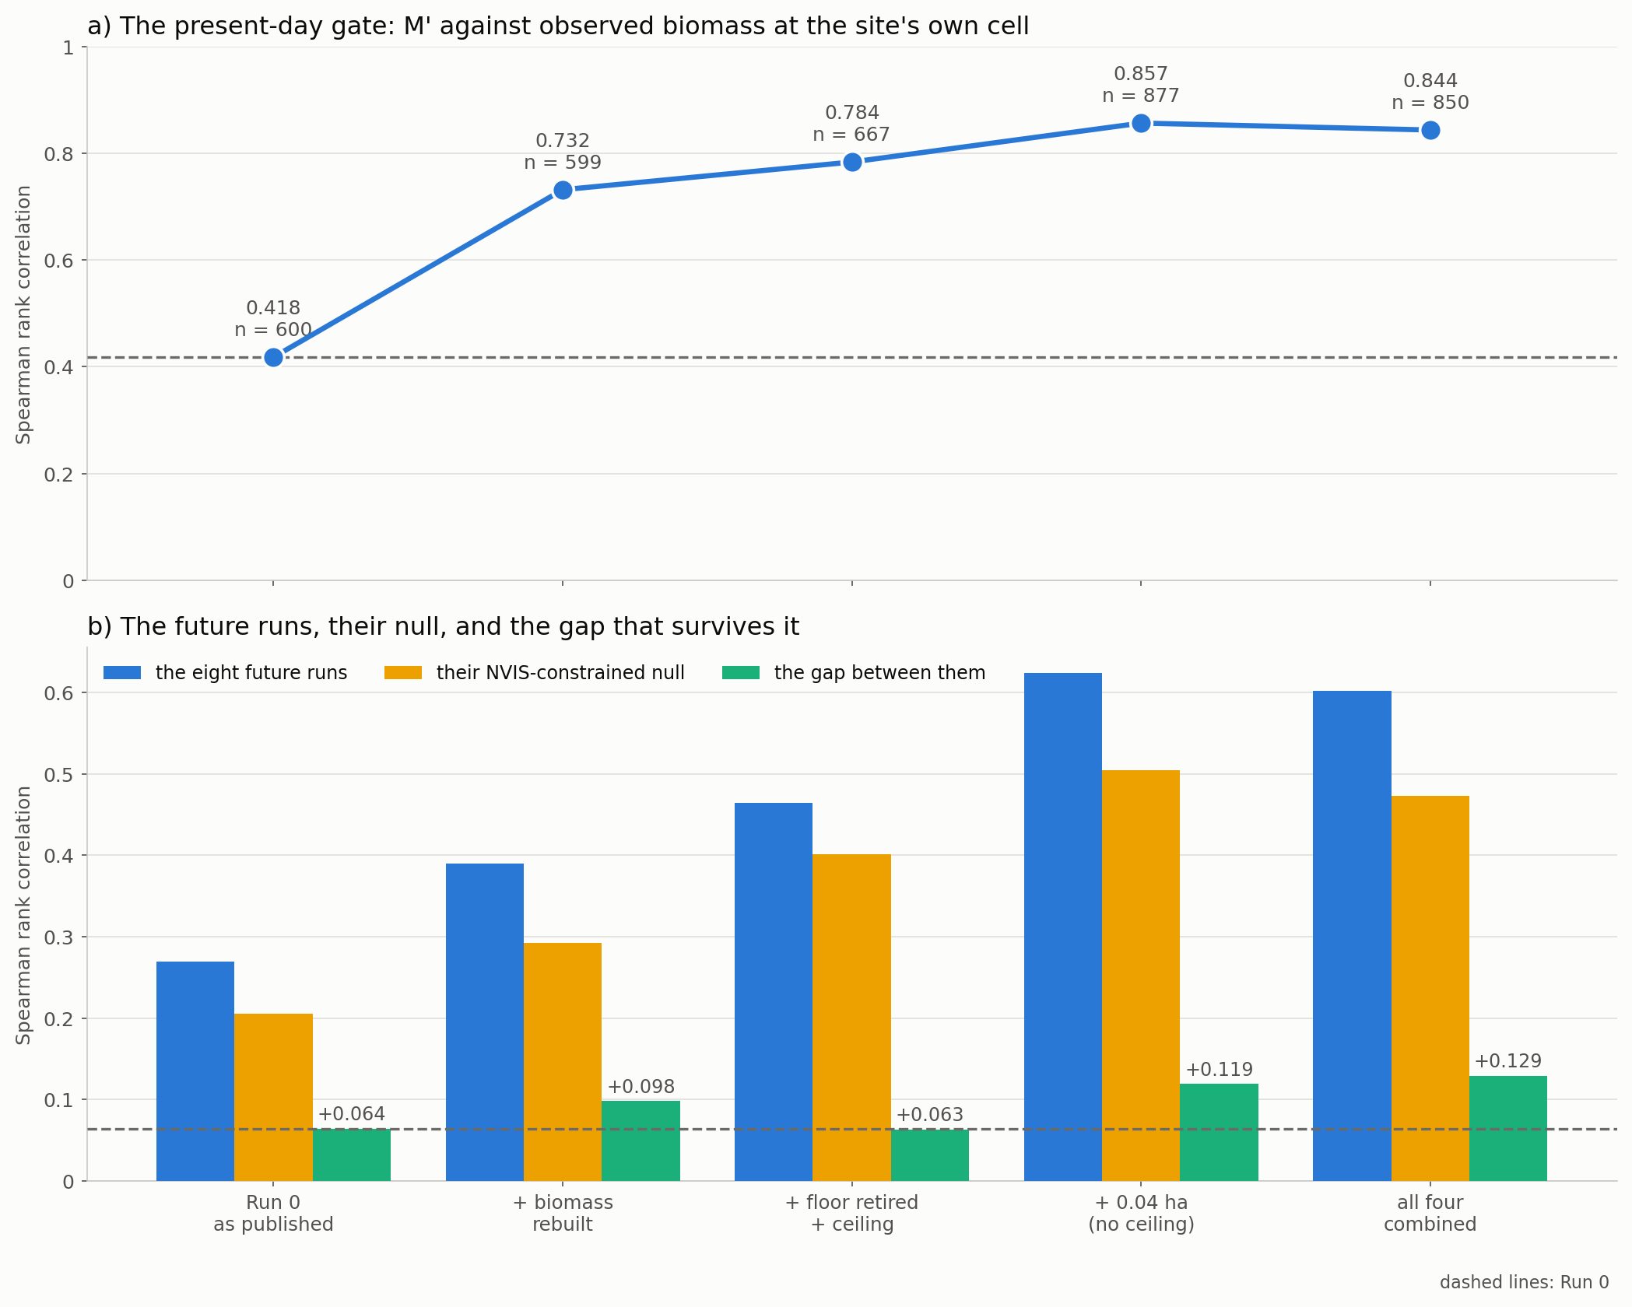
Figure 2. What each ingredient adds. Panel (b) shows the null rising with the runs, and the gap that survives it.

How it decomposes, and where it is not additive
The rebuild does most of the work on the gate: 0.418 to 0.732 of the total movement from 0.418 to 0.844. The 0.04 ha threshold does most of the rest, 0.784 to 0.857. The ceiling costs a little gate, 0.857 to 0.844, because it removes 27 of the highest-biomass sites.
The ingredients are NOT additive on the gap, and that is worth stating rather than smoothing over. Retiring the floor and adding the ceiling at 0.05 ha gives a gap of +0.063 - BELOW the rebuild alone at +0.098 - because the null rises faster than the runs do on that sample. Only when the 0.04 ha threshold is added does the gap recover, to +0.129. Any of these decisions taken on its own would have been judged differently from how it behaves in combination.
The ceiling is worth keeping on the gap rather than on the gate: it raises the gap from +0.119 to +0.129, because it lowers the null more than it lowers the runs. Given that it is also the control for Run_03's known over-estimation, both reasons point the same way.

Coverage
The sample is no longer confined to eastern Queensland and New South Wales. Sites below 37 S rise from 4 to 147, which was the limitation every earlier report had to state and none could remove.
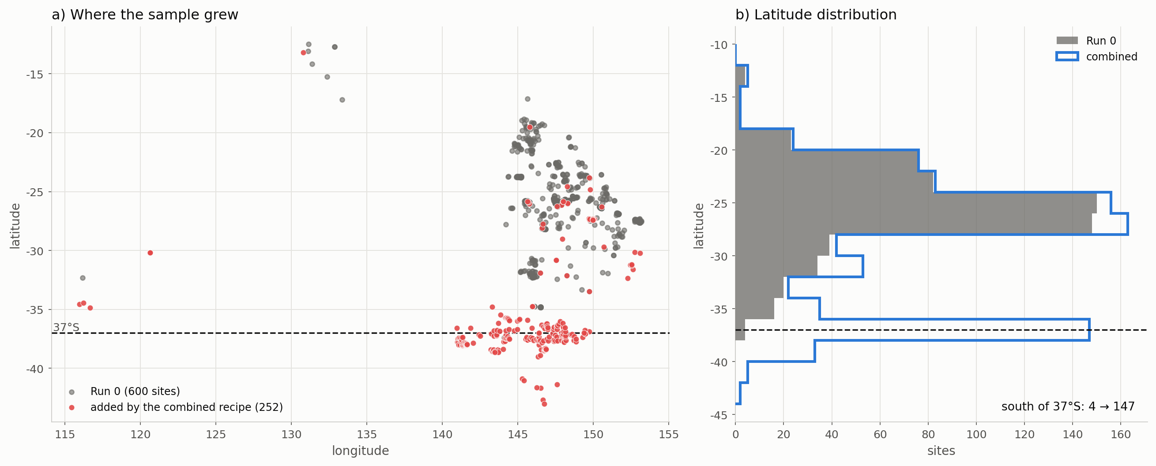
Figure 3. Where the sample grew.

What to be careful about
- The nulls rise with the runs. The NVIS-constrained null goes from 0.205 under Run 0 to 0.473 here, so a large part of the raw correlation gain is that the cleaned sample is easier to rank at all. The gap is the honest measure, and it doubles - +0.064 to +0.129 - which is a real result but a smaller one than the headline correlations suggest.
- The ratio is not independent of the library. Run_03's scale constant is calibrated to the library's own median plot biomass, so M' over observed biomass carries that calibration. Quote the rank correlation and the gap; quote the ratio only with the calibration stated.
- This is a configuration, not an experiment. Five decisions were changed at once, and only the three intermediate rungs make it decomposable at all. The ceiling in particular has never been tested on its own against Run 0.
- The no-analogue share rises from 16.1 to 19.7 per cent. The larger sample reaches climates that are slightly harder to match, and the late-century high-forcing windows remain extrapolation under this configuration exactly as under every other.
- The southern sites are one provider. DELWP Victoria supplies nearly all of them, so the coverage gain is a sensitivity to including one data source, as Run_02 said. It is a real gain and it rests on a narrow base.

What to do with it
- Report this as the corrected configuration and Run 0 as published. The difference between them is the headline of the whole exercise: the present-day gate goes from 0.418 to 0.844 once the observation is sound and the sample is not needlessly cut.
- Do not present it as a one-change result. Point to Run_03 for the rebuild, Run_02 for the threshold, Run_04 for keeping the DBH filter, and to this folder's intermediate rungs for the rest.
- Test the ceiling on its own before relying on it. It earns its place here for a reason different from the one proposed, and it has not been run against Run 0 in isolation.
- The stem-mass alignment defect still needs reporting to the library's custodians. Everything above depends on working around it.

Files
file | what it holds
Step_01_build_table.py | the five decisions, and the ceiling's calibration
Step_02_run_and_compare.py | the five configurations
Step_03_plots.py | the figures
Step_04_write_report.py | this document
outputs/reference_table_combined.csv | 850 sites
outputs/build_trail.csv | the build
outputs/ceiling_calibration.csv | where the ceiling came from
outputs/provider_effects.csv | what each provider contributes
outputs/combined_headline.csv | Table 1

