Run 1 - verified mature only
Space_time_validation/New_proposal/Run_01 · generated 2026-09-23 · one change from Run 0: --maturity "verified mature", 327 sites instead of 600

What was changed, and nothing else
The parent folder's Step_03 was run exactly as it stands, with one flag altered. Everything else is Run 0: NVIS-constrained matching, Eq. (1) of the window-mean FPI, all 174 predictors, PCA to 95 per cent of the historical variance, the 99th percentile no-analogue cutoff. No analysis code was written for the matching itself.
Step_03 names its outputs from the feature set, the constraint and the averaging order, but not from the maturity classes, so running it with a different --maturity overwrites the published Run 0 results. Step_01 of this folder therefore copies every file Step_03 will touch into a private backup, runs it, takes the results, and puts the backup back - verifying each restored file against a content hash. An earlier version trusted git for this and failed silently, because matches*.csv is in the repository's .gitignore and git can only protect what it tracks; the Run 0 match table had to be regenerated. The backup is now file-level and unconditional.

Why this run exists
In the present-day gate the two maturity classes carry almost the same observed biomass and behave completely differently.
class | n | median ratio | rho | observed AGB | AGB per m2/ha basal area | plot area (ha) | max DBH (cm)
verified mature | 327 | 0.61 | 0.49 | 117.5 | 7.3 | 0.40 | 68
likely mature | 273 | 0.34 | 0.39 | 109.8 | 17.4 | 0.24 | 40
POOLED (Run 0) | 600 | 0.49 | 0.42 | 112.4 | 10.2 | 0.24 | 52

Table 1. The present-day gate split by maturity class. The last three columns are properties of the OBSERVATION, not of M', so a difference in them is a difference in the data.
The likely-mature group returns a ratio of 0.34 against 0.61, on observed biomass that differs by less than 8 per cent. The explanation is in the last two columns and has nothing to do with maturity. Those sites report 17.4 Mg of biomass per square metre per hectare of their own live basal area, against 7.3 for the verified group - a figure at the very top of what a stand can physically carry - and they were measured on plots 40 per cent smaller. A per-hectare figure from a smaller plot is the same few trees divided by less ground. The likely-mature half is not less mature; it is more inflated.
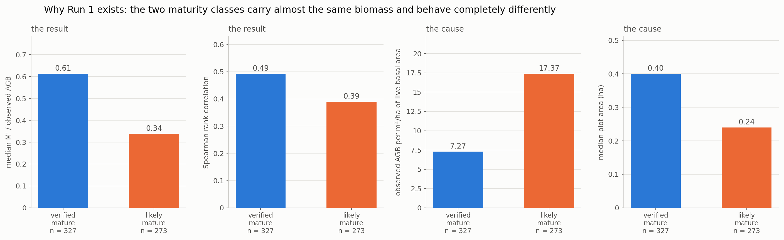
Figure 1. The two classes on the quantities that separate them. The first two panels are the result; the last two are the cause.

What Run 1 did
Across the eight scenario-windows, on the analogue-found sites: the median ratio rises from 0.465 to 0.557 and the rank correlation from 0.269 to 0.371. The hypothesis is confirmed - the likely-mature half was dragging the headline numbers down.
run | sites 0 / 1 | ratio Run 0 | ratio Run 1 | change | rho Run 0 | rho Run 1 | change
same_cell_present_day | 600 / 327 | 0.494 | 0.613 | +0.119 | 0.418 | 0.492 | +0.074
historical_analogue | 574 / 305 | 0.491 | 0.605 | +0.114 | 0.300 | 0.395 | +0.095
random_cells | 600 / 327 | 0.445 | 0.478 | +0.033 | 0.205 | 0.286 | +0.081
ssp126_2035-2064 | 550 / 295 | 0.465 | 0.597 | +0.132 | 0.273 | 0.368 | +0.096
ssp245_2035-2064 | 542 / 292 | 0.470 | 0.568 | +0.099 | 0.272 | 0.381 | +0.110
ssp370_2035-2064 | 518 / 273 | 0.464 | 0.558 | +0.093 | 0.266 | 0.434 | +0.168
ssp585_2035-2064 | 489 / 254 | 0.427 | 0.555 | +0.128 | 0.243 | 0.376 | +0.133
ssp126_2070-2099 | 535 / 285 | 0.441 | 0.557 | +0.116 | 0.230 | 0.352 | +0.122
ssp245_2070-2099 | 287 / 148 | 0.365 | 0.447 | +0.082 | 0.287 | 0.373 | +0.086
ssp370_2070-2099 | 62 / 41 | 0.557 | 0.393 | -0.164 | 0.055 | 0.114 | +0.059
ssp585_2070-2099 | 15 / 14 | 0.742 | 0.613 | -0.129 | 0.389 | 0.248 | -0.142

Table 2. Every run, analogue-found stratum only.
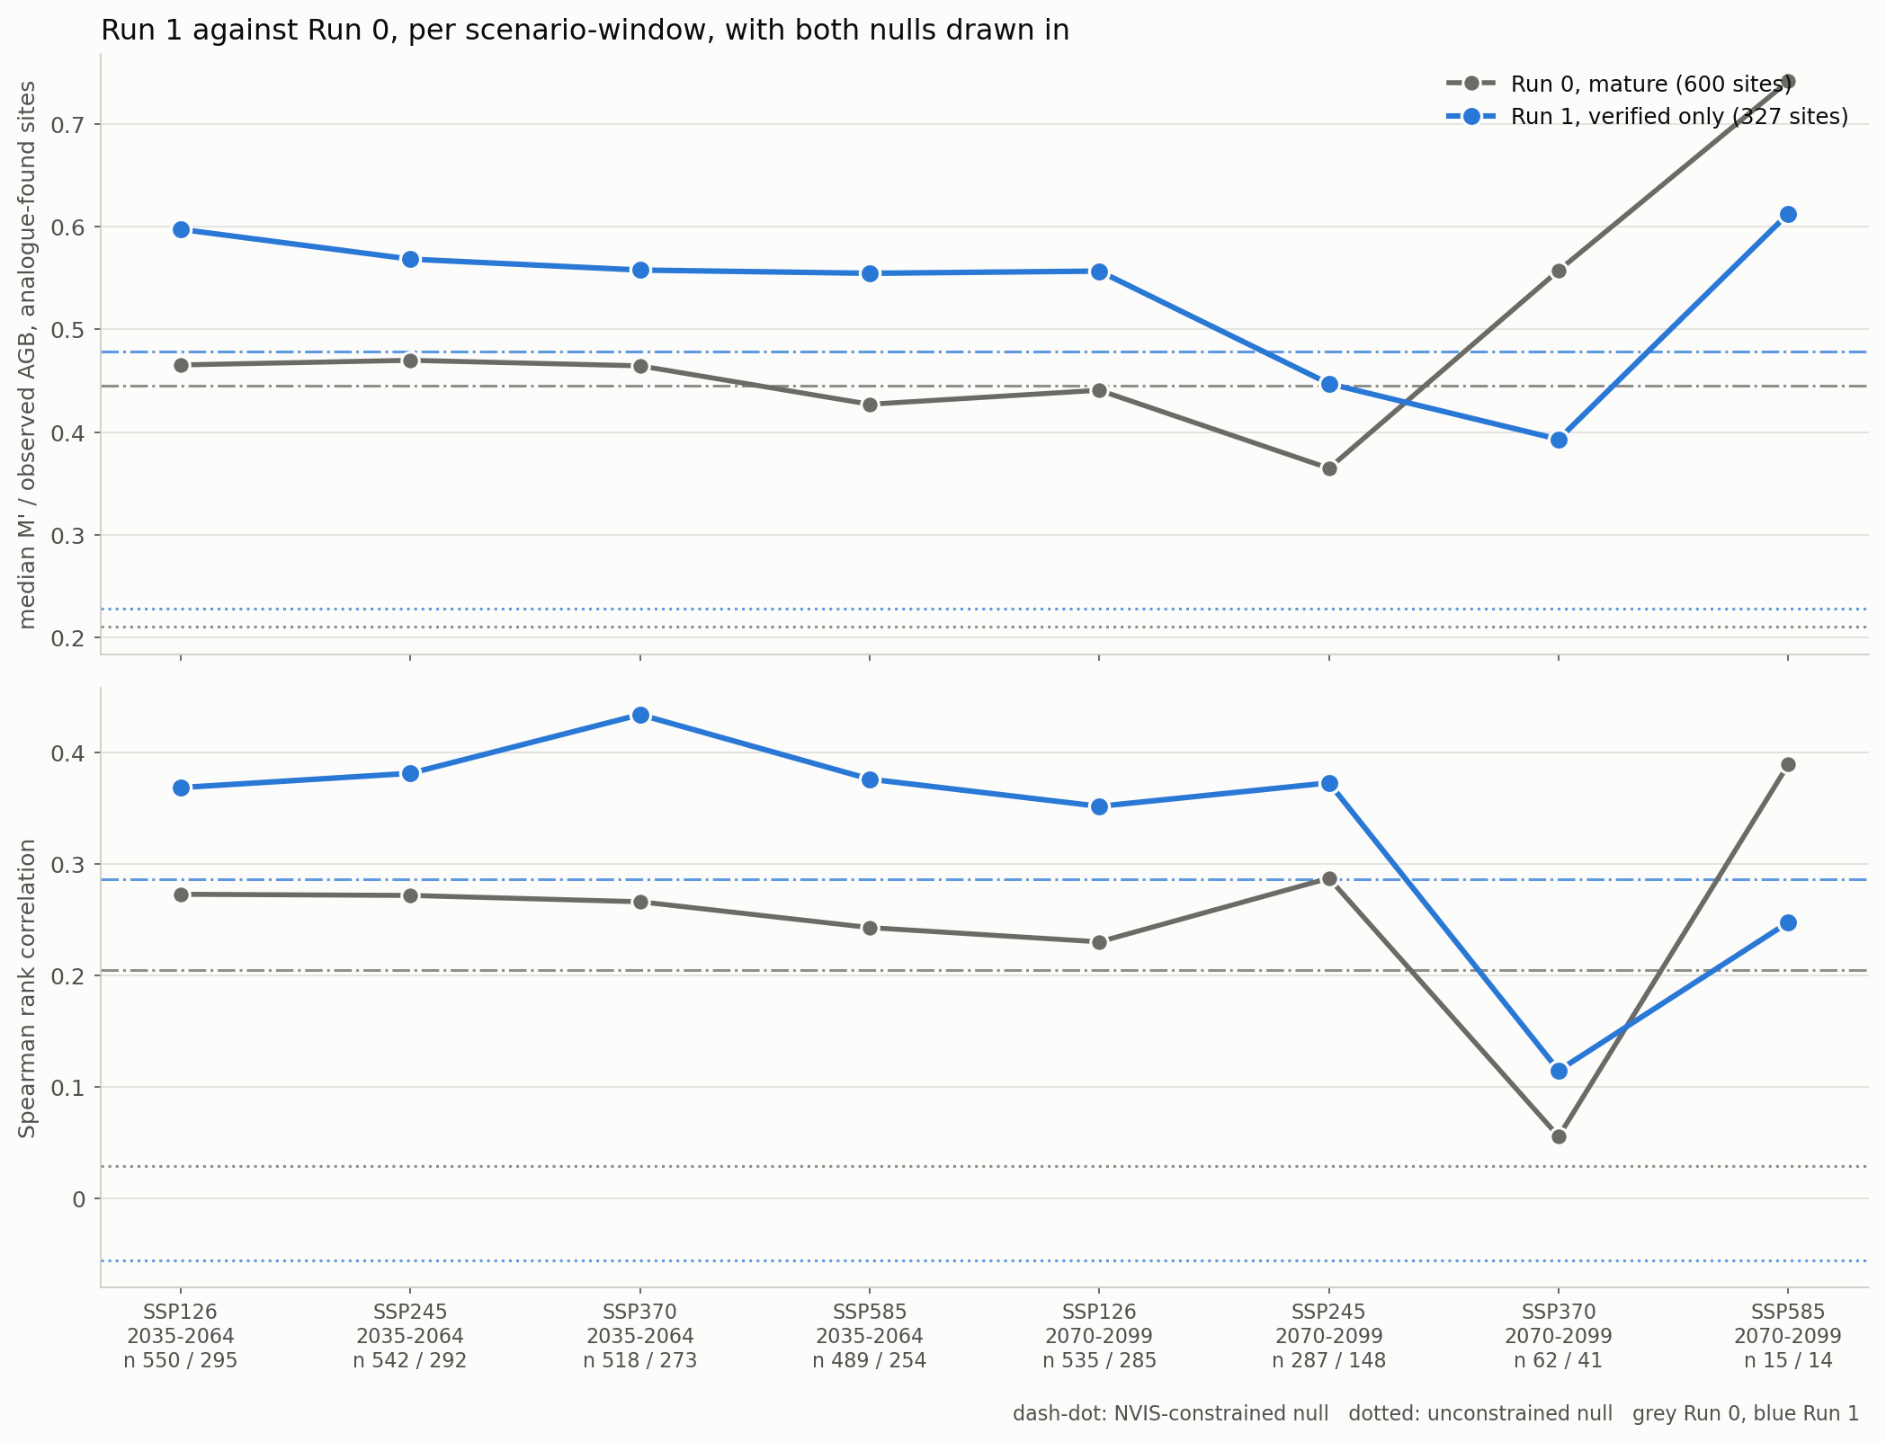
Figure 2. Run 1 against Run 0 per scenario-window, with both nulls drawn in as horizontal lines.
Two windows move the other way - SSP370 and SSP585 2070-2099 - and they should not be read. They retain 41 and 14 sites of 327. Under every configuration those two windows are extrapolation beyond what the observations constrain, and Run 1 halving the sample makes them worse, not better.

What it is worth, once both nulls are read
A null drawn from the same 327 sites is easier to beat for exactly the reason the runs are: the sample is cleaner. So the change in the runs overstates what the change bought. The honest measure is the GAP between the runs and their own null, and both nulls have to be there because they answer different questions.
run | null | n | null ratio | null rho | gap: runs minus null, rho
Run 0 | NVIS-constrained | 600 | 0.445 | 0.205 | +0.064
Run 0 | unconstrained | 600 | 0.210 | 0.029 | +0.240
Run 1 | NVIS-constrained | 327 | 0.478 | 0.286 | +0.084
Run 1 | unconstrained | 327 | 0.228 | -0.056 | +0.426

Table 3. Both nulls under both configurations.
Against the NVIS-constrained null the gap improves from +0.064 to +0.084 - a gain of +0.020, against a headline gain in rho of +0.102. Four fifths of what Run 1 appears to buy is shared with its own null, which is to say it is the sample getting cleaner rather than the matching getting better. Against the unconstrained null the gap grows from +0.240 to +0.426, which is the other half of the picture: the method plainly has skill, and Run 1 increases it.
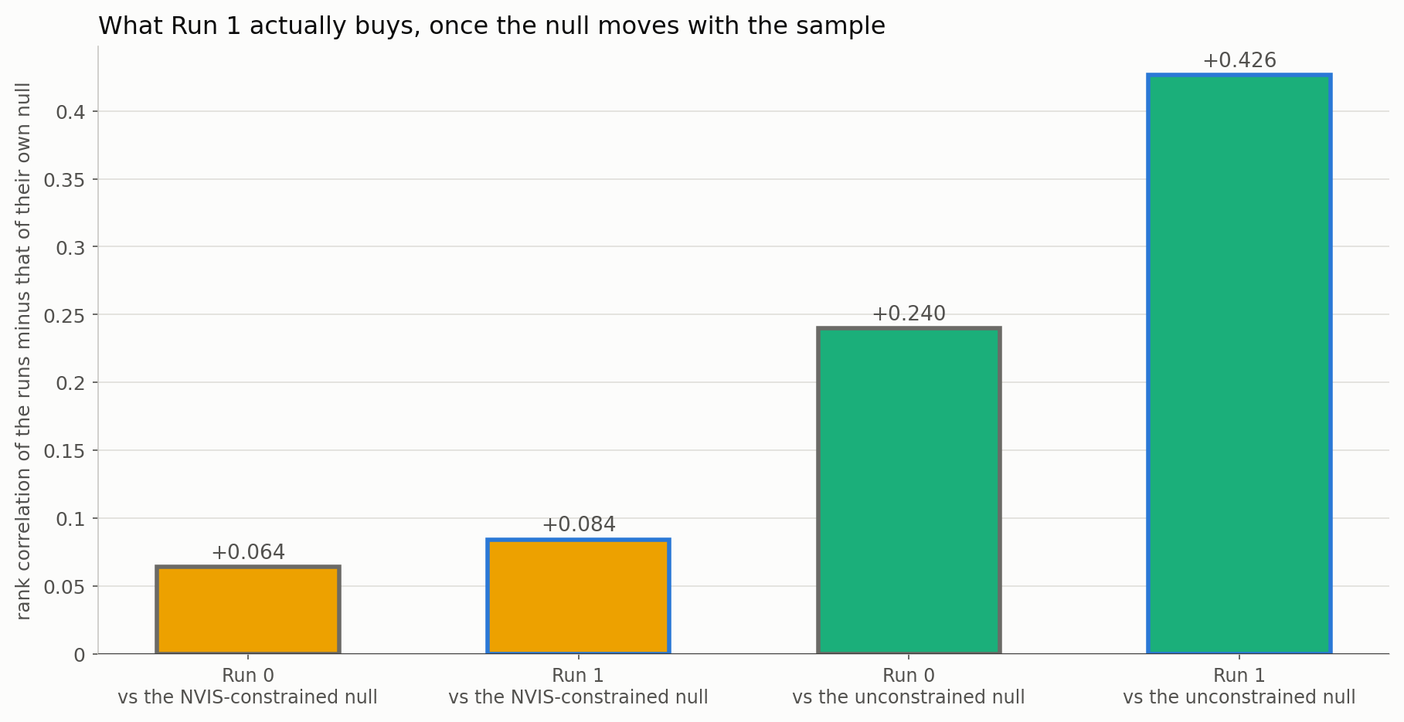
Figure 3. What Run 1 buys once the null is allowed to move with the sample.

What it cost
The bootstrap interval on the median ratio widens from 0.163 to 0.270 across the eight windows, a 66 per cent loss of precision, and the two late-century high-forcing windows fall to 41 and 14 sites. That is the price of halving the sample and it is not small.

What to conclude
- The hypothesis is confirmed. The likely-mature half was dragging the headline numbers down, and removing it raises the ratio by +0.092 and the rank correlation by +0.102.
- But the mechanism is plot size, not maturity. The likely-mature sites report 17.4 Mg of biomass per m2/ha of their own basal area from plots 40 per cent smaller. They are not less mature stands, they are more inflated per-hectare figures. The maturity threshold is acting as a proxy for a data-quality problem.
- Which means the better fix is a plot-area floor, not a stem-size threshold. Filtering on maturity discards 273 sites to remove an inflation that a minimum plot area would remove directly, and without also discarding the genuinely mature stands that happen to sit in that group. That is worth running as its own one-change test.
- Report Run 1 as a sensitivity, not as a replacement. Four fifths of the apparent gain is shared with its own null, the precision loss is 66 per cent, and the two late-century high-forcing windows become unusable at 41 and 14 sites.
- Both nulls were necessary to reach that reading. Against the unconstrained null alone Run 1 looks like a large improvement; against the constrained null alone it looks like almost none. The truth needs both.

Files
file | what it holds
Step_01_run_verified_only.py | runs the parent's Step_03 with the one flag, protecting the parent
Step_02_compare_vs_run0.py | the diagnostic and the comparison
Step_03_plots.py | the figures
Step_04_write_report.py | this document
outputs/gate_by_maturity.csv | Table 1
outputs/run01_vs_run00.csv | Table 2
outputs/both_nulls.csv | Table 3
outputs/matches_nvis.csv | Run 1's site-level matches, and five companion tables from Step_03

