Validating future M the way Roxburgh et al. (2019) validated M'
Validation_M/National_biomass_library/Roxburgh_validation · generated 2026-09-22 · the eight future M' layers, every component of the ratio produced by the random forest, scored against the National Biomass Library with the paper's own protocol

What Roxburgh did, and what is transplanted here
Roxburgh et al. (2019) updated FullCAM's maximum above-ground biomass layer by fitting a random forest to the ratio between the existing model and field observations. For each of 5,739 minimally disturbed biomass records he formed his Eq. (2), lambda_i = M_i / O_i, interpolated lambda across the continent with a random forest on 23 climate and soil covariates, and multiplied it through his Eq. (3), M' = lambda x M. The layer that came out is New_M_2019, which this repository calls Revised_M_Roxburgh and uses as the historical anchor of every future projection.
He judged the result on four numbers, computed on untransformed data and reported in his Table 4:
- ME, the mean error E - O. The sign is the bias, and a negative value is under-prediction.
- RMSE, the root mean squared error, which is the precision.
- EF, model efficiency (his Eq. (4), Nash and Sutcliffe 1970). 1.0 is perfect, 0.0 means the layer is no better than predicting the mean of the observations everywhere, and a negative value is worse than that.
- LCC, Lin's concordance correlation coefficient (his Eq. (5)). This is agreement with the 1:1 line rather than with any line, so unlike a correlation it can see a constant offset or a wrong slope.
He also stratified everything into Forest (canopy cover above 50 per cent) and Woodland (20 to 50 per cent) using the NVIS Major Vegetation Subgroups of his Table 2, compared the frequency distributions with a Kolmogorov-Smirnov test, reported means by state and vegetation class, and measured the spatial autocorrelation of his sample because clustered plots break the independence a random calibration/validation split assumes. All of that is reproduced here, on the same MVS class list, and applied to the eight future layers as well as to the two present-day ones he scored himself.

What a future layer can be asked
Comparing a future M' against a present-day observation is not a validation of the future, and nothing in this report should be read as one. It asks a narrower and answerable question: does the projected layer stay inside the envelope that observed maximum biomass defines, and where it leaves that envelope, in which direction and by how much. A divergence that grows with forcing is the projected change, not an error. The present-day layers, which can be validated, sit beside the future ones in every table so that the two can be told apart.

The sample
One row per observation, not per site. Roxburgh's n = 5,739 counts records and sites recur within it; the space-time validation next door collapses repeat visits to one row per site taking the maximum, which is right for a question about a site's potential but wrong here, because a maximum taken over an unequal number of visits raises the observed values and manufactures apparent under-prediction.
filter | surviving records
all site visits | 15,904
biomass recorded and positive | 13,599
live basal area recorded | 13,580
dead basal area under 20% of total | 11,189
production estates removed | 4,482
planted projects removed | 4,297
biomass at most 1500 t DM/ha | 4,195
inside the NLUM mask | 4,194

That leaves 4,194 records against his 5,739. The difference is almost entirely the two filters of his we cannot reproduce: the satellite forest-cover continuity check over 1972-2016, and the custodian-by-custodian disturbance metadata of his Supplementary Appendix A. Between them those removed roughly 60 per cent of the 14,453 records he began with. Our sample therefore retains disturbed stands his did not, and that is the first thing to suspect wherever the numbers below differ from his.

Result 1 - the transplant is correct
Before applying the protocol to anything new it has to reproduce the paper on the layers the paper itself produced. It does, at the level of the layers: averaged over the records, Original M and Revised_M_Roxburgh land within a few per cent of the continental means his Table 5 reports.
class | Original M here | his Table 5 | Revised M here | his Table 5
Forest | 168.7 | 172.1 | 231.0 | 234.4
Woodland | 81.0 | 48.5 | 68.0 | 49.5

The Forest agreement is close to exact. The layers are being read correctly, on the right grid, at the right places.

Result 2 - the fit statistics do not reproduce, and the reason is the sample
Scored against our records, the same file Roxburgh scored at EF 0.40 and LCC 0.62 returns EF -0.41 and LCC -0.08. The original M he scored at EF 0.14 returns EF -0.23. Both are below zero, which means neither layer predicts these observations better than their own mean would.
layer | n | ME | RMSE | EF | LCC | Roxburgh's own
Original M (FullCAM before 2019) | 4,194 | -54.0 | 295.8 | -0.23 | -0.10 | ME -35.3, RMSE 239.1, EF 0.14, LCC 0.25
Revised_M_Roxburgh (New_M_2019) | 4,194 | -36.1 | 315.6 | -0.41 | -0.08 | ME -8.0, RMSE 200.7, EF 0.40, LCC 0.62
Eq. (1) on modelled historical FPI | 4,194 | -22.0 | 292.2 | -0.20 | -0.11
Future M, SSP126 2035-2064 | 4,194 | -38.4 | 314.8 | -0.40 | -0.08
Future M, SSP126 2070-2099 | 4,194 | -40.9 | 315.6 | -0.41 | -0.08
Future M, SSP245 2035-2064 | 4,194 | -39.1 | 315.9 | -0.41 | -0.08
Future M, SSP245 2070-2099 | 4,194 | -37.7 | 316.2 | -0.41 | -0.08
Future M, SSP370 2035-2064 | 4,194 | -39.6 | 315.8 | -0.41 | -0.08
Future M, SSP370 2070-2099 | 4,194 | -44.0 | 317.1 | -0.42 | -0.08
Future M, SSP585 2035-2064 | 4,194 | -41.8 | 313.5 | -0.39 | -0.08
Future M, SSP585 2070-2099 | 4,194 | -47.8 | 316.1 | -0.41 | -0.08

Table 1. Roxburgh's Table 4, recomputed on our records for every layer. His published values are given for the two layers he scored.
The layer is the same file, so the whole of that gap belongs to the sample. Step_03 walks every sample decision that differs between his construction and ours, scoring the same layer each time, and the result is unambiguous: no single choice recovers his agreement.
sample | n | ME | EF | LCC | Spearman rho
Roxburgh's construction (the baseline here) | 4,194 | -36.1 | -0.41 | -0.08 | -0.143
one row per site, maximum measurement | 2,472 | -65.7 | -0.40 | -0.09 | -0.070
plot at least 0.05 ha | 3,837 | -24.0 | -0.48 | -0.12 | -0.215
plot at least 0.50 ha | 1,055 | +102.6 | -3.66 | -0.02 | -0.038
library as at 2017, the vintage he used | 4,194 | -36.1 | -0.41 | -0.08 | -0.143
biomass consistent with basal area | 3,210 | -110.4 | -0.29 | 0.00 | +0.078
stem-verified mature only | 593 | +50.2 | -1.36 | -0.14 | -0.015
mature (verified or likely) | 963 | -37.1 | -0.88 | -0.09 | +0.114
Forest only | 1,695 | +91.3 | -0.82 | -0.08 | -0.026
Woodland only | 2,337 | -118.4 | -0.23 | -0.00 | -0.112
top 1% of observations trimmed (> 1261 t DM/ha) | 4,152 | -23.3 | -0.48 | -0.08 | -0.142
all of this repo's filters together | 2,560 | -121.3 | -0.34 | -0.02 | +0.032
this repo's filters, one row per site | 1,688 | -124.6 | -0.36 | -0.04 | +0.079
this repo's filters, per site, mature only | 600 | -139.3 | -0.31 | 0.07 | +0.418

Table 2. Every sample decision, one at a time, scoring Revised_M_Roxburgh.
On his construction the rank correlation between observed biomass and his own layer is -0.14. Every single-filter variant stays between -0.22 and +0.11. Only the full stack this repository applies - a minimum plot area, the biomass-versus-basal-area consistency check, records from 1985 on, one row per site, and mature stands only - reaches +0.42, and it does so on 600 records out of 4,194. The positive agreement reported by the space-time validation is produced by the conjunction of those filters, not by any one of them, and not by the layer having broad skill against this library.
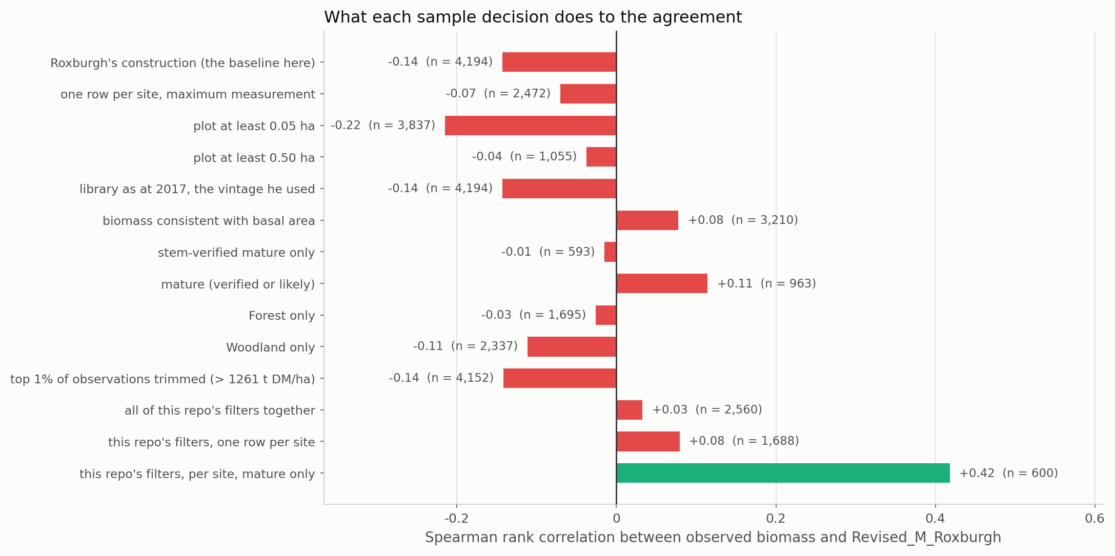
Figure 1. What each sample decision does to the agreement between observed biomass and Revised_M_Roxburgh. Green marks the only variant that reaches a rank correlation above 0.2.
How to read it: each bar is the Spearman rank correlation on the subsample named on the left, with that subsample's size beside it. The quantity is a rank correlation rather than EF or LCC because rank is what a maximum-biomass layer must at minimum get right - it should put the productive sites above the unproductive ones even if the level is wrong - and because it is not thrown by the extreme values this library contains.

Result 3 - why the observations cannot resolve this
Two checks on the observation itself, in order. The first passes and the second explains everything above.

The biomass field is sound
The library reports a plot figure in t DM per hectare and separately lists every stem with its own dry mass, its allometric model and the subplot area it was measured in. Rebuilding the plot figure from the stems - summing stem mass within each subplot, dividing by that subplot's area, averaging over subplots - reproduces the reported value at a rank correlation of 0.922 over 1,995 surveys, with a median ratio of 1.08. The aggregation, the subplot areas and the per-hectare scaling are all correct. Whatever is wrong is not the arithmetic.

The per-hectare figure is dominated by plot size
Across the sample, reported biomass correlates with the area of the plot it was measured in at Spearman -0.562. That is far stronger than its correlation with any modelled layer (-0.143 against Revised_M_Roxburgh), and it runs the wrong way: the smaller the plot, the larger the reported biomass per hectare.
plot area | records | median observed | median M | rho against M
(0.0, 0.05] | 366 | 240 | 133 | +0.039
(0.05, 0.15] | 1,380 | 162 | 64 | -0.144
(0.15, 0.3] | 434 | 81 | 55 | -0.204
(0.3, 0.45] | 958 | 35 | 77 | -0.312
(0.45, 1000.0] | 1,056 | 11 | 98 | -0.037

Table 3. Median reported biomass by the size of the plot it came from.
Median reported biomass falls from about 240 t DM per hectare on plots of 0.05 hectares or less to about 11 on plots above 0.45 hectares - a twenty-fold gradient produced by sampling geometry alone. A per-hectare figure from a 0.02 hectare plot is one large tree multiplied by fifty, and plots of that size are placed where there is something to measure. No spatial layer can reproduce that gradient, because nothing about the location predicts how large a plot a given agency chose to lay out there.
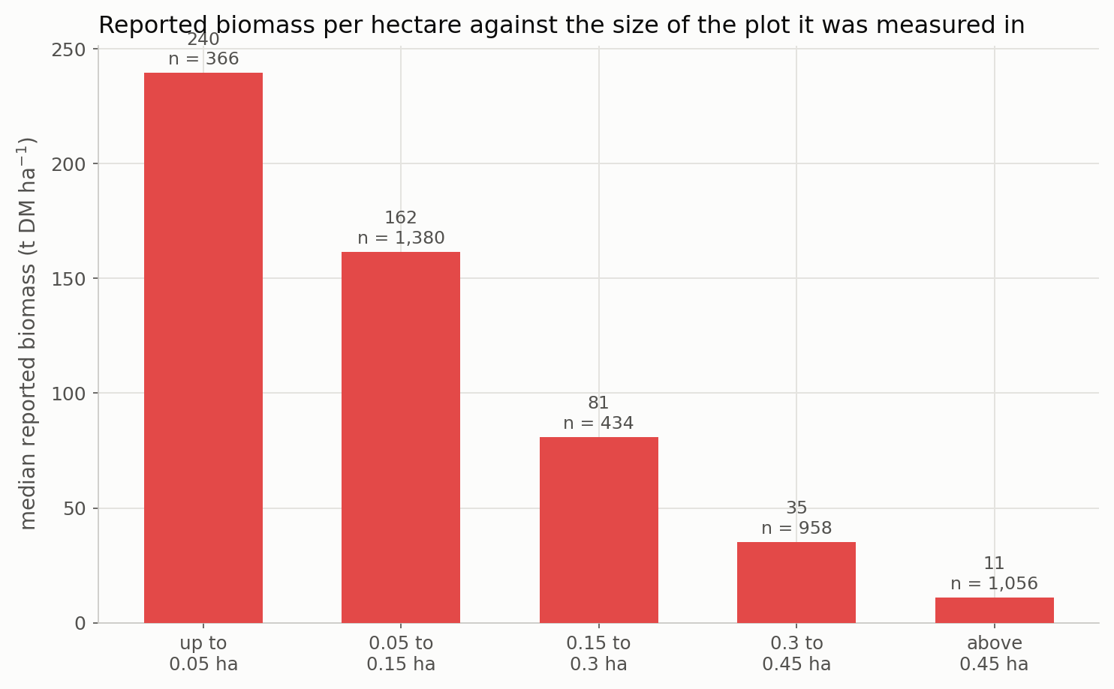
Figure 2. Reported biomass per hectare against the size of the plot it was measured in. The count of records in each band is given above the bar.
The same effect appears provider by provider, which rules out the alternative explanation that plot size is merely a proxy for region:
data provider | n | median plot (ha) | median observed | rho vs M | rho vs plot area
Queensland NFPP | 1,647 | 0.40 | 20 | -0.24 | -0.35
Darwin Centre for Bushfire Research | 808 | 0.08 | 197 | +0.06 | -0.17
DSITI Queensland Herbarium | 647 | 0.24 | 93 | +0.39 | -0.30
Department of Parks and Wildlife (WA) | 502 | 0.13 | 83 | -0.08 | -0.18
DELWP Victoria | 214 | 0.04 | 202 | +0.16 | n/a
University of Queensland | 74 | 0.02 | 442 | +0.13 | +0.07
Western Regeneration Pty. Ltd. | 57 | 0.10 | 486 | +0.13 | n/a
CSIRO | 56 | 0.25 | 22 | +0.01 | +0.13
TERN Australia | 53 | 1.00 | 4 | +0.13 | -0.03

Table 4. Within each provider, what the reported biomass tracks.
Inside the largest provider - Queensland NFPP, 1,647 records on uniform 0.4 hectare plots - the rank correlation with Revised_M_Roxburgh is -0.24. Only one provider, DSITI Queensland Herbarium, reaches a positive correlation of note (+0.39). The library is a stem inventory assembled from many surveys with different designs, and it was never built to be a wall-to-wall biomass map; this is a statement about what a comparison against it can resolve, not a criticism of it.

Result 4 - the errors are spatially clustered
Roxburgh measured the spatial correlation of his sample and reported it falling below 0.2 beyond about 10 km, then balanced the data by up-sampling at a 10 by 10 km scale before fitting. The same correlogram on the residual observed-minus-modelled gives 0.80 within 10 km here, and it does not fall below 0.2 until about 200 km, beyond which it is -0.04.
separation | pairs | residual correlation
0 to 1 km | 2,961 | +1.108
1 to 2 km | 1,637 | +1.355
2 to 5 km | 7,154 | +0.409
5 to 10 km | 11,993 | +0.323
10 to 20 km | 20,980 | +0.277
20 to 50 km | 61,156 | +0.361
50 to 100 km | 137,194 | +0.245
100 to 200 km | 328,218 | +0.186
200 to 500 km | 685,430 | +0.022
500 to 1000 km | 433,835 | -0.074
1000 to 3000 km | 1,681,783 | -0.061

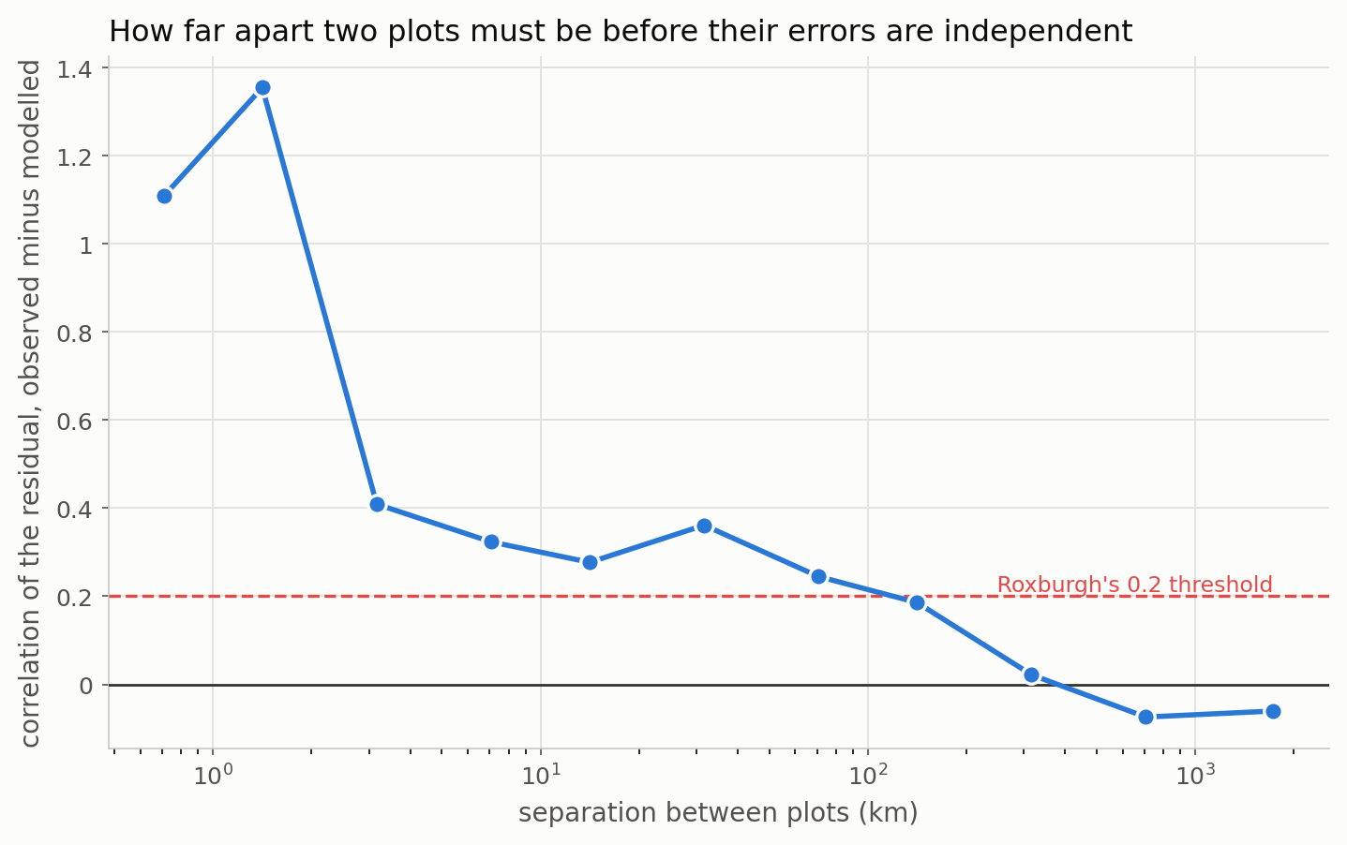
Figure 3. How far apart two plots must be before their errors are independent. The distance axis is logarithmic because the bins are; the correlation axis is linear.
This matters for reading his Table 4 as much as ours. A random 70/30 split of a sample this clustered puts near neighbours on both sides of the split, so the withheld 30 per cent is not independent of the 70 per cent the model saw, and the validation statistics are optimistic by an amount this design cannot quantify. Roxburgh raises the concern himself in his Section 2.4 and addresses it by bootstrap up-sampling; the point here is only that his 0.40 and 0.62 are an upper bound on what an independent sample would give, which narrows the gap against our numbers from the other side.

Result 5 - what this says about the future layers
The eight future layers score EF -0.42 to -0.39 and LCC -0.08 to -0.08, against -0.41 and -0.08 for Revised_M_Roxburgh. They are indistinguishable from it and from each other. That is the expected result and not a disappointment: each future layer differs from the historical anchor by a few per cent in the median, while the observation carries a twenty-fold artefact from plot size. A test with this much noise in the reference cannot resolve a signal that small, and no amount of additional statistics will change that.
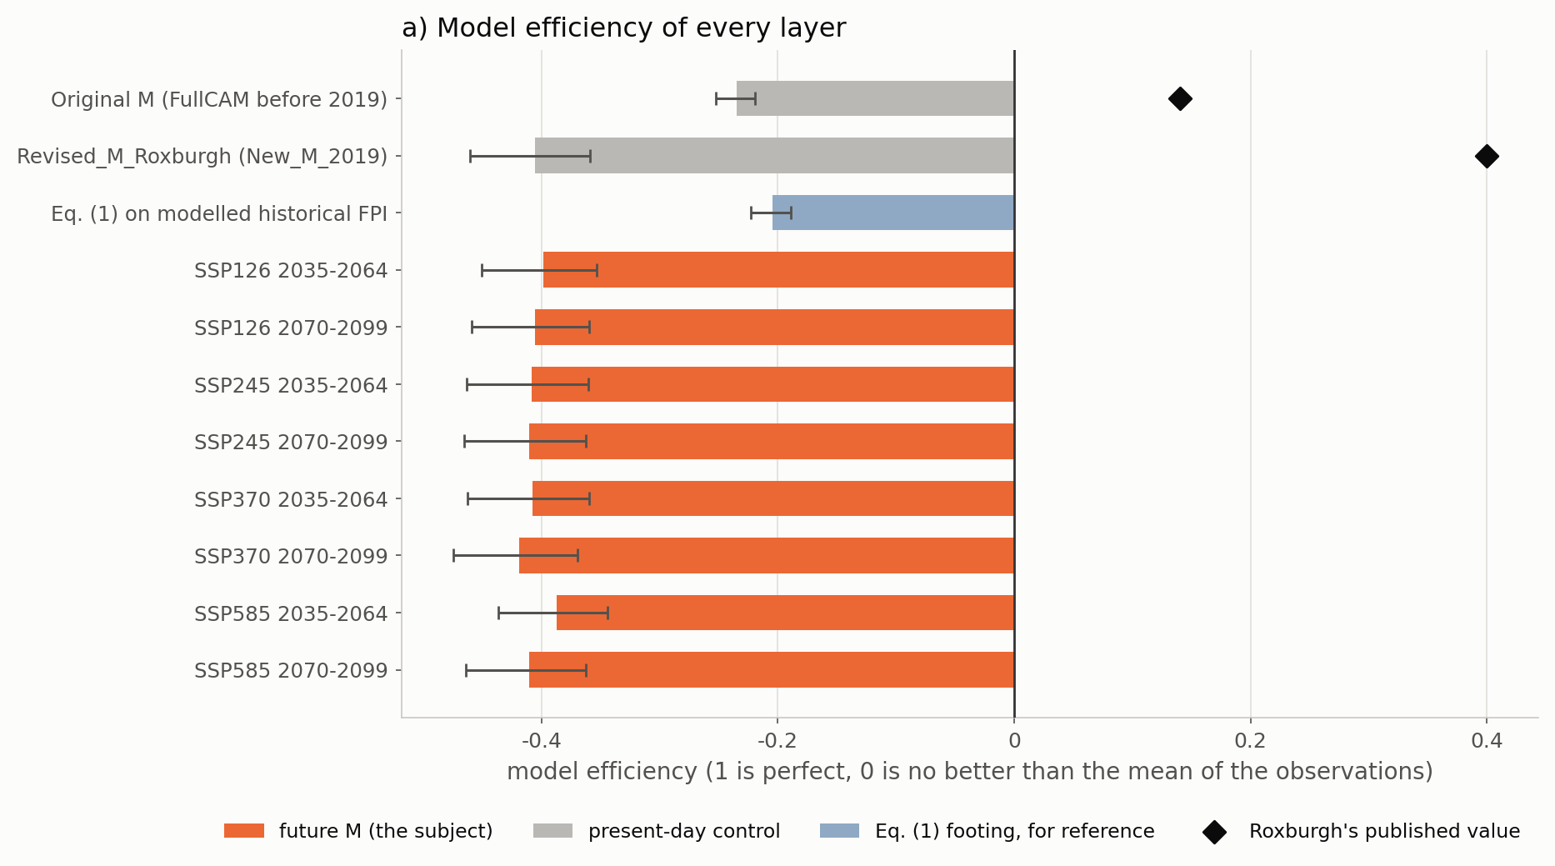
Figure 4. Model efficiency of every layer, with 95 per cent bootstrap intervals. The black diamonds are Roxburgh's published values for the two layers he scored.
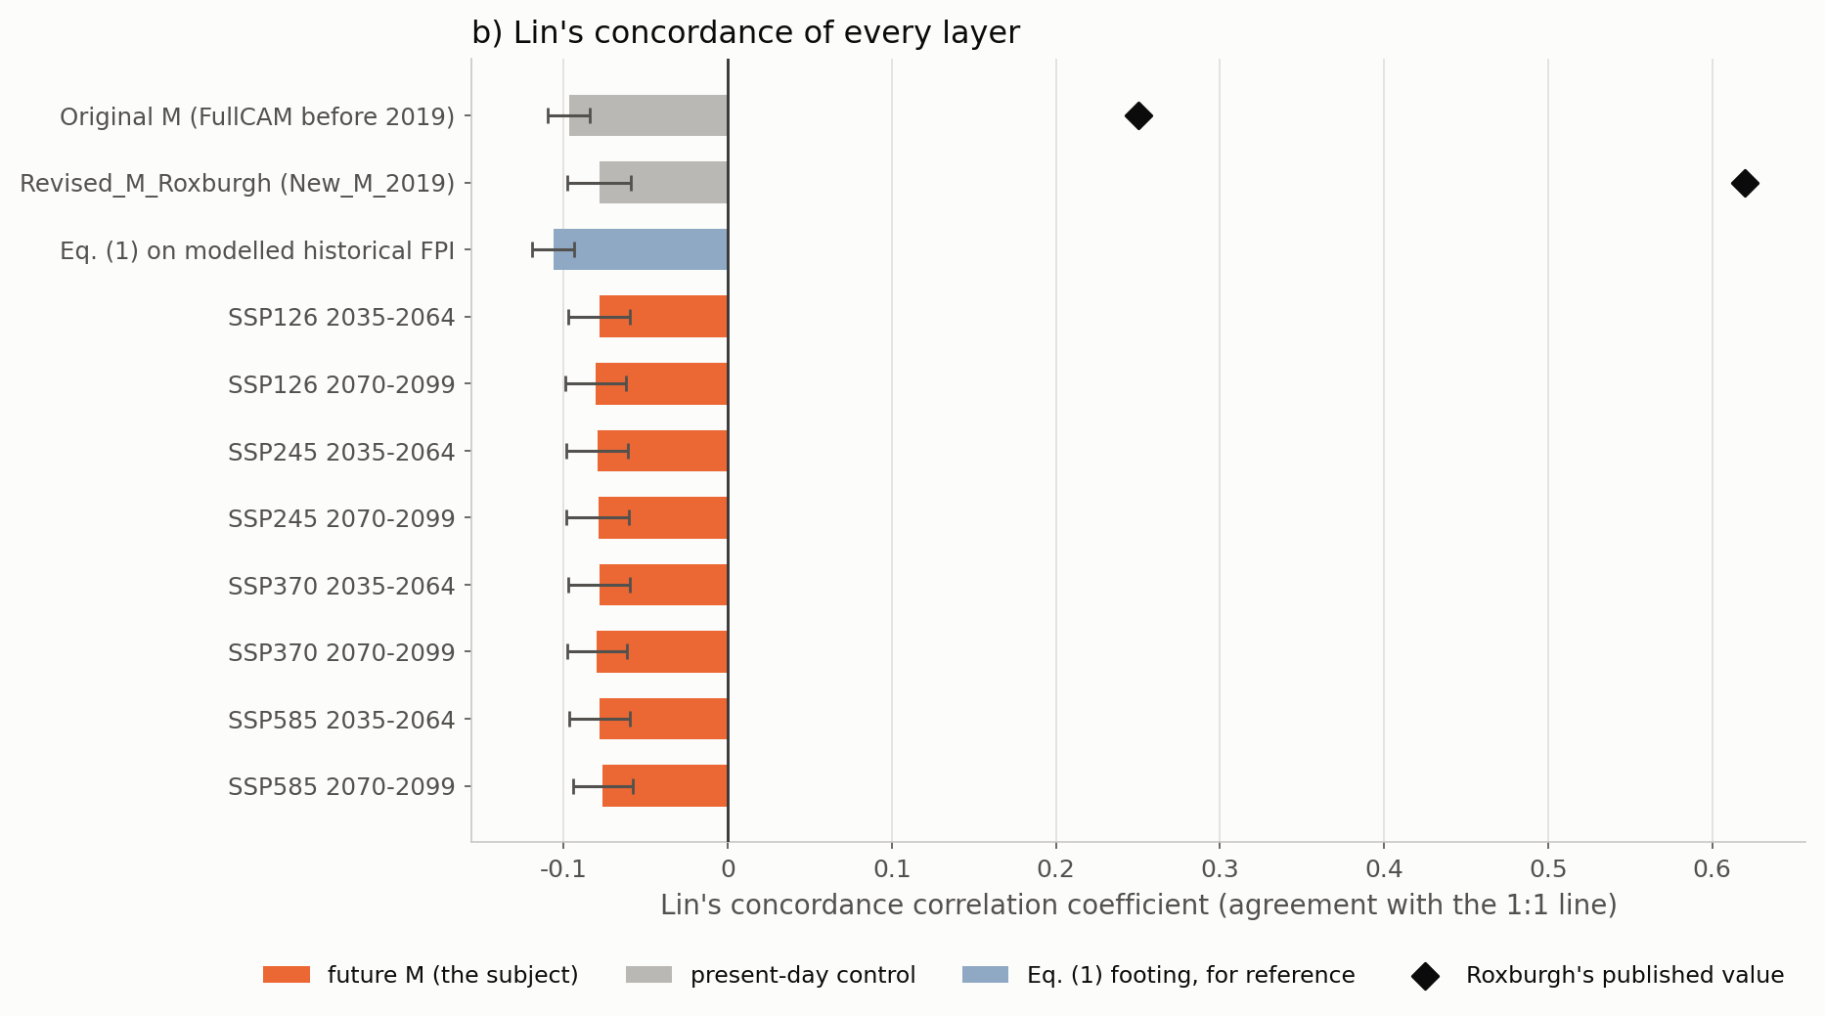
Figure 5. Lin's concordance correlation coefficient of every layer, on the same basis.
The one thing the future layers do say is visible in the distributions rather than the fit statistics. As forcing increases the projected distribution spreads: its median falls while its upper tail rises.
layer | median | 95th percentile | maximum | KS statistic against the observations
Original M (FullCAM before 2019) | 90.0 | 272 | 473 | 0.370
Revised_M_Roxburgh (New_M_2019) | 82.0 | 378 | 1162 | 0.266
Eq. (1) on modelled historical FPI | 121.8 | 302 | 488 | 0.489
Future M, SSP126 2035-2064 | 81.0 | 369 | 1189 | 0.263
Future M, SSP126 2070-2099 | 78.9 | 363 | 1221 | 0.251
Future M, SSP245 2035-2064 | 81.3 | 364 | 1223 | 0.261
Future M, SSP245 2070-2099 | 82.0 | 368 | 1367 | 0.261
Future M, SSP370 2035-2064 | 80.0 | 361 | 1243 | 0.259
Future M, SSP370 2070-2099 | 75.6 | 357 | 1429 | 0.240
Future M, SSP585 2035-2064 | 79.0 | 361 | 1233 | 0.256
Future M, SSP585 2070-2099 | 72.7 | 347 | 1454 | 0.235

Table 5. Distribution of each layer against the observed biomass, whose median is 53.3, 95th percentile 771 and maximum 1496 t DM per hectare.
Every layer is rejected against the observations at any conventional threshold, which given the plot-size artefact is unsurprising and not informative on its own. The shape is informative. Roxburgh's original M could not exceed 473 t DM per hectare on these records while the observations reach far beyond that; his revised layer lifted the ceiling to about 1,160, which is the improvement his Figure 6b reports. The future layers keep that ceiling and raise it further with forcing - to about 1,450 under SSP585 2070-2099 - while their medians fall. The projection is not shifting the map down uniformly; it is pulling the middle down and the top up, which is the same result the comparison folder reports as a rising spatial coefficient of variation.
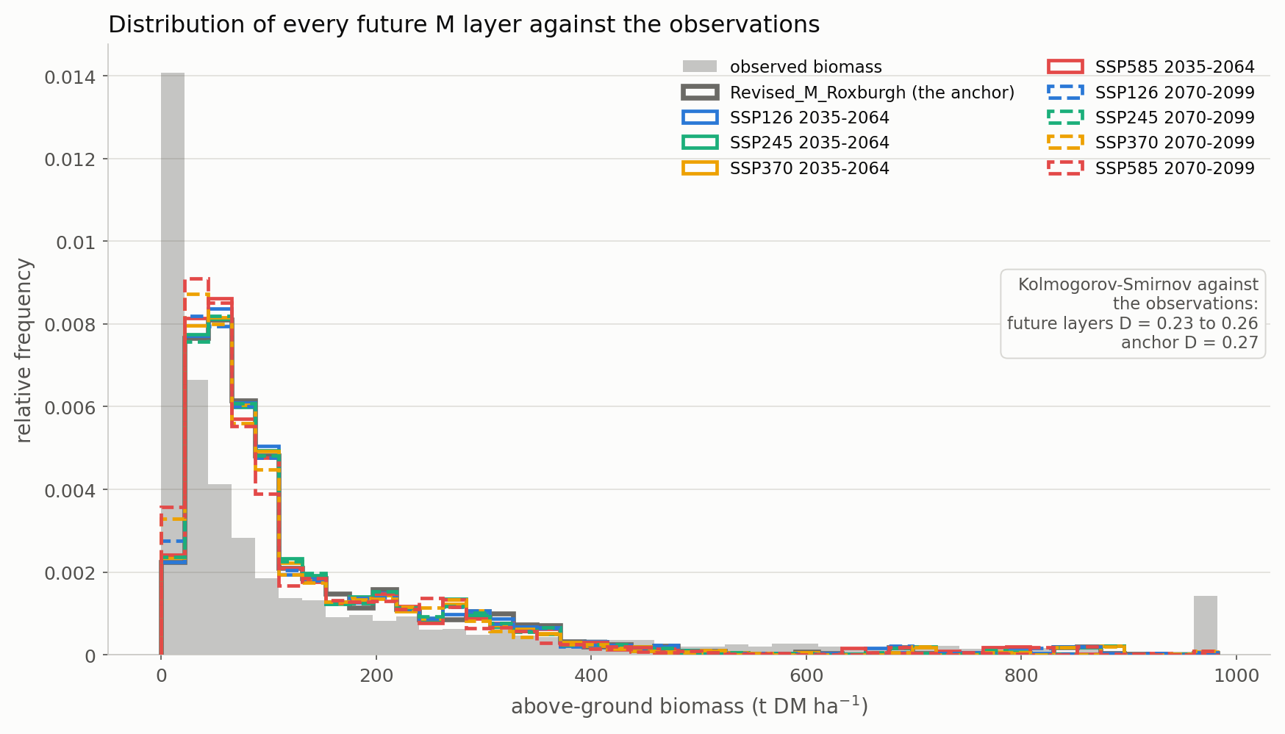
Figure 6. Distribution of modelled maximum biomass against the observations. Observed biomass is the filled grey histogram; the three lines are the original layer, the revised layer and the most strongly forced future layer.

The scatter, and the strata
Roxburgh's Figure 4 plots observed against predicted biomass for each layer. His version uses log10 axes for display with the statistics computed on untransformed data; the statistics here are his, the axes are linear, and the records beyond the axis are counted on the panel. What a log axis would hide is exactly what these panels need to show: the cloud has no orientation.
The two control panels come first because they are what licenses everything after them. They are the layers Roxburgh scored himself, so his own values are printed on each for comparison.
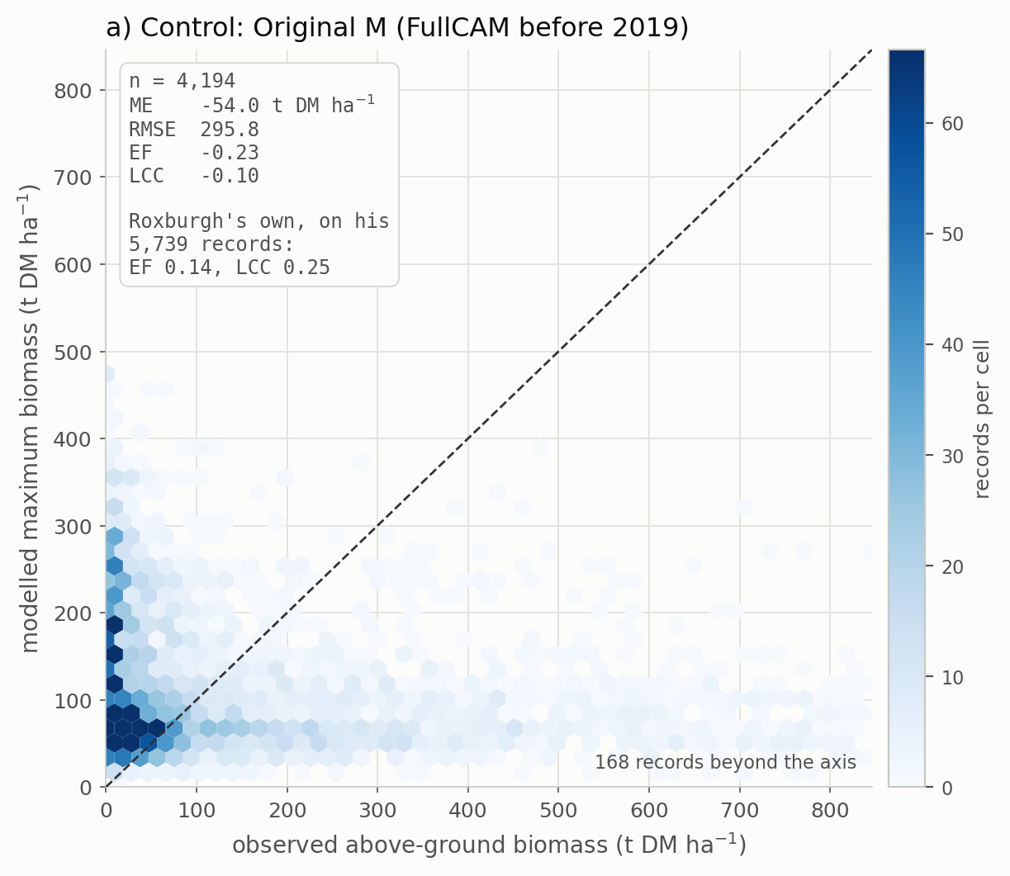
Figure 7a. CONTROL. Observed against modelled biomass for the original FullCAM layer. Colour is the number of records per hexagonal cell on a linear scale clipped at the 98th percentile, so the dense core does not saturate. The dashed line is 1:1.
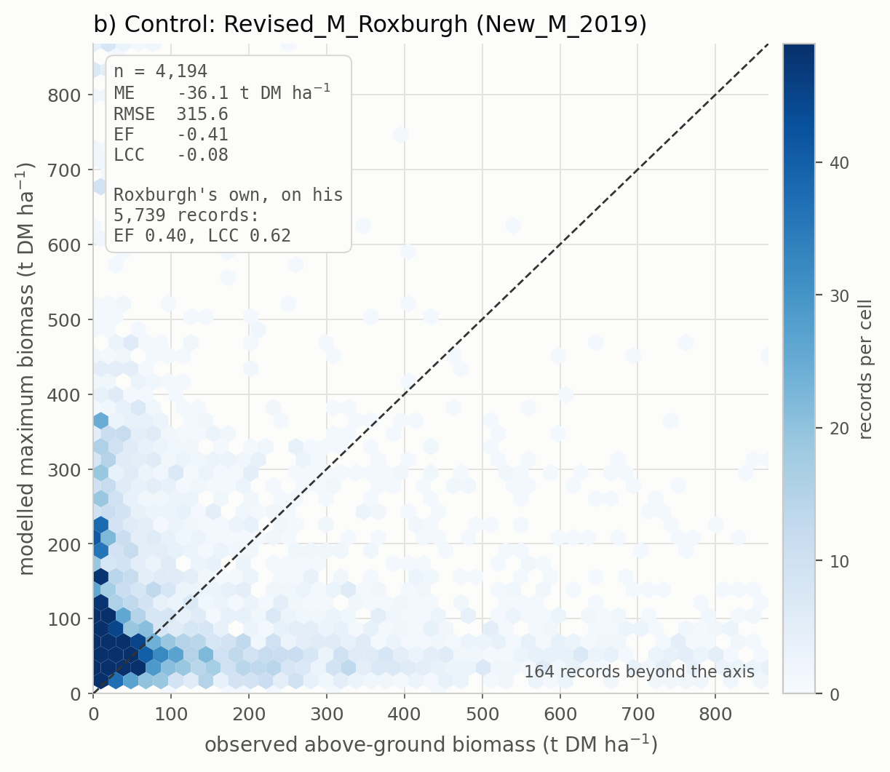
Figure 7b. CONTROL. Observed against modelled biomass for Revised_M_Roxburgh, the historical anchor. Colour is the number of records per hexagonal cell on a linear scale clipped at the 98th percentile, so the dense core does not saturate. The dashed line is 1:1.
The eight future layers follow, on one grid and on shared axes. They are not given eight separate pages deliberately: the comparison between them is the point, and the fact that eight scenario-windows produce eight indistinguishable clouds is itself the result of this folder.
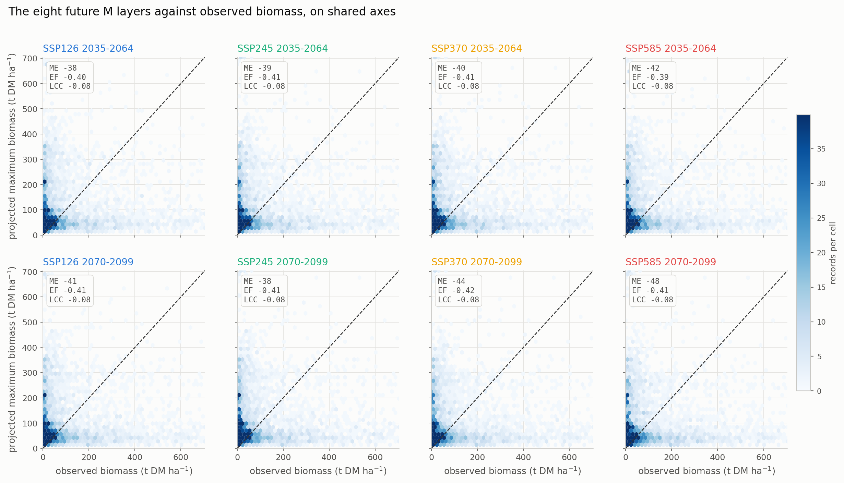
Figure 8. The eight future M layers against observed biomass, on shared axes, each panel carrying its own ME, EF and LCC. Panel colour follows the scenario and is kept across every figure in this report.

By vegetation class
layer | class | n | ME | EF | LCC
Original M (FullCAM before 2019) | Excluded | 162 | -180.5 | -0.26 | -0.01
Revised_M_Roxburgh (New_M_2019) | Excluded | 162 | -181.0 | -0.28 | -0.02
Future M, SSP585 2070-2099 | Excluded | 162 | -188.4 | -0.29 | -0.01
Original M (FullCAM before 2019) | Forest | 1,695 | +29.0 | -0.34 | -0.17
Revised_M_Roxburgh (New_M_2019) | Forest | 1,695 | +91.3 | -0.82 | -0.08
Future M, SSP585 2070-2099 | Forest | 1,695 | +75.1 | -0.78 | -0.09
Original M (FullCAM before 2019) | Woodland | 2,337 | -105.5 | -0.20 | -0.02
Revised_M_Roxburgh (New_M_2019) | Woodland | 2,337 | -118.4 | -0.23 | -0.00
Future M, SSP585 2070-2099 | Woodland | 2,337 | -127.2 | -0.26 | -0.00

The pooled statistics hide a sign reversal. Averaged over the records, the layers over-predict Forest and under-predict Woodland, while the observations run the other way - our Woodland records carry MORE biomass than our Forest records, which is ecologically backwards and is the plot-size artefact again, since the Woodland records come disproportionately from small plots. Two quantities that are ordered oppositely across the dominant stratum cannot correlate positively when pooled, and that is the arithmetic behind the negative numbers in Table 1.
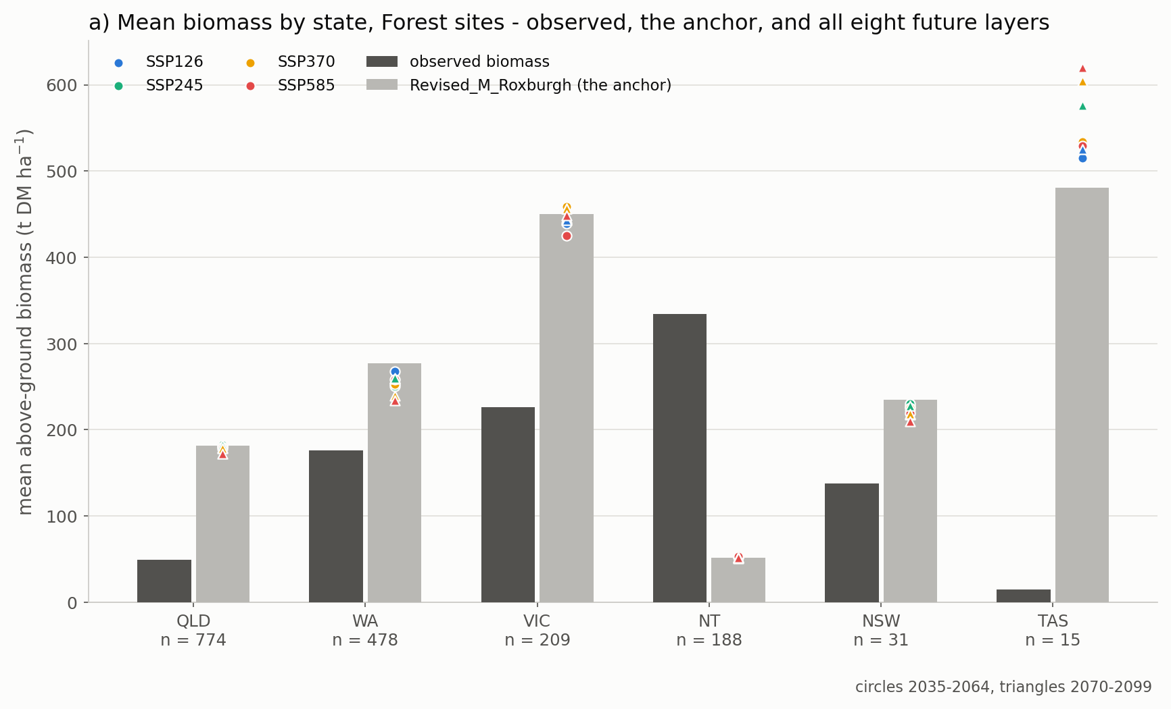
Figure 8a. Mean observed and modelled biomass by state, Forest sites, with the record count under each state. Roxburgh's Figure 8 in the same form.
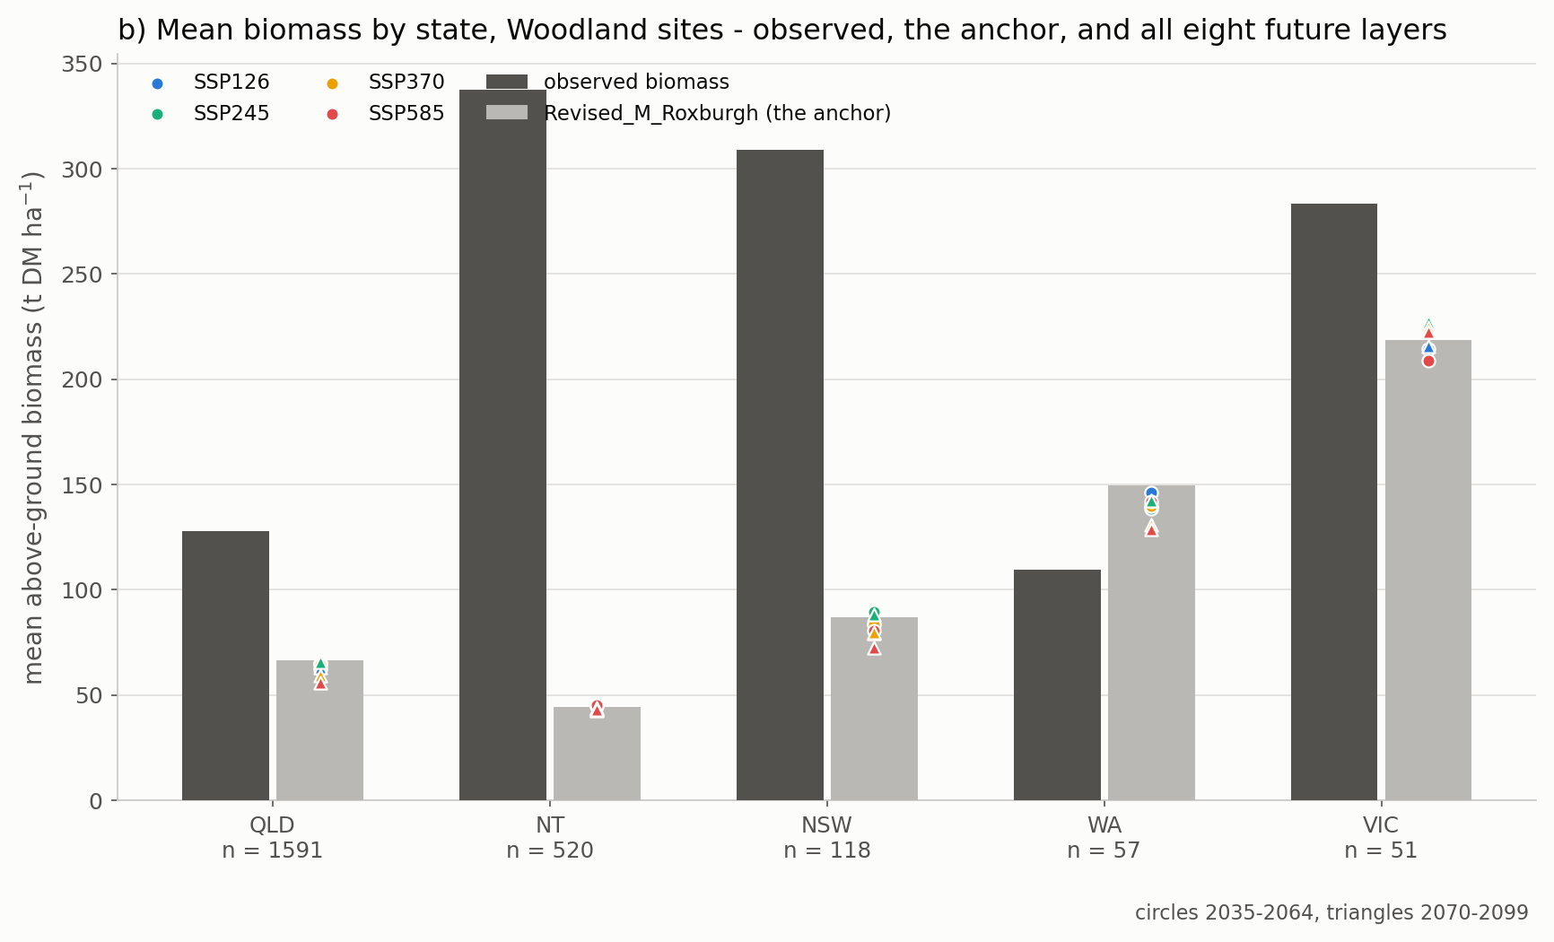
Figure 8b. Mean observed and modelled biomass by state, Woodland sites, with the record count under each state. Roxburgh's Figure 8 in the same form.
Read these two figures as a diagnostic of the sample rather than of the layers. Tasmania contributes 15 Forest records with a mean observed biomass of 15 t DM per hectare, against a modelled 480 - Tasmanian tall forest does not carry 15 t DM per hectare, and those records are small or recently disturbed plots that survived our filters because we lack his. The Northern Territory contributes 188 Forest records at a mean of 334 against a modelled 52, which is the opposite artefact: savanna measured on 0.08 hectare plots. Neither state can be used to judge a layer.

Lambda, the ratio the method is built on
Roxburgh's Eq. (2) is lambda_i = M_i / O_i, and his entire method is a spatial model of that ratio. Its distribution is therefore the most direct statement any of these layers makes about the observations. A lambda above 1 means the layer sits above the measured biomass, which is the direction a MAXIMUM should err in; below 1 means it sits under a stand already measured carrying more, which a maximum should not do.
layer | median lambda | interquartile range | share of records above 1
Original M (FullCAM before 2019) | 1.60 | 0.39 to 8.02 | 59.5%
Revised_M_Roxburgh (New_M_2019) | 1.52 | 0.38 to 8.63 | 58.6%
Eq. (1) on modelled historical FPI | 2.34 | 0.56 to 10.21 | 65.7%
Future M, SSP126 2035-2064 | 1.49 | 0.37 to 8.49 | 58.4%
Future M, SSP245 2035-2064 | 1.49 | 0.36 to 8.37 | 58.4%
Future M, SSP370 2035-2064 | 1.48 | 0.36 to 8.32 | 58.2%
Future M, SSP585 2035-2064 | 1.44 | 0.35 to 8.26 | 57.7%
Future M, SSP126 2070-2099 | 1.44 | 0.35 to 8.32 | 57.7%
Future M, SSP245 2070-2099 | 1.50 | 0.37 to 8.51 | 58.4%
Future M, SSP370 2070-2099 | 1.38 | 0.33 to 7.86 | 56.8%
Future M, SSP585 2070-2099 | 1.32 | 0.32 to 7.62 | 56.1%

Table 6. Roxburgh's Eq. (2) per layer.
This is the one place where the eight future layers separate cleanly, and they separate in the right order. The anchor sits at a median lambda of 1.52. Mid-century the four scenarios sit at 1.44 to 1.49, and by 2070-2099 they fall to 1.44 under SSP126 and 1.32 under SSP585 - a monotone decline with forcing. The projection is moving TOWARDS the observed biomass, which is what a falling maximum under a drying and warming climate should do, and the ordering across scenarios is the signal the fit statistics were too noisy to see.
Read it with the caveat the rest of this report establishes. The LEVEL of lambda is not interpretable here - a median of about 1.5 against a library whose per-hectare figures carry a twenty-fold plot-size artefact says nothing about whether the layer is right. The ORDERING across the eight layers is interpretable, because every layer is divided by the same observations, so the artefact is common to all eight and cancels out of the comparison between them. That is why this figure works where the fit statistics do not.
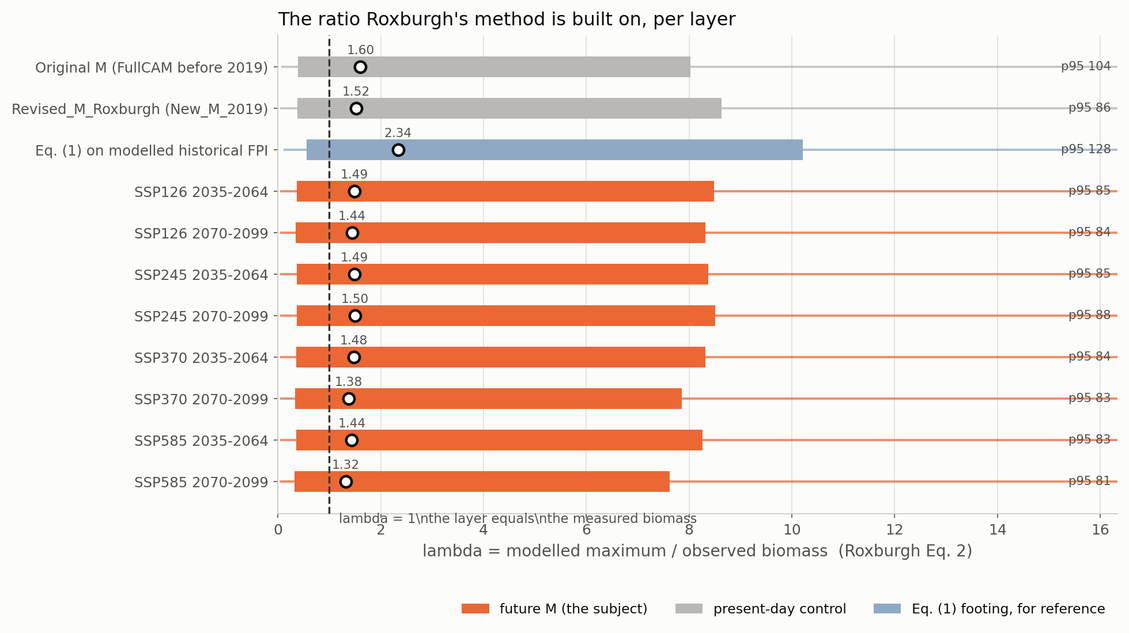
Figure 9. Lambda = modelled maximum over observed biomass, per layer. The marker is the median, the bar the interquartile range and the thin line the 5th to 95th percentile, with the 95th printed where it falls beyond the axis. The dashed line is lambda = 1.

What to conclude
The protocol transplants correctly and the layers are read correctly, but the National Biomass Library as we are able to filter it cannot discriminate between these maximum-biomass layers - not between the eight future ones, and not even between the original FullCAM layer and Roxburgh's revision of it.
- Do not quote EF or LCC from this folder as evidence about any layer. Quote them as evidence about the reference: a test whose observation carries a twenty-fold artefact from plot size has no power to resolve a few per cent of projected change.
- The positive agreement the space-time validation reports is real but narrow. It appears only under the full stack of filters, on 600 of 4,194 records, and the honest statement is that those filters select a subsample on which the layer ranks sites, not that the layer ranks this library.
- Roxburgh's own published statistics are an upper bound. His sample is clustered well beyond the 10 km he balanced at - the residual correlation here does not fall below 0.2 until about 200 km - so a random 70/30 split leaks, and EF 0.40 and LCC 0.62 flatter what an independent sample would give. This is his own caveat, extended.
- The filtering we cannot reproduce is the likely difference. He removed roughly 60 per cent of the library using satellite cover continuity and custodian disturbance metadata. Obtaining those, or an equivalent, would be the single most useful thing that could be done to make this comparison work.
- A plot-size floor is not a substitute for that filtering. Requiring at least 0.5 hectares leaves 1,055 records and still gives a rank correlation of -0.04: the small plots are not merely noisy, their removal leaves a sample with different problems.
- Lambda is the exception, and the one result worth quoting from this folder. Its LEVEL is not interpretable, but its ORDERING across the eight layers is, because every layer is divided by the same observations and the plot-size artefact cancels between them. It falls monotonically with forcing, which the fit statistics were too noisy to show.
- The future layers should otherwise be evaluated on process, not on this reference. What can be checked - that the historical limit returns New_M_2019 exactly, that the change factors are bounded and smooth, that the climate signal behaves as forcing increases - is checked in Option_B_matched_footing and in the comparison folder, and those checks are informative in a way this one is not.

Files
file | what it holds
Step_01_build_records.py | the record table and every layer sampled at each plot
Step_02_fit_statistics.py | ME, RMSE, EF and LCC - his Table 4
Step_03_sample_sensitivity.py | what each sample decision does
Step_04_observation_quality.py | the stem rebuild and the plot-size artefact
Step_05_distributions_and_strata.py | KS tests, state means, spatial autocorrelation
Step_06_plots.py | the figures
Step_07_write_report.py | this document
outputs/*.csv | every number quoted above
plots/fig_01..09 | the figures in this report

