The space-for-time validation, re-run one change at a time: what was learned
Space_time_validation/New_proposal · generated 2026-09-23 · six studies, 31 configurations

How to read this
Every configuration is placed on one axis: the rank correlation of the eight future runs MINUS the rank correlation of their own NVIS-constrained null. That is the only quantity comparable across runs. Each run changes the sample, and a changed sample moves the null with it, so a bare correlation or ratio flatters or punishes a run for reasons that have nothing to do with the change being tested.
Ratios are reported but never compared between runs. Raising a plot-area floor lifts every ratio, a randomly chosen M' included; the ratio moving towards 1 is not on its own evidence of anything. Both nulls are carried through every configuration, and every metric comes from the analogue-found stratum rather than from rows that force a match onto a site with no analogue.

The six studies
study | what it changed | outcome
Run_0 | eleven parameters, one at a time | only the sample matters; nothing methodological moves rho by 0.04
Run_01 | verified mature only | works, but the mechanism is plot size, not maturity
Plot_area_floor_method | raise the plot-area floor | best single gain: gap +0.128 at 0.40 ha on 584 sites
Run_02 | lower the threshold to 0.04 ha | southern coverage 4 to 113 sites; metric gain not resolvable
Run_03 | rebuild biomass from stem diameters | largest change of all: the present-day gate rises 0.42 to 0.73
Run_04 | maturity from basal area | the rule is sound, the sample it unlocks is not

Every configuration on one axis
Run 0 sits at a gap of +0.064. The best configuration tested is ba_07_labelled at +0.226, on 461 sites.
study | configuration | sites | ratio | rho | null rho | gap
Run_04 | ba_07_labelled | 461 | 0.378 | 0.240 | 0.014 | +0.226
Run_0 | run07_cutoff_95 | 600 | 0.321 | 0.399 | 0.205 | +0.194
Plot_area_floor_method | area_040 | 584 | 1.275 | 0.351 | 0.223 | +0.128
Plot_area_floor_method | area_030 | 607 | 1.274 | 0.338 | 0.230 | +0.107
Plot_area_floor_method | area_050 | 365 | 1.441 | 0.447 | 0.339 | +0.107
Run_0 | run08_k5 | 600 | 0.409 | 0.308 | 0.205 | +0.103
Run_03 | rebuilt_b2p5 | 599 | 0.386 | 0.390 | 0.292 | +0.098
Run_03 | rebuilt_b2p3 | 599 | 0.403 | 0.392 | 0.295 | +0.097
Run_03 | rebuilt_b2p7 | 598 | 0.373 | 0.391 | 0.298 | +0.093
Run_0 | run01_verified_only | 327 | 0.557 | 0.371 | 0.286 | +0.084
Run_01 | verified_only | 327 | 0.557 | 0.371 | 0.286 | +0.084
Run_02 | floor_004 | 778 | 0.515 | 0.309 | 0.225 | +0.084
Run_0 | run10_minclass_100 | 600 | 0.464 | 0.271 | 0.199 | +0.072
Run_0 | run06_variance_99 | 600 | 0.483 | 0.270 | 0.205 | +0.065
Run_0 | run03_mean_of_annual | 600 | 0.464 | 0.269 | 0.205 | +0.064
Run_0 | run00_baseline | 600 | 0.465 | 0.269 | 0.205 | +0.064
Run_03 | reported_stem_only | 599 | 0.464 | 0.268 | 0.207 | +0.061
Run_02 | floor_004_no_unsw | 770 | 0.514 | 0.309 | 0.262 | +0.047
Plot_area_floor_method | area_025 | 676 | 1.204 | 0.244 | 0.210 | +0.034
Run_0 | run09_noqc | 688 | 0.608 | 0.071 | 0.043 | +0.027
Run_0 | run02_unconstrained | 600 | 0.462 | 0.231 | 0.205 | +0.026
Plot_area_floor_method | area_010 | 1326 | 0.891 | 0.155 | 0.141 | +0.015
Run_0 | run05_reduced | 600 | 0.456 | 0.215 | 0.205 | +0.010
Run_04 | ba_07 | 1240 | 0.809 | -0.044 | -0.049 | +0.005
Run_02 | floor_004_south | 113 | 0.846 | 0.071 | 0.071 | +0.000
Run_04 | ba_14 | 745 | 1.063 | -0.084 | -0.082 | -0.002
Plot_area_floor_method | area_025_mature | 298 | 0.753 | 0.372 | 0.380 | -0.007
Run_04 | ba_09 | 1083 | 0.897 | -0.052 | -0.040 | -0.012
Run_04 | ba_05 | 1377 | 0.757 | -0.058 | -0.033 | -0.025
Plot_area_floor_method | area_020 | 871 | 0.917 | 0.118 | 0.151 | -0.033
Run_0 | run04_climate_only | 600 | 0.480 | 0.128 | 0.205 | -0.077

Table 1. Every configuration, ordered by the gap to its own null. Ratios are shown for completeness and should not be compared between rows.
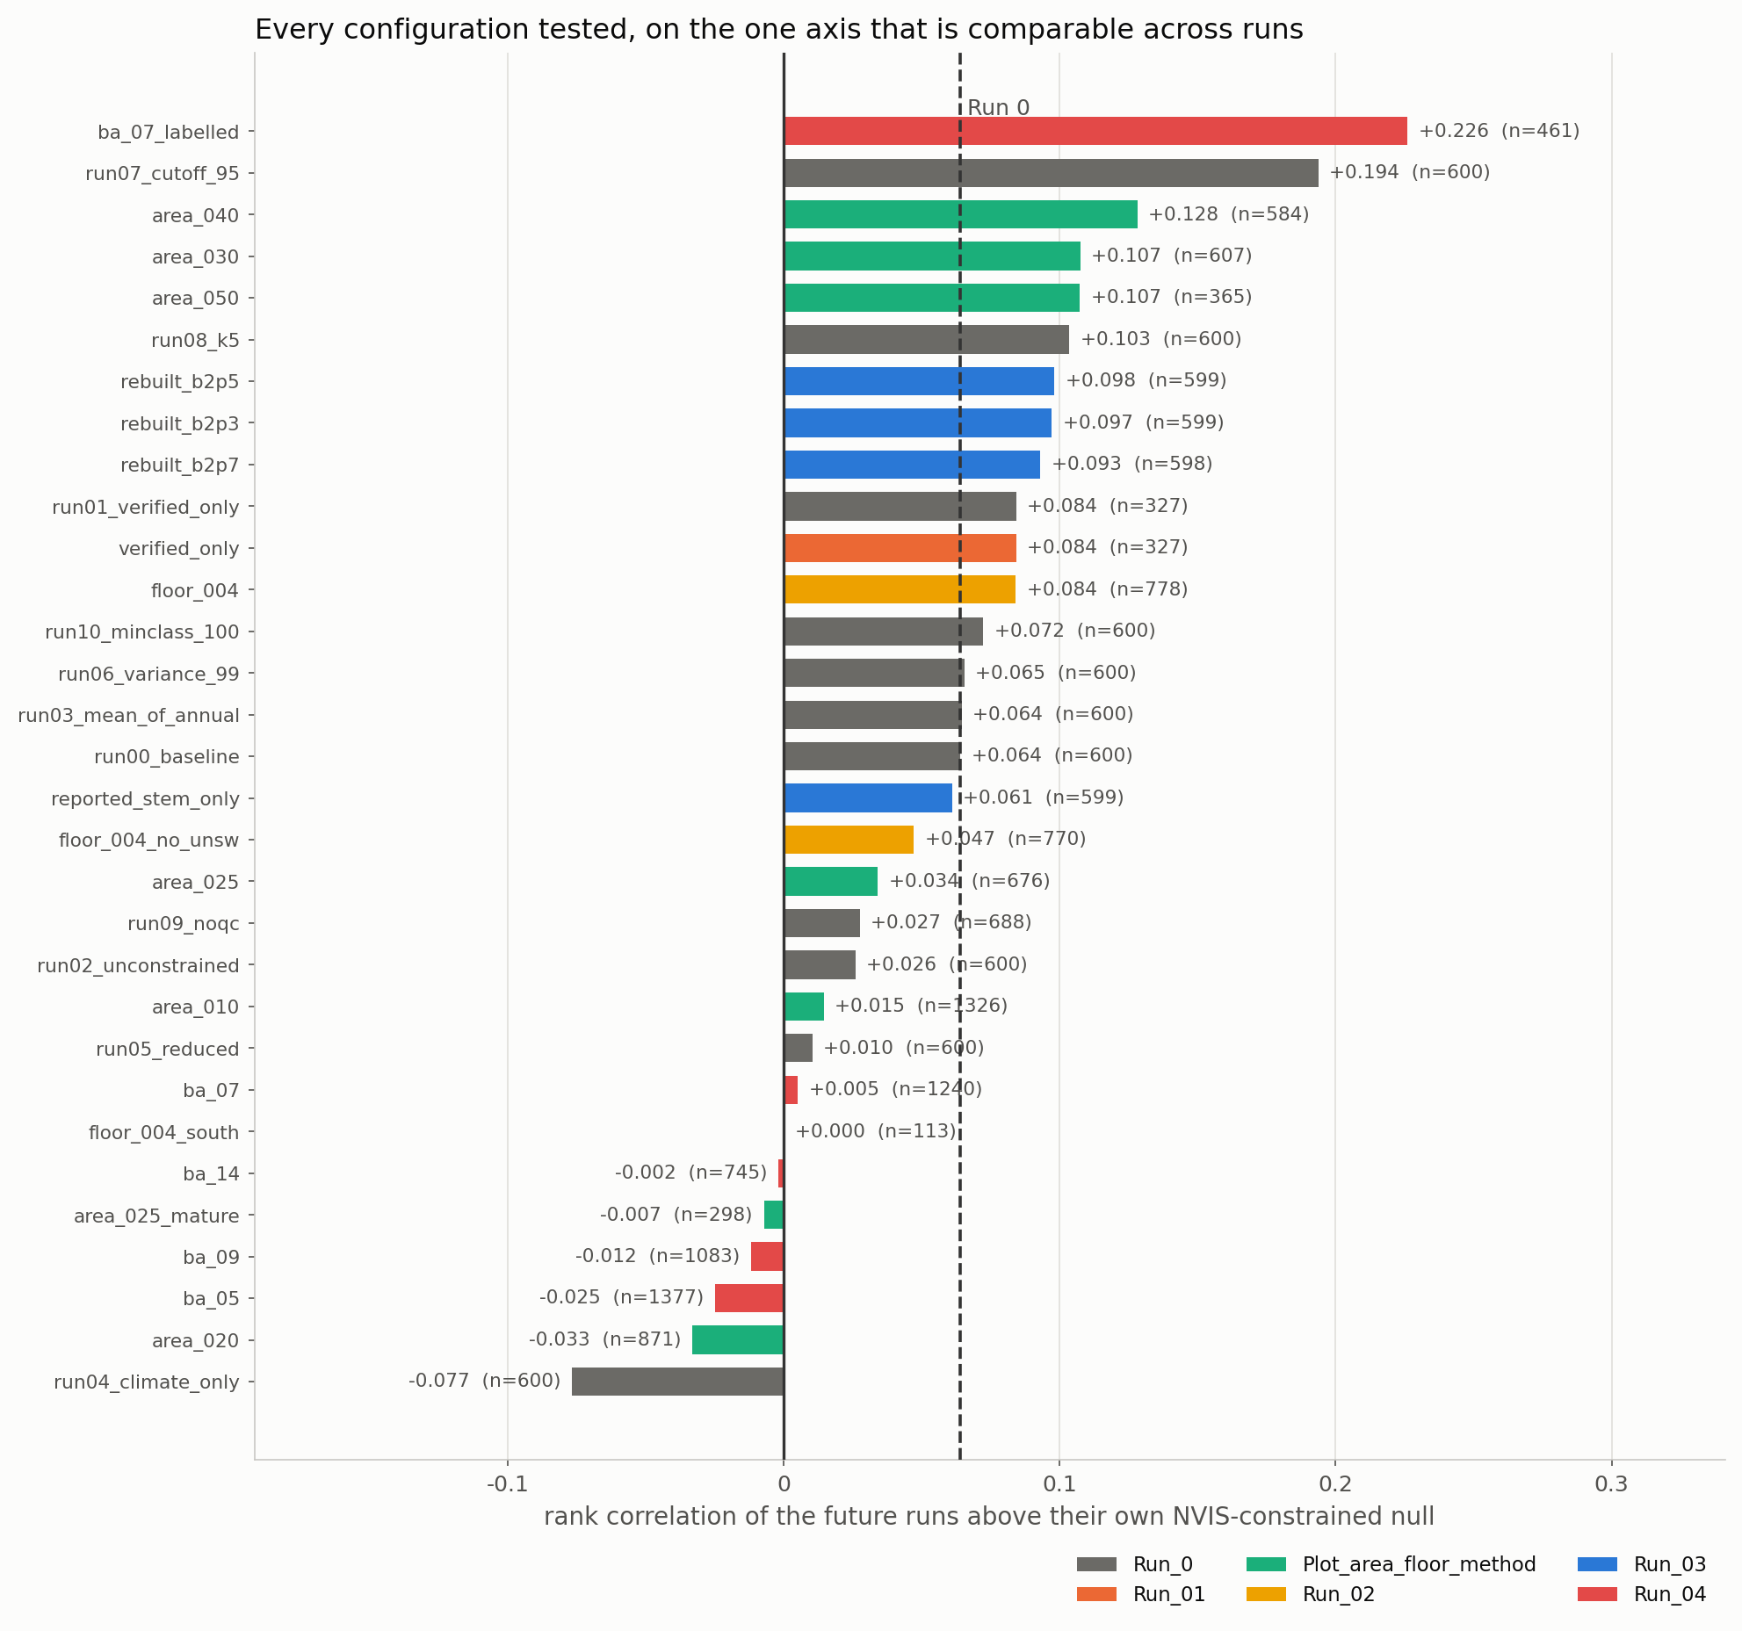
Figure 1. Every configuration tested, on the one axis that is comparable across runs.

The present-day gate
The gate is the most direct test in the validation: M' against observed biomass at the site's own cell, with no matching involved at all. The published conclusion is that it does not pass, on a rank correlation of about 0.42. Two changes move it, and only one moves it upward.
configuration | sites | present-day gate rho
Run 0, as published | 600 | 0.418
verified mature only | 327 | 0.492
plot-area floor 0.40 ha | 584 | 0.373
Run 0 on the stem-data sites | 599 | 0.416
biomass rebuilt from diameters | 599 | 0.732
basal-area rule, labelled sites | 461 | 0.320
basal-area rule, all sites | 1240 | -0.023

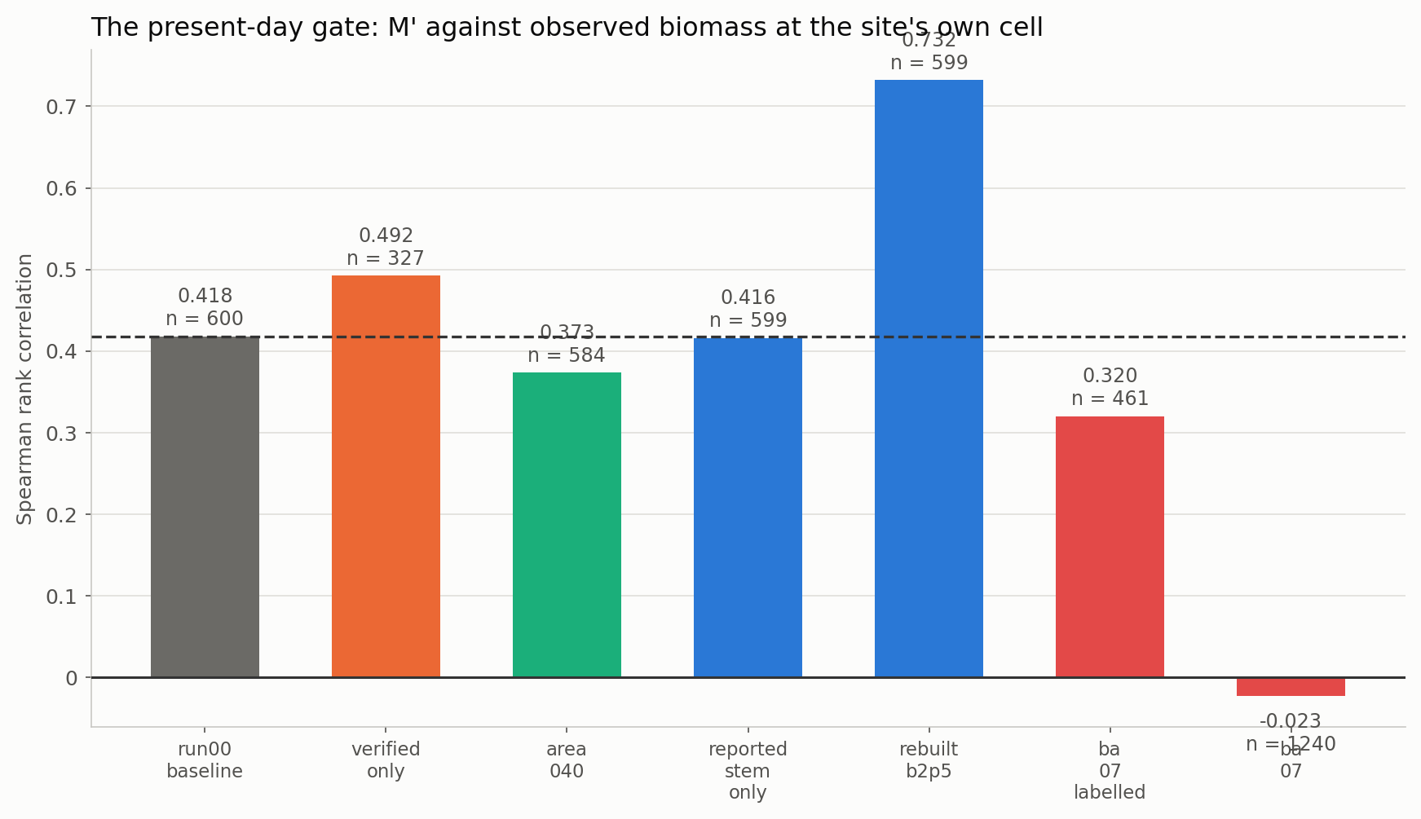
Figure 2. The present-day gate under the configurations that measured it.
The pairing in the middle of that table is the single most important result of the whole study. `reported_stem_only` and `rebuilt_b2p5` hold the SAME 599 sites, matched the same way, against the same M'. Only the observed biomass differs - the library's column, or the stem diameters. The gate goes from 0.416 to 0.732.

What runs through all six
- Every improvement came from the observation, never from the matching. Run_0 tested eleven parameters one at a time and nothing methodological - the averaging order, the PCA variance, the NVIS fallback threshold, the predictor set - moved the rank correlation by as much as 0.04. The two changes that did move it were both decisions about which observations to admit, and the largest change of all was a correction to how the observation is computed.
- The library's plot sizes drive more than anything else. The likely-mature half that Run_01 removed was carrying 17.4 Mg of biomass per square metre per hectare of its own basal area from plots 40 per cent smaller; raising the floor to 0.40 ha lifted the ratio from 0.465 to 1.275; and the sites Run_04's expansion admitted came from providers measuring savanna on eighth-hectare plots. The same artefact appears in every study that looked for it.
- The stem-level biomass column is not aligned with the stem attributes. Run_03 established this on the library's own terms: holding survey, plot, subplot, allometric model and species constant, mass has no relationship to diameter, although the documentation names diameter as the explanatory variable. The per-survey sum is sound, which is what a permutation does. This affects every stem-level use of the National Biomass Library and should go back to its custodians.
- Carrying both nulls repeatedly changed the reading. It downgraded Run_01, where four fifths of the apparent gain turned out to be shared with its own null; it stopped Run_02's ratio being quoted as a result; and it is what showed Run_04's expansion to be a reversal rather than a dilution. A ratio or a correlation quoted against neither null is uninterpretable.
- Two of the runs looked like improvements and were not. A tighter no-analogue cutoff and a climate-only predictor set both raised the rank correlation while removing most of the sample, and both would have been quoted as gains had the surviving sample not been reported beside the metric. Never read a metric whose no-analogue share moved.
- The 600-site cap is not only a maturity limit. Run_04 found that the providers who record stems are the providers whose biomass behaves, so the stem-record requirement is doing duty as a data-quality filter as well. Describing the cap as a limitation without saying that overstates how much a larger sample would buy.

What to do with this
- Publish Run 0 as the configuration, and report Run_03 as the correction that matters. The rebuild changes the headline conclusion of the space-time validation: a substantial part of the present-day gate's failure was a property of the library's biomass column rather than of M'.
- Quote rankings, not levels. Run_03's scale constant is calibrated to the library's own median, so its ratio is not independent of the library; the plot-area floor lifts every ratio including the null's. The rank correlation and the gap to the null are the robust quantities throughout.
- Adopt a plot-area floor in the 0.30 to 0.50 ha band if one filter is to change, in preference to a stem-size threshold. It removes the inflation directly rather than through a proxy, and keeps the sites the maturity rule discards for having no stem data.
- Do not adopt the basal-area maturity rule, do not stack the plot-area floor with the maturity filter, and treat the 0.04 ha threshold as a coverage sensitivity rather than a default.
- Everything above is bounded by what the earlier work established and no run here changed: the sample is eastern-forest heavy, and the late-century high-forcing windows are extrapolation beyond the observational record under every configuration tested.

Files
file | what it holds
Summary_of_runs.py | this document, built from the tables below
outputs/all_runs.csv | Table 1 - every configuration
Run_0/ | the one-at-a-time sweep, and its own report
Run_01/ | verified mature only
Plot_area_floor_method/ | raising the plot-area floor
Run_02/ | lowering the threshold to 0.04 ha
Run_03/ | biomass rebuilt from stem diameters
Run_04/ | the basal-area maturity rule

