Run 5 - the biomass-to-basal-area ceiling, on its own
Space_time_validation/New_proposal/Run_05_ceiling · generated 2026-09-23 · the test combined_Run said was missing

Why
combined_Run introduced a ceiling on the ratio of observed biomass to the stand's own live basal area, and flagged that it had never been tested against Run 0 in isolation. It was also the ingredient that did not do what it was asked to do: it was proposed to remove University of NSW at about 106 and Queensland Herbarium at 35.6, but those are REPORTED ratios and the rebuild had already repaired them. This run supplies the missing test.
The ceiling is not circular, which is the first thing to establish. It is computed from biomass and basal area, both reported in the site table, and M' appears nowhere in it. It removes records on a criterion internal to the observation, so any improvement it produces is not the result of discarding whatever disagrees with M'.

The calibration does not transfer
base | verified sites | median ratio | p90 | p95 | p99
reported (Run 0) | 327 | 7.27 | 37.3 | 52.0 | 88.3
rebuilt (Run 3) | 327 | 16.79 | 24.9 | 27.5 | 31.3

Table 1. The verified-mature group's ratio on each base.
The same percentile of the same group is 52.0 on reported biomass and 27.5 on Run 3's rebuild, because the rebuild changes the whole distribution. combined_Run's 34.5 is a third value again, from its own wider base. So the ceiling must be recalibrated wherever it is applied, and it is the PERCENTILE that is the parameter, not the number. Applying combined_Run's 34.5 to Run 0 would have been testing two changes at once.

The result
configuration | sites | ceiling | median AGB | gate rho | future rho | null rho | gap
Run 0 as published | 600 | n/a | 112.4 | 0.418 | 0.269 | 0.205 | +0.064
+ ceiling at the verified p99 | 585 | 88.3 | 105.0 | 0.442 | 0.277 | 0.209 | +0.068
+ ceiling at the verified p95 | 542 | 52.0 | 93.1 | 0.492 | 0.321 | 0.248 | +0.073
+ ceiling at the verified p90 | 496 | 37.3 | 80.2 | 0.518 | 0.371 | 0.264 | +0.107
Run 3's rebuild, no ceiling | 599 | n/a | 124.3 | 0.732 | 0.390 | 0.292 | +0.098
rebuild + ceiling at p95 | 580 | 27.5 | 123.9 | 0.718 | 0.376 | 0.248 | +0.128

Table 2. Analogue-found sites only.
The ceiling earns its place on its own. Against Run 0 it raises the present-day gate from 0.418 to 0.518 and the gap to the constrained null from +0.064 to +0.107, and it does so MONOTONICALLY - the tighter the ceiling, the larger the gain, through p99, p95 and p90. A filter that improved the result at one arbitrary threshold and not at others would be suspect; this one behaves like a filter removing a real contaminant.
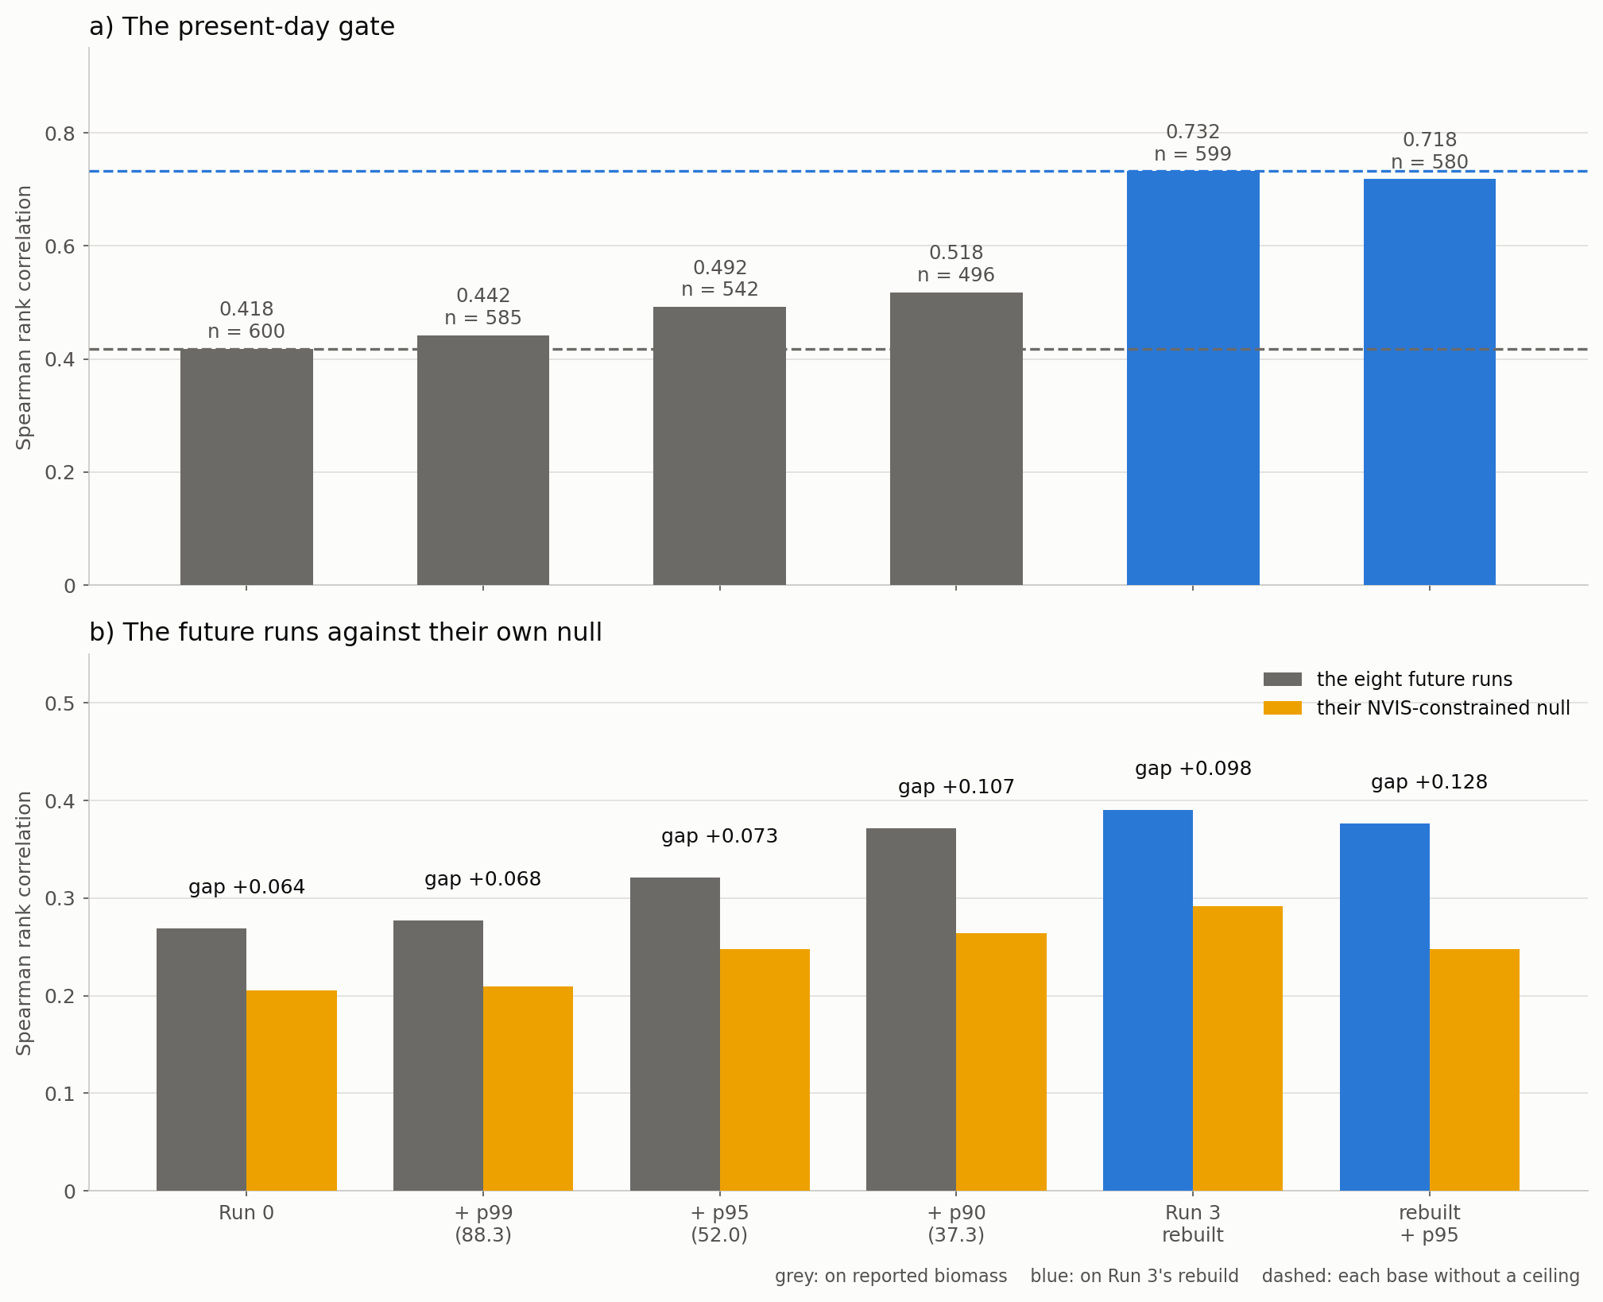
Figure 1. The ceiling on both bases. Dashed lines are each base without a ceiling.
On the rebuilt base it behaves differently and combined_Run read it correctly: the gap rises from +0.098 to +0.128 while the gate falls slightly, 0.732 to 0.718. The ceiling buys gap rather than gate there, because it lowers the null more than it lowers the runs. Both bases agree that it is worth applying; they disagree about which statistic it improves.

What it costs, and what it removes
The tightest ceiling keeps 496 of 600 sites and lowers the median observed biomass from 112.4 to 80.2 Mg/ha. It is removing high-biomass records, and the question is whether they are real.
provider | sites removed | median ratio | median AGB | median plot (ha)
DSITI Queensland Herbarium | 68 | 55.5 | 415 | 0.24
Western Regeneration Pty. Ltd. | 26 | 54.5 | 634 | 0.10
UQ Joint Remote Sensing Research Pro | 8 | 53.2 | 588 | 0.25
Flinders University (SA) | 2 | 46.8 | 461 | 0.10

A ratio of 37 Mg of biomass per square metre per hectare of basal area is already at the edge of what a stand can physically carry, and the records above it sit at 70 and beyond. They are not high-biomass stands; they are per-hectare figures that their own basal area does not support. That is the same inflation every run in this study has met, reached through a different door.
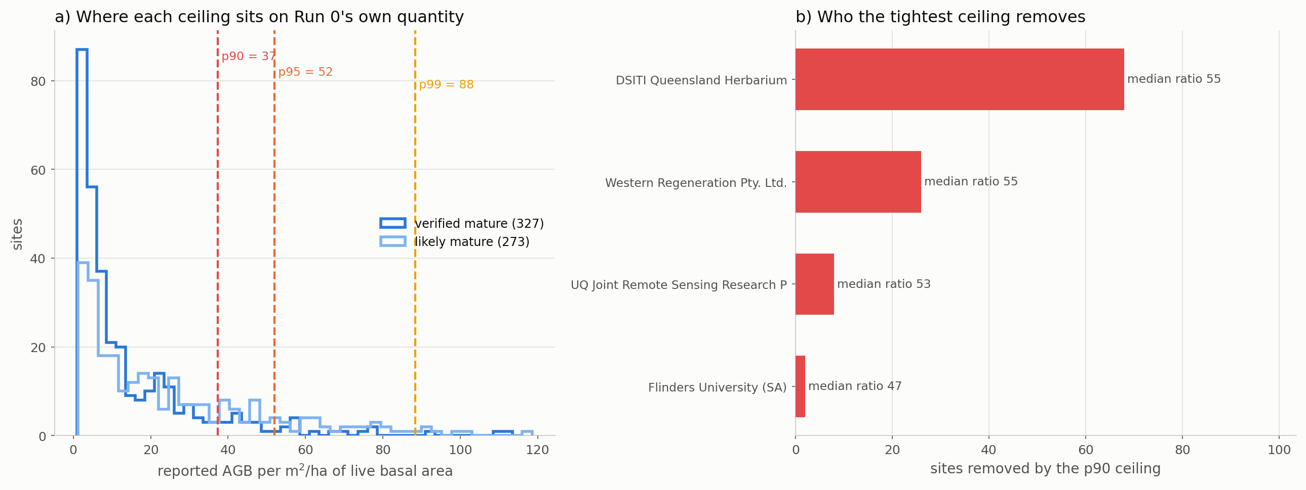
Figure 2. Where each ceiling falls on Run 0's own quantity, and who the tightest one removes.

What to conclude
- The ceiling is justified on its own and combined_Run's use of it stands. It improves Run 0 without the rebuild, improves the rebuild without anything else, and improves monotonically with tightness.
- It is not circular. The ratio is computed from two site-table columns and M' enters nowhere, so it cannot be removing records for disagreeing with the layer.
- Calibrate the percentile, never the value. The same percentile is 52.0 on reported biomass, 27.5 on Run 3's rebuild and 34.5 on combined_Run's wider base. A number carried between bases is a different filter.
- p90 is the better choice than p95 on reported biomass - gap +0.107 against +0.073 - but it costs 104 sites, and on the rebuilt base the difference between percentiles is much smaller because the rebuild has already removed most of what the ceiling targets.
- This closes the open item combined_Run listed. The remaining one is that the stem-mass alignment defect should go back to the library's custodians.

Files
file | what it holds
Step_01_run_ceiling.py | the calibration and the six runs
Step_02_plots_and_report.py | the figures and this document
outputs/ceiling_calibration.csv | Table 1
outputs/run05_headline.csv | Table 2
outputs/removed_by_ceiling.csv | every site each ceiling removes
outputs/<config>/matches.csv | site-level matches, and metrics.csv

