The space-for-time validation, one change at a time
Validation_M/National_biomass_library/Space_time_validation/New_proposal · generated 2026-09-23 · 11 configurations, each differing from Run 0 in exactly one parameter

Why one change at a time
The validation next door settles several questions at once - which sites count as mature, whether matching is constrained to vegetation, which averaging order, which predictors, how far is too far. When a result moves under a configuration that changed four things, nothing can be said about which of the four moved it. Every run here therefore changes exactly ONE parameter against Run 0 and holds the rest fixed. The difference between a run and Run 0 is then attributable to that parameter; the runs are comparable to each other only through Run 0, never directly.
Nothing in the parent folder was modified. This analysis imports its Step_03 as a module and reuses the matching, the metrics and the bootstrap unchanged, but selects its own inputs and writes only inside New_proposal/. Run 0 reproduces the published configuration exactly, which is the check that has to pass before any delta means anything: present-day analogue 0.491 and rho 0.300, constrained null 0.445 and 0.205, unconstrained null 0.210 and 0.029.

Two rules carried through every run
BOTH NULLS ARE REPORTED, ALWAYS. Random cells drawn under the same NVIS constraint, and random cells drawn without it. They answer different questions and neither alone is the answer. Against the unconstrained null the analogue search wins decisively - that is what shows the method has skill at all. Against the constrained null the gap is small - that is what says how much of the skill is knowing the vegetation subgroup rather than matching the climate. Quoting only the first overstates the method; quoting only the second understates it.
METRICS COME FROM THE ANALOGUE-FOUND STRATUM. A site whose nearest future cell lies beyond the no-analogue cutoff is still assigned a match, because there is always a nearest cell - but that match is not an analogue. Including those forced matches inflates the median ratio in the late-century runs while the rank correlation collapses. Every number in this report is computed on the sites that retained an analogue, with the no-analogue share reported beside it.

The run matrix
run | what changed | how
run00_baseline | (none) | the current configuration
run01_verified_only | maturity | verified mature only, dropping the likely-mature half
run02_unconstrained | matching constraint | no NVIS constraint on the analogue search
run03_mean_of_annual | averaging order | mean of the annual Eq. (1) M rather than Eq. (1) of the mean FPI
run04_climate_only | predictors | the 91 climate columns, dropping the 83 soil columns
run05_reduced | predictors | 16 columns: 7 annual climate means and one slice of 9 soil properties
run06_variance_99 | PCA variance kept | 0.99 of the historical variance rather than 0.95
run07_cutoff_95 | no-analogue cutoff | the 95th percentile of within-historical NN distance, not the 99th
run08_k5 | neighbours averaged | the mean of the 5 nearest cells rather than the single nearest
run09_noqc | data quality | the sample without the AGB-versus-basal-area consistency filter
run10_minclass_100 | NVIS fallback threshold | a subgroup needs 100 pool cells before it constrains, not 25

The reading rule that has to come first
A change that also moves the no-analogue share is not a like-for-like comparison. The metric is then computed on a different set of surviving sites, and those survivors are not a random subset - they are the sites whose climate still has a counterpart, which are systematically the wetter and more productive ones. A rank correlation can rise simply because the awkward sites have been removed. Runs are flagged on that basis rather than dropped, at a threshold of ten percentage points against Run 0, whose own no-analogue share is 16.1%.
run | what changed | change in no-analogue share | apparent change in rho | apparent change in ratio
run04_climate_only | predictors | +65 pp | -0.115 | +0.014
run07_cutoff_95 | no-analogue cutoff | +46 pp | +0.133 | -0.119
run08_k5 | neighbours averaged | +12 pp | +0.071 | -0.024

Table 1. The runs whose deltas cannot be attributed to the change alone.
Both belong to the same trap. Tightening the no-analogue cutoff from the 99th to the 95th percentile discards the marginal matches, and the rank correlation duly rises - on a median of about a hundred surviving sites out of 600. Dropping the 83 soil columns collapses the predictor space to five components, which shrinks every distance in it, and against a cutoff computed in that same shrunken space most sites end up with no analogue at all. Neither run says what it appears to say.
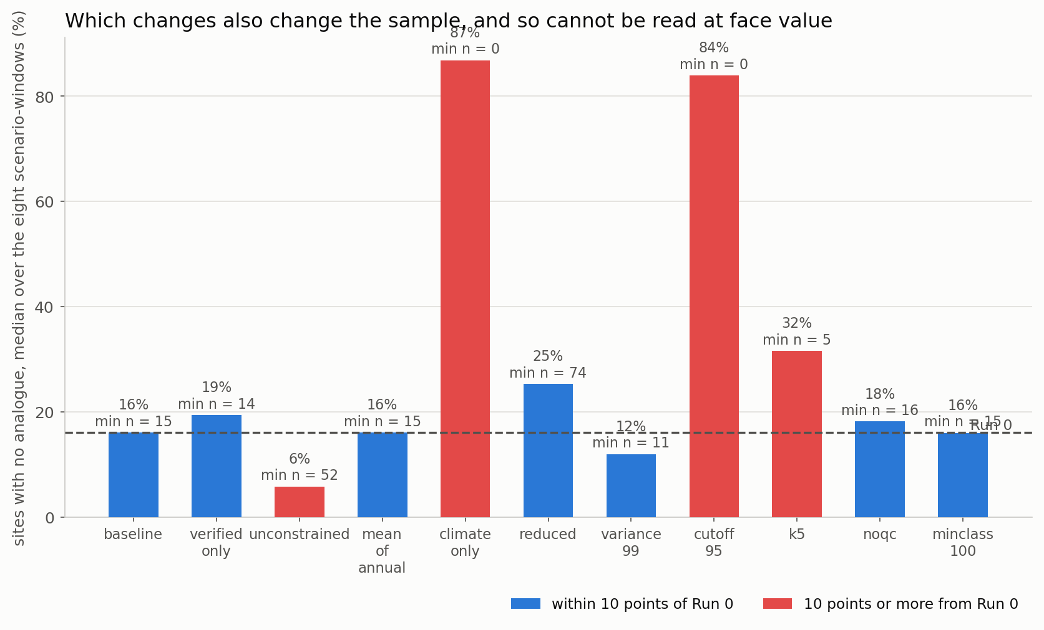
Figure 1. The no-analogue share under each configuration, with the smallest surviving sample printed on each bar. Red marks the runs that moved it by ten points or more against Run 0.

What actually moves the result
Run 0 gives a median ratio of 0.465 and a rank correlation of 0.269 across the eight scenario-windows. Of the changes whose sample stayed comparable, these are the deltas, largest first:
run | what changed | sites | change in rho | change in ratio | change in no-analogue
run09_noqc | data quality | 688 | -0.179 | +0.121 | +1.4 pp
run01_verified_only | maturity | 327 | +0.103 | +0.096 | +1.7 pp
run05_reduced | predictors | 600 | -0.035 | +0.001 | +7.2 pp
run02_unconstrained | matching constraint | 600 | -0.017 | -0.001 | -8.2 pp
run06_variance_99 | PCA variance kept | 600 | +0.014 | +0.023 | -1.6 pp
run10_minclass_100 | NVIS fallback threshold | 600 | +0.001 | -0.000 | -0.1 pp
run03_mean_of_annual | averaging order | 600 | +0.000 | -0.001 | +0.0 pp

Table 2. Every attributable change, ordered by the size of its effect on the rank correlation.
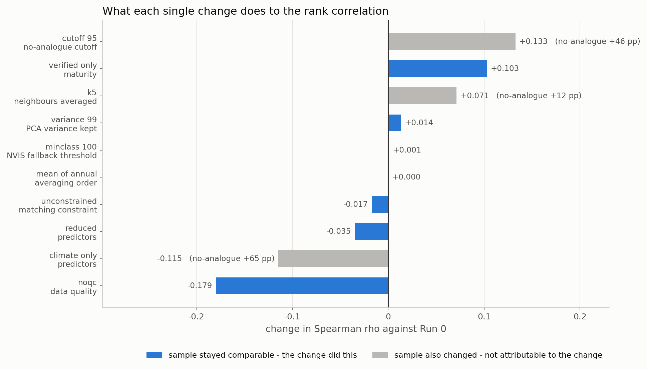
Figure 2. What each single change does to the rank correlation. Grey bars are the runs whose sample also changed and which therefore cannot be read at face value.
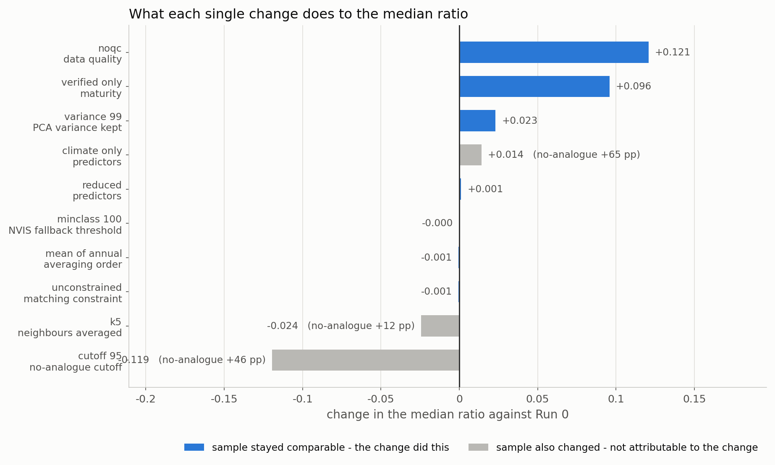
Figure 3. The same for the median ratio.

The answer in one sentence
The two changes that move the result are both about the SAMPLE, not about the method. Removing the biomass-versus-basal-area consistency filter costs 0.179 of rank correlation, and restricting the sample to stem-verified mature stands gains +0.103. Every methodological choice tested - the averaging order, the PCA variance retained, the NVIS fallback threshold, the predictor set - moves the rank correlation by less than 0.035, and two of them move it by less than 0.002.

Run by run

run01_verified_only - maturity
Rank correlation +0.103, median ratio +0.096, no-analogue share +1.7 pp against Run 0, on 327 sites.
Restricting to stems of 50 cm or more raises both the ratio and the rank correlation, on half the sample. That is the expected direction and it is the cleanest evidence in this folder that the likely-mature half carries stands short of their maximum: M' is a maximum, so a sample closer to maturity should agree with it better. The cost is 327 sites and a wider interval on everything.
Nulls under this configuration: constrained 0.478 (rho 0.286), unconstrained 0.228 (rho -0.056).

run02_unconstrained - matching constraint
Rank correlation -0.017, median ratio -0.001, no-analogue share -8.2 pp against Run 0, on 600 sites.
Dropping the NVIS constraint barely moves the future runs, but it RAISES the present-day analogue's rank correlation. The constraint is not improving the match; it is restricting the pool, and a site's best climate analogue is sometimes in another vegetation subgroup. Keep the constraint for the reason it was added - two cells can share a climate and carry different vegetation - but it is not buying accuracy here.
Nulls under this configuration: constrained 0.445 (rho 0.205), unconstrained 0.210 (rho 0.029).

run03_mean_of_annual - averaging order
Rank correlation +0.000, median ratio -0.001, no-analogue share +0.0 pp against Run 0, on 600 sites.
The averaging order changes nothing at all. This is the cleanest possible confirmation of the argument made in the parent folder: the Jensen gap cancels when numerator and denominator are built in the same order, so the choice between Eq. (1) of the mean FPI and the mean of the annual Eq. (1) M does not reach the validation.
Nulls under this configuration: constrained 0.445 (rho 0.205), unconstrained 0.210 (rho 0.029).

run04_climate_only - predictors
Rank correlation -0.115, median ratio +0.014, no-analogue share +64.8 pp against Run 0, on 600 sites. The sample also changed, so this delta is not attributable to the change alone.
Nulls under this configuration: constrained 0.445 (rho 0.205), unconstrained 0.210 (rho 0.029).

run05_reduced - predictors
Rank correlation -0.035, median ratio +0.001, no-analogue share +7.2 pp against Run 0, on 600 sites.
Sixteen columns instead of 174 costs a little rank correlation and raises the no-analogue share. Consistent with the relative-contrast diagnostic in the parent folder, which found the full space was not suffering from distance concentration and so had nothing to gain from being reduced.
Nulls under this configuration: constrained 0.445 (rho 0.205), unconstrained 0.210 (rho 0.029).

run06_variance_99 - PCA variance kept
Rank correlation +0.014, median ratio +0.023, no-analogue share -1.6 pp against Run 0, on 600 sites.
Keeping 0.99 of the variance instead of 0.95 more than doubles the components, from 18 to 41, and changes essentially nothing. The extra components carry noise, not structure.
Nulls under this configuration: constrained 0.445 (rho 0.205), unconstrained 0.210 (rho 0.029).

run07_cutoff_95 - no-analogue cutoff
Rank correlation +0.133, median ratio -0.119, no-analogue share +46.1 pp against Run 0, on 600 sites. The sample also changed, so this delta is not attributable to the change alone.
Nulls under this configuration: constrained 0.445 (rho 0.205), unconstrained 0.210 (rho 0.029).

run08_k5 - neighbours averaged
Rank correlation +0.071, median ratio -0.024, no-analogue share +12.5 pp against Run 0, on 600 sites. The sample also changed, so this delta is not attributable to the change alone.
Averaging the five nearest cells instead of taking one improves the rank correlation and lowers the ratio. Part of that is real - a single cell's M' carries the full noise of one FPI prediction - and part is the rising no-analogue share, so read it as suggestive rather than settled.
Nulls under this configuration: constrained 0.445 (rho 0.205), unconstrained 0.210 (rho 0.029).

run09_noqc - data quality
Rank correlation -0.179, median ratio +0.121, no-analogue share +1.4 pp against Run 0, on 688 sites.
Putting back the records whose reported biomass contradicts their own basal area is the single most damaging change tested. The rank correlation collapses while the ratio rises towards 1, which is the same fact twice: those records contribute biomass values unrelated to the stands they describe, which depresses the observed median and adds pure noise to the ranking.
Nulls under this configuration: constrained 0.593 (rho 0.043), unconstrained 0.268 (rho 0.005).

run10_minclass_100 - NVIS fallback threshold
Rank correlation +0.001, median ratio -0.000, no-analogue share -0.1 pp against Run 0, on 600 sites.
Requiring 100 pool cells before a subgroup constrains the match, rather than 25, changes nothing measurable. The fallback is rare enough not to matter.
Nulls under this configuration: constrained 0.445 (rho 0.199), unconstrained 0.210 (rho 0.029).

Both nulls, every configuration
The two nulls behave differently across the matrix and the difference is the point. The unconstrained null sits near 0.210 with a rank correlation near zero under almost every configuration - the analogue search beats it everywhere, which is what establishes that the method does something. The constrained null tracks the runs closely, because it inherits whatever the configuration did to the sample, and the gap between it and the runs is the honest measure of what the climate matching adds on top of knowing the vegetation subgroup.
run | runs: ratio | null NVIS | null free | runs: rho | null NVIS | null free
run00_baseline | 0.465 | 0.445 | 0.210 | 0.269 | 0.205 | 0.029
run01_verified_only | 0.557 | 0.478 | 0.228 | 0.371 | 0.286 | -0.056
run02_unconstrained | 0.462 | 0.445 | 0.210 | 0.231 | 0.205 | 0.029
run03_mean_of_annual | 0.464 | 0.445 | 0.210 | 0.269 | 0.205 | 0.029
run04_climate_only | 0.480 | 0.445 | 0.210 | 0.128 | 0.205 | 0.029
run05_reduced | 0.456 | 0.445 | 0.210 | 0.215 | 0.205 | 0.029
run06_variance_99 | 0.483 | 0.445 | 0.210 | 0.270 | 0.205 | 0.029
run07_cutoff_95 | 0.321 | 0.445 | 0.210 | 0.399 | 0.205 | 0.029
run08_k5 | 0.409 | 0.445 | 0.210 | 0.308 | 0.205 | 0.029
run09_noqc | 0.608 | 0.593 | 0.268 | 0.071 | 0.043 | 0.005
run10_minclass_100 | 0.464 | 0.445 | 0.210 | 0.271 | 0.199 | 0.029

Table 3. Every configuration against both nulls, analogue-found sites only.
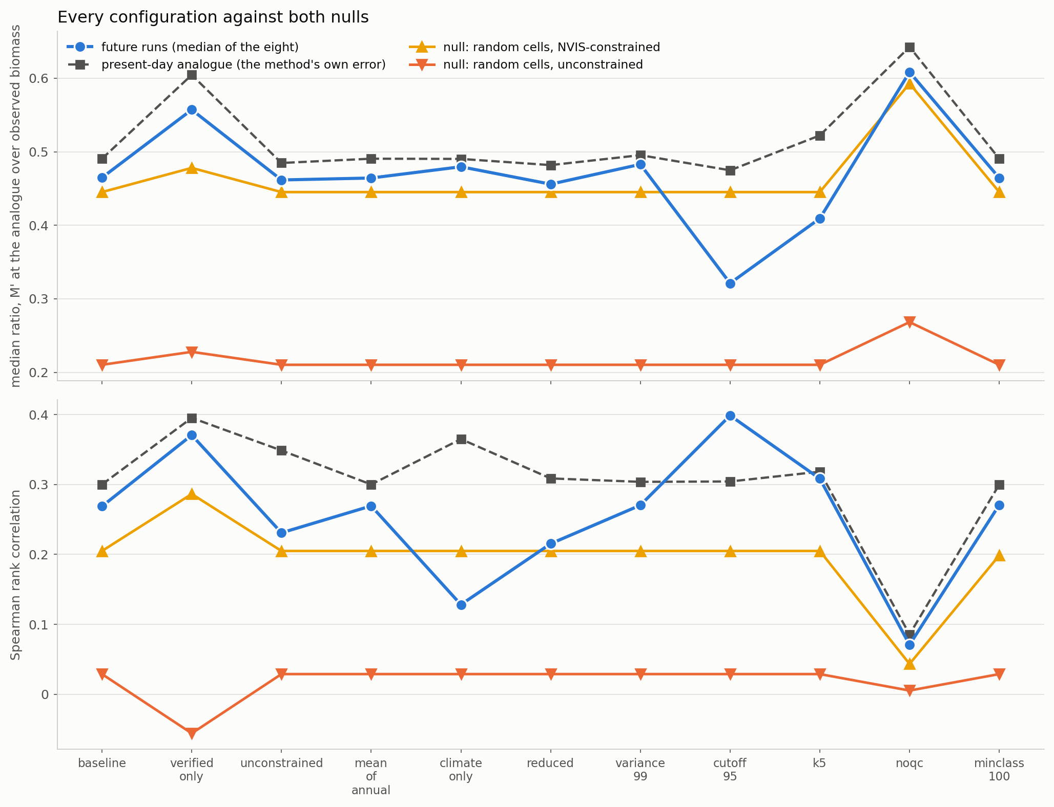
Figure 4. The runs, the present-day control and both nulls, under every configuration.

The scenario-windows themselves
The deltas above are medians over the eight scenario-windows. They hide the late-century windows, where the no-analogue share is high under every configuration and the surviving sample is small. Those windows should not be quoted as results regardless of which configuration produced them.
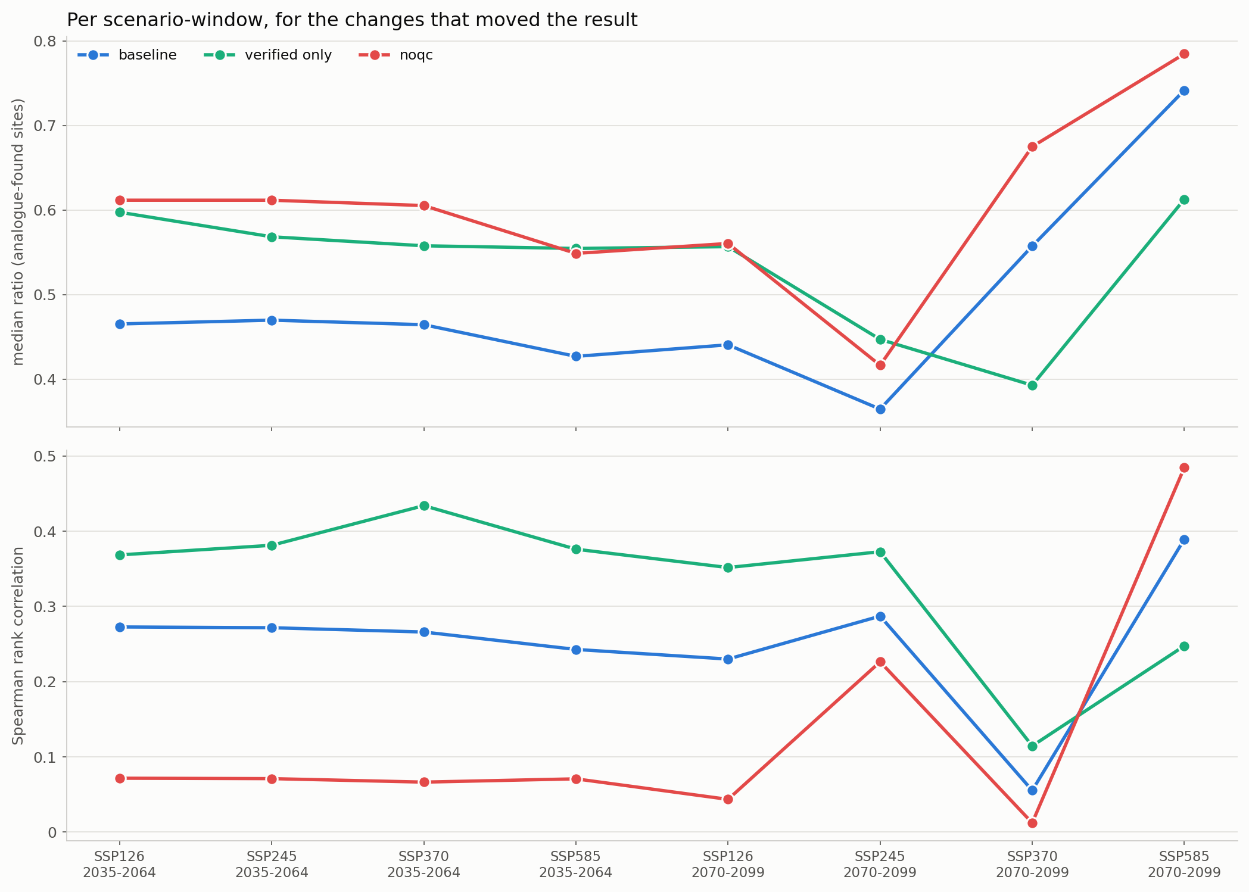
Figure 5. Per scenario-window, for Run 0 and the two changes that moved the result.

What to take from this
- The configuration is not the problem. Nothing methodological tested here moves the rank correlation by as much as 0.04 without also changing which sites survive. Time spent tuning the matcher is time wasted.
- The sample is the problem. The data-quality filter and the maturity threshold between them account for essentially all of the movement, and both are decisions about which observations to admit.
- Report both nulls, every time. The unconstrained null is what shows the method has skill; the constrained null is what shows how much of that skill is the vegetation constraint. A ratio quoted against neither is uninterpretable.
- Never read a metric whose no-analogue share moved. Two of the eleven runs here look like improvements and are not, and both would have been quoted as gains if the surviving sample had not been reported alongside.
- Run 0 remains the configuration to publish. Run 1 - verified-mature only - is the one defensible alternative, and it should be reported as a sensitivity rather than a replacement, because halving the sample widens every interval.

Files
file | what it holds
Step_A_run_ofat.py | the run matrix and every statistic
Step_B_plots.py | the figures
Step_C_write_report.py | this document
outputs/run_matrix.csv | what each run changed
outputs/ofat_summary.csv | one row per run per stratum
outputs/ofat_deltas.csv | every run against Run 0, with the comparability flag
outputs/<run_id>/matches.csv | the site-level matches of that run
plots/fig_01..05 | the figures in this report

