**Austin Tesch**

**Chapter One**

**Date: 04-18-24**

**First program: ch2_pgm1; A program that adds two integers.**

**Code:**

// Programmer: Austin Tesch

// Purpose: Add together two integers and display their value.

// Date modified: 04-18-24

//Compiler used:  XCODE v. 15.0

#include <iostream>

**using** **namespace** std;

**int** main()

{

**int** integer1 = 75, integer2 = 25, total;

total = integer1 + integer2;

cout << "Total value of the 2 integers is: " << total << endl;

**return** 0;

}

**Output:**

**Second program: ch2_pgm2; A program to determine the total distance this car can travel on a full tank.**

**Code:**

// Programmer: Austin Tesch

// Purpose: A program to determine the total distance this car can travel on a full tank.

// Date modified: 00-00-00

//Compiler used:  XCODE v. 15.0

#include <iostream>

**using** **namespace** std;

**int** main()

{

**int** full_tank = 10;

**float** mpg_town = 27.5, mpg_highway = 32.7,

range_town, range_highway;

range_town = mpg_town * full_tank;

range_highway = mpg_highway * full_tank;

cout << "Total range in town is: " << range_town << " miles." << endl;

cout << "Total range on highway is: " << range_highway << " miles." << endl;

**return** 0;

}

**Output:**

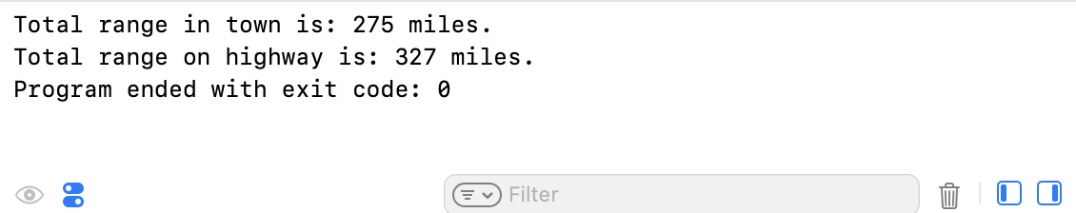

**Third Program: ch2_pgm3; Convert the average amount of ocean level rise from millimeters to both centimeters and inches.**

**Code:**

// Programmer: Austin Tesch

// Purpose: Convert the average amount of ocean level rise from millimeters to both centimeters and inches.

// Date modified: 04-18-24

//Compiler used:  XCODE v. 15.0

#include <iostream>

**using** **namespace** std;

**int** main()

{

**float** millimeters = 1.8, centimeters, inches;

centimeters = millimeters * 0.1;

inches = centimeters * 0.3937;

cout << "The average rise of oecan levels in centimeters: " << centimeters << endl;

cout << "The average rise of ocean levels in inches: " << inches << endl;

**return** 0;

}

**Output:**

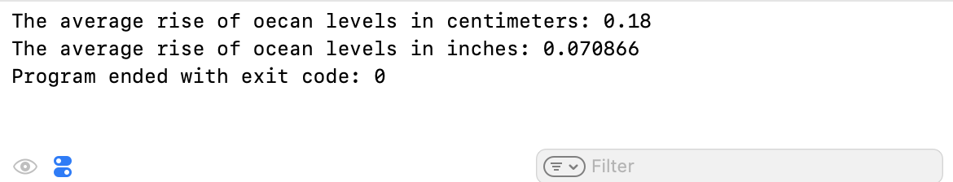

**Fourth Program: ch2_pgm4; Determine the total amount of paint required to cover a surface.**

**Code:**

// Programmer: Austin Tesch

// Purpose: Determine the total amount of paint required to cover a surface.

// Date modified: 04-18-24

//Compiler used:  XCODE v. 15.0

#include <iostream>

**using** **namespace** std;

**int** main()

{

**float** covrage_gallon = 340, surface_height, surface_length, total_area;

// Get height of surface.

cout << "What is the total height of the surface (in feet)? ";

cin >> surface_height;

// Get length of surface.

cout << "What is the total lenght/width of the surface (in feet)? ";

cin >> surface_length;

// Total area of surface; height * length

total_area = surface_height * surface_length;

// Determine amout of paint required for first and second coat.

**float** first_coat = total_area / covrage_gallon;

**float** second_coat = first_coat * 2;

// Display amout of paint required.

cout << "You will need " << second_coat << " gallons of paint to apply 2 coats to your surface." << endl;

**return** 0;

}

**Output:**

