**Austin Tesch**

**Chapter 4**

**05-03-24**

**Program 1**: ch4_pgm1; A program that prompts the user to input a number between 2 and 11.

**Code:**

/*

Programmer: Austin Tesch

Date modified: 05-02-24

Compiler used:  XCODE v. 15.0

Purpose: A program that prompts the user to input a number between 2 and 11. Use a switch statement to exhibit the corresponding Roman numeral representation of the entered number.

Input Validation: Decide how the program should handle an input that is less than 2 or greater than 11.

*/

#include <iostream>

#include <string>

using namespace std;

int main()

{

// Prompt user for input value between 2 and 11

cout << "Provide a numeral between the values of 2 and 11: " << endl;

int user_numeral;

cin >> user_numeral;

// Match users number with its corresponding Roman Numeral

// Use a switch statement

bool isBwtween = false;

string roman_numeral;

switch (user_numeral) {

case 2:

roman_numeral = "II";

isBwtween = true;

break;

case 3:

roman_numeral = "III";

isBwtween = true;

break;

case 4:

roman_numeral = "IV";

isBwtween = true;

break;

case 5:

roman_numeral = "V";

isBwtween = true;

break;

case 6:

roman_numeral = "VI";

isBwtween = true;

break;

case 7:

roman_numeral = "VII";

isBwtween = true;

break;

case 8:

roman_numeral = "VIII";

isBwtween = true;

break;

case 9:

roman_numeral = "IX";

isBwtween = true;

break;

case 10:

roman_numeral = "X";

isBwtween = true;

break;

case 11:

roman_numeral = "XI";

isBwtween = true;

break;

default:

cout << "The numeral you provided is not between 2 and 11. Exiting." << endl;

break;

}

// Output the corresponding Roman Numeral to the user

if (isBwtween)

{

cout << "The Roman Numeral for " << user_numeral << " is: " << roman_numeral << endl;

}

return 0;

}

**Output:**

**Program 2: ch4_pgm2; A change-counting game that asks the user to enter what coins to use to make exactly fifty cents.**

**Code:**

/*

Programmer: Austin Tesch

Date modified: 05-02-24

Compiler used:  XCODE v. 15.0

Purpose:

A change-counting game that asks the user to enter what coins to use to make exactly fifty cents.

The program should ask the user to enter the number of pennies, nickels, dimes, and quarters.

If the total value of the coins entered is equal to fifty cents, the program should congratulate the user for winning the game.

Otherwise, the program should display a message indicating whether the amount entered was more or less than fifty cents.

Use constant variables to hold the coin values.

*/

#include <iostream>

using namespace std;

int main()

{

// Set constants for coin values

const int PENNIE_VALUE = 1,

NICKEL_VALUE = 5,

DIME_VALUE = 10,

QUARTER_VALUE = 25,

TARGET_AMOUNT = 50;

// Introduce game and check that the user is ready to play.

cout << "Provied me with 50 cents!\n"

<< "You will be asked to input any of the following coins:\n"

<< "Pennies, Nickels, Dimes, and Quarters\n"

<< "Are you ready to play? (y/n)" << endl;

char play_response;

bool readyToPlay = false;

cin >> play_response;

if (play_response == 'y'){

readyToPlay = true;

}

if (readyToPlay){

// Values of user input

int amount_pennies, amount_nickels, amount_dimes, amount_quarters;

cout << "Great! Let's play!" << endl;

// Prompt pennies

cout << "Select amount of Pennies: " << endl;

cin >> amount_pennies;

// Prompt nickels

cout << "Select amount of Nickels: " << endl;

cin >> amount_nickels;

// Prompt dimes

cout << "Select amount of Dimes: " << endl;

cin >> amount_dimes;

// Prompt quarters

cout << "Select amount of Quarters: " << endl;

cin >> amount_quarters;

// Compute user total

int user_coin_total =

(amount_pennies * PENNIE_VALUE) +

(amount_nickels * NICKEL_VALUE) +

(amount_dimes * DIME_VALUE) +

(amount_quarters * QUARTER_VALUE);

if (user_coin_total == TARGET_AMOUNT){

cout << "Thats exactly 50 cents! Congratulations!" << endl;

}

else if (user_coin_total > TARGET_AMOUNT){

cout << "Your total value is too high, you gave me " << user_coin_total << " cents! Try again!" << endl;

}

else

cout << "Your total is too low, you gave me " << user_coin_total << " cents! Try again!" << endl;

}

else

// User does not want to play

cout << "Okay, lets play sometime!" << endl;;

return 0;

}

**Output:**

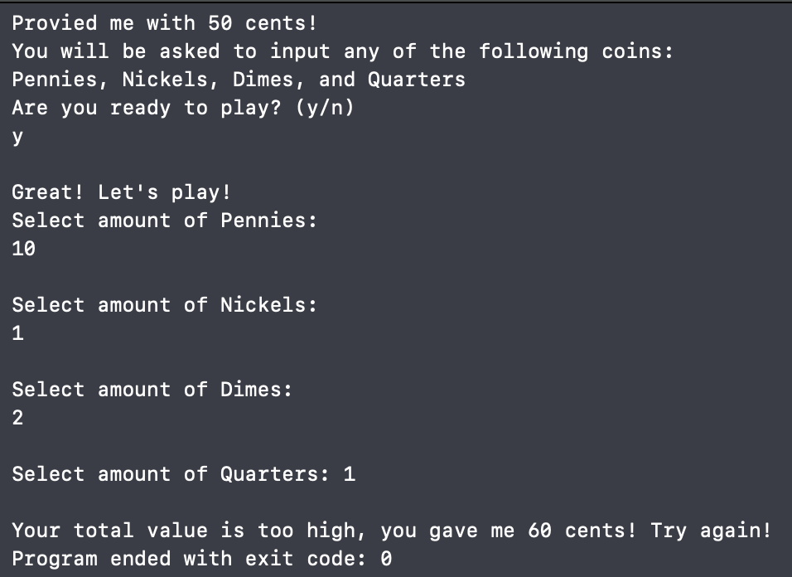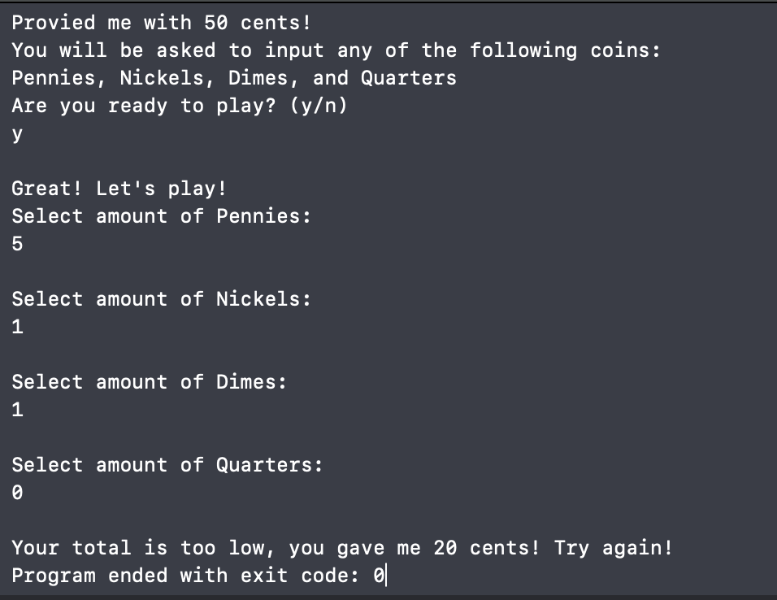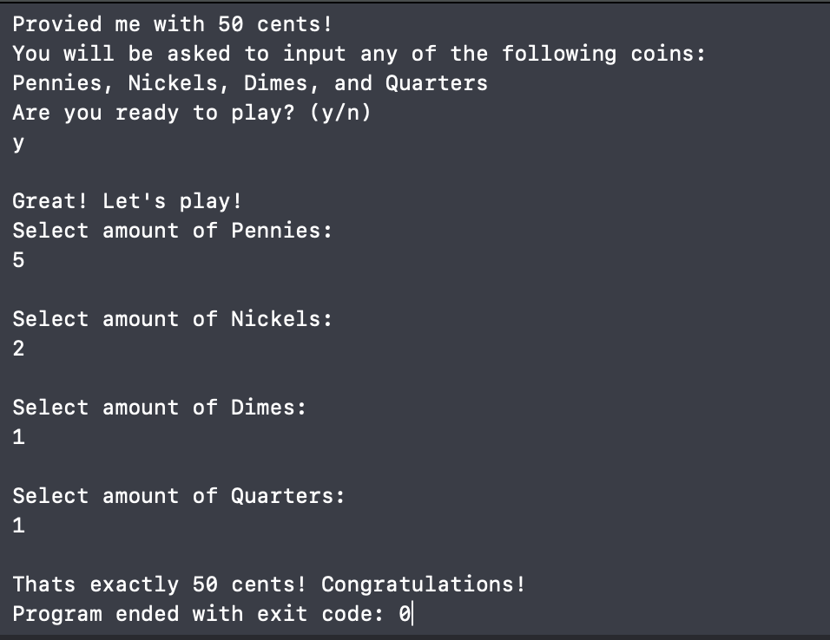

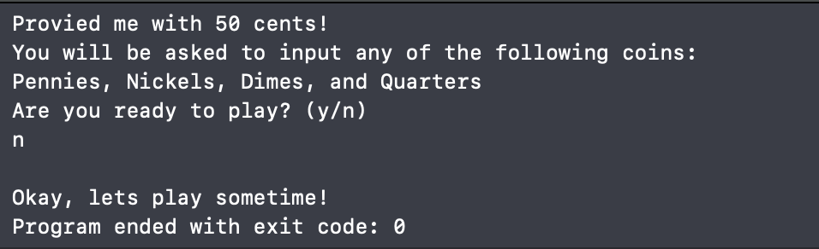

**Program 3: ch4_pgm3; A program that prompts the user to enter the names of two primary colors to mix.**

**Code:**

/*

Programmer: Austin Tesch

Date modified: 05-02-24

Compiler used:  XCODE v. 15.0

Purpose:

A program that prompts the user to enter the names of two primary colors to mix.

If the user enters anything other than “red,” “blue,” or “yellow,” display an error message.

Otherwise, display the name of the secondary color produced.

Red, blue, and yellow are classified as primary colors since they cannot be produced by blending other colors.

Combining two primary colors results in a secondary color: red and blue yield purple, red and yellow produce orange, and blue and yellow form green.

*/

#include <iostream>

#include <string>

using namespace std;

int main(){

// Prompt user to input 2 primary colors

cout << "Provide the two primary colors you would like to combine: " << endl;

string primary1, primary2;

cin >> primary1 >> primary2;

/*

CHECK THAT THE COLORS PROVIED ARE PRIMARY

MIX THE COLORS TOGETHER

OUTPUT THE SECONDARY COLOR TO THE USER

*/

// first primarty chosen is red

if (primary1 == "red"){

// second primary is blue

if (primary2 == "blue"){

cout << "You produced the color purple." << endl;

}

// second primary is yellow

else if (primary2 == "yellow"){

cout << "You produced the color orange." << endl;

}

// second primary is red

else if (primary2 == "red"){

cout << "You combined two of the some color." << endl;

}

// 'non-primary' provided

else{

cout << "The second color provided does not appear to be primary." << endl;

}

}

// first primary is blue

else if (primary1 == "blue"){

//second primary is yellow

if (primary2 == "yellow"){

cout << "You produced the color green." << endl;

}

// second primary is red

else if (primary2 == "red"){

cout << "You produced the color purple." << endl;

}

// second primary is blue

else if (primary2 == "blue"){

cout << "You combined two of the some color." << endl;

}

// 'non-primary' provided

else{

cout << "The second color provided does not appear to be primary." << endl;

}

}

// first primary is yellow

else if (primary1 == "yellow"){

// second primary is red

if (primary2 == "red"){

cout << "You produced the color orange." << endl;

}

// second primary is blue

else if (primary2 == "blue"){

cout << "You produced the color green." << endl;

}

// second primary is yellow

else if (primary2 == "yellow"){

cout << "You combined two of the same color." << endl;

}

// 'non-primary' provided

else{

cout << "The second color provided does not appear to be primary." << endl;

}

}

// 'non-primary' provided

else{

cout << "The first color you provided does not appear to be primary." << endl;

}

return 0;

}

**Output:**

**Program 4: ch4_pgm4; A program that asks the user to enter a year and then reports when the next leap year will be.**

**Code:**

/*

Programmer: Austin Tesch

Date modified: 05-02-24

Compiler used:  XCODE v. 15.0

Purpose:

A program that asks the user to enter a year and then reports when the next leap year will be.

Here is how we decide on a leap year:

If it is divisible by 400, it is a leap year

else if it is divisible by 100, it is NOT a leap year

else If it is divisible by 4, it is s leap year

*/

#include <iostream>

using namespace std;

int main(){

// prompt user for a year

cout << "Provied a year and I will tell you when the next leap year will be: " << endl;

int user_year, leap_year;

cin >> user_year;

leap_year = user_year;

// start check at next year

leap_year++;

// keep track of increments

int increment = 0;

// calculate next year that is multiple of 4

if (leap_year % 4 != 0){

increment = 4 - (leap_year % 4);

}

// adjust year to next multiple of 4

leap_year += increment;

// exclude century years that are not leap years

if ((leap_year % 100 == 0) && (leap_year % 400 != 0)){

// skip to next possible leap year

leap_year += 4;

}

// output when the next leap year will be

cout << "The next leap year following the year " << user_year << " will be in the year: " << leap_year << endl;

return 0;

}

**Output:**

